8.2 - Studying

In Czech we have two verbs for studying – studovat and učit se

What’s the difference? This is something we talked about (some) when we learned these verbs back in unit 2, but it’s worth us going over again briefly:

učit se – is studying in the sense of sitting down with books and learning material, for example in the library, before a test, etc. or a skill (such as cooking or skiing).

studovat - is studying as in a major at school or something more serious

 | 
Tihle studenti se učí v knihovně.  These students are studying in the library. | Marie se učí matematiku.  Marie is studying (learning) math.
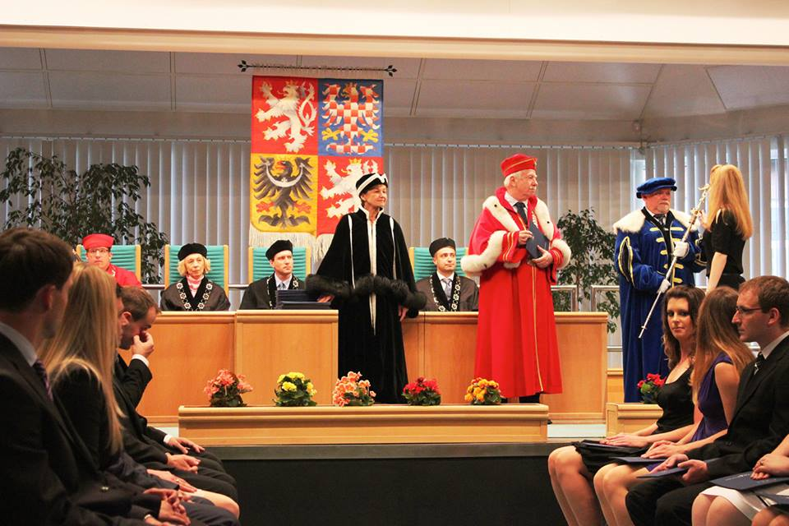
Tihle studenti studovali ekonomii.
These students studied economics.

Important to remember(!) – whether you use učit se ‘to learn, study’ or studovat ‘to study (major)’, the thing you study will be the direct object and will be in the accusative case. Take a look back at the examples above (where applicable) and take note of this.

Images used in this document come from these sources.

