1 | 1 | Lekcija 4: Kako ste?

| Gender of Nouns (Plural)
M A S C U L I N E ( Ø → – i )
Ovo je... | 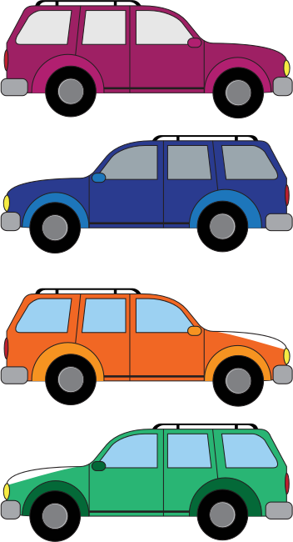 | Ovo su...
Ovo je... | automobil | Ovo su... | automobili
Ovo je... | (audio) | Ovo su... | (audio)
F E M I N I N E ( -a → -e )
Ovo je... |  | Ovo su... | 
Ovo je... | knjiga | Ovo su... | knjige
Ovo je... | (audio) | Ovo su... | (audio)
N E U T E R ( -o → -a )
Ovo je... |  | Ovo su... | 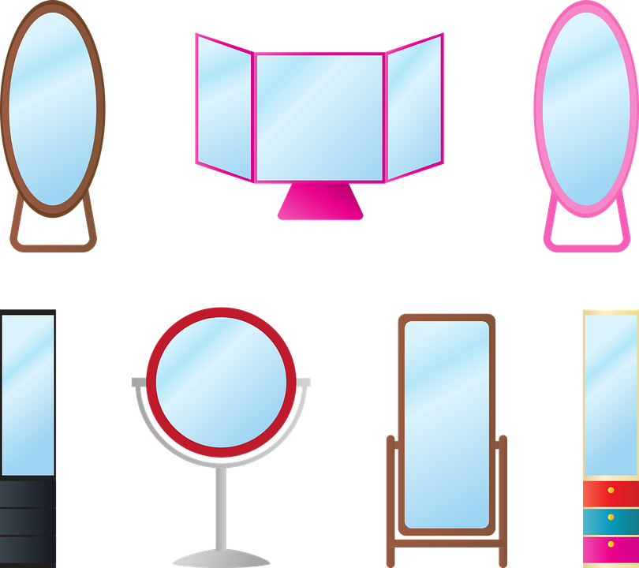
Ovo je... | ogledalo | Ovo su... | ogledala
Ovo je... | (audio) | Ovo su... | (audio)
N E U T E R ( -e → -a )
Ovo je... |  | Ovo su… |   
Ovo je... | 🌾🌱 polje | Ovo su… | polja
Ovo je... | (audio) | Ovo su… | (audio)

 | The majority of masculine nouns end in a consonant, and when they are pluralized, they get the ending -i (automobil → automobili).
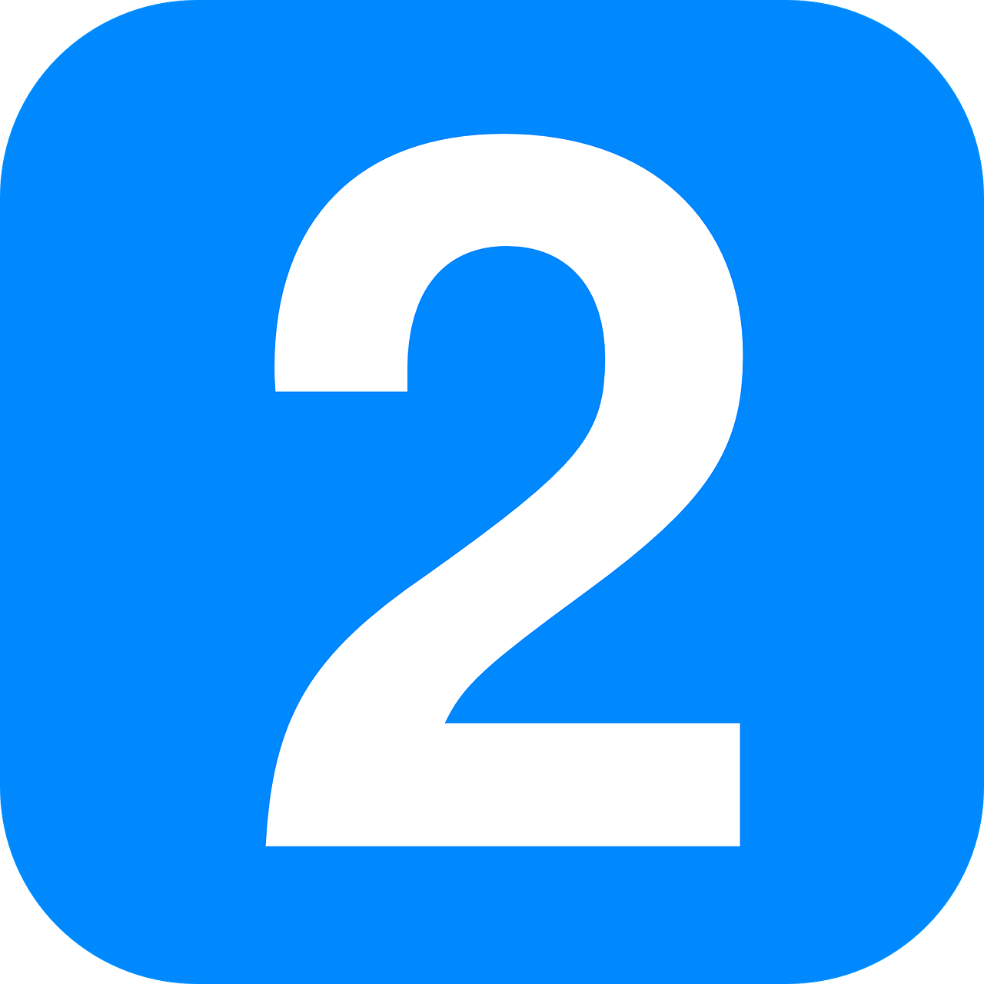 | Feminine nouns that end in -a in the singular form, when pluralized, will take the ending -e (knjiga → knjige).
 | Neuter words that have the ending -o or -e in their singular form get the ending -a when pluralized (ogledalo → ogledala; polje → polja). ‼️

1.1 Zadatak 15. Množina
What is the plural form of the following nouns? Choose the correct answer from the drop/down list.
[h5p id="8"]

| More about the verb “BITI”
Let’s refresh our memory about the verb biti. The verb biti is a very common verb in Croatian. In the Present Tense it has two forms, a stressed and unstressed form. However, for now we will look only at its unstressed form.
pronoun | verb biti | English | pronoun | verb biti | English
ja | sam | I am | mi | smo | we are
ti | si | you are | vi | ste | you all are; You formal
on/ona/ono | je | he/se/it is | oni/one/ona | su | they are
For short sentences, when saying that you are (a student, an instructor) you always need to use a pronoun before the verb. You can only say: Ja sam student (studentica)… Ti si student (studentica). You cannot say: Sam student.

1.1 Zadatak 16. Ovo su ljudi i stvari
Sentences are in singular and plural form. Choose the most logical word to finish the sentences below.
[h5p id="9"]

1.1 Zadatak 17. Stvari
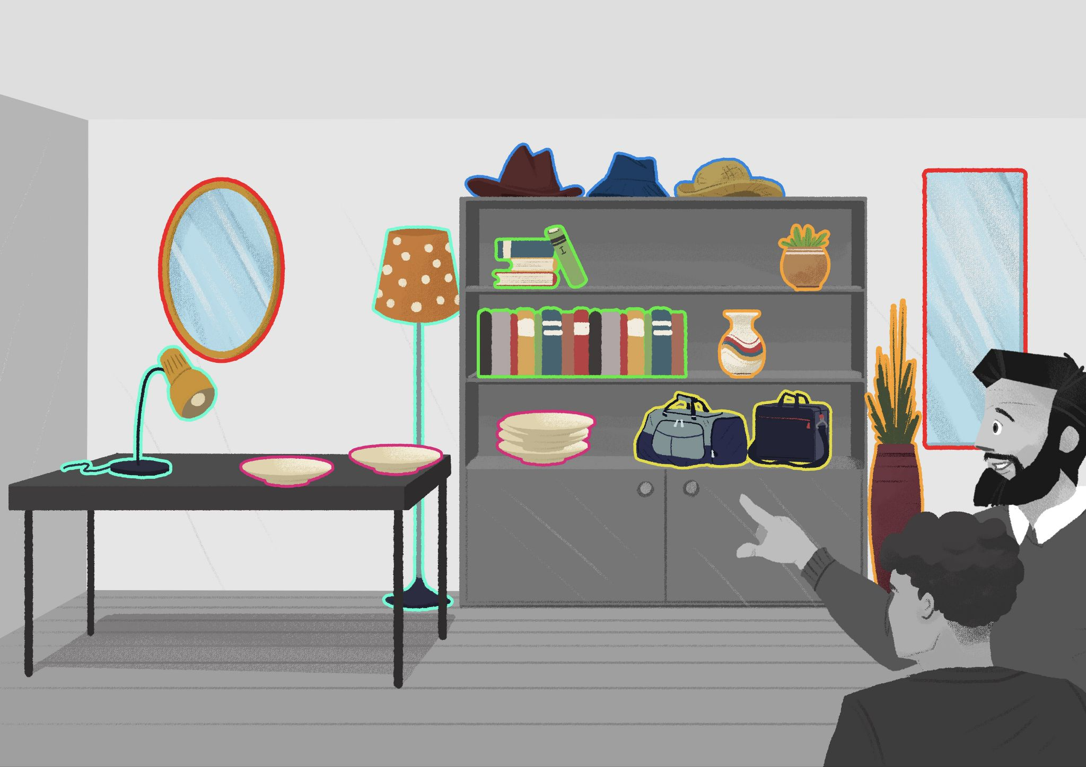
Help James identify what he has in his apartment. Look at the picture and place (write down) all of the plural items in the correct category below.
Example:
Ovo je moj mobitel. Ovo su moji mobiteli.
Ovo je moja gitara. Ovo su moje gitare.
[h5p id="10"]

1.1 Zadatak 18. Tko su oni?
Drag the answers to the appropriate blanks.
[h5p id="11"]

1.1 Zadatak 19. Prijatelji
Read the following sentences and drag the words to the appropriate blanks.
[h5p id="12"]

1.1 Zadatak 20. Kako se kaže?
Look at the pictures and choose the most appropriate corresponding question(s) to it. More than one answer might be possible.
[h5p id="678"]

Images used in this document are from these sources.

