1.7 - Asking 'what kind' - jaký

If you want to ask ‘What kind of ________?’ in Czech, you use the word jaký. It is an adjective in form, and has all the same endings, as in the chart below:

masculine | feminine | neuter
jaký | jaká | jaké

Take a look at the following examples:

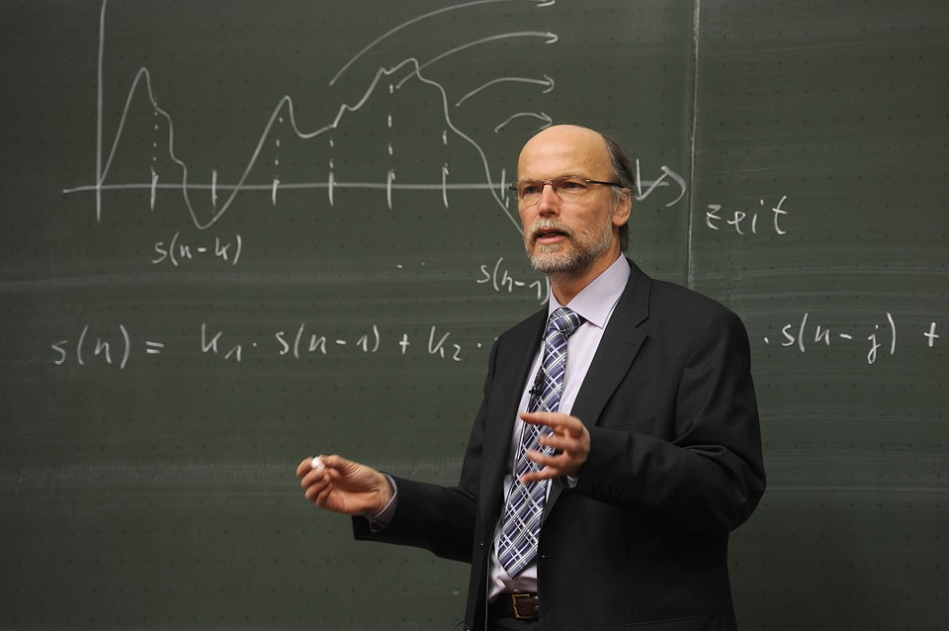  -Jaký je pan Novák profesor?  -Je dobrý profesor.  -What kind of professor is Mr. Novák?  -He’s a good professor. | 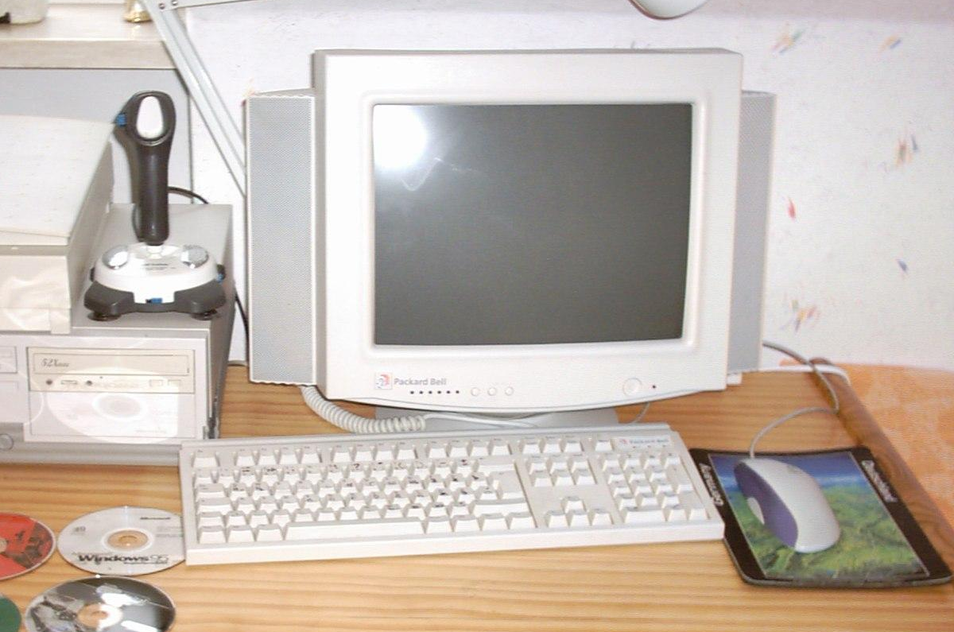  -Jaký je ten počítač?  -To je starý počítač.  -What kind of computer is this?  -This is an old computer.
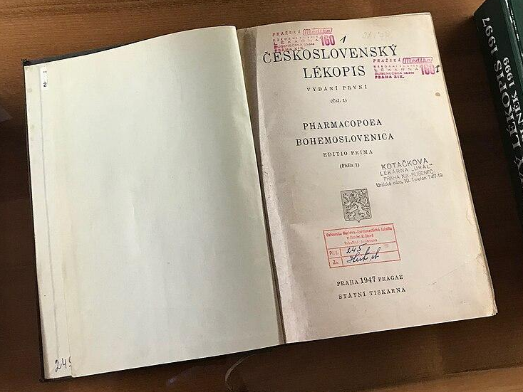  -Jaká je ta kniha?  -To je stará kniha.  -What kind of book is that?  -That is an old book. | 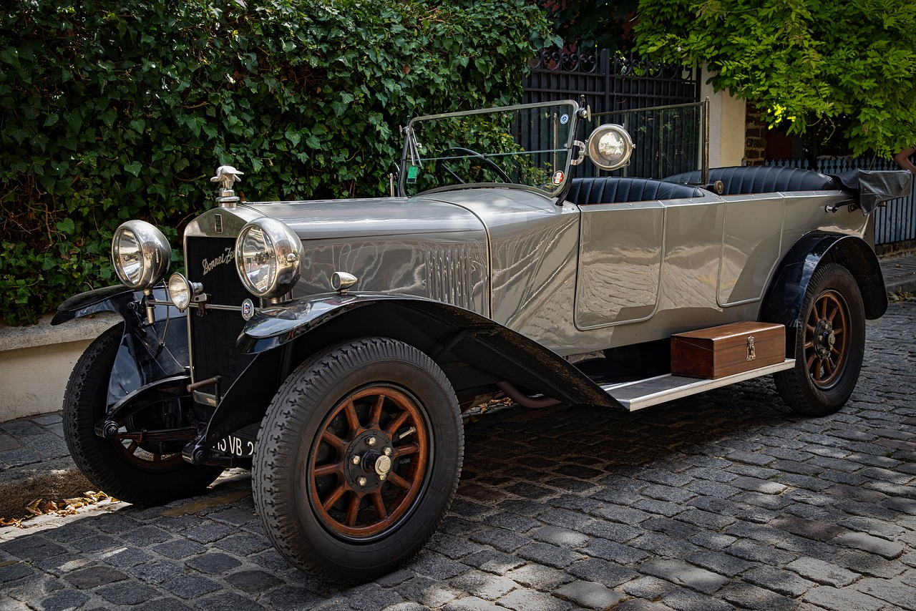  -Jaké je to auto?  -To je staré auto.  -What kind of car is this?  -This is an old car.

jaký | Use when the noun that is being asked about is masculine (animate and inanimate), as in the case of profesor or počítač above.
jaká | Use when the noun that is being asked about is feminine, as in the case of kniha above.
jaké | Use when the noun that is being asked about is neuter, as in the case of auto above.

Images used in this document come from these sources.

