4 | 1 | Lekcija 4: Gdje živiš?

4.1 Zadatak 7. Telefonski razgovor
🔊 Marko just moved away from home for his studies. He is telling his mother about his life in Zagreb and his room.
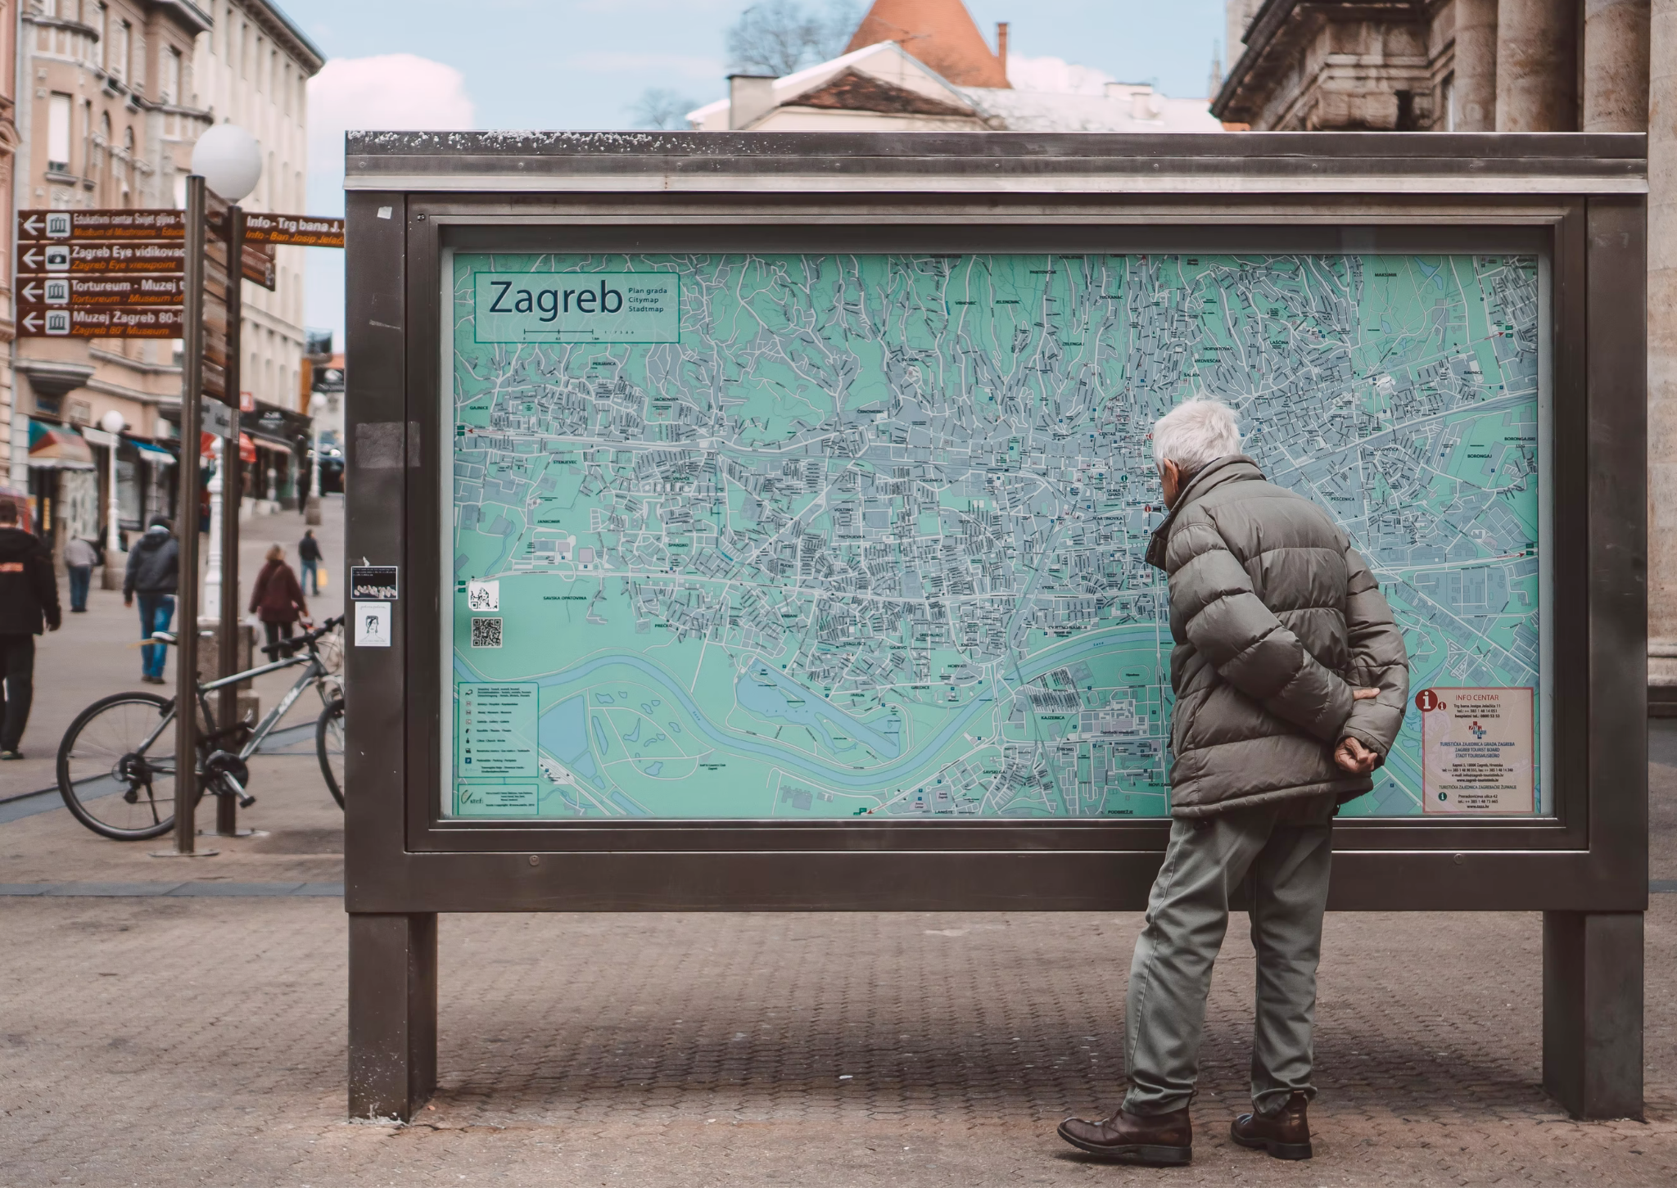 | 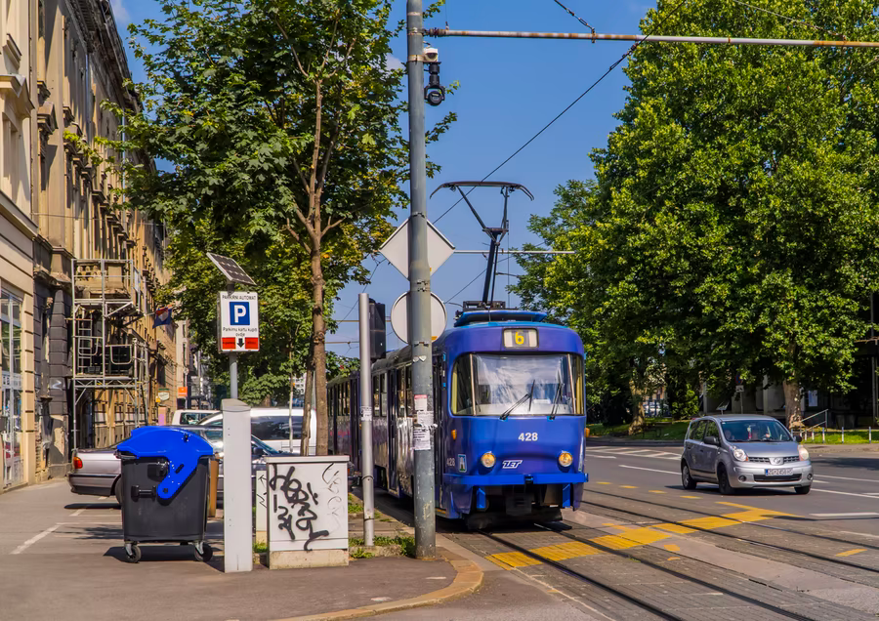
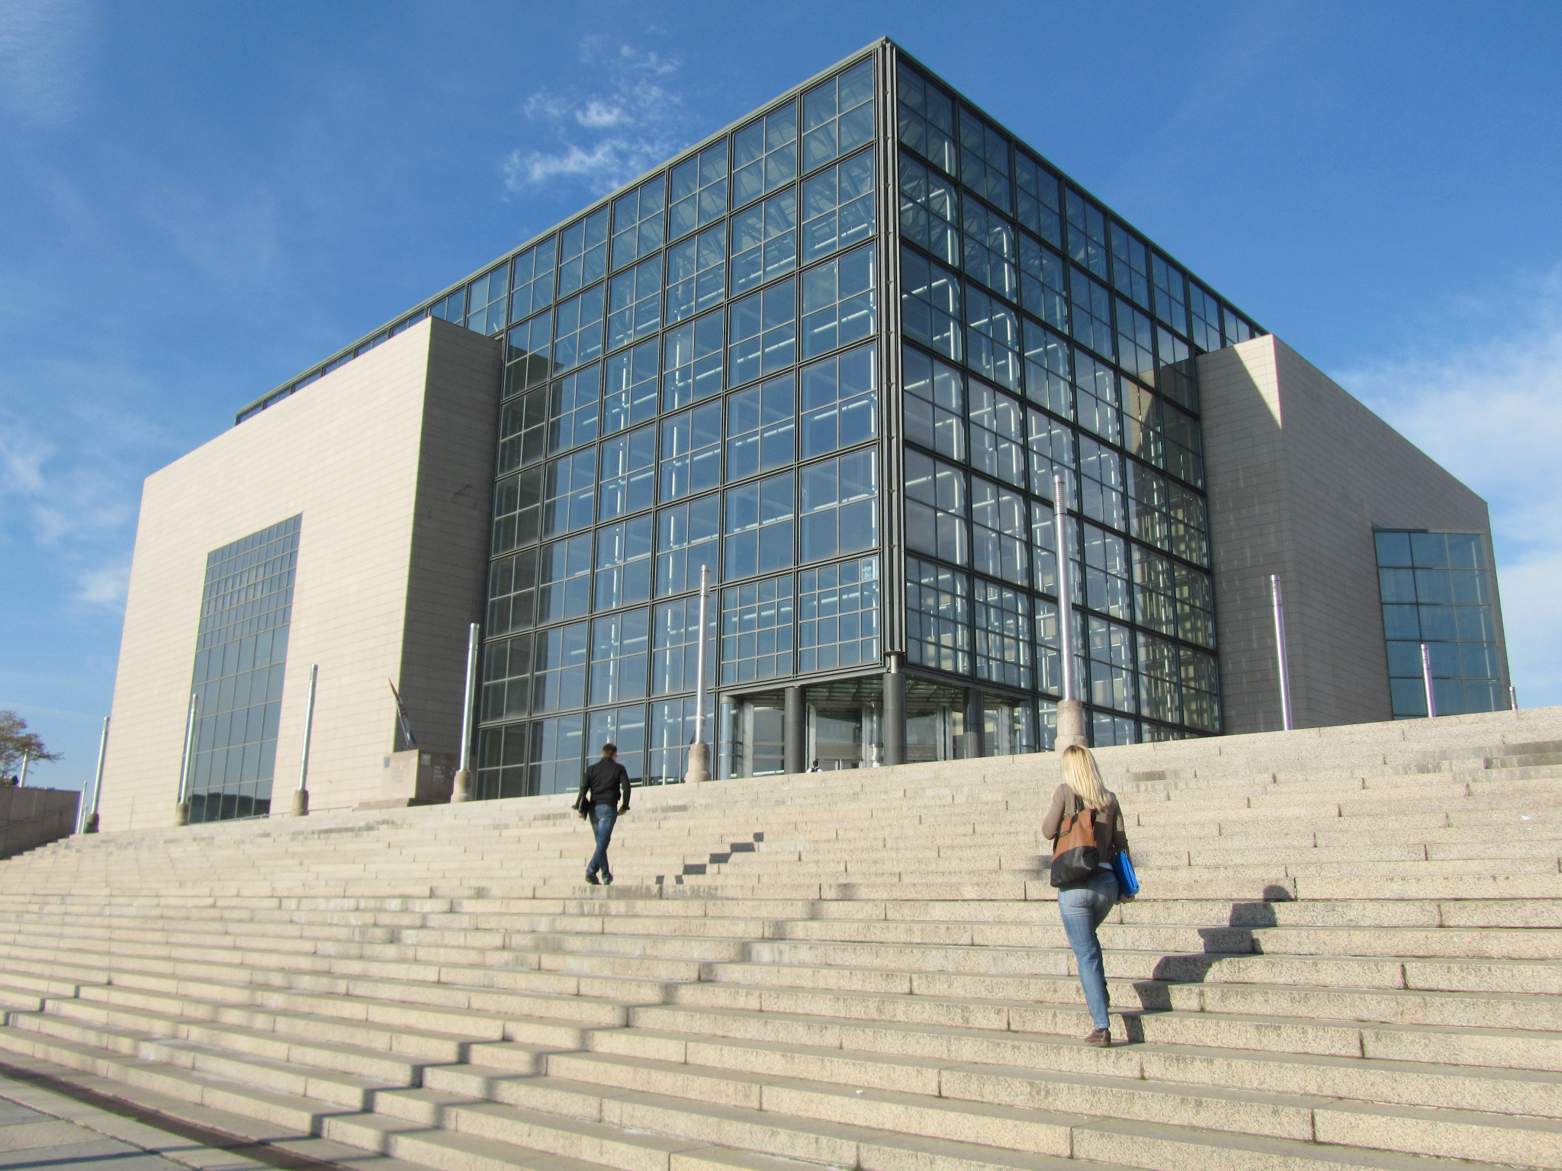 | 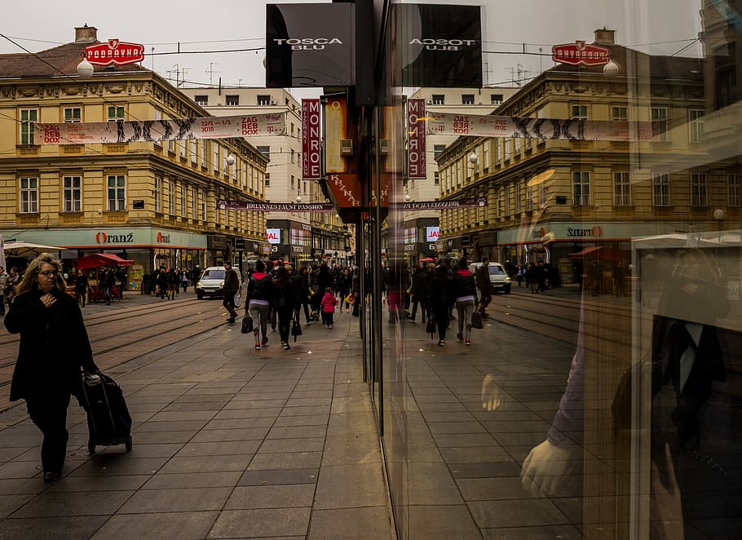

(audio)
[h5p id="405"]

Images used in this document are from these sources.

