4.9 - Buying Clothes

This lesson is mostly a few vocabulary items for shopping for clothes.

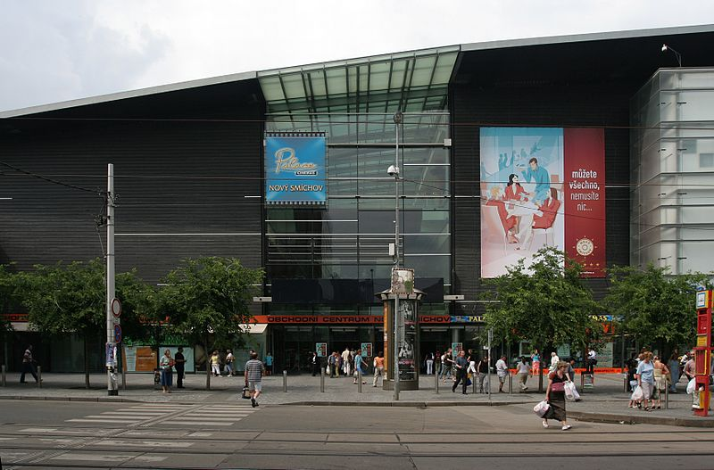
Obchodní centrum Nový Smíchov

You may go to a mall to do your shopping, in which case you’ll go to a obchodní centrum - lit. ‘store center’ or a nákupní centrum - lit. ‘shopping center’, though despite its name, it is more like a mall – the American concept of a bunch of stores all centered around a parking lot is much less common there than in the United States.

velikost - size  In Czech these are just like in English (in the age of globalisation, t-shirt sizes are the same pretty much everywhere and all based on English): S, M, L, XL, XXL  If you wanted to say these, you would say:  S - esko  M - emko  L - elko  XL - ixelko  XXL - ixixelko  Other sizes get more complicated (typically either in inches for some brands or centimeters for other brands).  Women’s sizes (2, 4, 6, etc.) tend to be easy to convert (just add 30 – so 2 is 32, 4 is 34, etc.)  Here is some more information on European sizes. | 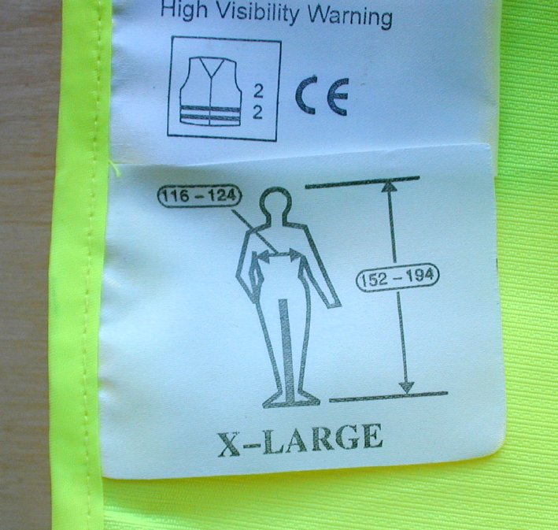
Oddělení - You might need to find different parts of a store (oddělení - divisions). A few words that will come in handy:  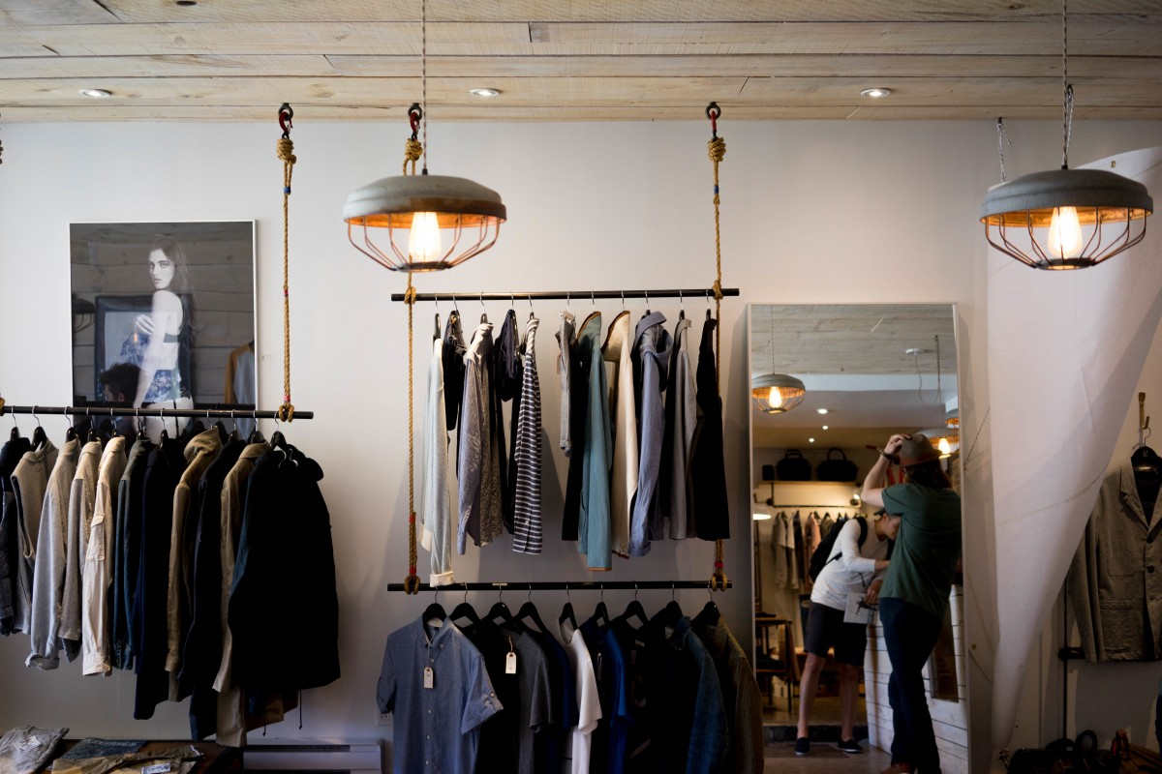  móda - fashion  - pánská móda - men’s fashion  - dámská móda - women’s fashion  obuv (f.) - footwear  - pánská obuv - men’s footwear  - dámská obuv - women’s footwear | 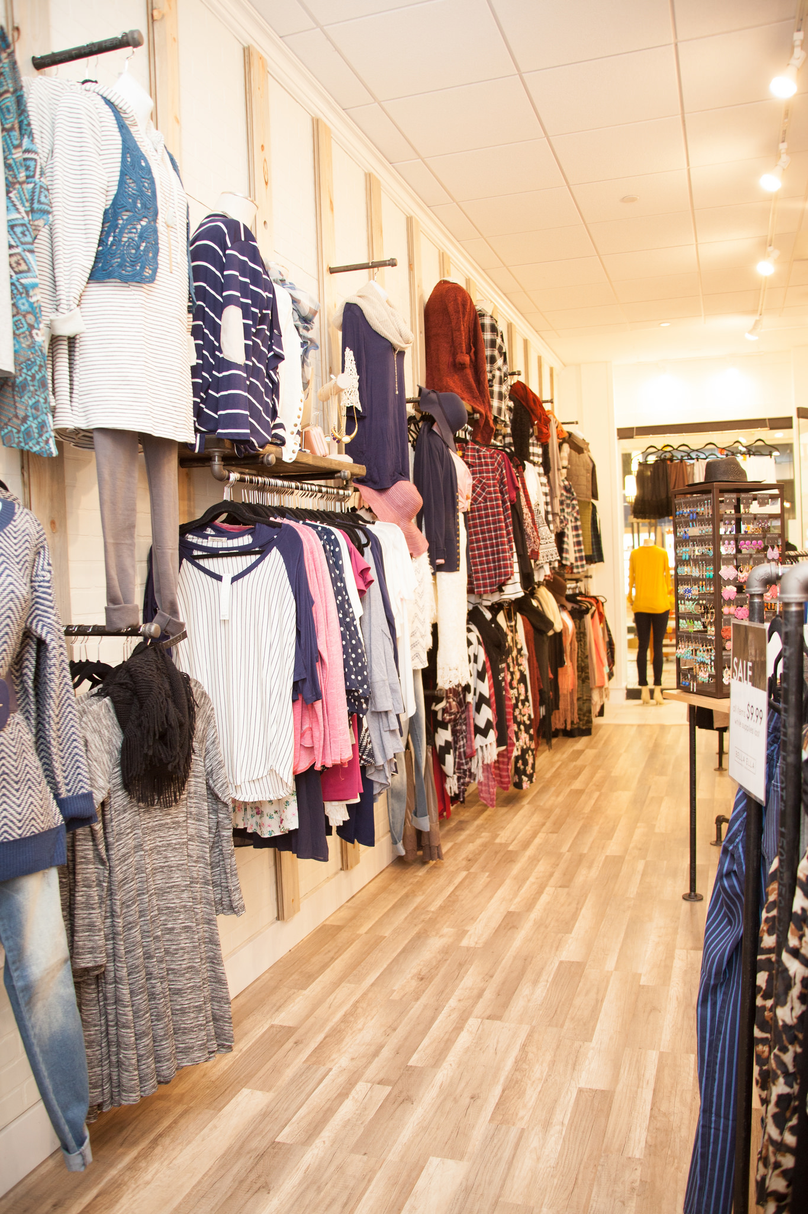
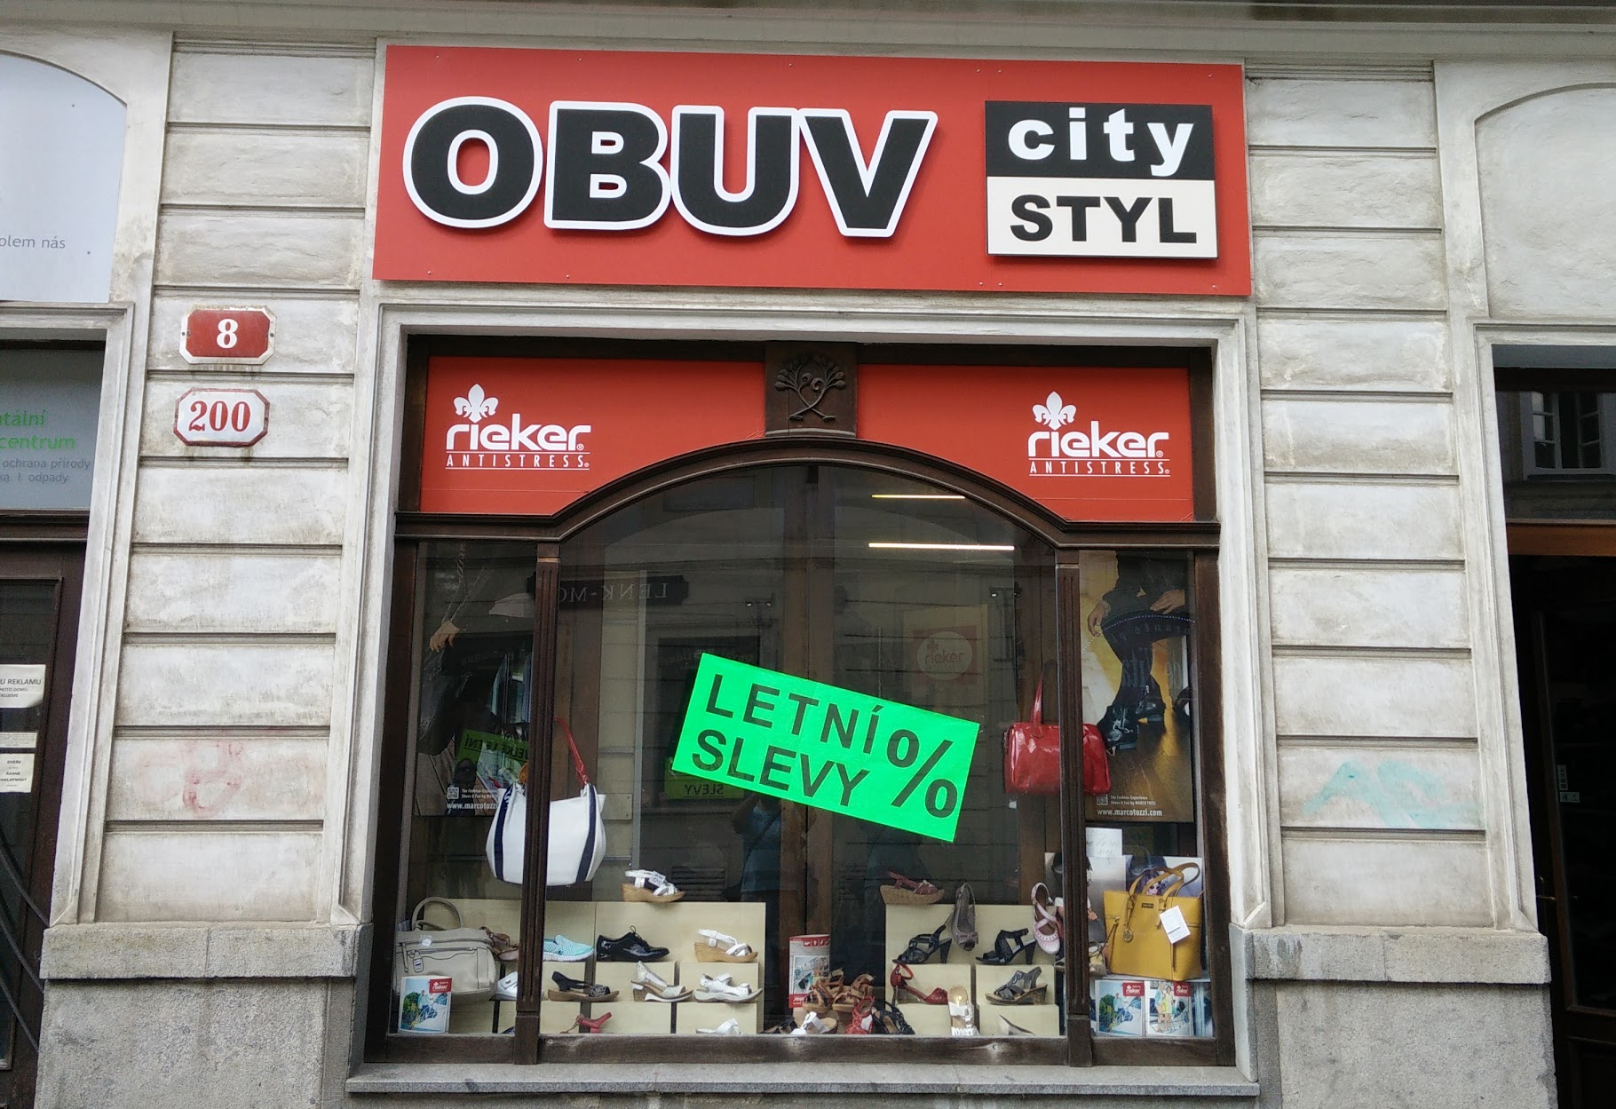  Other Useful Vocabulary  cena - price  sleva (often plural - slevy) - sales!  nákupní košík - shopping cart (in the sense of an online store | 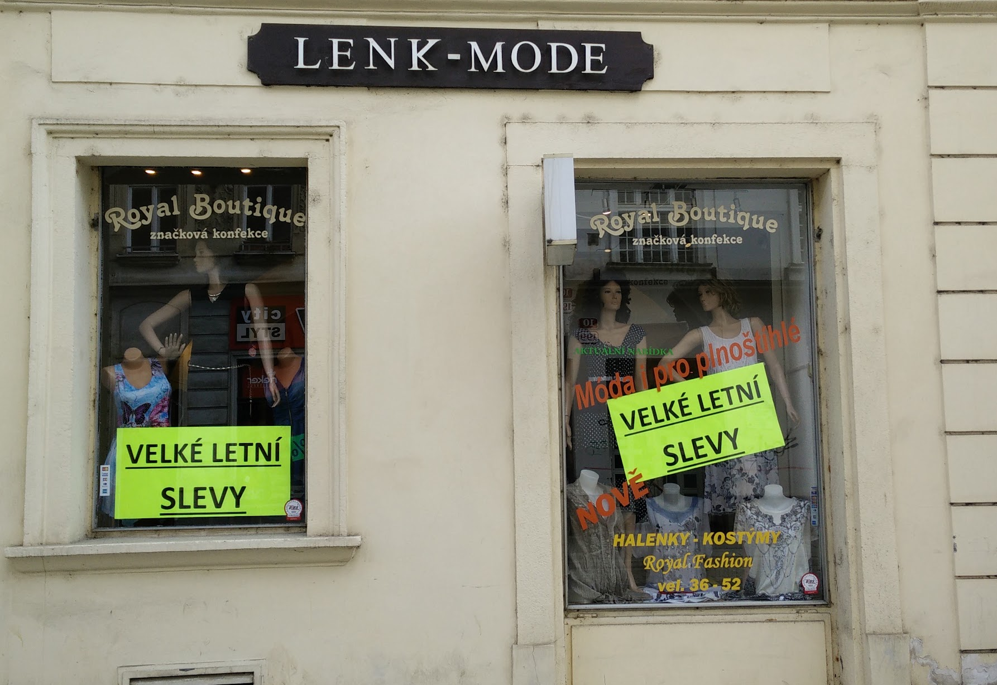

Images used in this document come from these sources.

