6.8 - less, more...the least, the most…

Below you will find another set of words you will find useful for qualifying how much you do of something.

méně / míň | ‘less’
více / víc | ‘more’
nejméně / nejmíň | ‘the least’
nejvíce / nejvíc | ‘the most’

For example, you can combine líbit se with the following qualifiers:

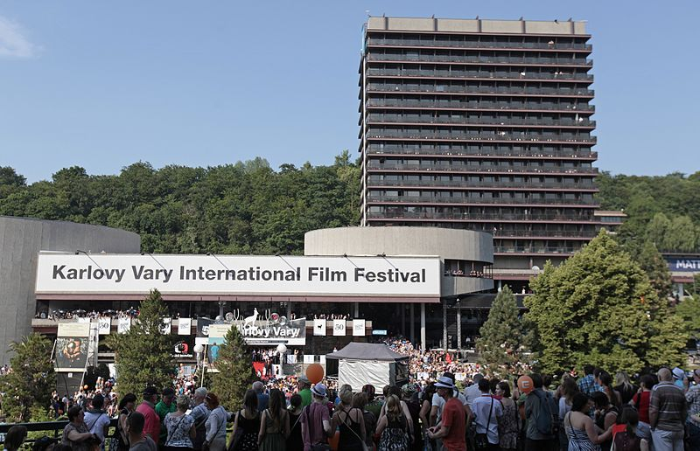  Tenhle film se mi líbí trochu míň.  I like this movie a little less. | 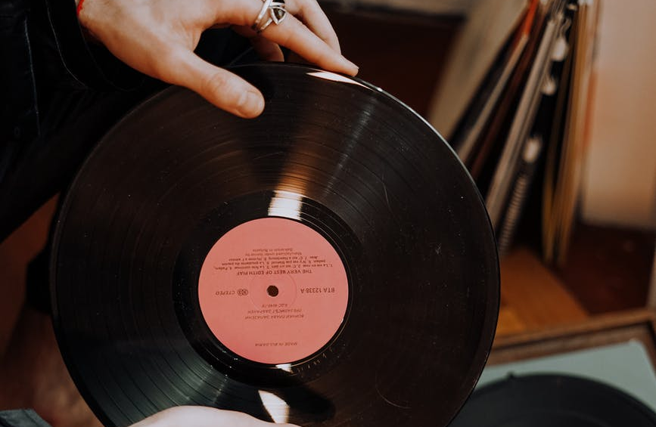  To nové album se mi líbí trochu víc.  I like the new album a little more.
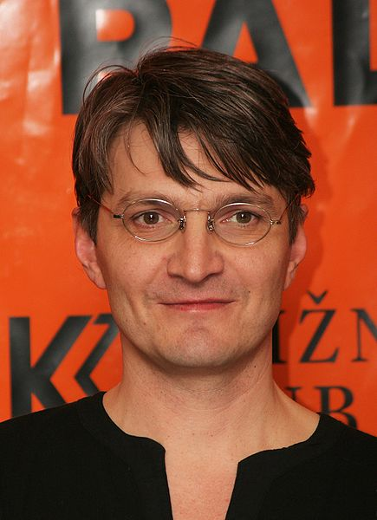  Jeho nový film se mi líbí nejvíce.  I like his new movie the best. | 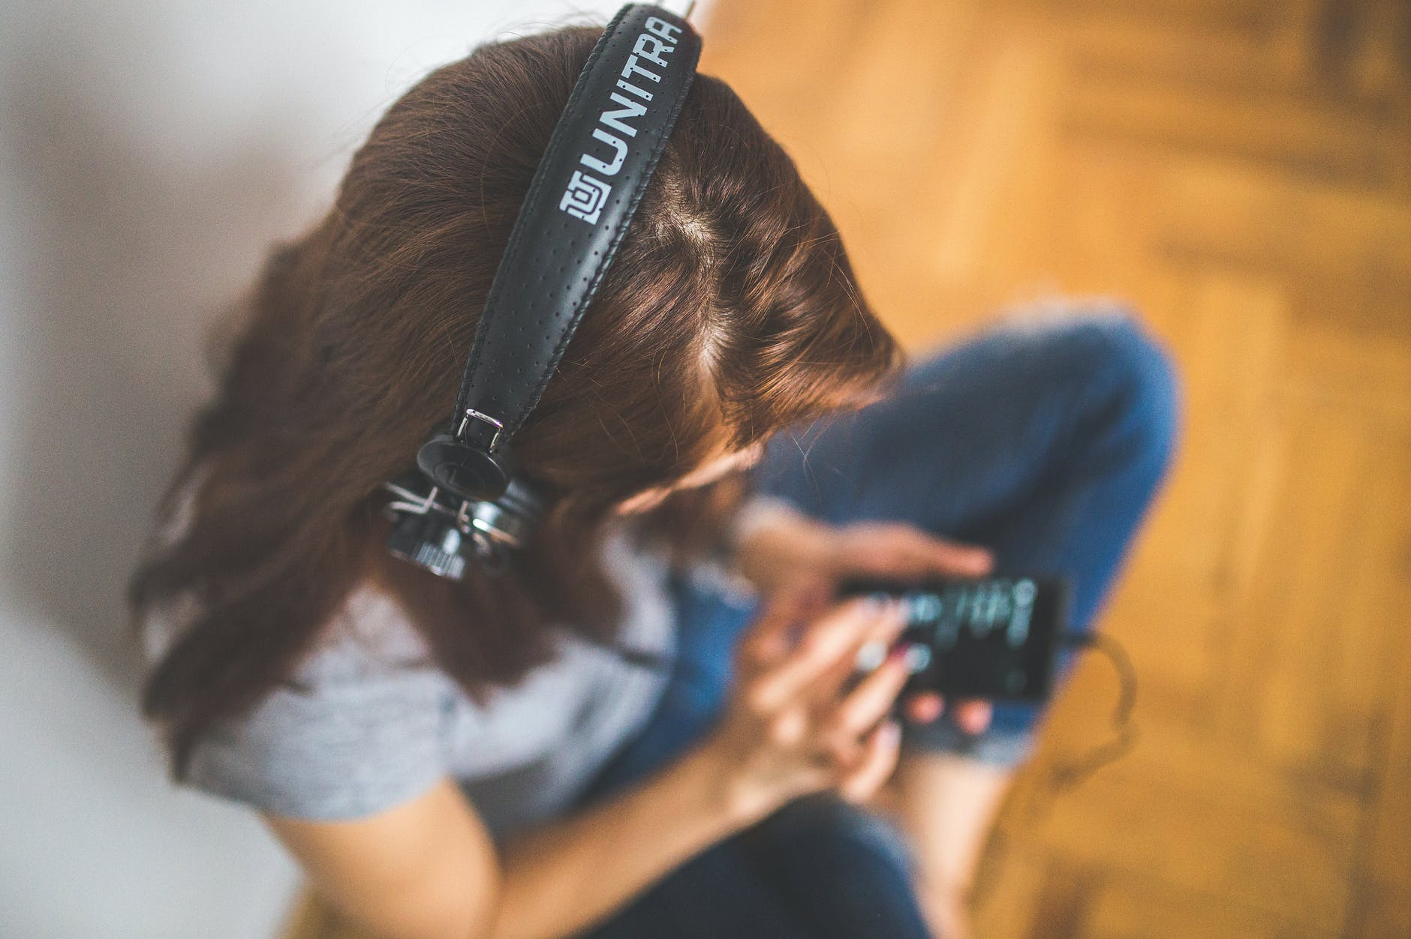  Nejvíc se mi líbí tahle písnička.  I like this song the best.

Images used in this document come from these sources.

