9.5 - rodinné setkání - family get-together

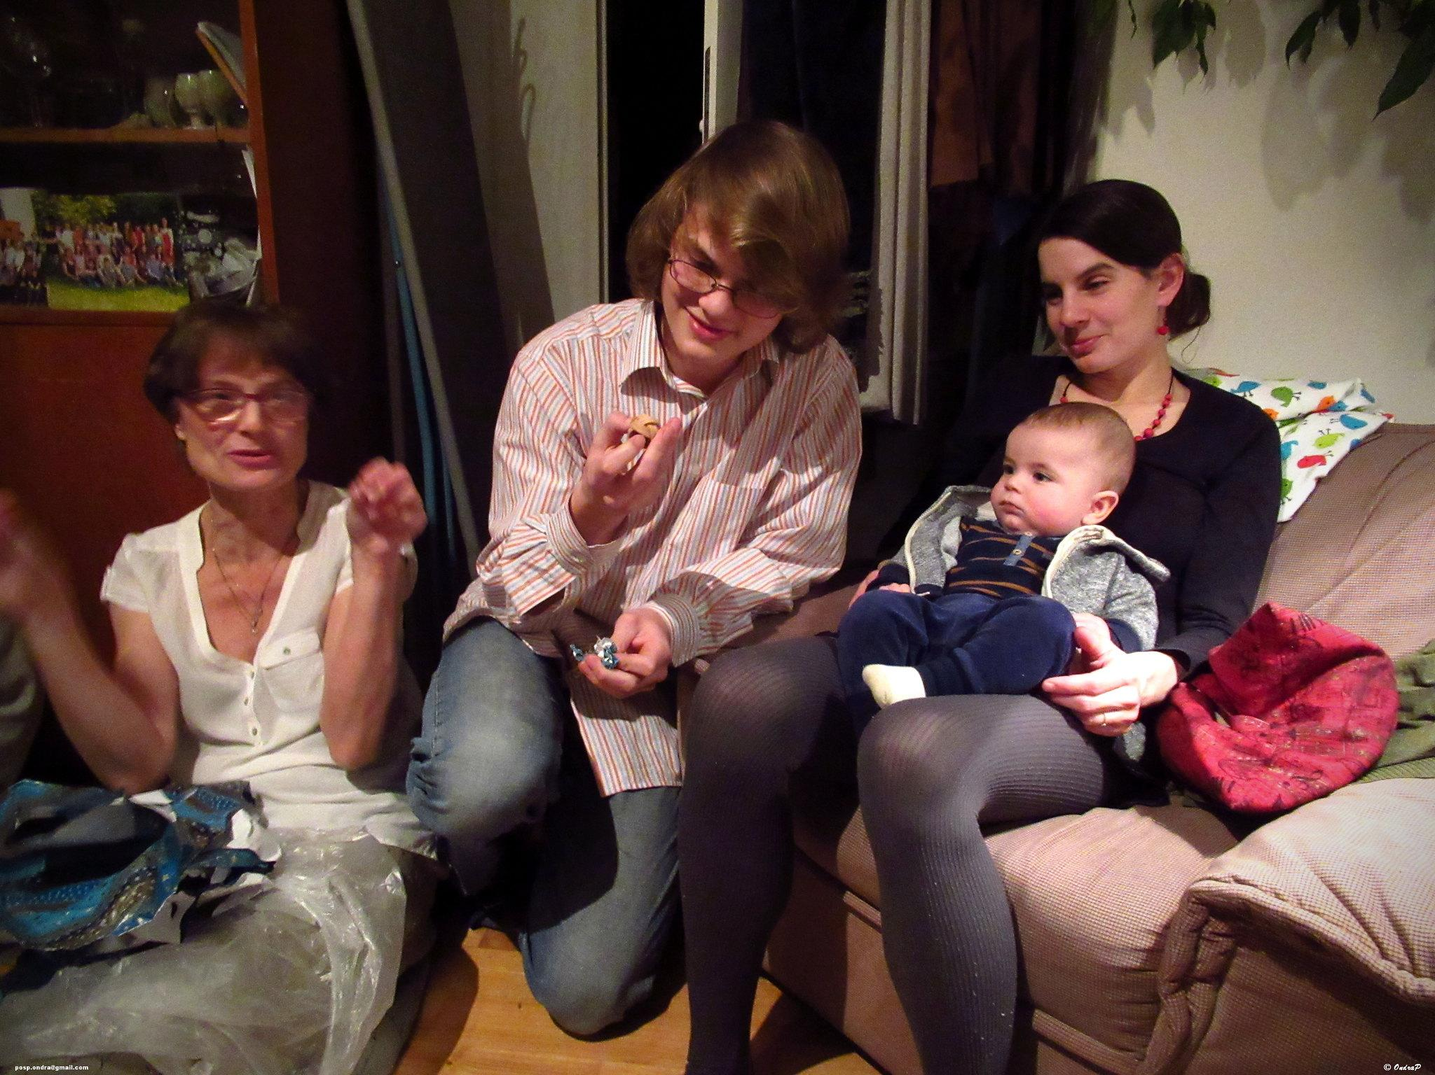 | 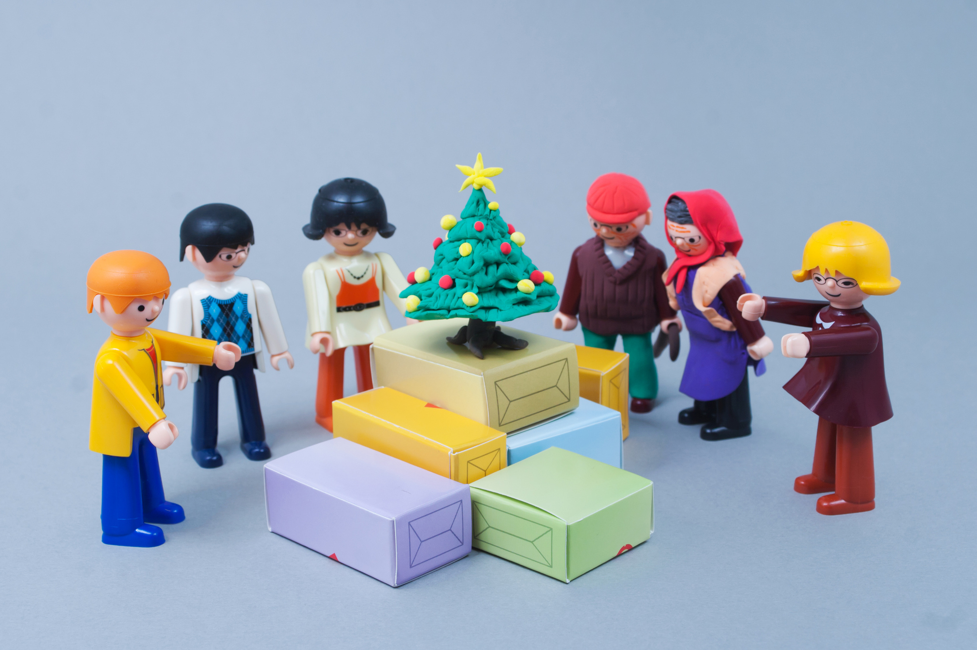
Tahle rodina se sešla na štědrovečerní večeři | Tahle trochu netypická rodina se taky schází na Vánoce

When we talk about Christmas or other holidays, we often talk about getting together with family. Here we’re going to learn a few vocabulary items to talk about family gatherings.

We know the word rodina ‘family’. From the word rodina we get an adjective rodinný - ‘family ______’. So we have for example:

rodinné setkání - family get-together

We also might need to talk about people meeting up. Here are a few new verbs:

setkávat se / setkat se - to meet up, get together
scházet se / sejít se - to meet up, get together

Images used in this document come from these sources.

sejít se is conjugated like jít ‘to go’, i.e. sejdu se, sejdeš se… It literally means ‘to go, come together’.

