7.10 - Buď…nebo…

Buď...nebo… means ‘Either...or…’ and is really useful, especially since when we’re talking about things we do in the afternoon or evening, there are often several things we actually do, so we might want to give multiple possibilities. Check out a few examples:

 | 
Ondra se většinou buď dívá na televizi, nebo (si) čte.

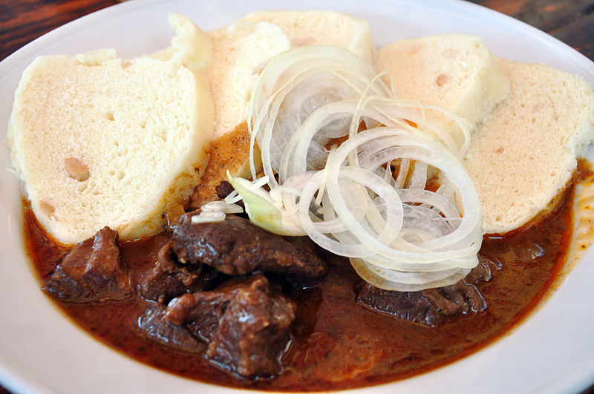 | 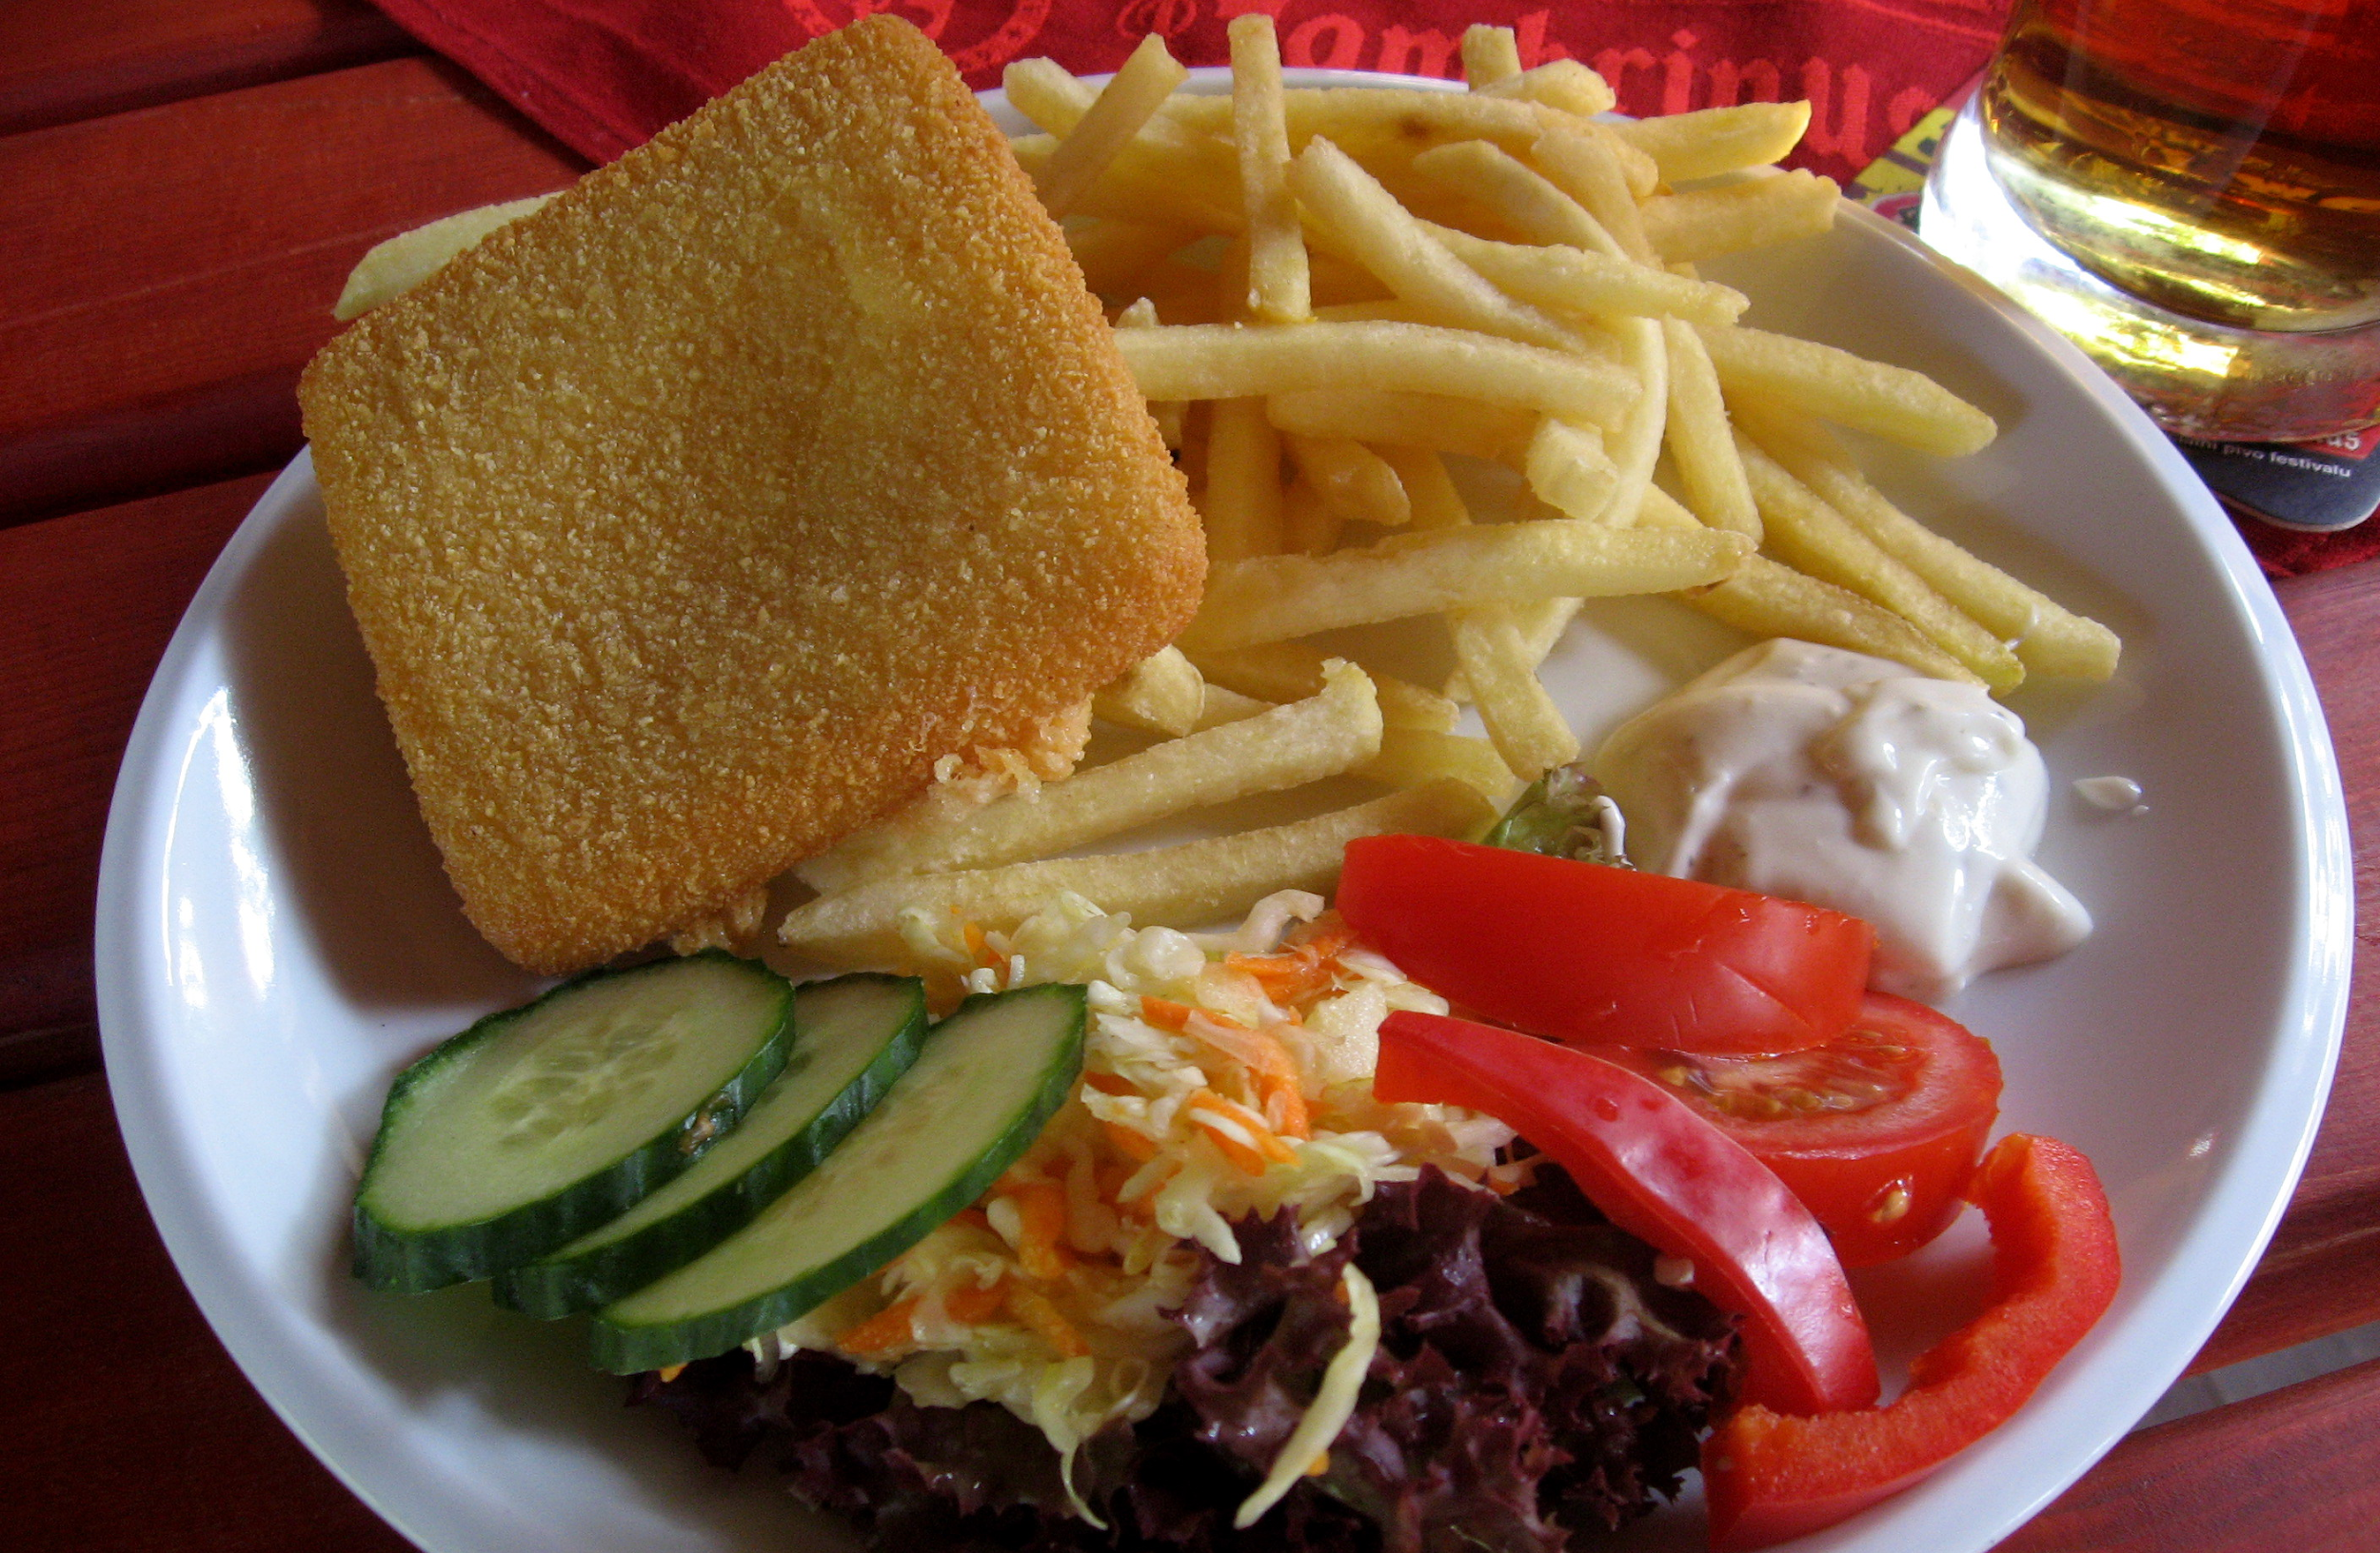
Když jsem v hospodě, obvykle si dám buď guláš, nebo smažený sýr.

Images used in this document come from these sources.

One can find the alternate buď...anebo…, where anebo is just a variant of nebo ‘or’

