8 | 2 | Lekcija 2: Pripreme za put

8.2 Zadatak 3. Recept
Before completing this assignment be sure you read the Grammar section in today’s lesson.
Your task is to pick one of the recipes from the list and present it to the rest of the class.
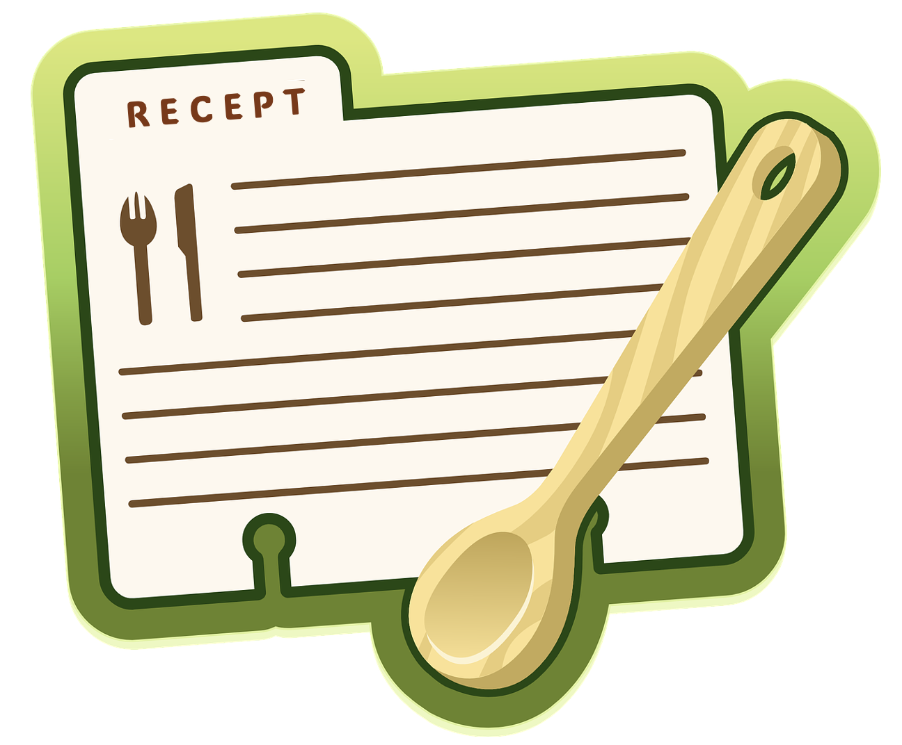 | 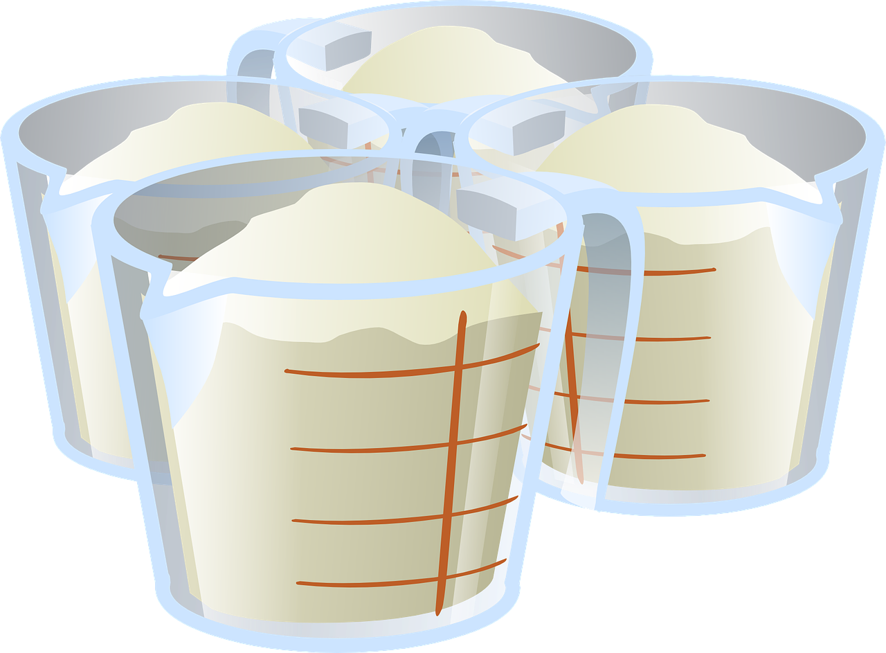
Say which recipe you picked, why, and what ingredient(s) we need if we want to prepare it. Be sure to tell us the exact amount of each ingredient. Submit your video recording online. Some measures that you will often find in recipes are:
g = gram | ml = mililitar | dag/dkg = dekagram
Be careful how you form the Genitive of these nouns when expressing quantity.

8.2 Zadatak 4. Što pripremiti?
Use one of the popular recipe sites in Croatia called Coolinarika. Find two recipes – one for glavno jelo and one for desert. What would you like to prepare for your guests, family members, or your friends? Write the exact amount for each ingredient. Write complete sentences.

Recept 1
↦

Recept 2
↦

8.2 Zadatak 5. Moje navike
Tell us about your eating and drinking habits. Do you drink enough water or too much coffee? Do you eat a lot of sweets? How much meat do you eat? Here are some examples that you can use. However, do not limit yourself only to these given options.
jedna litra vode dnevno | jedna šalica kave | jedan komad kolača
dvije boce vode tjedno | dvije šalice čaja | dva kilograma mesa
Submit your video recording online.

8.2 Zadatak 6. Kultura – razgovor
Listen to the dialogue from today’s lesson one more time. Then, answer the questions.

| Pitanje (hrvatski)
Što Matija misli o Luki?
→

| Questions (in English)
How would you say in English Matija’s final comment about Luka?
→
What are the implications behind the comment? How do you interpret the answer and what do you think the relationship between Matija and Luka is?
→

Read the following online article and complete the task.
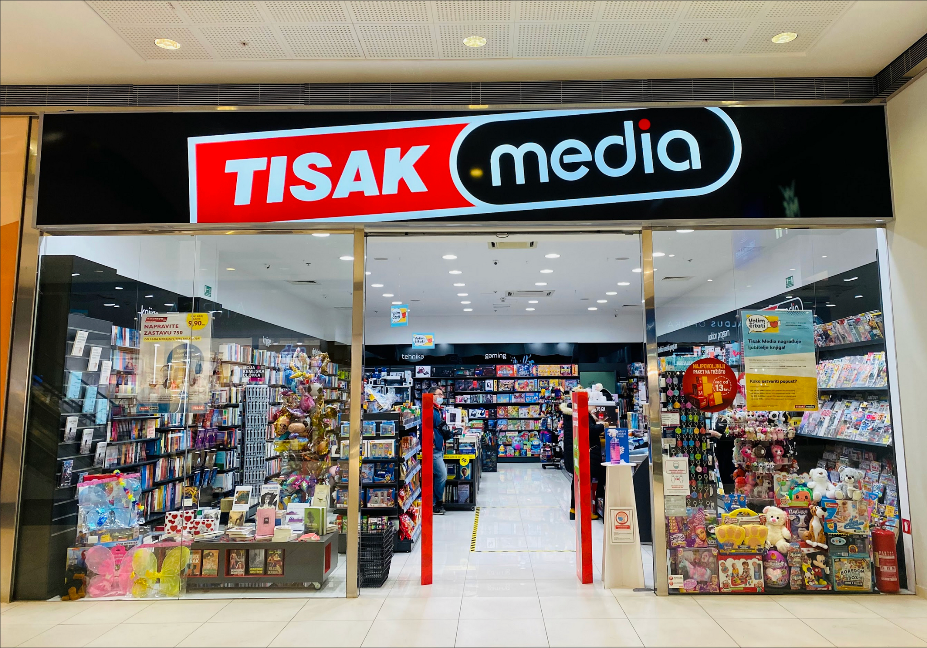 | 

| In Croatian
Što sve možemo kupiti/uraditi na kiosku Tiska? (Write as much as you can in Croatian.)
→

| In English
Is there a similar concept in your city/country? Where do you need to go in your city in order to complete the purchases that people in Croatia can do in Tisak booths?
→
Do you find this concept useful? Why?
→

Images used in this document are from these sources.

