1.11 - Odkud jste? ‘Where are you from?’

In this lesson we’re going to learn how to tell someone where you are from. This will require a few new forms, but for now we will focus primarily on learning how to say where you are from (and perhaps where a few people you know are from), as well as understanding when other people say where they are from.

The question word odkud means ‘from where’. You use it to ask where someone is from, as in:

Odkud jste?
Where are you from? (lit. From where are you?)

The word z - ‘from’, and so you would answer já jsem z __________.
You should respond by using the preposition z - ‘from’ and the name of the city, town, or country. However, there is an additional change we need to make…

The preposition z is followed by what are called the Genitive case endings. We will learn more about cases in Unit 2, however we have seen at least a taste of this.

Genitive Endings for Saying where from?

 | MA | MI | F | N
Hard stem | not applicable here | -u  nouns ending in -ov  Krakov - z Krakova  nouns ending in -ín or -ýn  Berlín - z Berlína  Londýn - z Londýna | -y  Praha - z Prahy  Ukrajina - z Ukrajiny | -a  Německo - z Německa  Brno - z Brna
Soft stem | not applicable here | -e  počítače | -e  Francie - z Francie | -e  there are virtually no neuter place names ending in -e in Czech. If you find one, it is most likely feminine  -í  z Ústí nad Labem
Soft stem | not applicable here | -e  počítače | -e  Plzeň - z Plzně

For now you should focus not on memorizing all of the endings given in the chart below, but rather becoming comfortable with understanding them in use, getting a little practice working from the chart, and learning a few forms that are common or relevant to your life (i.e. where you are from, your parents, etc.).

Additionally, you should know that you’ll occasionally run into a variant form ze, instead of z. It is used to help with pronunciation, as summarized in the chart below:

z | ze
the form used most of time | used when there’s a complicated consonant cluster or a word that starts with s or z (which would make it hard to pronounce otherwise)

Examples:
Odkud je Pavel? -Pavel je z Ostravy.  Where is Pavel from? -Pavel is from Ostrava.  Odkud je Eva? -Eva je z Prahy.  Where is Eva from? -Eva is from Prague.  Odkud je Tomáš? -Tomáš je z Liberce.  Where is Tomáš from? -Tomáš is from Liberec.  Odkud je Martina? -Martina je z Brna.  Where is Martina from? -Martina is from Brno.  Odkud je Sára? -Sára je ze Slovenska.  Where is Sára from? -Sára is from Slovakia. | 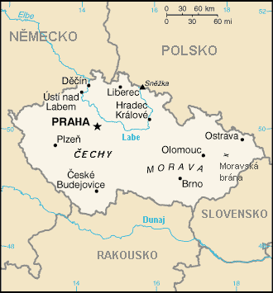

Below are some maps of Europe and the United States with Czech place names:

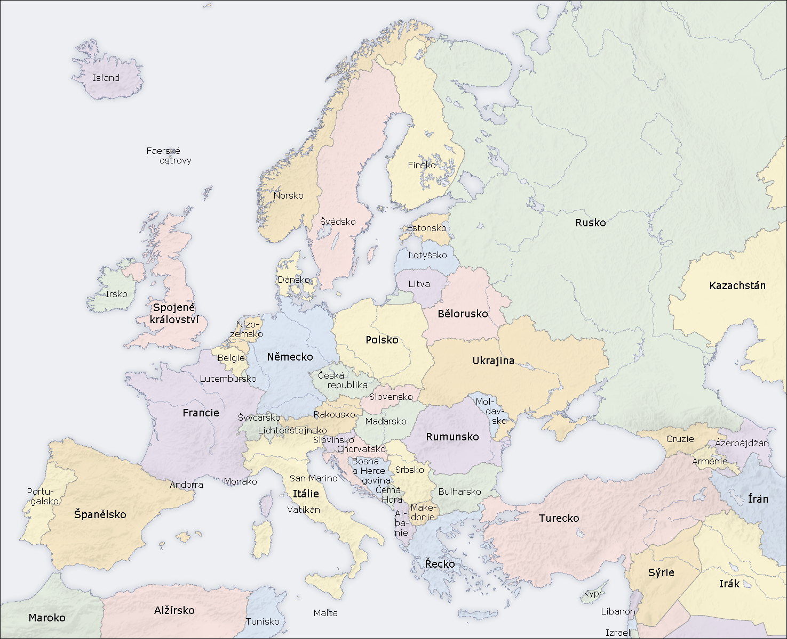
Evropa

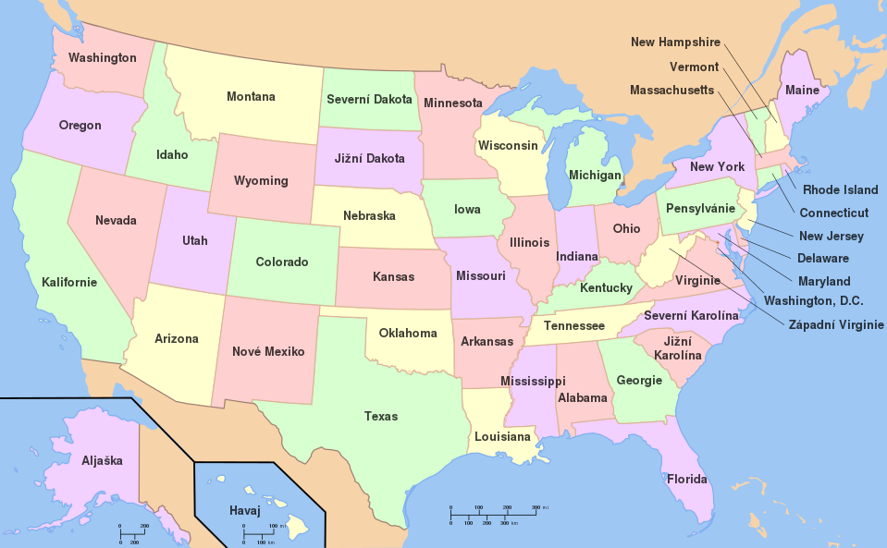
Spojené státy americké

Images used in this document come from these sources.

