8.6 - In five years, in ten years…

So what are you going to be doing in a week, in a month, in five years, ten years? Stressful, right?

Fortunately this construction in Czech is the opposite of stressful...in fact, it’s quite easy...

Za rok budu bydlet v Praze.
In a year I will be living in Prague.

Za měsíc Lenka bude doma.
In a month Lenka will be at home.

Za čtyři týdny Lukáš bude cestovat v Evropě.
In four weeks Lukáš will be travelling in Europe.

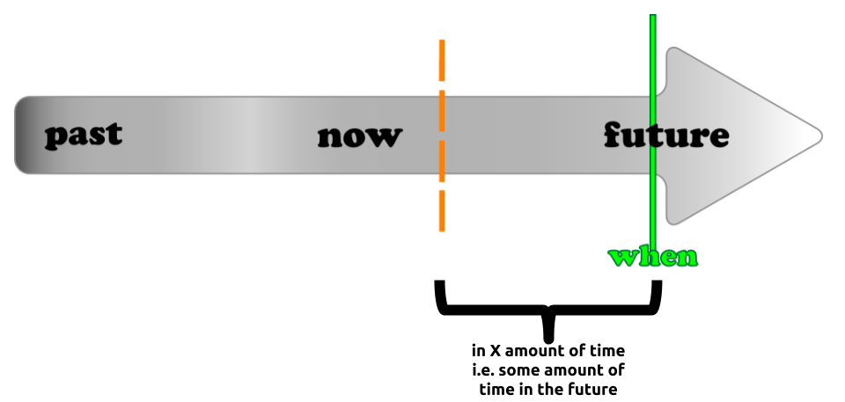

1  with accusative singular | za (jednu) sekundu 'in one second’  za (jednu) minutu 'in one minute’  za (jednu) hodinu 'in one hour’  za (jeden) den 'in one day’  za (jeden) týden 'in one week’  za (jeden)měsíc 'in one month’  za (jeden) rok ‘in one year’
2-4  with accusative plural | za dvě minuty 'in two minutes’  za tři minuty 'in three minutes’  za čtyři minuty 'in four minutes’  za dvě hodiny 'in two hours’  za tři hodiny 'in three hours’  za čtyři hodiny 'in four hours’  za dva měsíce ‘in two months’  za tři roky ‘in three years’
5+  genitive plural (here the genitive rule trumps the rule stating that these need to be in the accusative) | za pět hodin 'in five hours’  za šest dní 'in six days’  za osm měsíců 'in eight months’

Does this chart and this construction seem familiar? It should – remember Time for Completion?

Umyl jsem nádobí za jednu hodinu.
I washed the dishes in an hour.

Just like in English in an hour can also be a statement about the future.

Budu pracovat za hodinu.
I’ll be working in an hour.



Images used in this document come from these sources.

dní (or less commonly dnů) is the genitive plural of den

