7.7 - Duration of an Activity

In order to say how long you performed some activity, you just state the amount of time. There is no word corresponding to for in this type of construction.

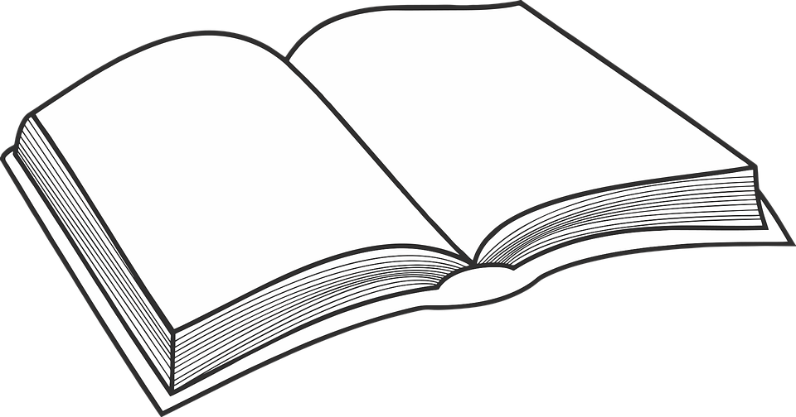
Četla jsem knihu (jednu) hodinu.
I read a book for an hour.

These answer the question – jak dlouho ‘(for) how long?’

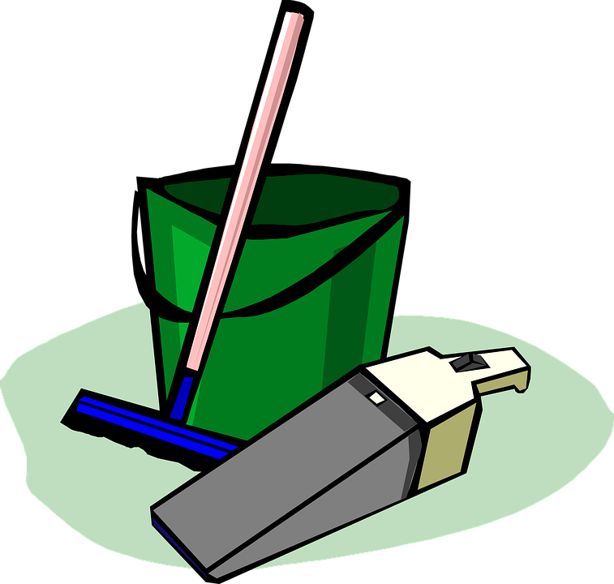
Jak dlouho jsi uklízel byt?
How long did you clean the apartment (work on cleaning the apartment) for?

The activity is combined with some sort of time expression indicating how long, such as dvě hodiny, pět minut, etc.

Včera jsem četla jednu hodinu.
Yesterday I read for one hour.

As you can see, the time expression jednu hodinu is in the accusative case. It is a rule that the time expression needs to be in the accusative case.

Oftentimes these expressions can also be translated using an expression such as I spent _____ time doing something. However, this is a much less literal translation.

Uklízeli jsme byt tři hodiny.
We spent three hours cleaning the apartment.

Here is a table that goes over these time expressions and what they will look like with various numbers:

1  with accusative singular | (jednu) sekundu ‘for one second’  (jednu) minutu ‘for one minute’  (jednu) hodinu ‘for one hour’  celou hodinu ‘for an entire hour’  (jeden) den ‘for one day’  celý den ‘for an entire month’  (jeden) týden ‘for one week’  celý týden ‘for all week’  (jeden) měsíc ‘for one month’  celý měsíc ‘for an entire month’
2-4  with accusative plural | dvě minuty ‘for two minutes’  tři minuty ‘for three minutes’  čtyři minuty ‘for four minutes’  dvě hodiny ‘for two hours’  tři hodiny ‘for three hours’  čtyři hodiny ‘for four hours’  dva dny ‘for two days’  tři dny ‘for three days’  čtyři dny ‘for four days’
5+  genitive plural (here the number if followed by the unit in the genitive plural) | deset minut ‘for ten minutes’  pět hodin ‘for five hours’  šest dní ‘for six days’  osm měsíců ‘for eight months’

Images used in this document come from these sources.

dní (or less commonly dnů) is the genitive plural of den

