6 | 3 | Lekcija 3: Filmska večer
For our next class session:
| Prezentacija - domaća zadaća
Prepare a presentation from your homework assignment (Zadatak 11).
| Razgovor o filmu
Watch a movie of your choice and complete the tasks below.

Moj izbor filma:
 |  |  | 

Film:
Godina proizvodnje:
Redatelj/-ica:
Zemlja porijekla:
Nagrade:
Glavni glumci:
Službeni web:

Razgovor o filmu:
Try to answer the following questions to your best ability. It’s ok if you can’t say much. The goal is to practice Croatian as much as possible at this point. Use class material for necessary vocabulary. You will have a chance to write your opinion in more detail in the last task, which will be in English.
| Pitanja
O čemu film govori?
→
Koja je vrsta filma?
→
Što misliš o filmu? Svđa li ti se film? [Be as specific as you can]
→
Koja je radnja filma? [The plot of the movie]
→
Je li film dostupan online? Gdje si gledao/-la film?
→
Kakvi su glumci?
→
Koji ti se glumac/glumica sviđa u filmu?
→

Vokabular:
In this section list all the new words that you have learned by watching the movie. In the left column, give the dictionary form of the word (i.e., the word in its Nominative form, or in its infinitive form). Then, use the word in a sentence. The sentence can be a very simple one; it doesn't have to be a line from the movie. Write at least 10 new words, but add as many additional rows as you want.
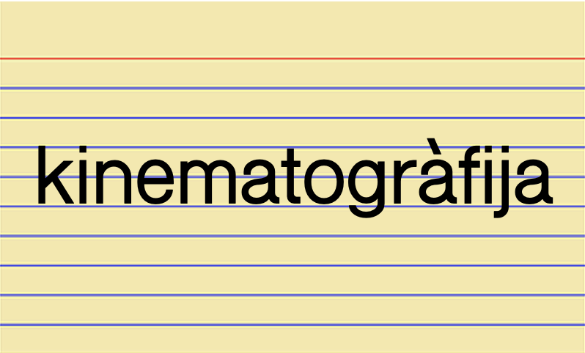 | 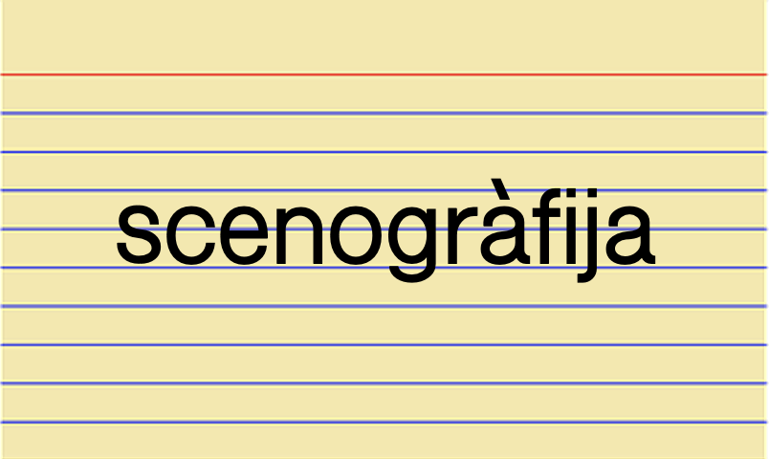

Dictionary form of the word | Sentence example

Moje mišljenje:

| In English
Tell us your overall opinion about the movie? Did you like the movie or not? Why? Would you recommend a movie to your friends who are not from the target area? Why? What topics are presented in the movie? Are there any similarities with US culture or the current situation? Are there any particular scenes from the movie that you liked or did not like? Why?
 | 
Include any relevant screenshots from the movie or any possible online sources (if there are any) that we can watch and discuss together.
| Answer the questions
→

* Note: These are just general guidelines. Feel free to write/include any other movie element that you find important.

Images used in this document are from these sources.

