4 | 2 | Lekcija 2: Više o zemlji

| Preposition + locative case
As for prepositions with the Locative case, we need to keep in mind what the message is that we want to express.
Rule #2: po + Locative = ‘along,’ ‘over,’ ‘on a surface’
The preposition po is followed by the Locative case when we want to indicate that someone’s activity or something occurs or is located all over a certain surface. | Example:  hodati po grad-u (m) / šum-i (f) / sel-u.  to walk around in the city / forest / village.

 |  | 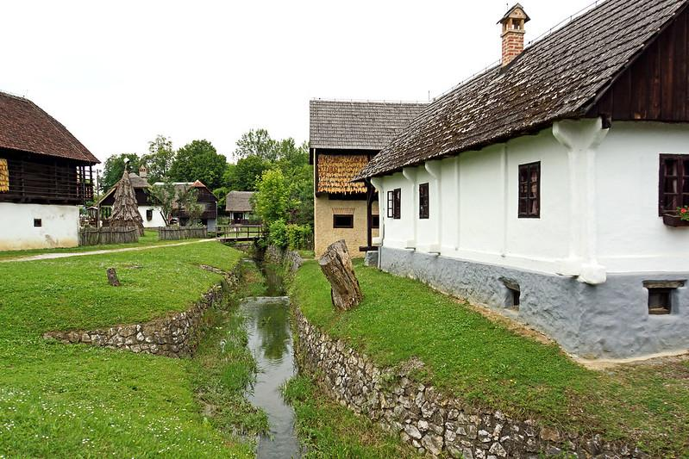
Marko šeta po grad-u (m).  I walk around in the city / forest / village. | Marija i njezin pas šetaju po šum-i (f).  Marija and her talk are walking around the forest. | Šetamo po sel-u (n.).  We are walking around the village.

Rule #3: o + Locative = ‘about’
The Locative case is followed after the preposition o when we want to indicate the meaning ‘about [a topic]’.  In sentences when we want to express that we are talking/thinking about someone or something we need to use the preposition o, followed by the Locative case. | Example:  Ja uvijek pričam o brat-u (m) / o sestr-i (f) / o sel-u (n)  I always talk about [my] brother / sister / village.

 |  | 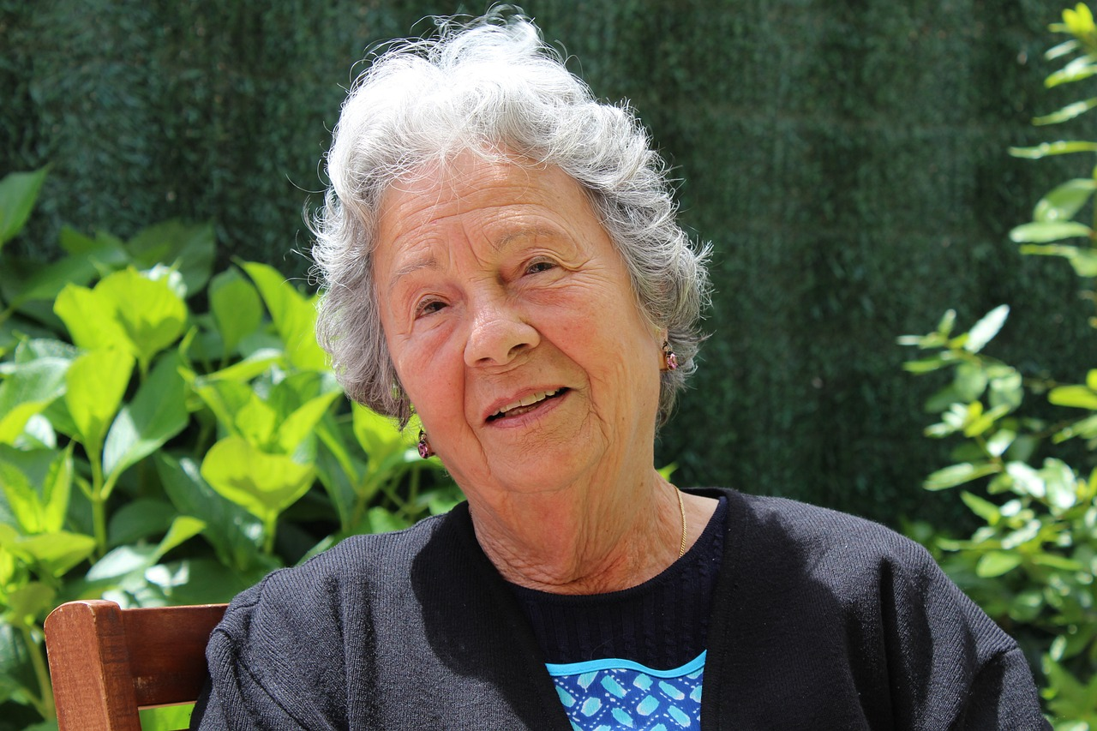
Ja uvijek pričam o brat-u (m)  I always talk about [my] brother. | Iva često priča o sestr-i (f).  Iva is talking about [her] sister. | Ljubica priča o sel-u (n)  Ljubica is talking about the village.

Additional Note: po + Locative - ‘(known) for’
When we want to express the meaning that someone or something is known for/by a certain thing, we should also use the preposition po + Locative. This is mostly expressed with the structure poznat/-a/-o po + Locative.

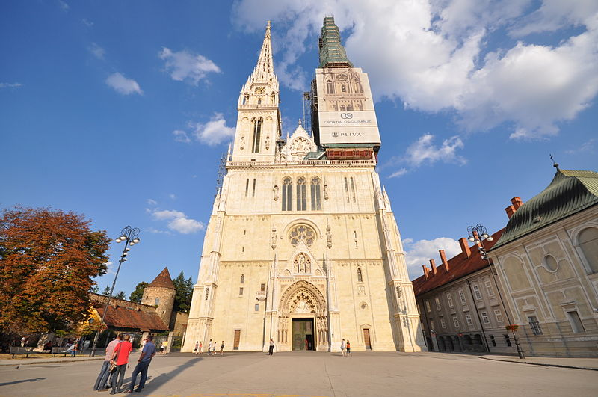 | 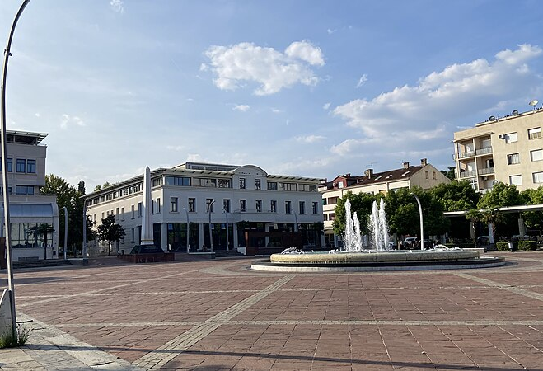 | 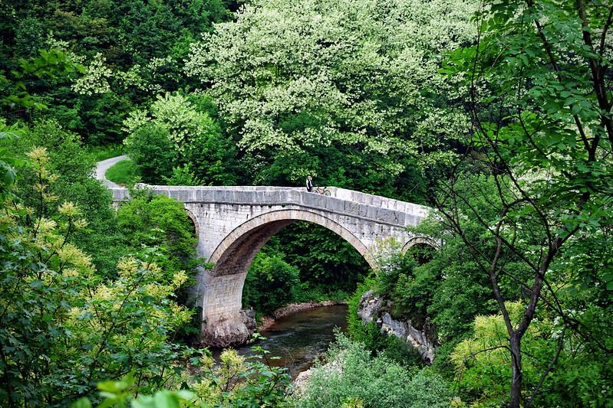
Zagreb je poznat po katedrali.  Zagreb is known for its cathedral. | Podgorica je poznata po trgu.  Podgorica is known for its [main] square. | Sarajevo je poznato po prirodi.  Sarajevo is known for its nature.

| Locative case – nouns in plural
case | masculine | feminine | neuter
N sing | restoran | planina | jezero
L pl | restoran-ima | planin-ama | jezer-ima
The general ending for masculine and neuter nouns in the Locative plural case is -ima, while for feminine nouns the ending is -ama. In masculine nouns, -ima is added to the stem (restoran). In neuter nouns,the -ima ending replaces the -о or -е of the dictionary form (jezer-o, kazališt-e). In feminine nouns, the -ama ending replaces the -а of the dictionary form (planin-a).

4.2 Zadatak 5. Hrvatska
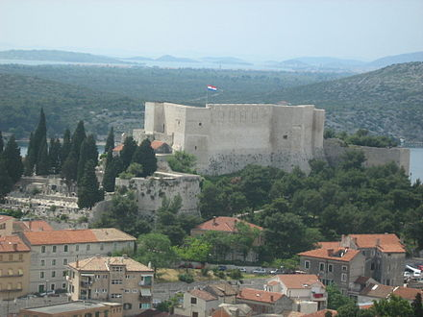 | 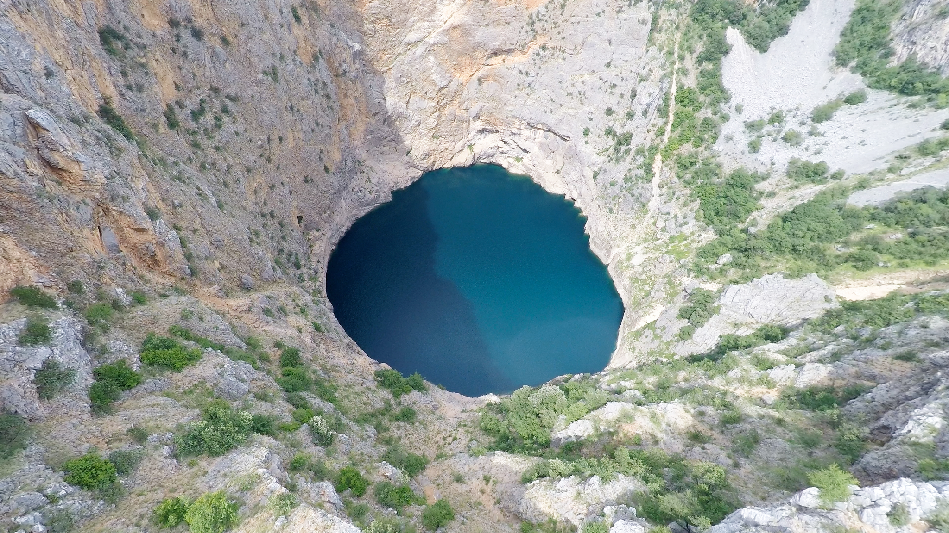 | 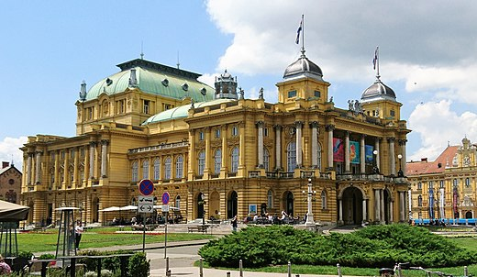
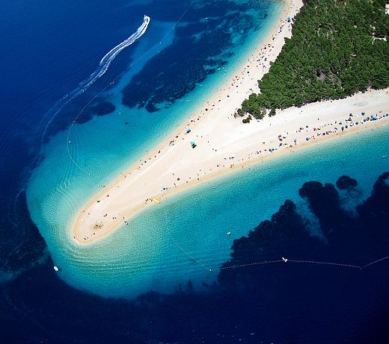 | 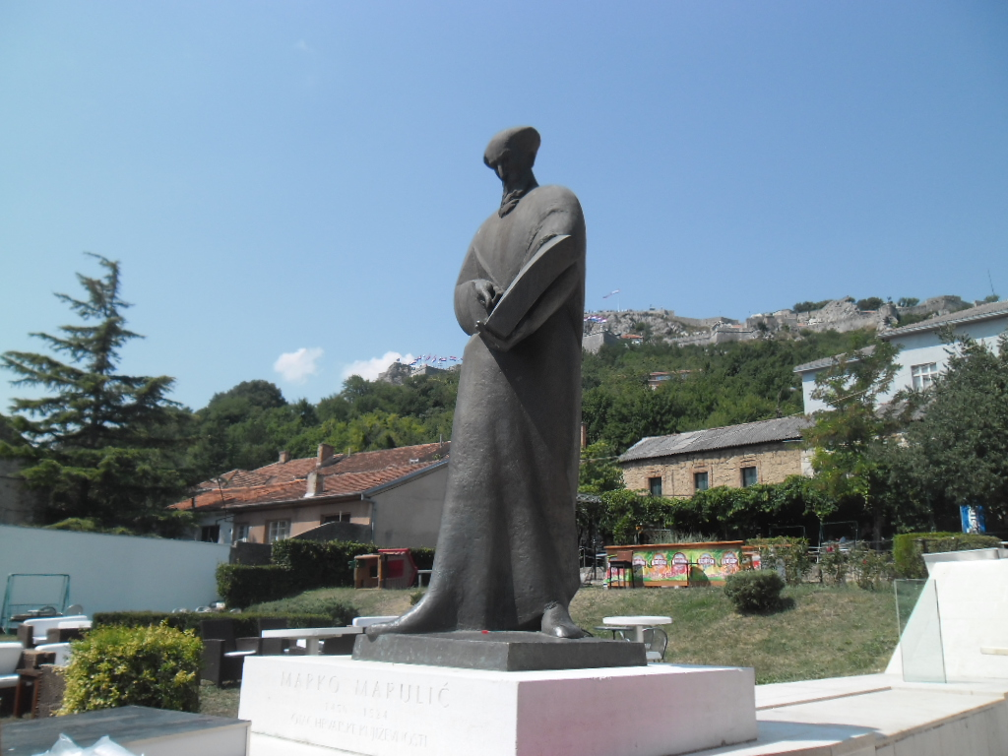 | 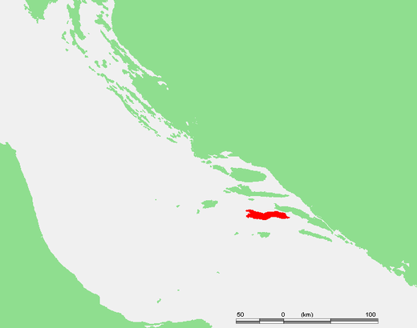
[h5p id="414"]

4.2 Zadatak 6. Gramatika
[h5p id="415"]

Images used in this document are from these sources.

