2 | 3 | Lekcija 4: Tradicija

2.3 Zadatak 12. Izlet u subotu
🔊 Listen to the dialogue. Talk with your classmates and answer the following questions. Use complete sentences when answering the questions.
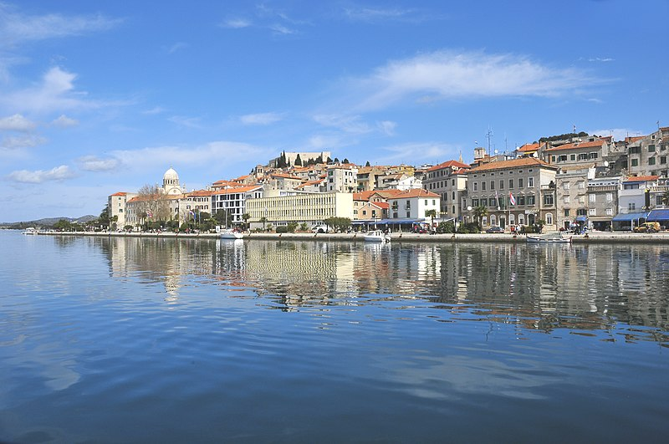 | 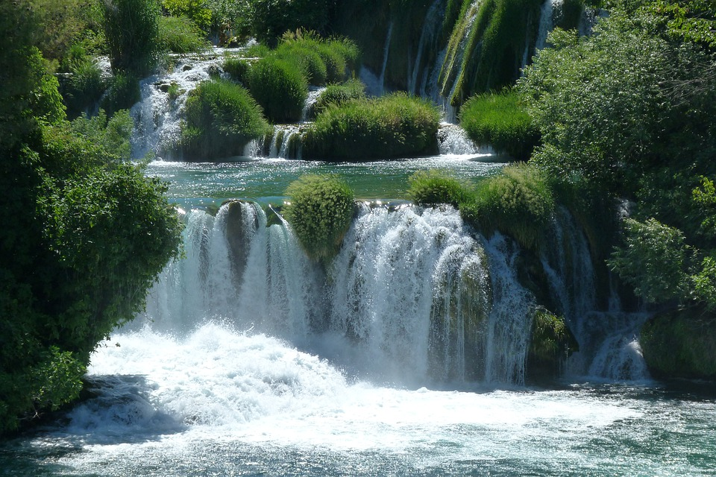 | 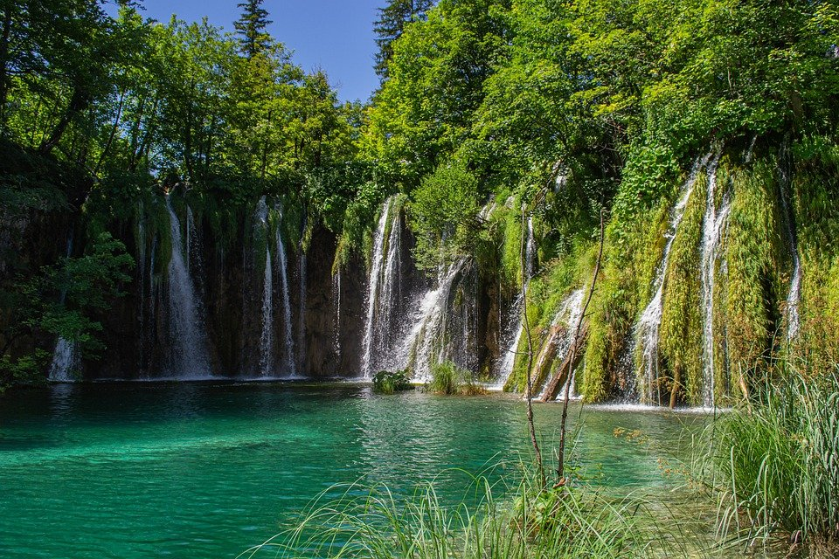
Šibenik | Slapovi Krke | Plitvička jezera

| Razumijevanje
1 | Tko organizira izlet u Šibenik?
1 | -
2 | Što James obavezno mora posjetiti?
2 | -
3 | Ide li James na slapove Krke ili na Plitvička jezera?
3 | -
4 | U koliko sati James ide u Šibenik na izlet?
4 | -
5 | U koliko sati James ide natrag za Split?
5 | -

| Research Question:
Based on the information that you collected from the dialogue, answer the following.
In the dialogue, you found out that Matija lives very close to the main bus station/terminal. When do you think Matija needs to be at the bus station to pick up James for a drink if he’s leaving Šibenik at 7pm? You might need to search online for the answer to this question.

[odgovor] → Matija mora ići na kolodvor oko …

2.3 Zadatak 13. Šibenik
🔊Watch the video and complete the task below. While you are listening to the story about Šibenik, follow the visual presentation.
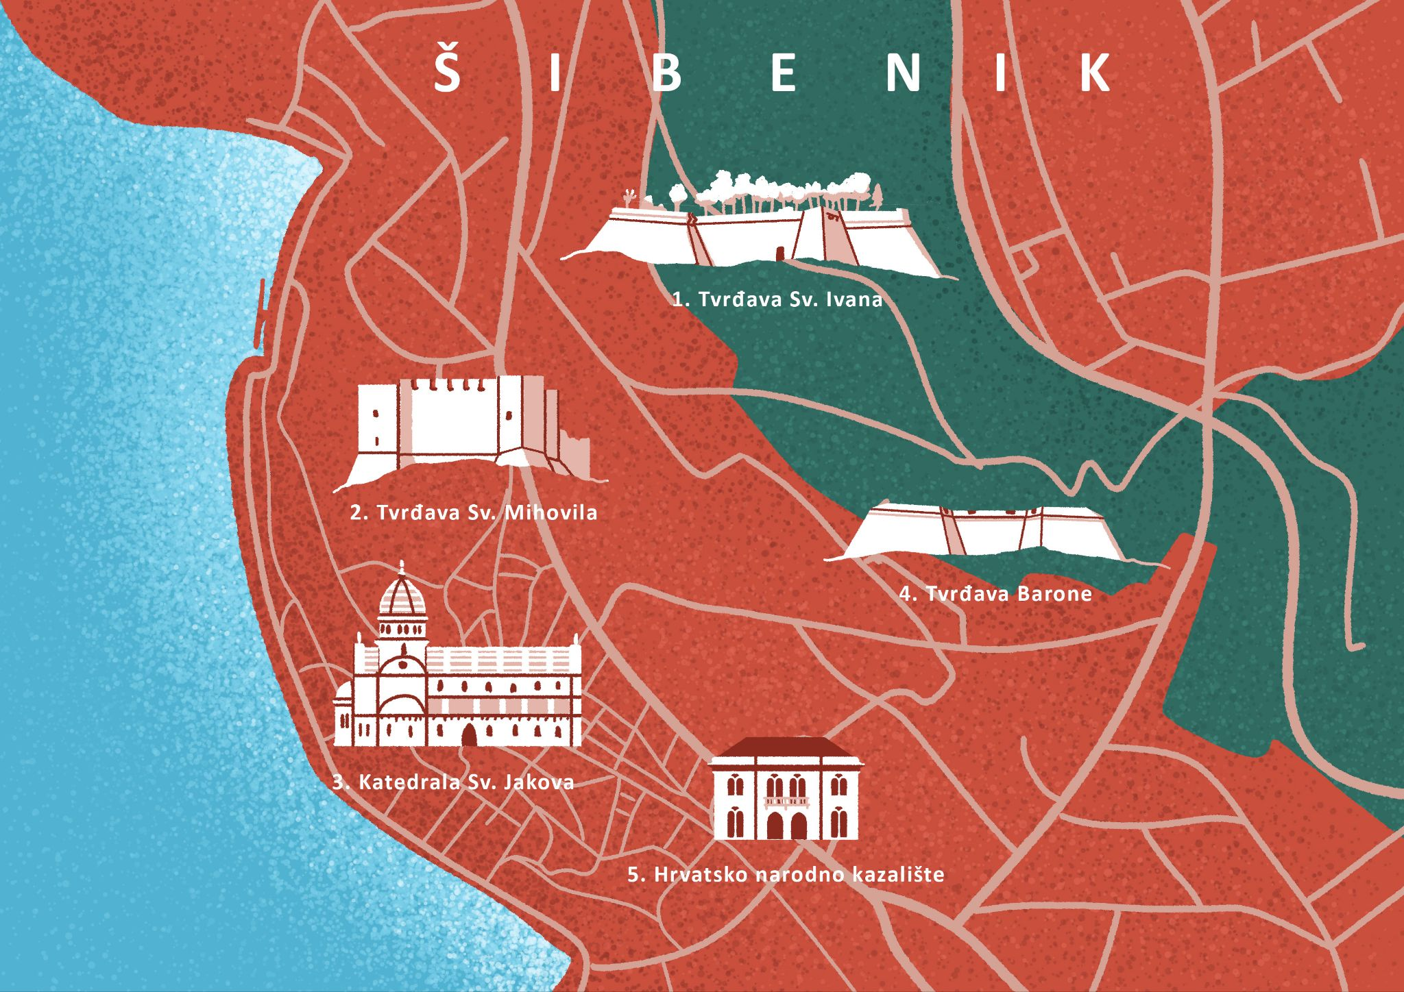 | 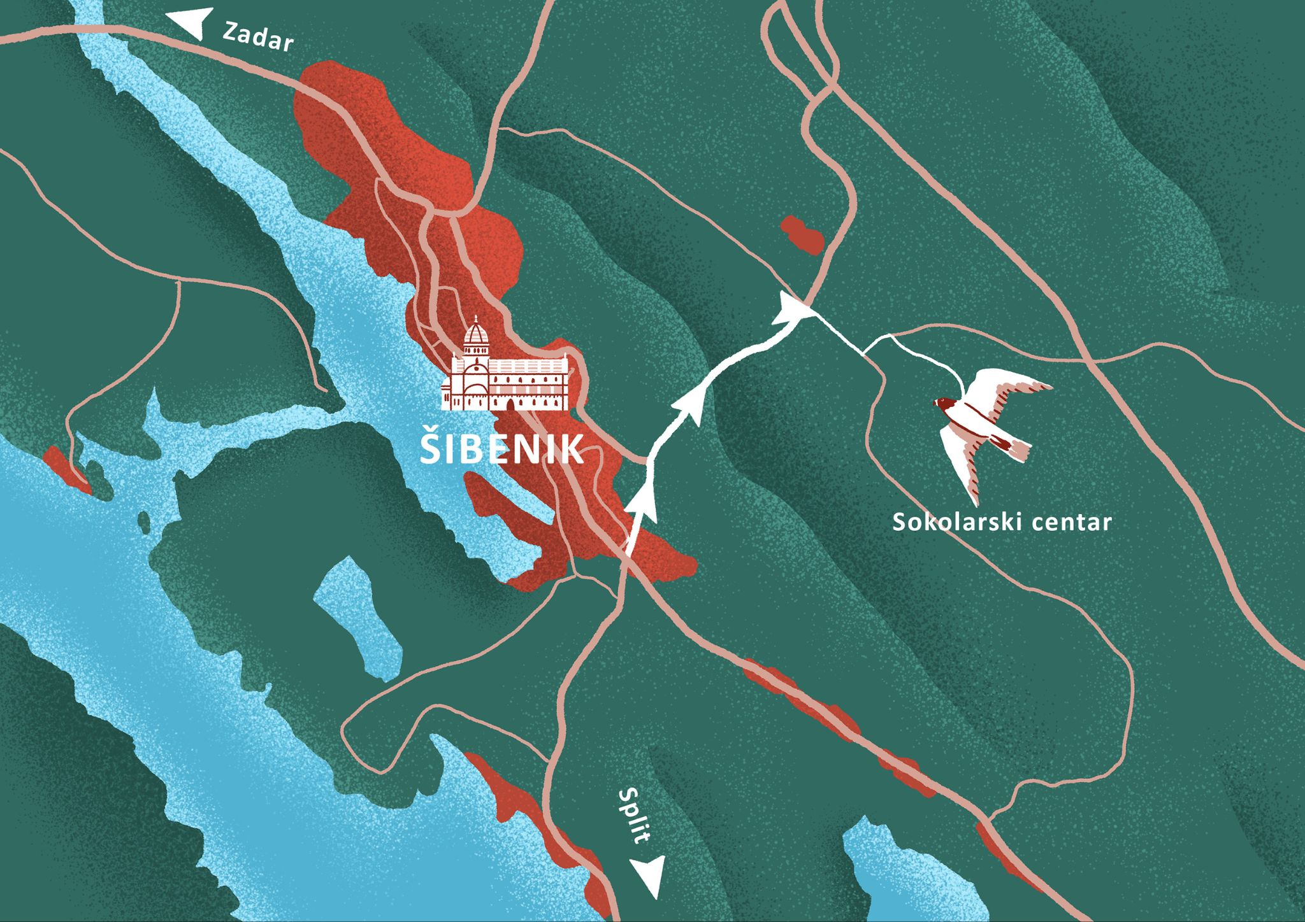
Talk with a classmate. Ask each other the following questions in Croatian to check that you understand all the information. In some of the questions, when applicable, include your personal opinions. Your opinions should be based on what you have seen in the video. 🧑‍🏫
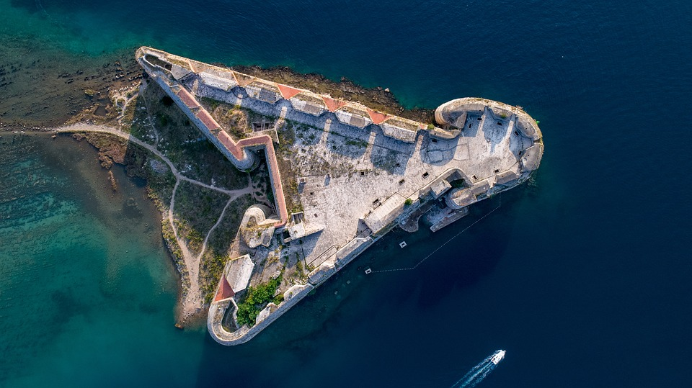 | 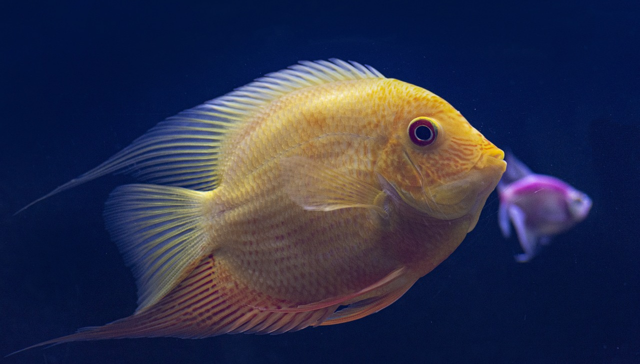 | 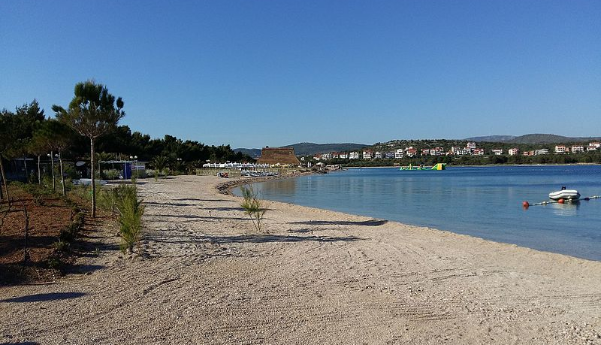
tvrđava | akvarij | plaža
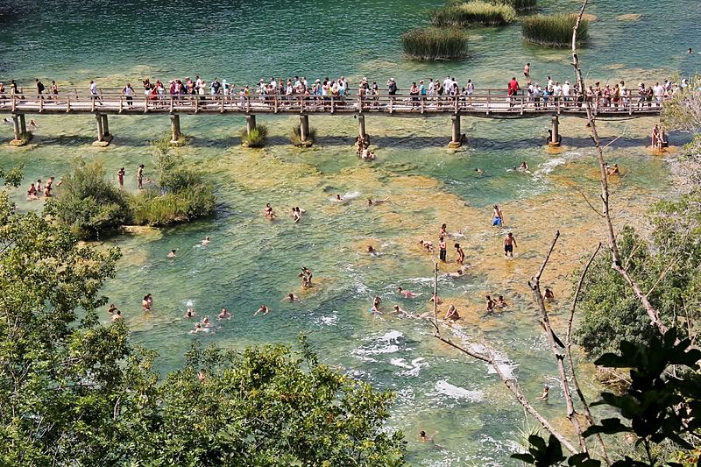 | 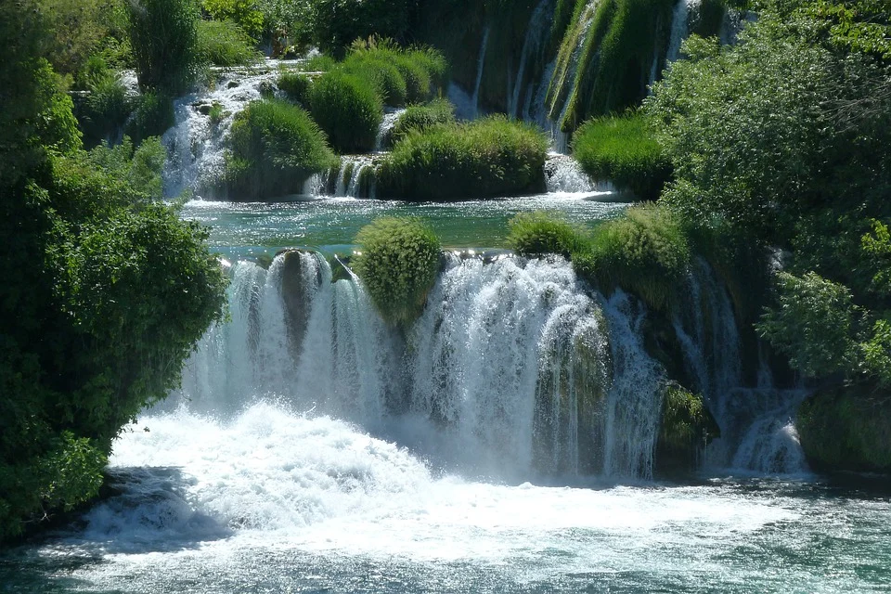 | 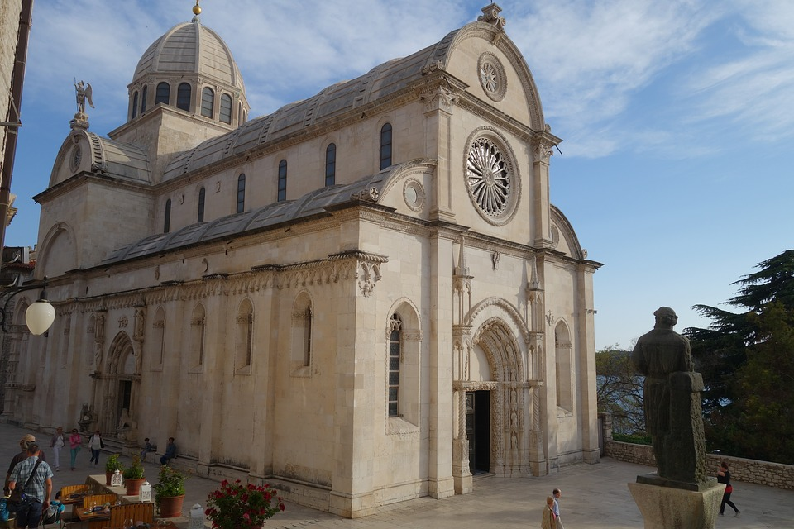
Nacionalni park Krka | slap – slapovi | katedrala

| Razumijevanje
1 | What does the city look like?
1 | -
2 | What do tourists visit when they go to Šibenik?
2 | -
3 | Where do children and adults go?
3 | -
4 | What can we see in Šibenik?
4 | -
5 | What can we buy when we go to the Aquarium?
5 | -
6 | Where else do tourists go?
6 | -
7 | What does an ethno village look like?
7 | -
8 | What kind of food restaurants have?
8 | -
9 | Where else do people go?
9 | -
10 | Where do ferries go?
10 | -
11 | What can we see in a national park?
11 | -
12 | What do islands look like?
12 | -

2.3 Zadatak 14. Što želiš posjetiti?
Before completing this task, go over your information collected in the previous task. Talk with a classmate and answer the following questions. If you were in Šibenik:

| Osobna pitanja
1 | Što želiš/ne želiš posjetiti?
1 | -
2 | Kamo želiš ići?
2 | -
3 | Kamo ne želiš ići?
3 | -
4 | Što misliš kakav je Šibenik?
4 | -
Your instructor will check your answers by asking you to provide some feedback on the opinions of the classmate you talked with.

2.3 Zadatak 15. Moja prezentacija
Prepare a PowerPoint presentation about your city.

Part 1
1️⃣ Before you start working on your PowerPoint presentation, do an online search, if needed, in order to find interesting places in your city. Be sure to include as many of the following elements (when applicable):
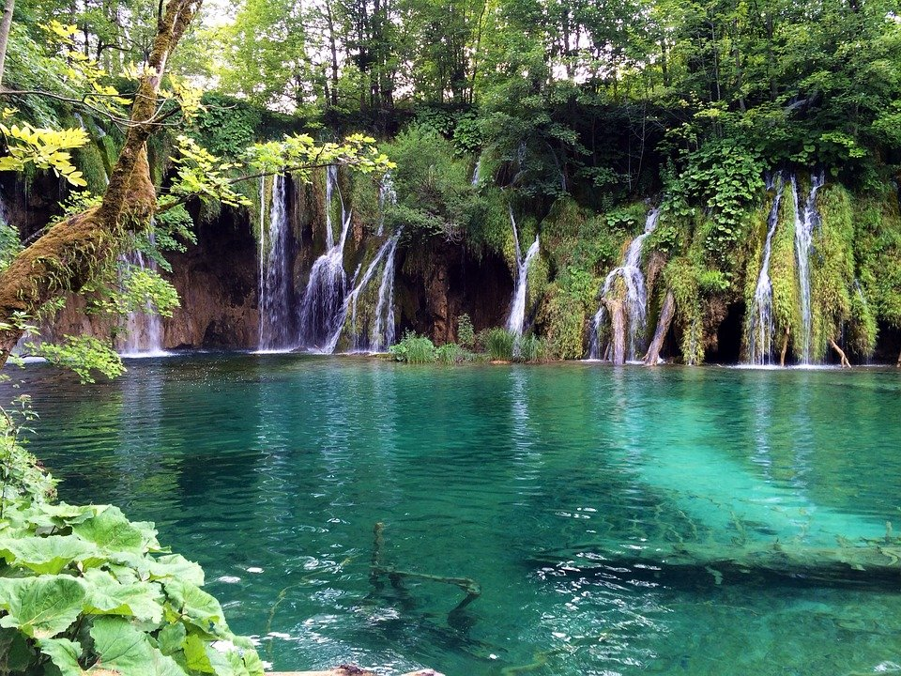 | 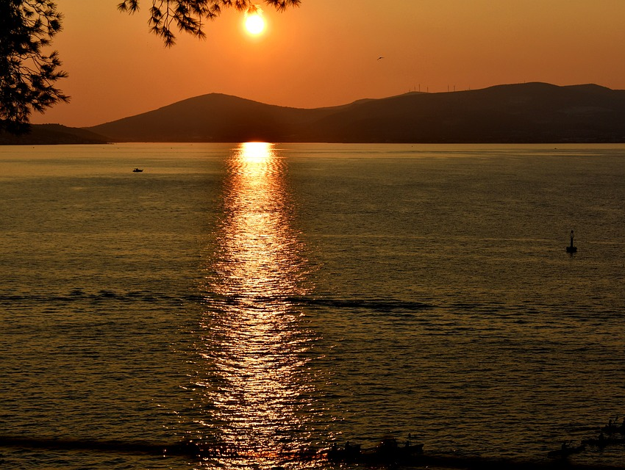 | 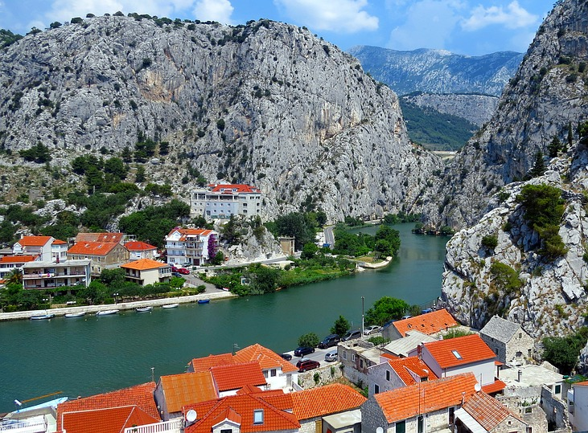
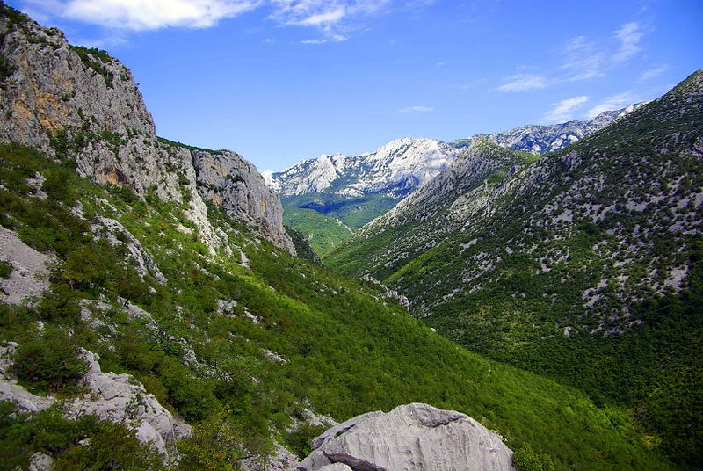 | 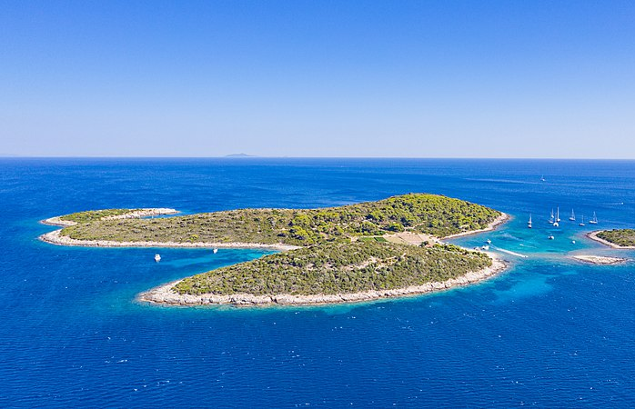 | 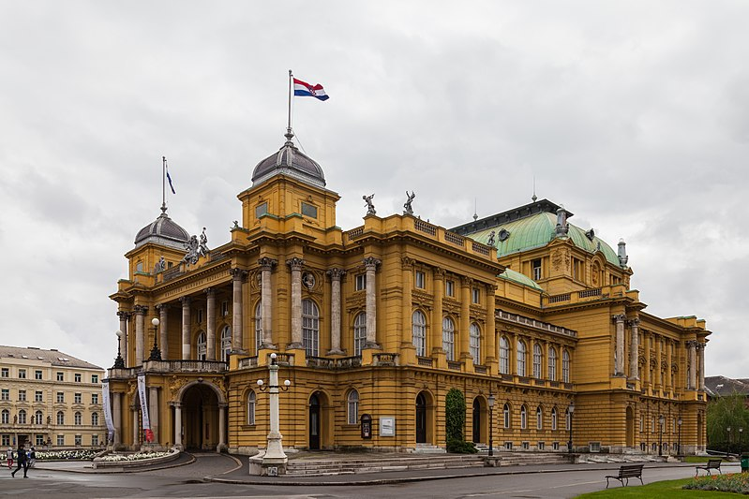
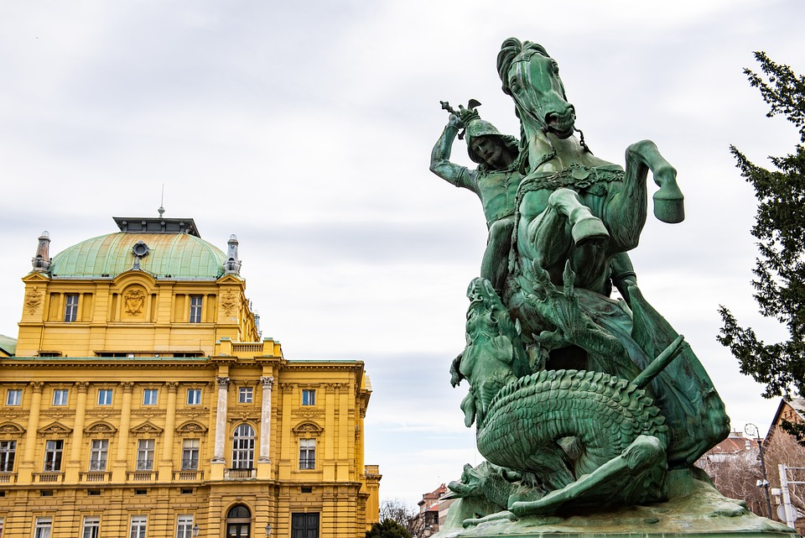 | 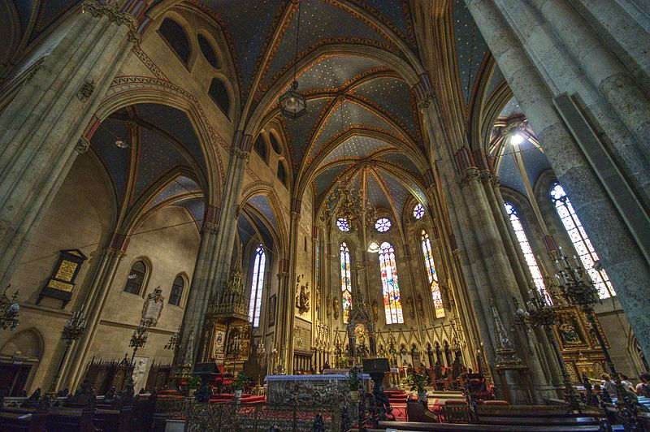 | 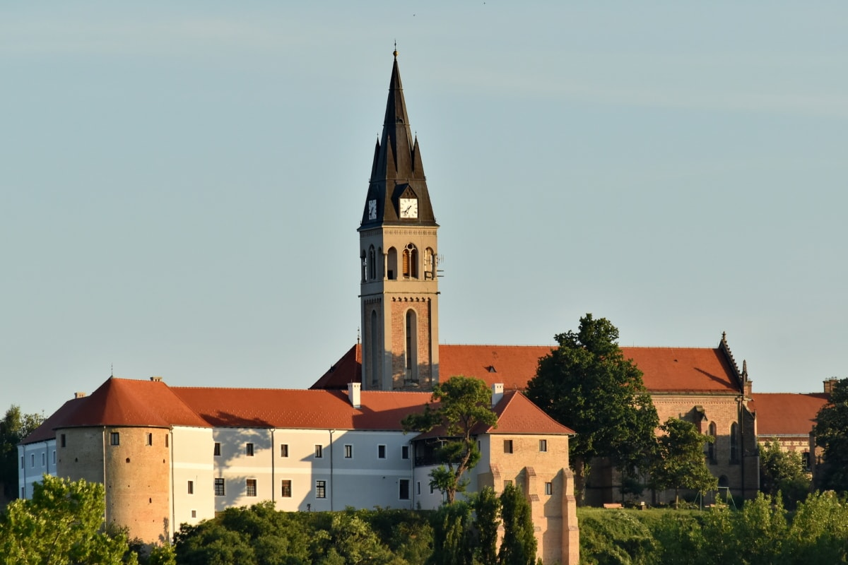
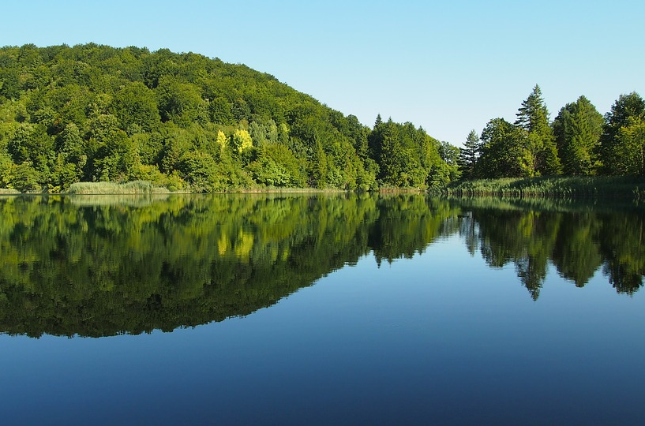 | 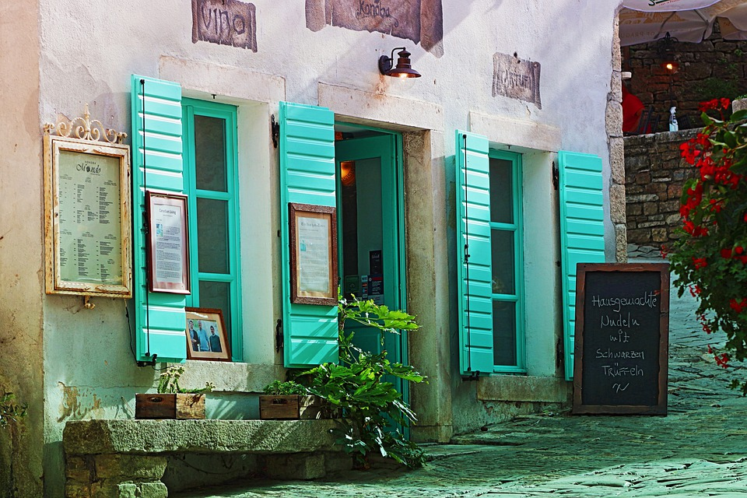 | 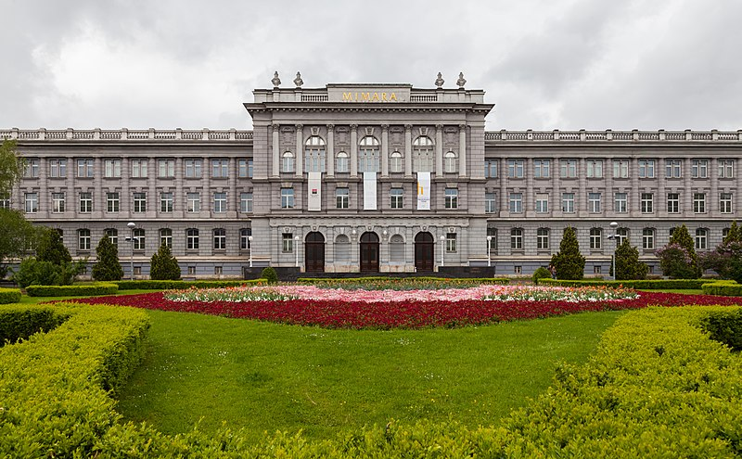
After you have collected all necessary information/locations/attractions, complete the table below. You should start the sentence with:

Turisti…
obično idu u/na | vole posjetiti | mogu vidjeti | trebaju posjetiti
[usually go] | [like] | [can] | [need]

Part 2
2️⃣ Start making notes on how you want to give your presentation. For each of the elements above, express your opinions -- how things look. For each place/location include names if possible. You will present on your city during the next class session.

[odgovor] →

Images used in this document are from these sources.

