2 | 3 | Lekcija 2: Vikend putovanje

| Preposition ZA
Together with the prepositions u/na that you encountered so far, there is another very common preposition when it comes to the Accusative case. The preposition za can easily be translated in English as for. Look at the following examples:

Example #1
Za vikend planiram ići u grad.
For the weekend, I plan to go to the city (center).

Example #2
Ova knjiga je za mamu.
This book is for (my) mom.

| Brojevi 11 - 19
You have already learned the numbers 0 to 10. Now let’s investigate how to say numbers from 11 to 19.
(audio) | 11 | jedan-naest | jedanaest
(audio) | 12 | dva-naest | dvanaest
(audio) | 13 | tri-naest | trinaest
(audio) | 14 | četiri-naest* | četrnaest
(audio) | 15 | pet-naest | petnaest
(audio) | 16 | šest-naest* | šesnaest
(audio) | 17 | sedam-naest | sedamnaest
(audio) | 18 | osam-naest | osamnaest
(audio) | 19 | devet-naest | devetnaest

2.3 Zadatak 4. Brojevi
(audio)
[h5p id="271"]

Answer the questions
[h5p id="610"]
[h5p id="611"]

| Time

Koliko je sati?
There are different ways to express time in Croatian. At this point we will look at the most simple way of expressing time. Look at the following time schedules:
Sat | Koliko je sati? | U koliko sati?
13:00 | jedan popodne | u jedan popodne
14:00 | dva popodne | u dva popodne
15:00 | tri popodne | u tri popodne
16:00 | četiri popodne | u četiri popodne
17:00 | pet popodne | u pet popodne
18:00 | šest popodne | u šest popodne
19:00 | sedam navečer | u sedam navečer
20:00 | osam navečer | u osam navečer
21:00 | devet navečer | u devet navečer
22:00 | deset navečer | u deset navečer
23:00 | jedanaest navečer | u jedanaest navečer
12:00 | podne | u podne
00:00 | ponoć | u ponoć
As you can see, Croatian uses a 24-hour system. Thus, to differentiate the morning and evening time, you can say:
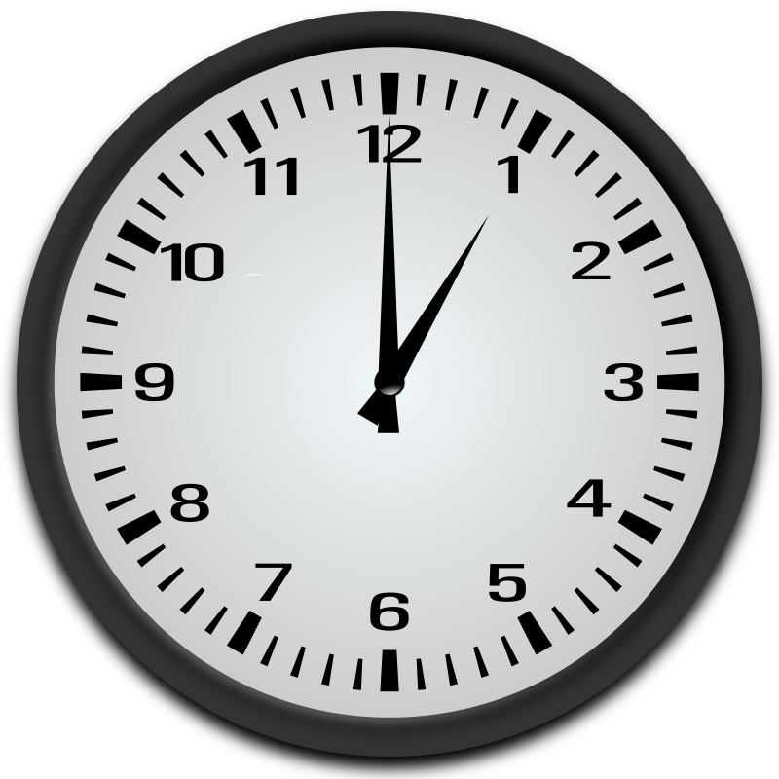 | 01:00 | jedan ujutro
 | 13:00 | jedan popodne

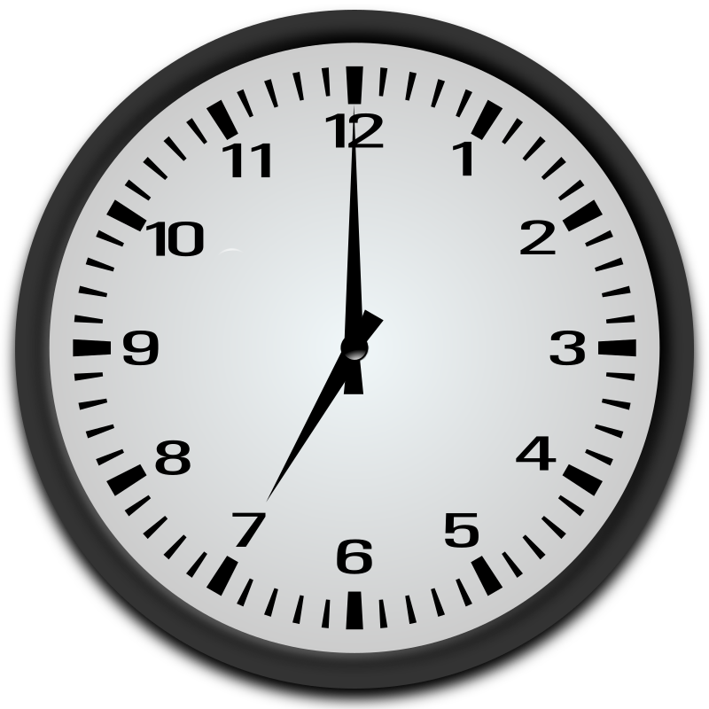 | 07:00 | sedam ujutro
 | 19:00 | sedam navečer

Look at the following picture.
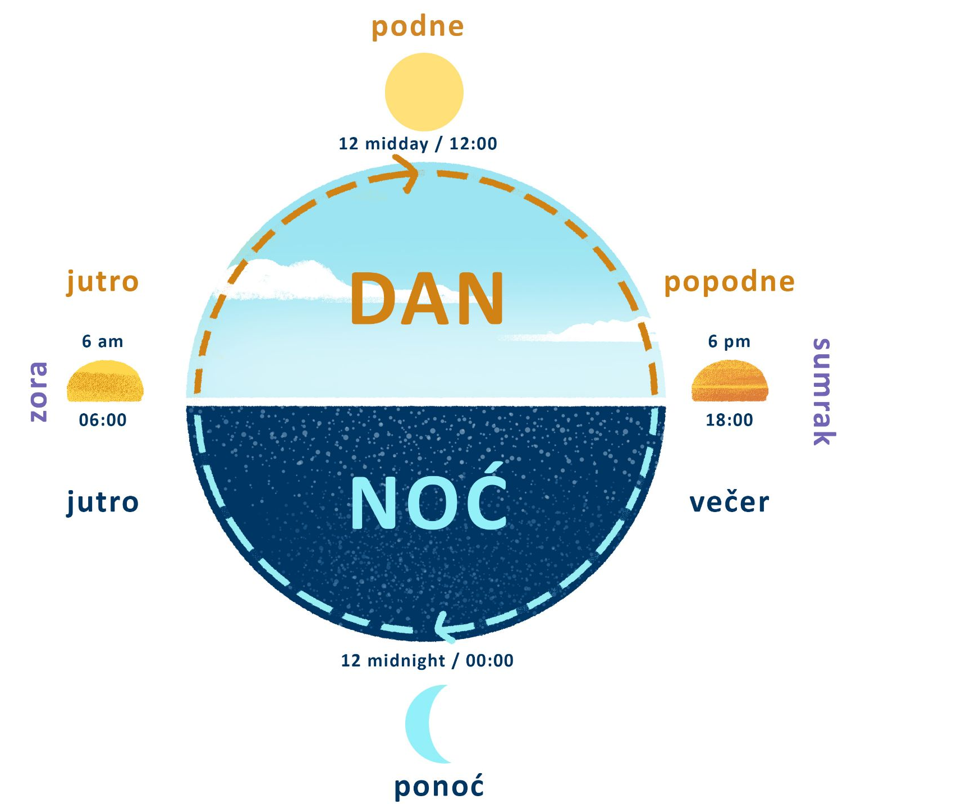

2.3 Zadatak 5. Koliko je sati?
How would you say the following time?
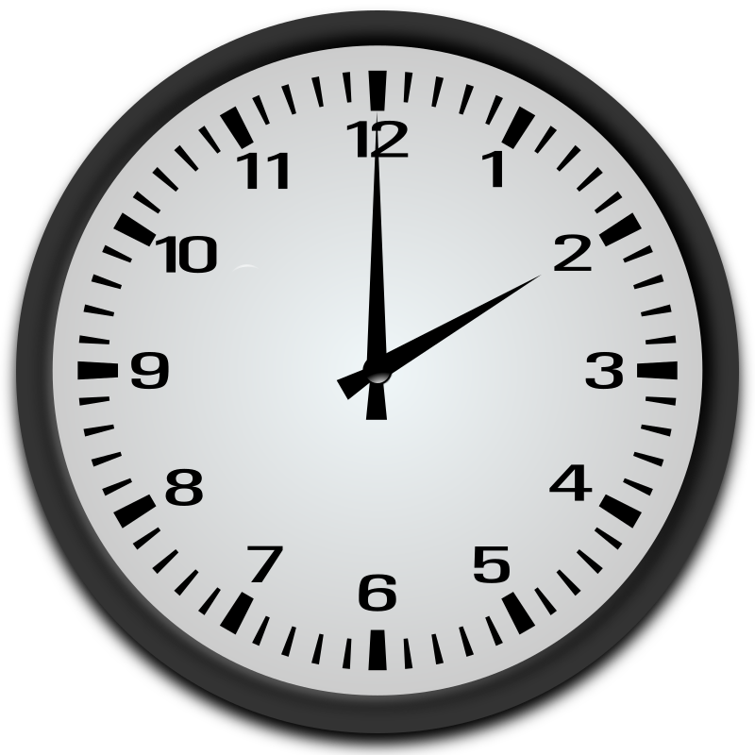 | 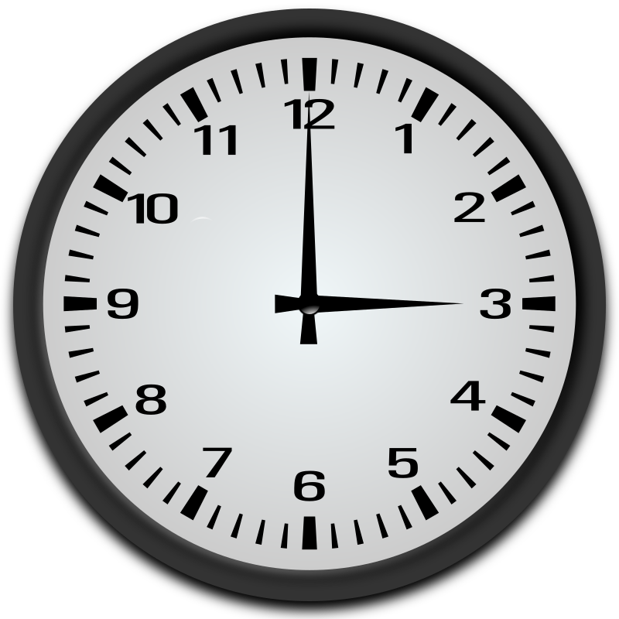 | 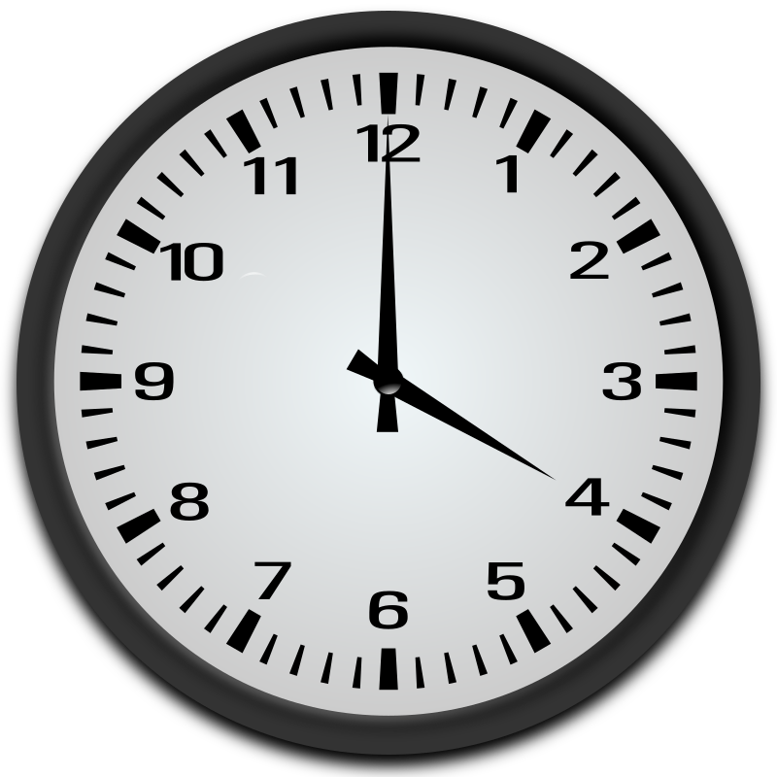
14:00 | 03:00 | 16:00
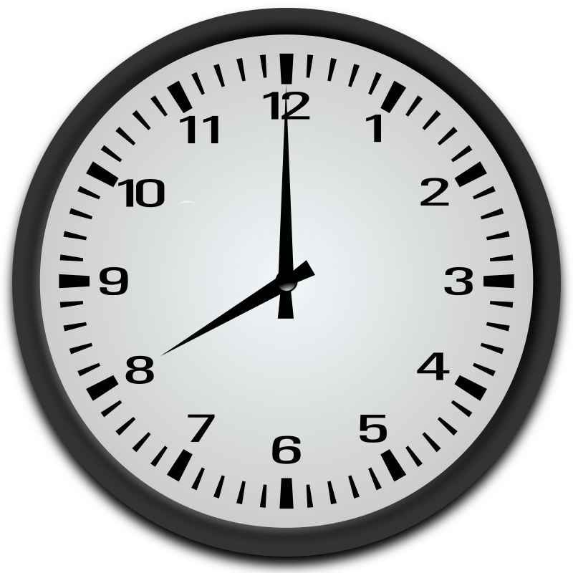 | 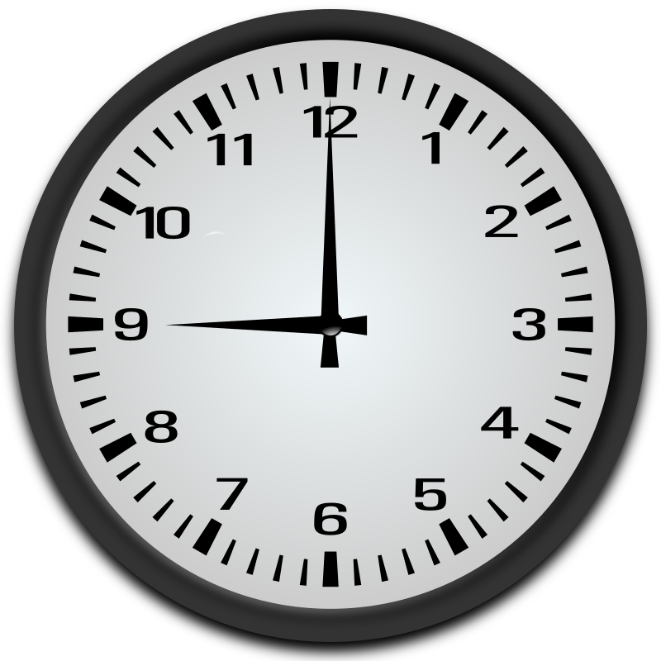 | 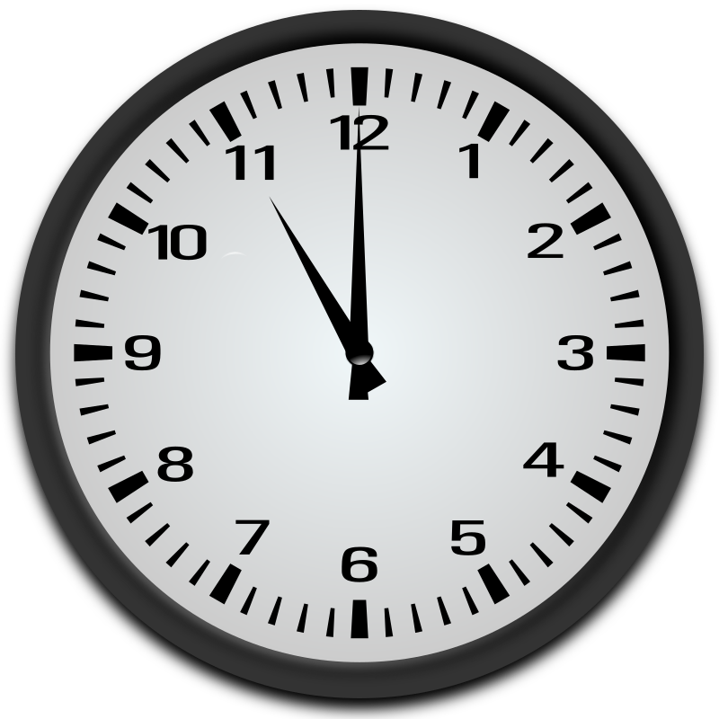
20:00 | 09:00 | 23:00
[h5p id="273"]

2.3 Zadatak 6. U koliko sati?

Listen to the text and complete the task.
Answer the following questions about Laura and her daily routine. Read the questions, look at the pictures, and say if she is doing a certain thing (1) in the morning, (2) in the afternoon, (3) in the evening, or (4) any combination of those.
(audio)
[h5p id="612"]
Images used in this document are from these sources.

