1.4 Alois Jirásek and the Old Czech Legends
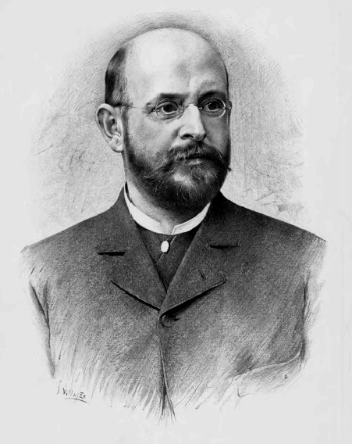

Alois Jirásek (August 23, 1851, Hronov, Kingdom of Bohemia – March 12, 1930, Prague, Czechoslovakia) was a Czech writer, author of historical novels and plays. Jirásek was a high school history teacher in Litomyšl and later in Prague until his retirement in 1909. He wrote a series of historical novels imbued with faith in his nation and in progress toward freedom and justice and was nominated for the Nobel Prize in Literature in 1918, 1919, 1921 and 1930.

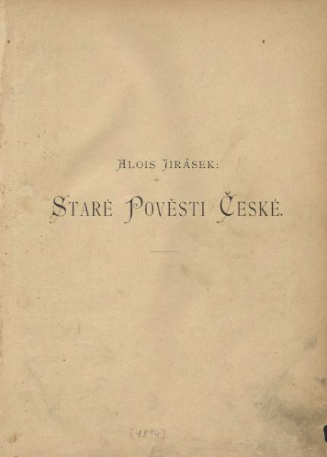
Jirásek is perhaps best known for his Old Czech Legends (Staré pověsti české) published in 1894, in which he recounts the popular Czech foundation myths.

A version of the Old Czech Legends was adapted into a stop motion feature length puppet film by the great Czech animator Jiří Trnka in 1956, and is available on YouTube here.

(first paragraph adapted from Wikipedia: https://en.wikipedia.org/wiki/Alois_Jir%C3%A1sek)

Images used in this document come from these sources.

