3 | 1 | Lekcija 3: Braća i sestre

3.1 Zadatak 5. Obitelj Petrić
Complete the text below by filling in the blanks with words from the word bank. There are two extra words. You might need to change the gender for some of the words. The text is about Luka’s family from his dad’s side.
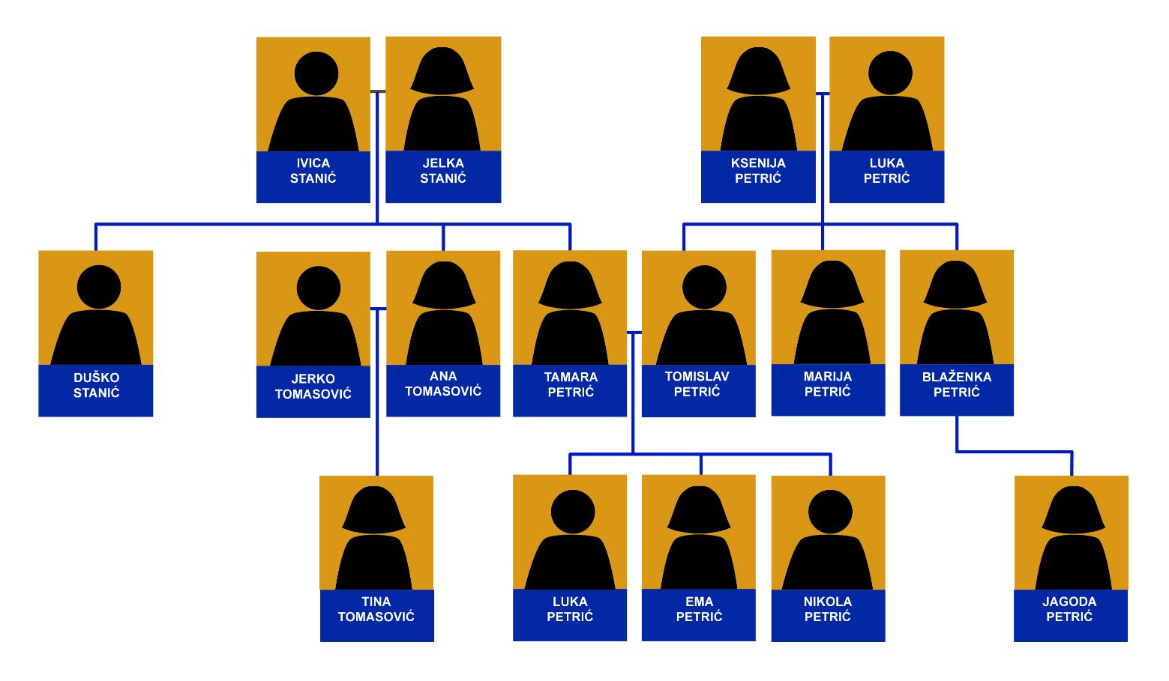
žena | prezime | sin | ujak | obitelj
unuk | djeca | tata | unuka | lijep

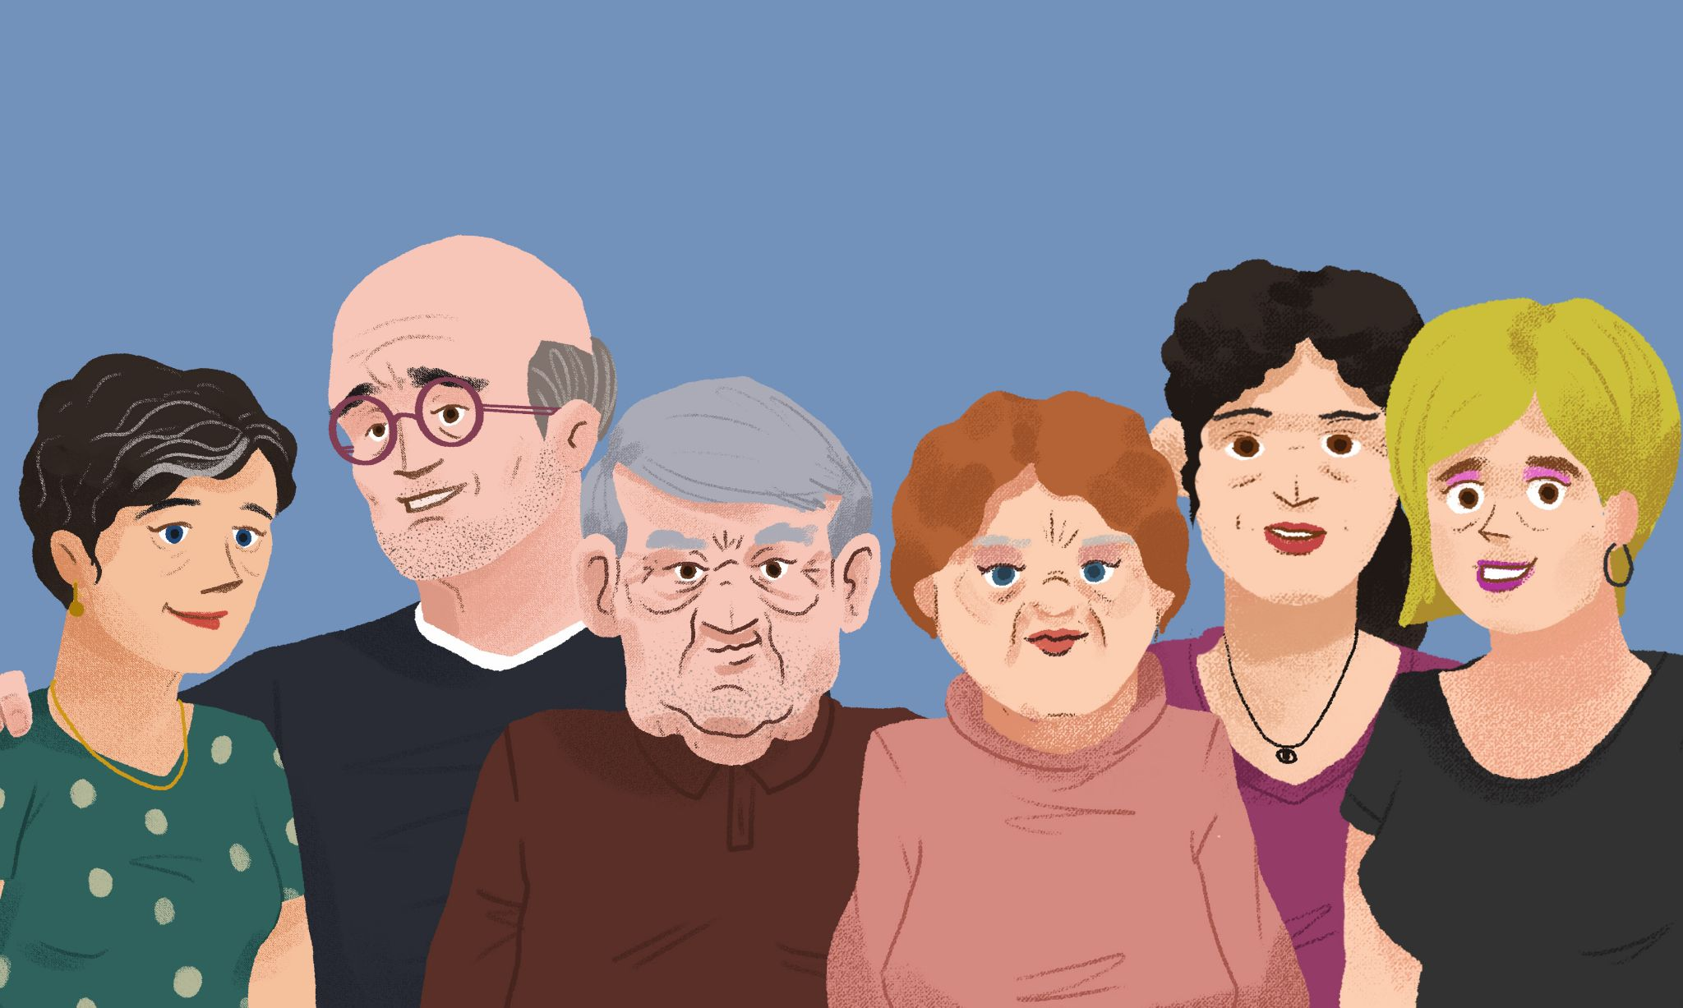 | 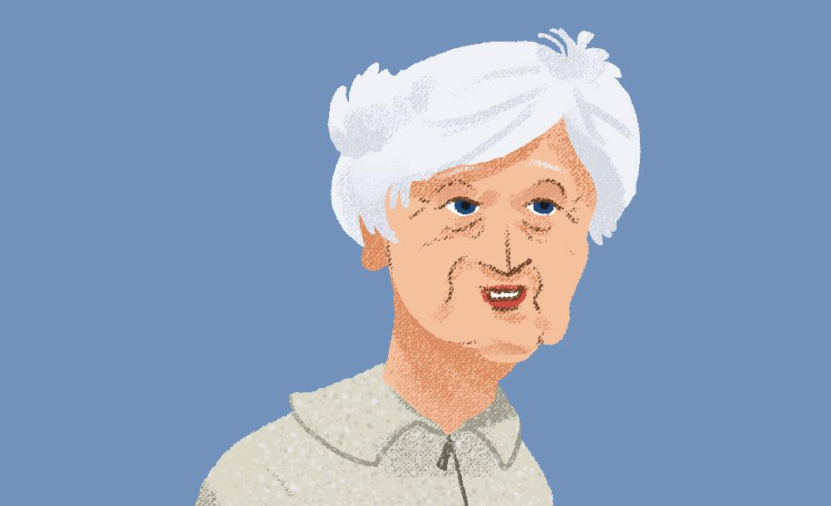

Tekst 1

Tko je ovo?
Ovo je Luka Petrić i njegova *žena* Ksenija. Ovo su njegova *djeca*: Tomislav, Marija i Blaženka. A ovo je njegova *unuka* Ema. Njezin *tata* Tomislav je njegov *sin*. Njegova žena se zove Tamara. James misli da je Tamara *lijepo* ime.
Tekst 2
A ovo je Ksenija, njezino *prezime* je također Petrić. Ona i Luka su baka *unuk*. A ovo je Jagoda, njezin *unuka*.

3.1 Zadatak 6. Obitelj Bogdan
In the pictures below, we see Petra Bogdan (Mario’s sister), once with her parents and then again with her own family. She is labeled with the letter [b] in both pictures. Read the sentences below aloud and fill in the letter of the person to whom the sentence refers and the letter of the speaker. The first one has been done for you as an example. If more than one option is possible, choose only one.
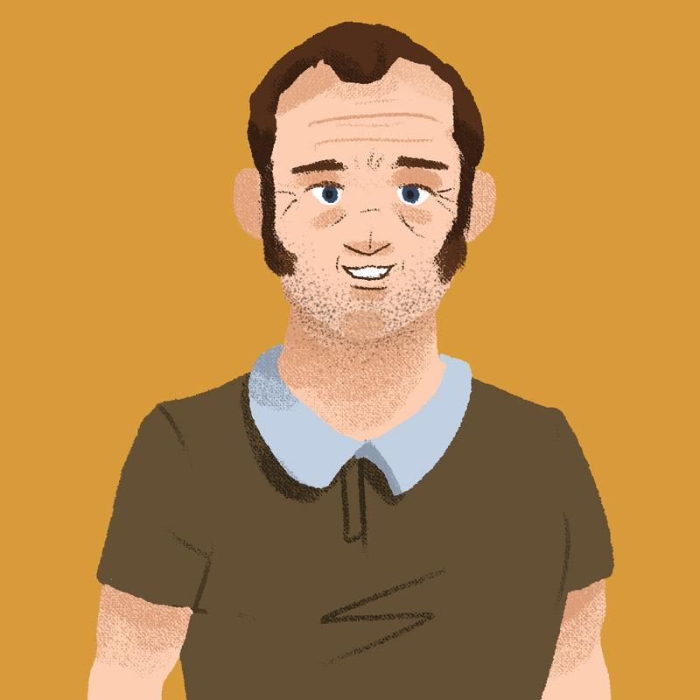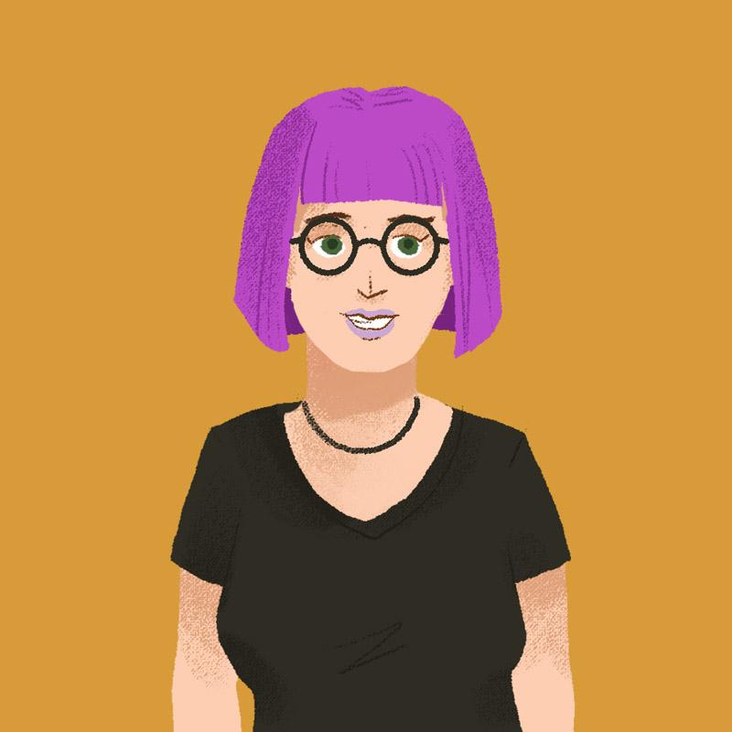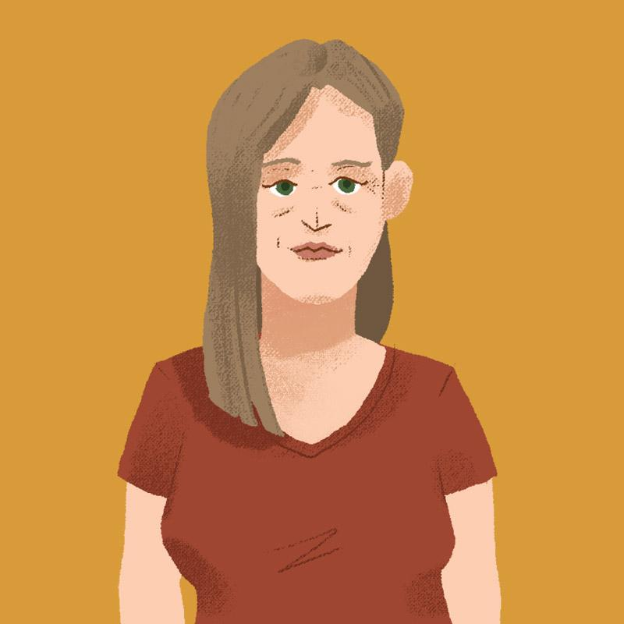 |  |  | 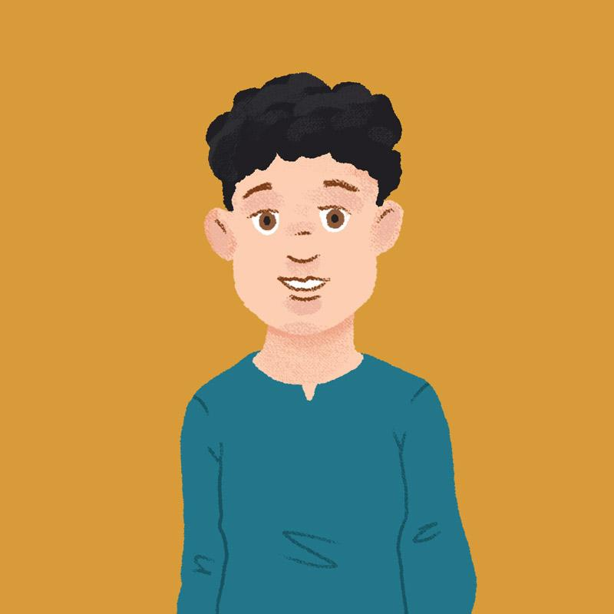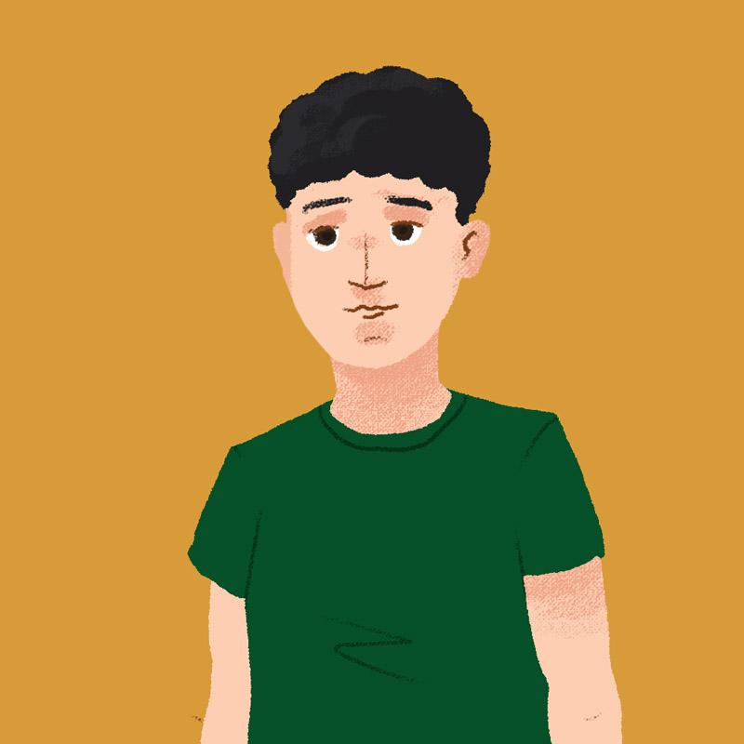
a | b | c | d | b | e | f

Speaker(s) | Sentence | Person/people referred to
B | Ja imam oca Zlatka. | A
 | Mi imamo baku Ljubicu.
 | Ja imam muža Zlatka.
 | Ja imam ženu Petru.
 | Ja imam brata Davida.
 | Ja imam djeda.
 | Mi imamo sinove.
 | Mi imamo mamu.

3.1 Zadatak 7. Koga imaš?
👥 Koga imaš? [Who do you have in your family?]
Talk with two of your classmates and ask them about family members. Mark their existing family members and write their names. You will need to present your findings to your instructor.
1 | Imaš li...?
1 | - Da, imam... Zove se... – or – Ne, nemam…

 | Student 1: | Student 2:
Imaš li [...]?
brata
sestru
mamu
tatu
muža
ženu
bratića
sestrićnu

3.1 Zadatak 8. Tko je ovo?
👥 Work with a partner to read the dialog below. Based on what you learn, fill in the chart to indicate the name of the person and his/her relationship to the speaker.
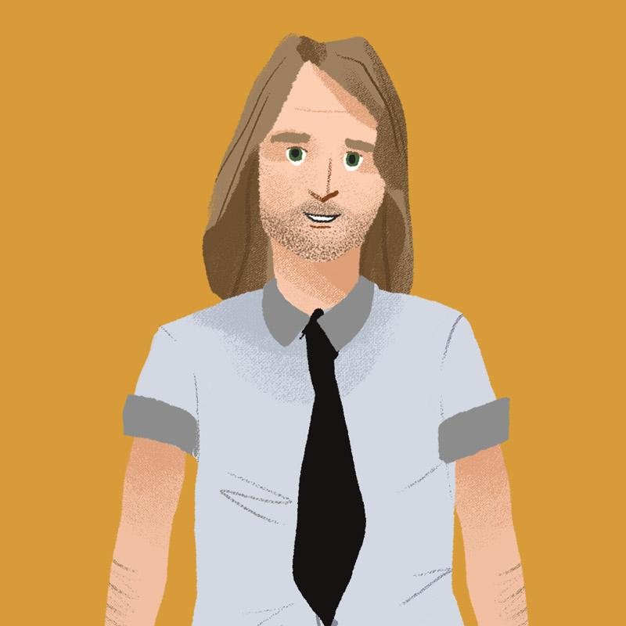 |  |  |  | 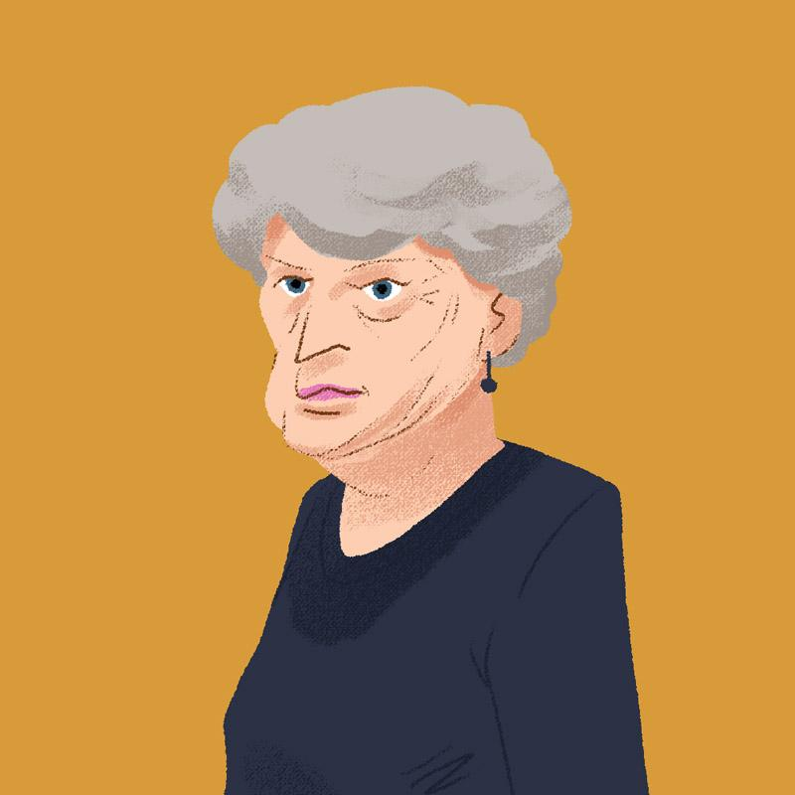
ja
Mario

Osoba A | Ovo sam ja, a ovo je moj tata.
Osoba B | Tvoj tata? Kako se zove?
Osoba A | Zove se Zlatko.
Osoba B | Zanimljivo ime.
Osoba A | Ovo je Zlatko, a ovo je njegova žena.
Osoba B | A kako se ona zove?
Osoba A | Zove se Ljubica.
Osoba B | Dakle, Zlatko i Ljubica su tvoji roditelji.
Osoba A | A ovo je njihova kći. Ona se zove Petra.
Osoba B | A tko je ovo? Je li ovo tvoja teta?
Osoba A | Ne, to nije moja teta. To je Kata. Zlatko i Kata su majka i sin.

3.1 Zadatak 9. Mario i Laura, intervju
🔊 Listen to the dialogue between Mario and Laura. While listening, complete Mario’s family tree. When you are done, you will need to check your answers with another classmate to see if you have the correct information. In your answer you will need to say the relation and personal name of each person. Listen carefully to the dialogue and how Mario answers the questions. You can also download a fillable PDF.
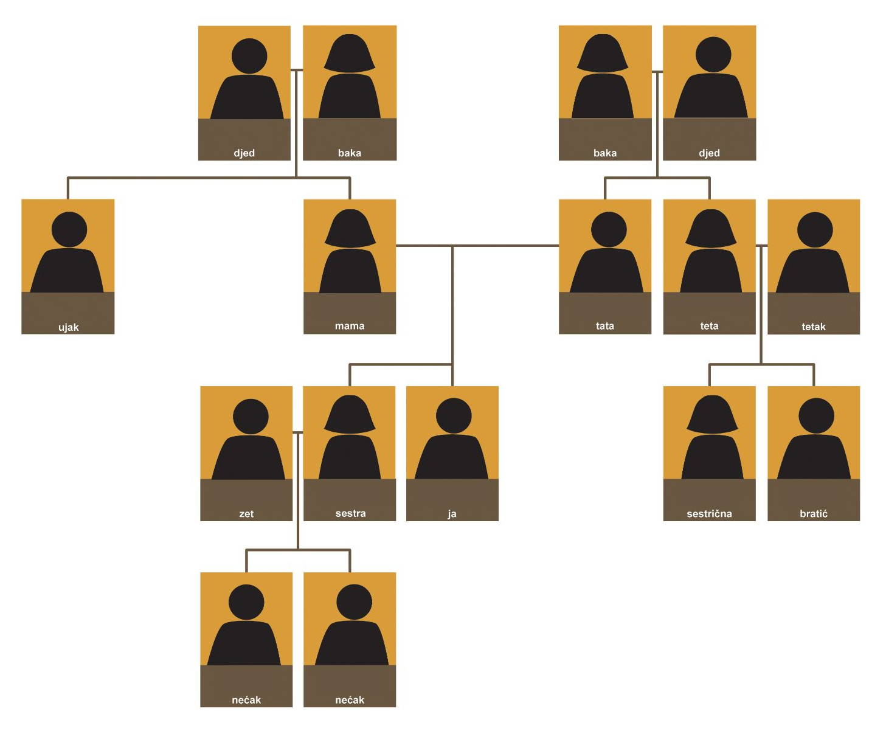

3.1 Zadatak 10. Moja braća i sestre
Below is a family picture with the children arranged in order of age. Write the appropriate letter in the blank to indicate the person from whose perspective the relationship is being described. One of the descriptions will not work for any of the people.
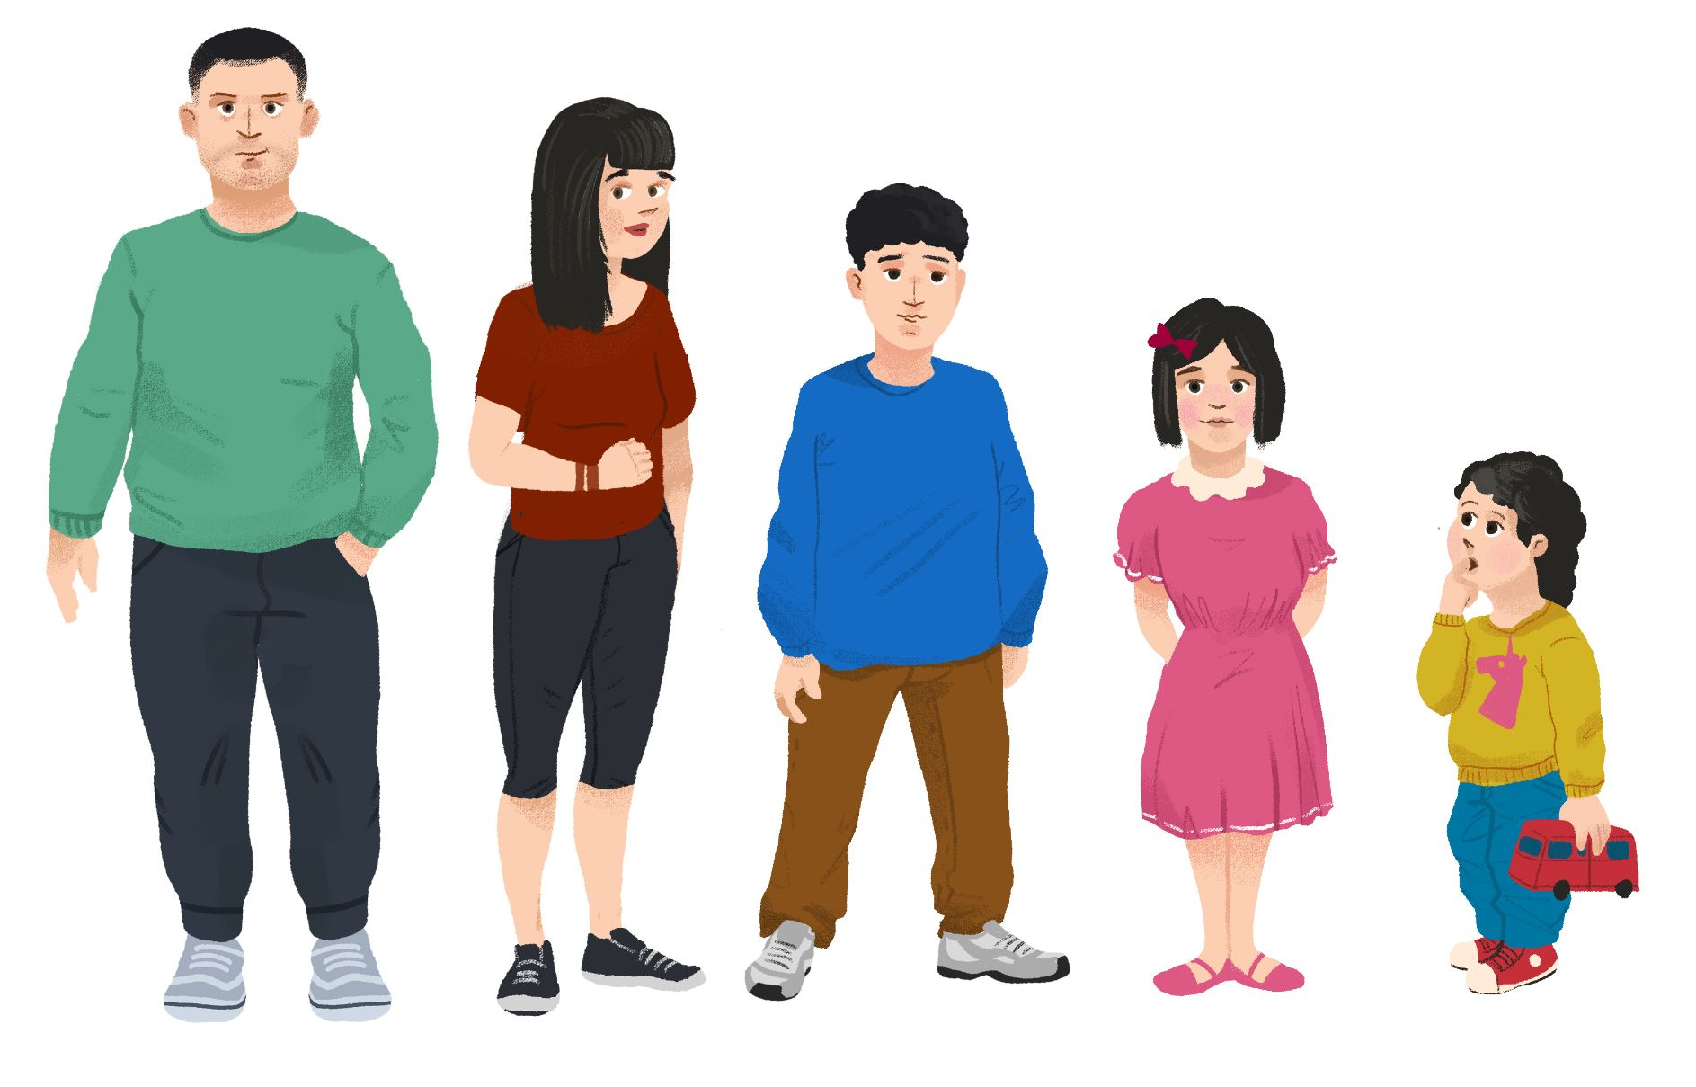 |  |  |  |  | 
a | b | c | d | e | Tko je tko?

Ovo je moj stariji brat, ovo je moj mlađi brat, a ovo su moje mlađe sestre.
Ovo su moja starija braća, a ovo su moje starije sestre.
Ovo je moja starija sestra, a ovo su moja mlađa braća.
Ovo su moja starija braća, ovo je moja starija sestra i ovo je moja mlađa sestra.
Ovo su moje mlađe sestre, a ovo je moj mlađi brat.
Ovo je moj stariji brat, ovo je moja starija sestra i ovo su moje mlađe sestre.

3.1 Zadatak 11. Moja obitelj
Now you will have a chance to talk about your own family using the dialog above as a model. In the box below, place your family pictures that you will describe. Do not write down any other information. This picture is intended as a visual guide for you to use while describing your family. Describe your family to your partner using as much vocabulary as you can. It is fine to repeat information and to point to your picture to clarify the person about whom you are talking.

NOTE: If you do not feel comfortable sharing your personal picture with the rest of the class/your classmate, use an online picture. Find one that at least closely represents your real family structure and place it in the box below.

Slika: moja obitelj
Copy and paste your picture here

Images used in this document are from these sources.

