9 | 3 | Lekcija 1: Strah i bolest

| The verb BOLJETI
The verb boljeti (to feel pain, to have pain/ache) only has the 3rd person singular form and the 3rd person plural form. We cannot conjugate the verb fully in the Present Tense. The structure you need to use can be one of the following: boli me (for one singular pain/ache) or bole me (for more than one pain at the same time). For example:
| Boli me
Boli me glava. = I have a headache.
Boli me grlo. = I have a sore throat.
| Bole me
Bole me oči. = My eyes hurt.
Bole me noge. = My legs hurt.

As you can see, the sentence structure when expressing pain is different than in English. In Croatian you will always use the structure of:
boli (sing.) / bole (pl.) | personal pronoun in the Accusative case | noun in the Nominative case

Look at the following example, together with English translation modified to fit the grammar structure.
ja | Boli me glava. | I | Head hurts me.
ti | Boli te glava. | You | Head hurts you.
on | Boli ga glava. | He | Head hurts him.
ona | Boli je glava. | She | Head hurts her.
mi | Boli nas glava. | We | Head hurts us.
vi | Boli vas glava. | You | Head hurts you [all].
oni/-e | Boli ih glava. | They | Head hurts them.

| The verb BOJATI SE
The verb bojati se (to have fear of something or someone) in Croatian is followed by the Genitive case. Even though it ends in -ati, it uses the set of endings that are usually associated with -iti verbs.
SINGULAR |  |  | PLURAL
(audio) | ja | boj-im se | (audio) | mi | boj-imo se
(audio) | ti | boj-iš se | (audio) | vi | boj-ite se
(audio) | on/-a/-o | boj-i se | (audio) | oni/-e/-a | boj-e se

| Na primjer
Ja se bojim mraka. = I have a fear of the dark.
Bojim se pauka. = I have a fear of spiders.

However, if the verb bojati se is followed by another transitive verb, then the noun will be in the Accusative case.

| Na primjer
Bojim se mraka. | (bojim se + Genitive case)
Bojim se gledati horor. | (bojim se + gledati + Accusative case)

| Do we use Genitive singular or Genitive plural with bojati se?
Short answer – it depends. If we are talking about abstract nouns (death, sickness, etc.) or nouns that we usually refer to in singular (darkness, crowd), we use the Genitive singular. If we are talking about general nouns that we can see and/or touch/feel (snakes, doctors, insects, etc.), we use the Genitive plural. This is because we are giving a general statement that we are afraid of all [snakes, doctors]. Look at the example.
Čega se bojiš?
Genitive sing. | Bojim se smrti i mraka. | I’m afraid of death and darkness.
Genitive pl. | Bojim se zmijâ i paukâ. | I’m afraid of snakes and spiders.

Note 1
We do not write –â in Genitive plural. This is only for your better understanding that the ending –a in Genitive plural is pronounced as /aa/.

Note 2:
Keep in mind, exceptions do exist.

| Feminine nouns ending in a consonant
We already talked about feminine nouns that end in –ost. Thus, it’s easy to recognize them and use the appropriate endings. Today you encountered a few more feminine nouns that end in a consonant. However, these do not have the ending –ost. They are completely irregular, and they need to be memorized as such.
 |  | 
kost  (bone) | smrt  (death) | bolest  (sickness)
These irregular nouns will follow the same declension pattern as feminine nouns that end in –ost. Look back at the Grammar section in this Unit’s Module 2 - Lesson 1 (section: Feminine nouns in –ost).

| Irregular nouns
In this lesson you encountered some other irregular nouns. Their irregularity is reflected in different forms. Look at the following division.
Some nouns will only have a plural form.
 | 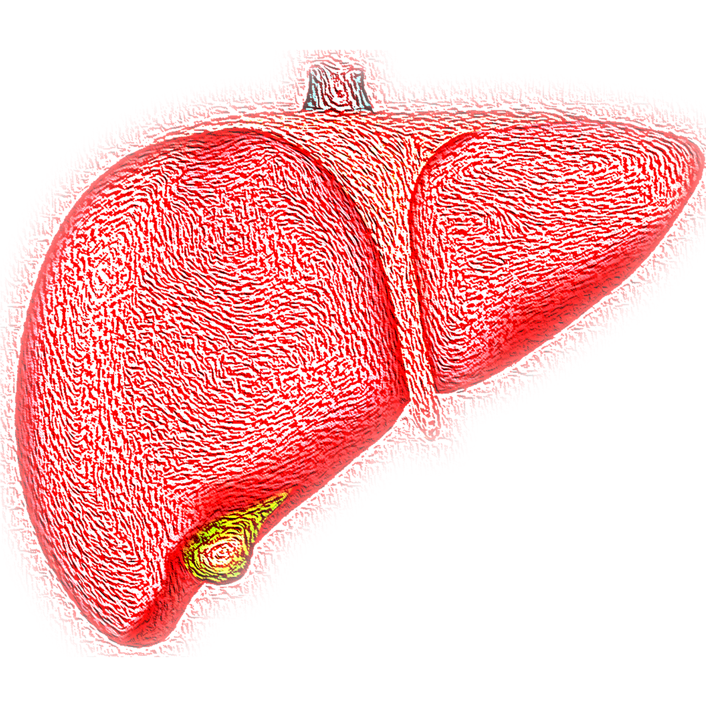 | 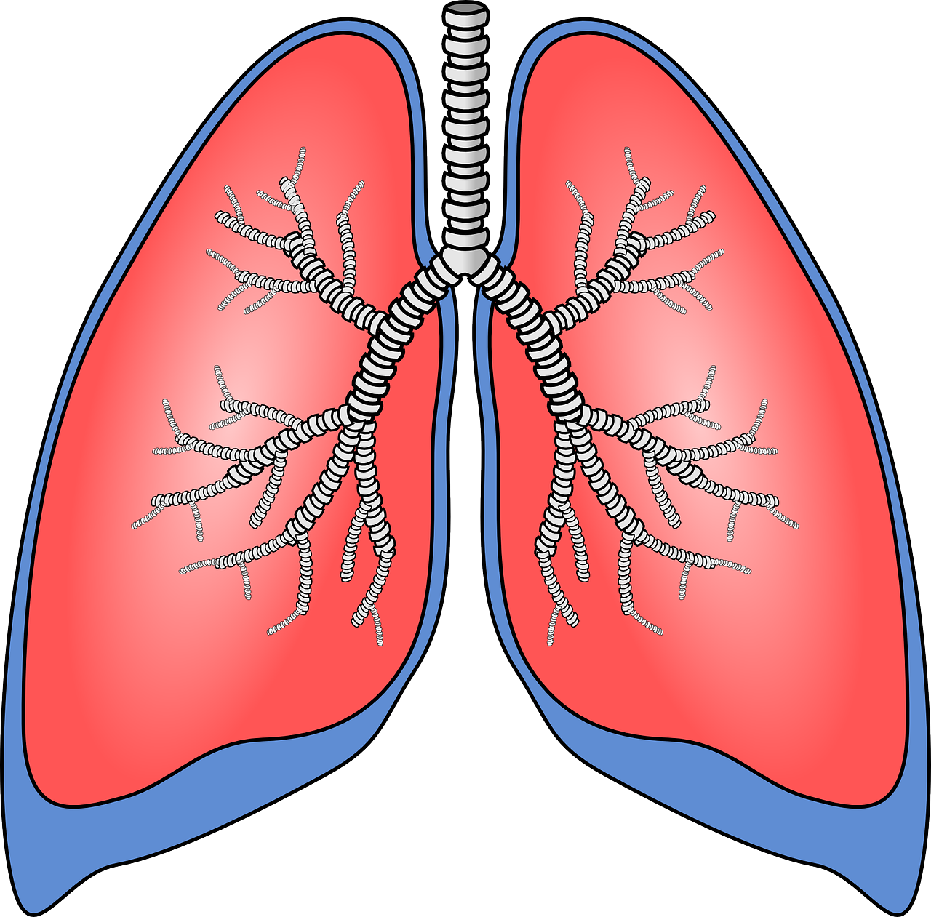
leđa  (back) | jetra  (liver) | pluća  (lungs)
Some of them have differences between their singular and plural forms.
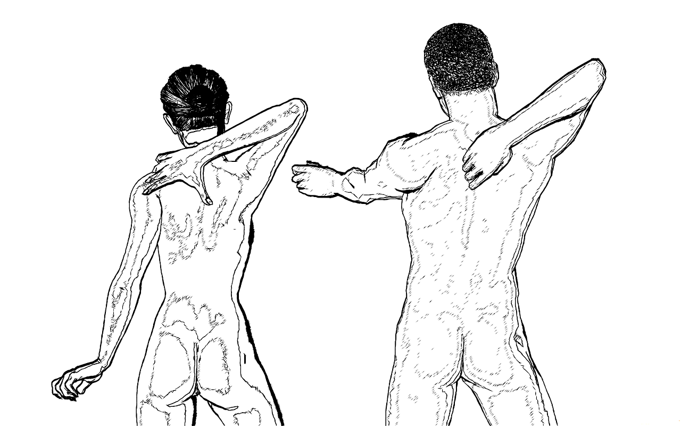 |  | 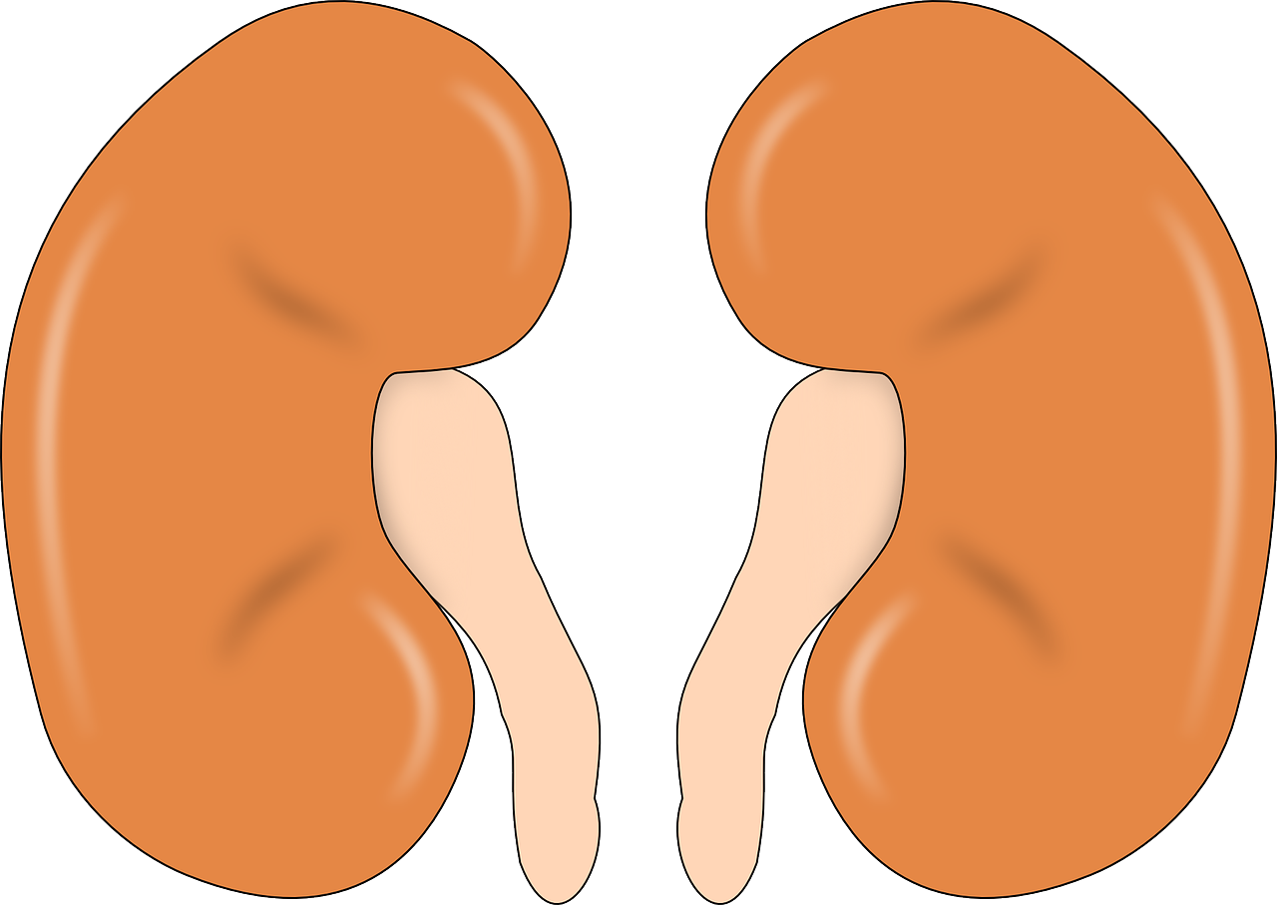
rame – ramena  (shoulder - shoulders) | mozak – mozgovi  (brain - brains) | bubreg – bubrezi  (kidney - kidneys)

Images used in this document are from these sources.

