1 | 1 | Lekcija 3: Upoznajmo se.

| What Language Do You Speak? – PRIČAM… / – GOVORIM…
In Croatian, when we want to say that someone is speaking a [foreign] language, we can use two different verbs to express the desired meaning:
- JA
- TI
 | In the standardized language form we would use: govoriti
 | In everyday life we would use: pričati

The difference between the two verbs is that govoriti can be translated as “to speak,” while the verb pričati can be translated as “to say or tell [something].”

If you want to use the standardized language form, you would say: Govorim engleski. However, in everyday life you will most likely hear people saying: Pričam engleski. Notice the difference between the two verbs as seen in the following examples:

Govoriti:
Govorim engleski. (I speak English.) -- standard form

Pričati:
Pričam engleski. (I speak English.) -- colloquial form
Pričam vic. (I’m telling a joke.) -- Note the literal meaning of the verb used to express the process of telling

You have already learned the names of the four countries. Now let’s investigate how you would say that you speak these and other languages.
zastava | država | jezik | slušanje
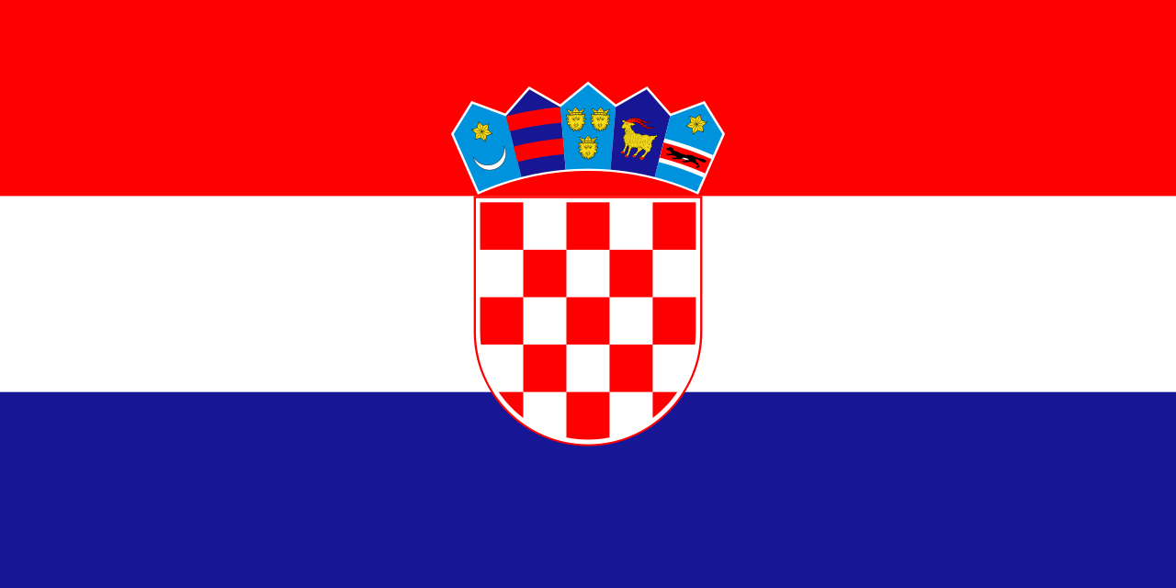 | Hrvatska | hrvatski | (audio)
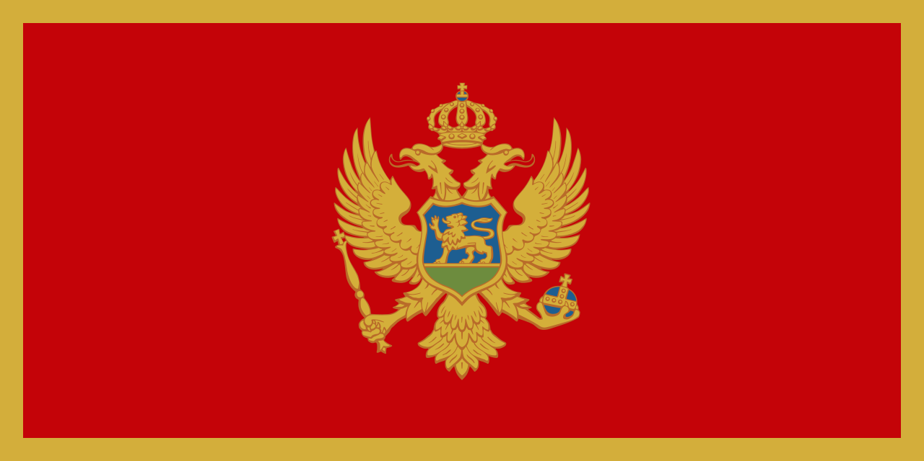 | Crna Gora | crnogorski | (audio)
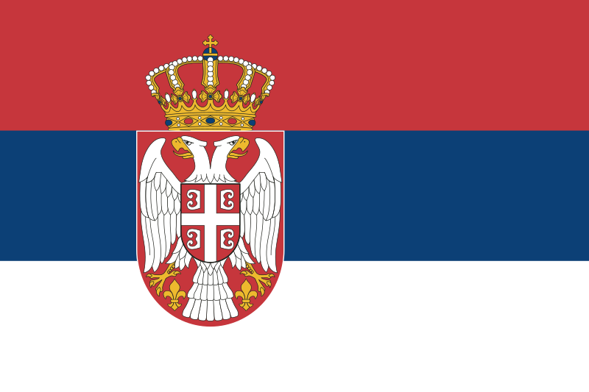 | Srbija | srpski | (audio)
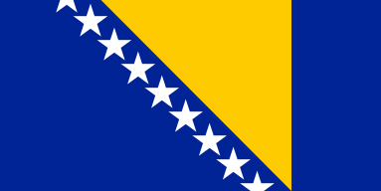 | Bosna i Hercegovina | bosanski | (audio)
 | Francuska | francuski | (audio)
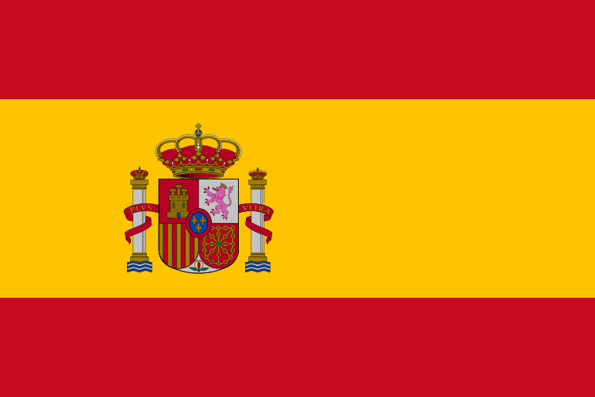 | Španjolska | španjolski | (audio)
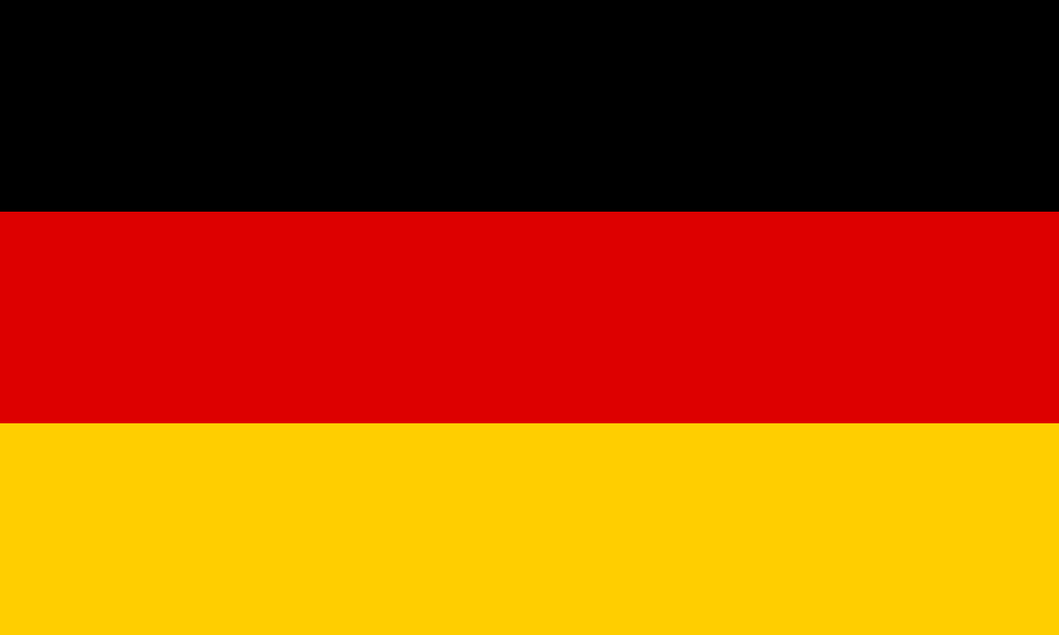 | Njemačka | njemački | (audio)
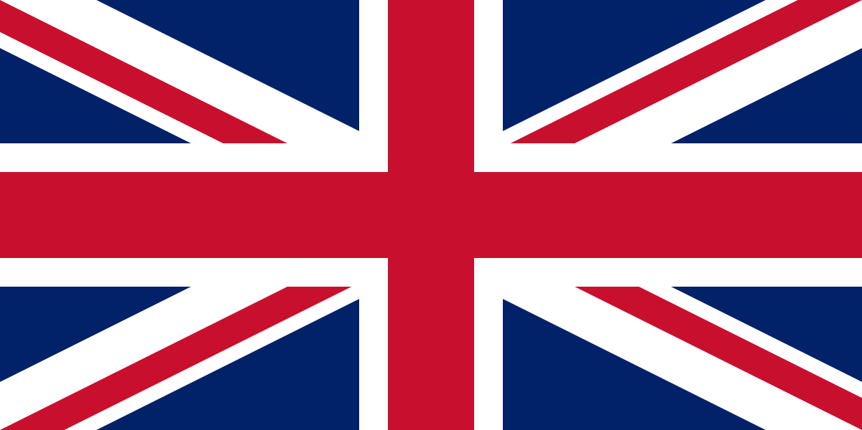 | Velika Britanija | engleski | (audio)
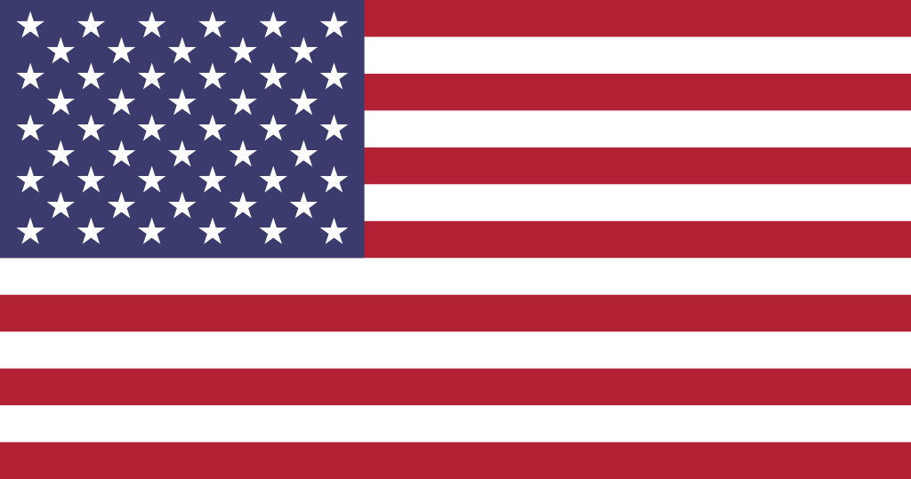 | SAD  Sjedinjene Američke Države | engleski | (audio)
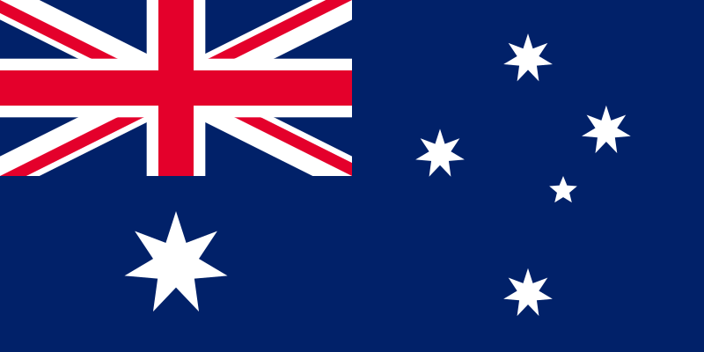 | Australija | engleski | (audio)
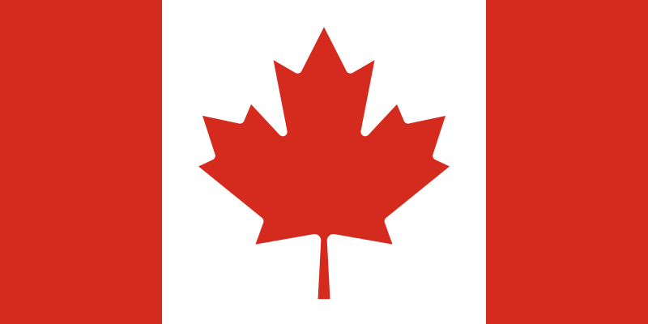 | Kanada | engleski | (audio)
 | Kanada | francuski | (audio)
 | Italija | talijanski | (audio)
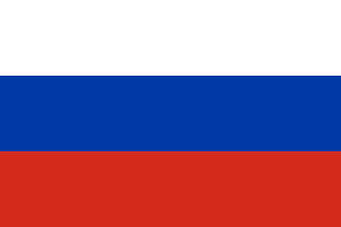 | Rusija | ruski | (audio)

1.1 Zadatak 13. Govorim engleski
🔊Listen to the dialogues from our class session again and mark the language(s) that each of the following characters speak. Then, answer the question about our students.


(audio) | (audio)
[h5p id="62"]
[h5p id="679"]

1.1 Zadatak 14. Koji jezik govori?
Read the sentences below and answer the question about the language spoken by these people. Choose the correct language from a drop-down list.
[h5p id="7"]

All flag images are from https://commons.wikimedia.org and are in the public domain.

