7.4 - coming and going - přicházet a odcházet
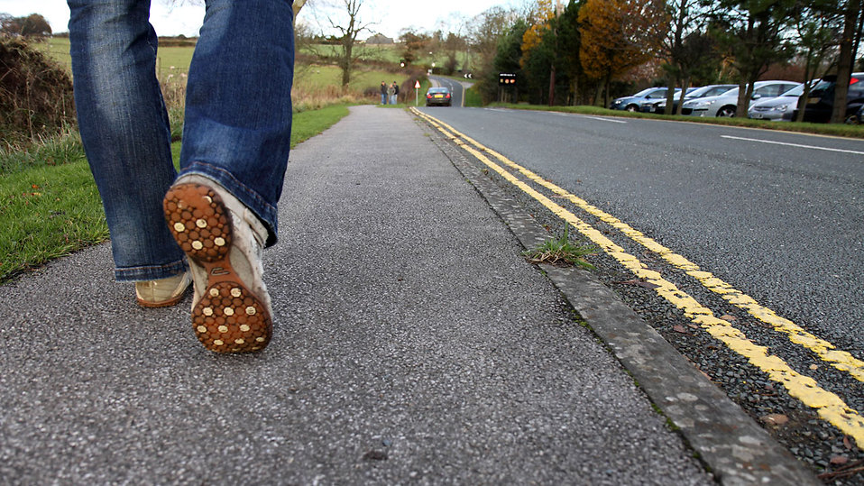

Let’s learn a couple new verbs! As with most verbs now we need to learn both an imperfective and a perfective:

Imperfective | Perfective | Definition
přicházet | přijít | to come, arrive
odcházet | odejít | to leave

přicházet and odcházet a regular -í- verbs, while přijít and odejít are conjugated just like jít ‘to go’ in both the present tense and past tense forms. Note also for now, the places you are leaving for / arriving at are all destinations (do + GEN, na + ACC).

Každý den odcházím na univerzitu v 9 hodin.
Every day I leave for the university at 9 o’clock.

Obvykle přicházíme domů v šest.
We usually arrive home at 6.

Včera jsem odešla do práce v sedm.
Yesterday I left for work at 7.

Viktor přišel do školy ve dvanáct.
Viktor arrived at school at 12.

Also note that you can arrive / come from a place using the preposition z + GEN ‘from’:

Lenka přišla z obchodu a hned jsme obědvali.
Lenka arrived from the story and we immediately had lunch.

Z práce nikdy neodcházím po sedmé hodině.
I never leave (from) work after 7 o’clock.

Finally, as you may have noticed, these verbs have the roots chodit and jít ‘to go by foot’. There are analogous verbs used for arriving and departing by vehicle that are related to the ‘to go by vehicle’ verbs jezdit / jet:

Imperfective | Perfective | Definition
přijíždět | přijet | to come, arrive
odjíždět | odjet | to leave

Images used in this document come from these sources.

notice that there’s an -e- in here. It is found in all conjugated forms (present and past), i.e. odejdu, odešel, odešla, etc.

