3.4 - the verb pít - to drink

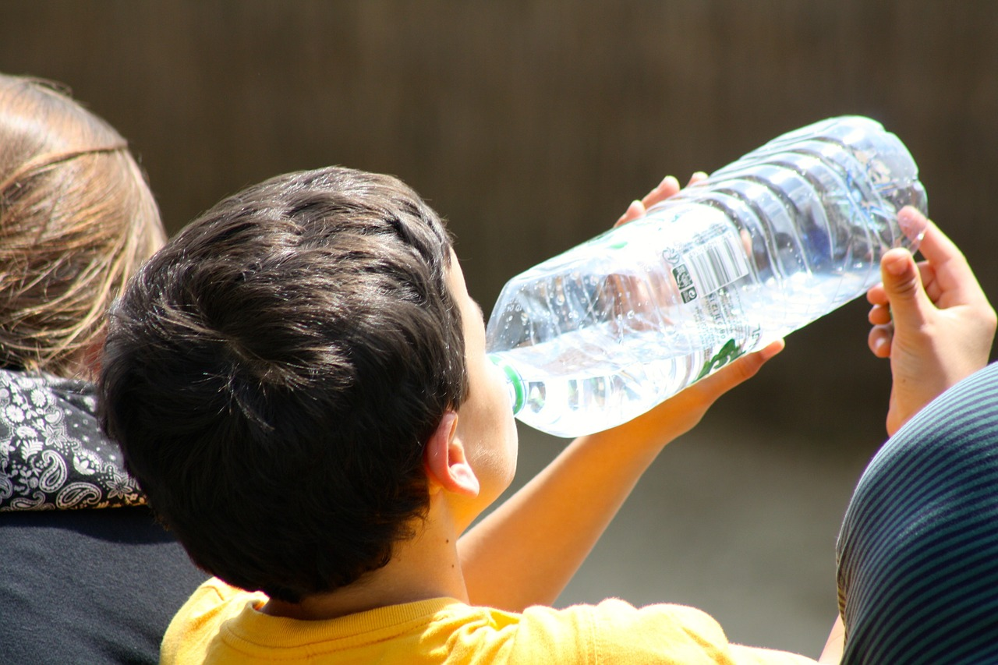 | 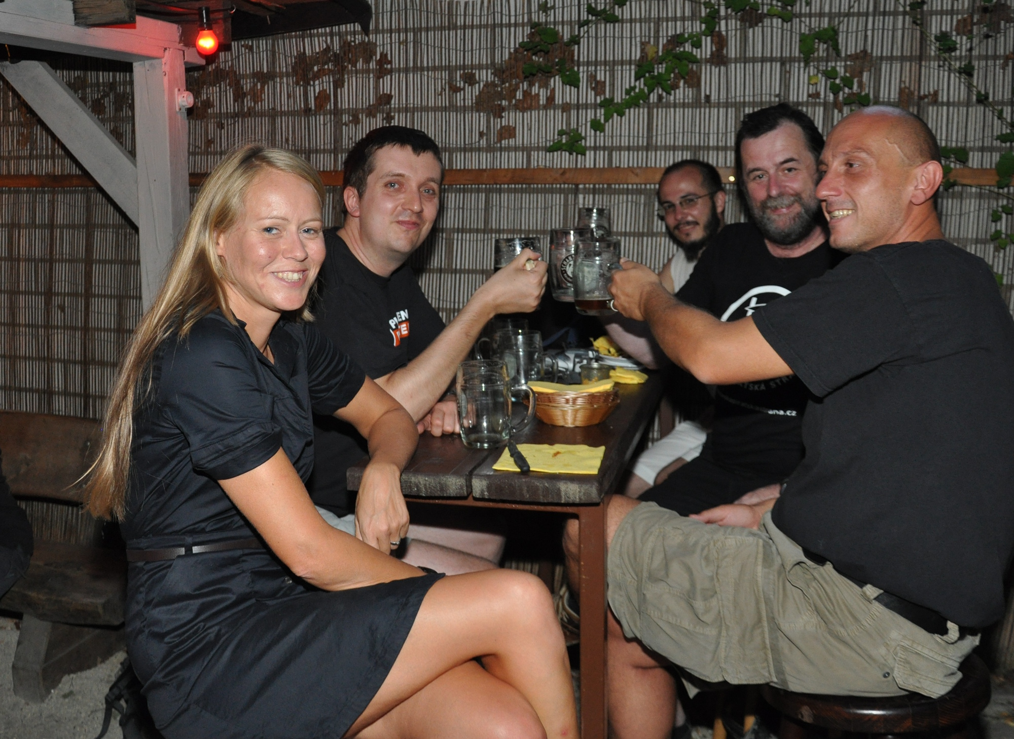

Since we’re learning about food, we also need to learn the verb pít - to drink. This verb is an -e- verb:, and as with most -e- type verbs you have to memorize a stem.

The stem for pít is pij-:

pít to drink

(já) | piju ‘I drink, am drinking’ | (my) | pijeme ‘we drink, are drinking’
(ty) | piješ ‘you drink, are drinking’ | (vy) | pijete ‘you drink, are drinking’
(on/ona/ono) | pije ‘he/she drinks, is drinking’ | (oni/ony/ona) | pijou ‘they drink, are drinking’

Using the verb pít
When people drink something, the people (I, you, he, she, Karel, Pavel, students, etc.) are the subject. The thing they are drinking is the direct object (just like with the verb jíst ‘to eat’)

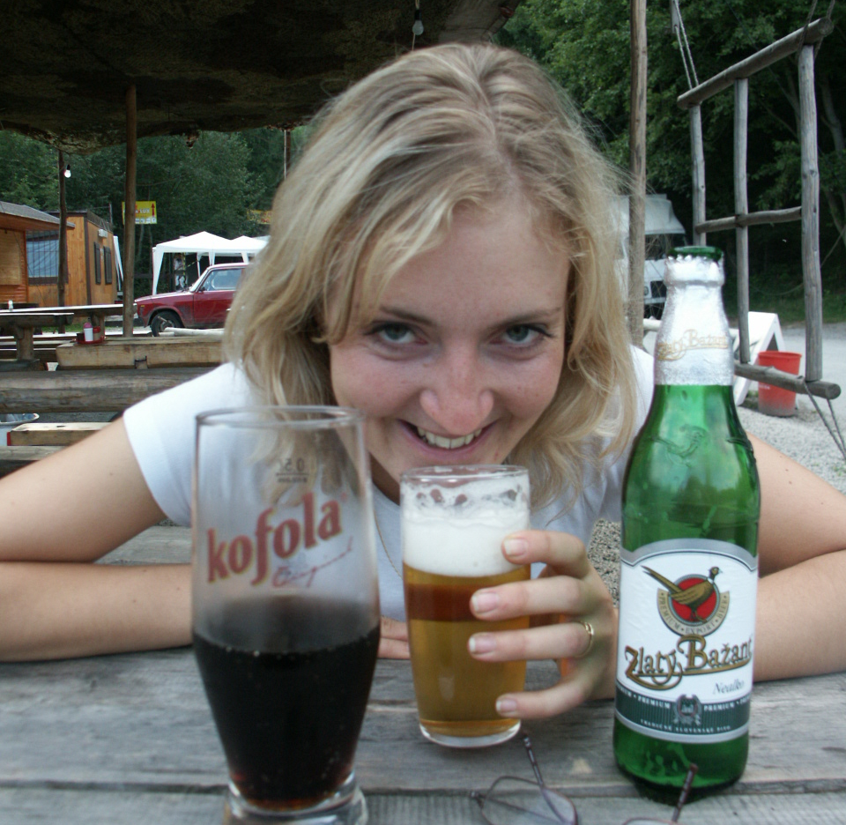 | 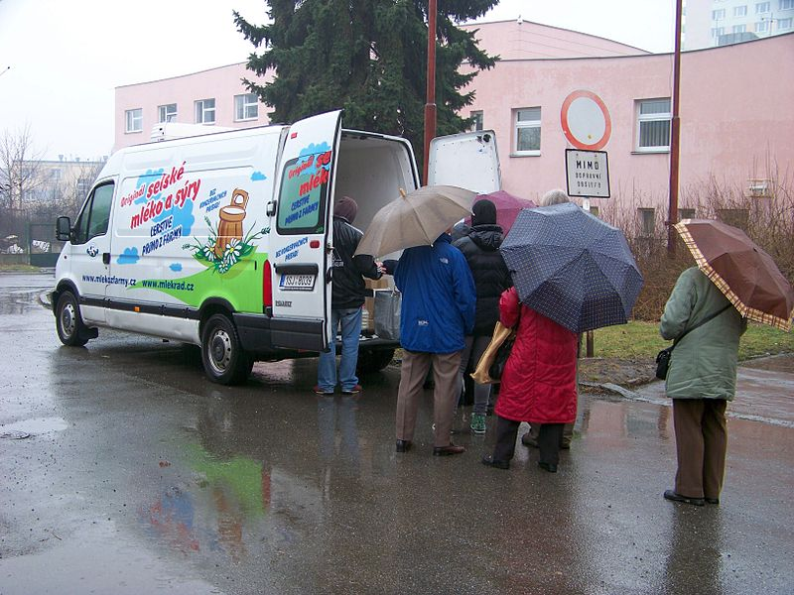 | 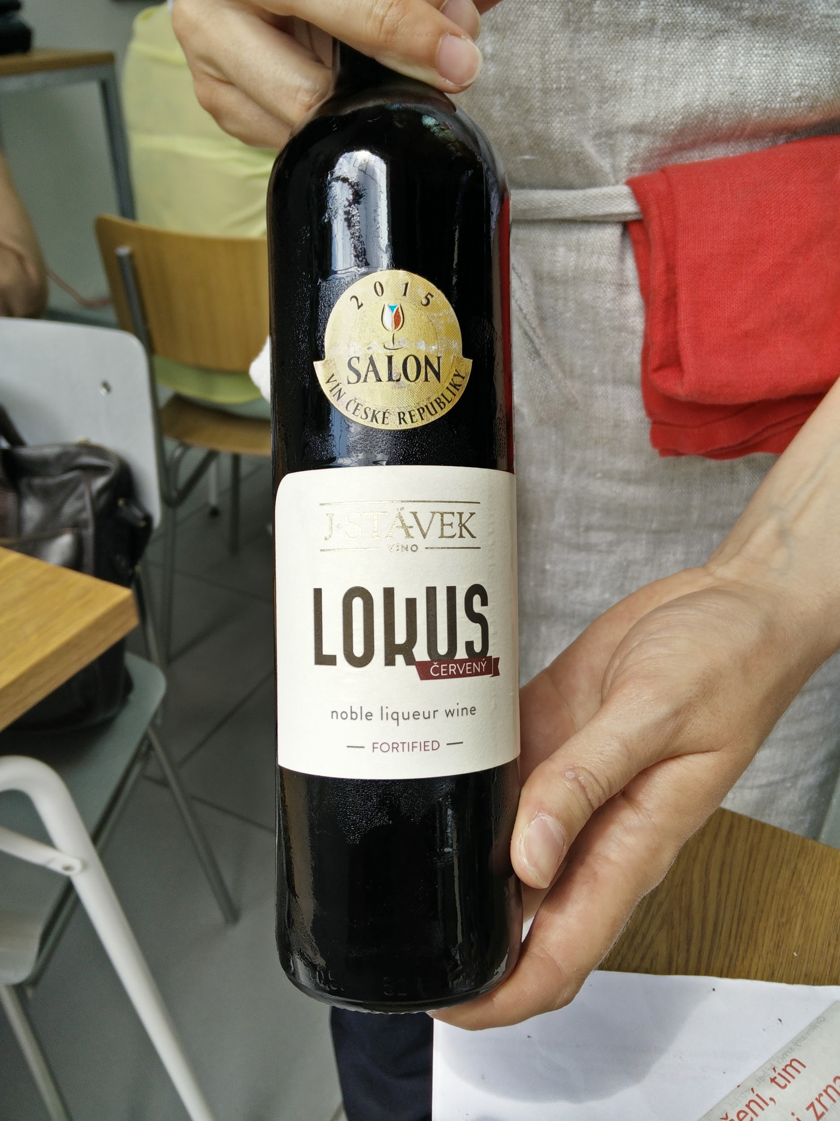
Janka pije pivo a kofolu.  Janka is drinking a beer and a kofola.  kofola - EN or CZ | Tihle lidé často pijou mléko.  These people often drink milk.  (note: this is a picture of people lining up for fresh farm delivery of milk in the Czech Republic, a trend that popped up in the past ten years). | Často piju moravské víno.  I often drink Moravian wine.

Each of these is using the accusative ending for the direct object (thing being drunk). Keep this in mind as you use this verb.

Images used in this document come from these sources.

