10.4 - Kupování jízdenek - vlak a autobus

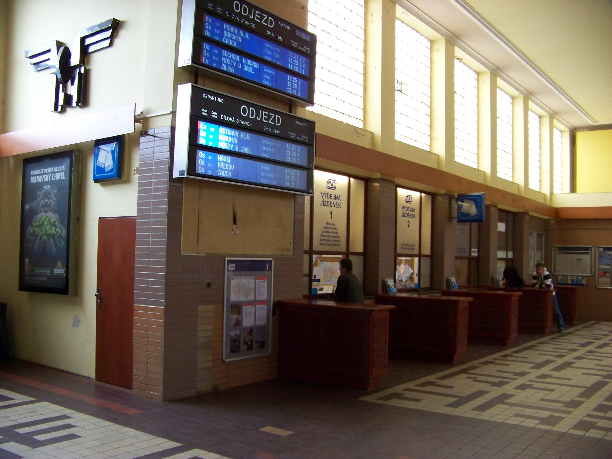 | 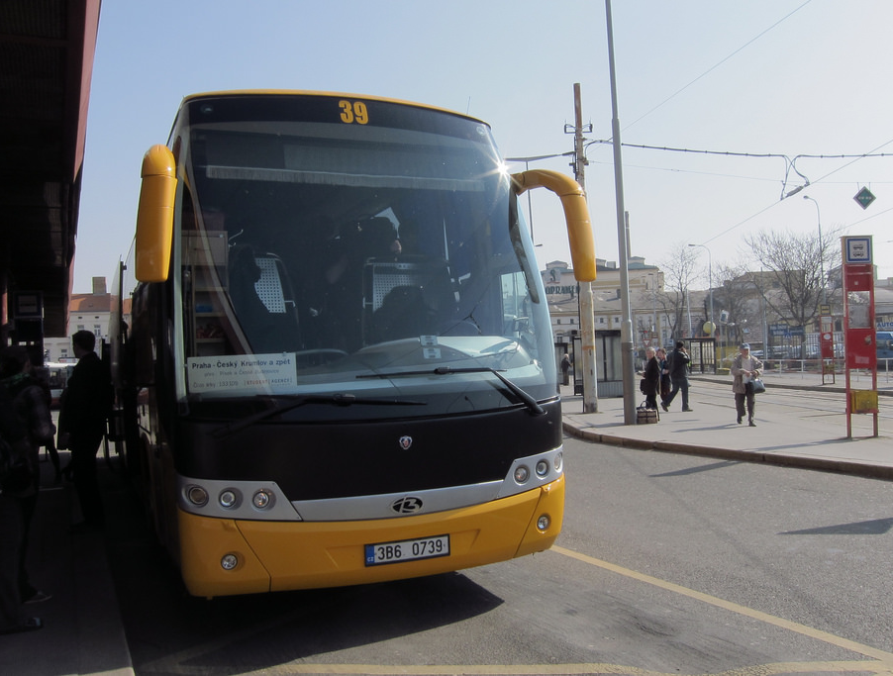
pokladny na nádraží | jízdenky na autobus se často kupují přímo u řidiče

Let’s say you want to buy tickets for a bus or a train. It’s actually pretty easy. There are lots of ways to buy tickets these days, whether you go to the counter at a station or buy them in some instances directly on the train or bus, or online prior to your trip.

If you are buying them in person, use the following formula:

Prosím, jednu jízdenku do _________________.

Here you fill in the blank with the place you are going to. Easy, right? In some instances, it may be advisable to purchase a místenka ‘place reservation’ for a train as well. A ticket for a train only gives you the right to travel on the train (and if it’s crowded, it can mean standing room). You can ask for a jízdenka s místenkou in these cases.

If you wish to purchase online, try the following:

https://www.cd.cz/eshop/
https://jizdenky.regiojet.cz/

Jízdenky:
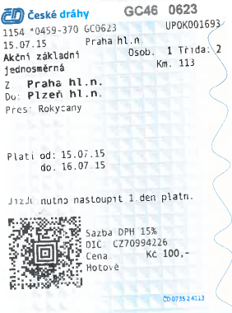  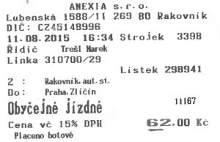 | 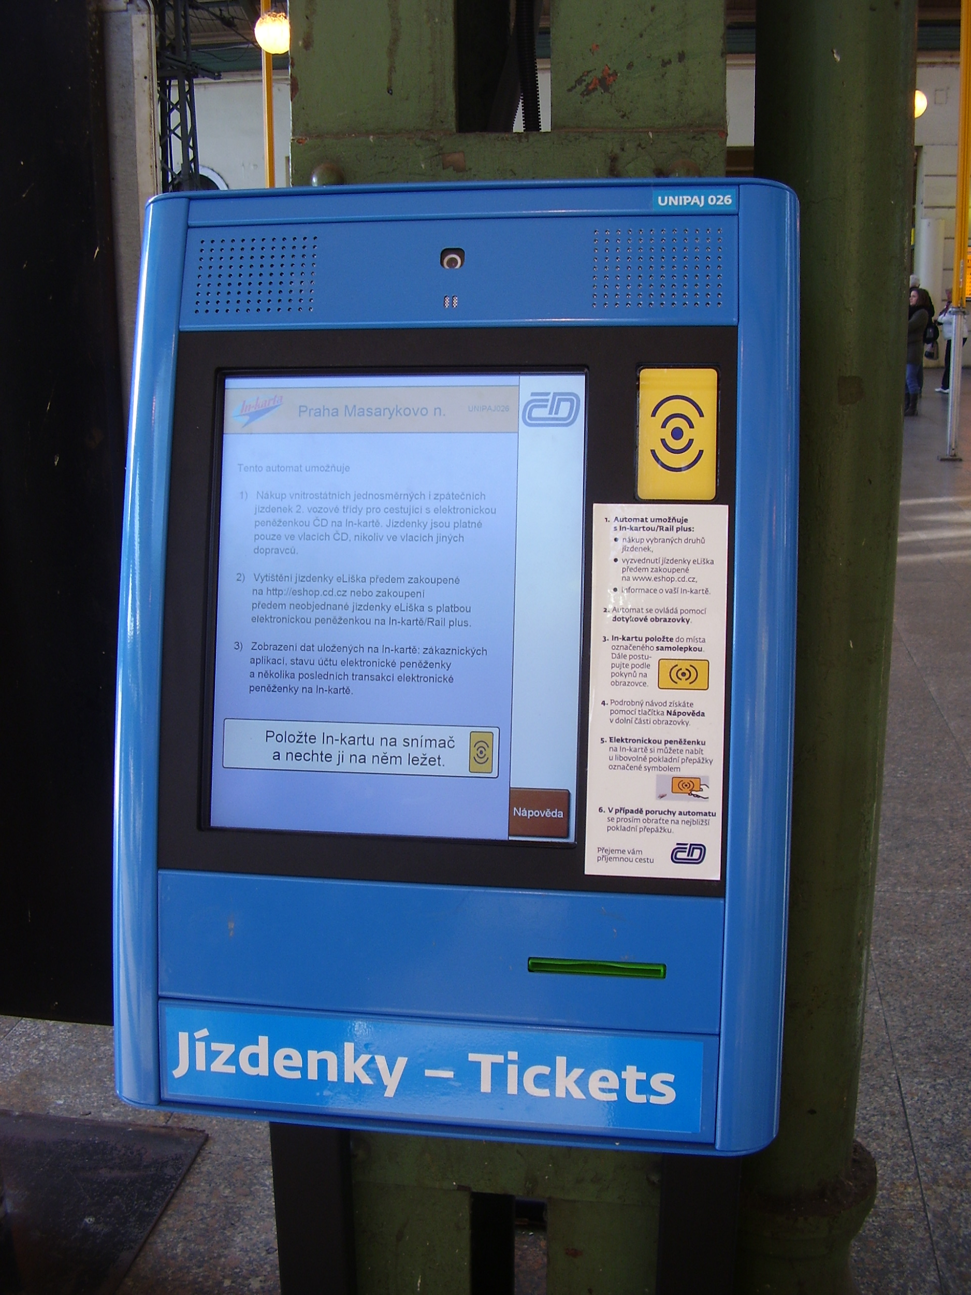
Jízdenka na vlak (nahoře) a autobus (dole) | Automat na jízdenky - České dráhy

Images used in this document come from these sources.

