7.2 - Conversational Clock Time, part 2 - time on the quarter hour

Now time on the quarter hour…

To indicate time on the quarter hour, we use the form čtvrt - quarter. You can probably already see that it’s related to words such as čtvrtý ‘fourth’ (as in ¼) and čtvrtek ‘Thursday’ (i.e. the fourth day of the week).

Let’s start by taking a look at the following examples:

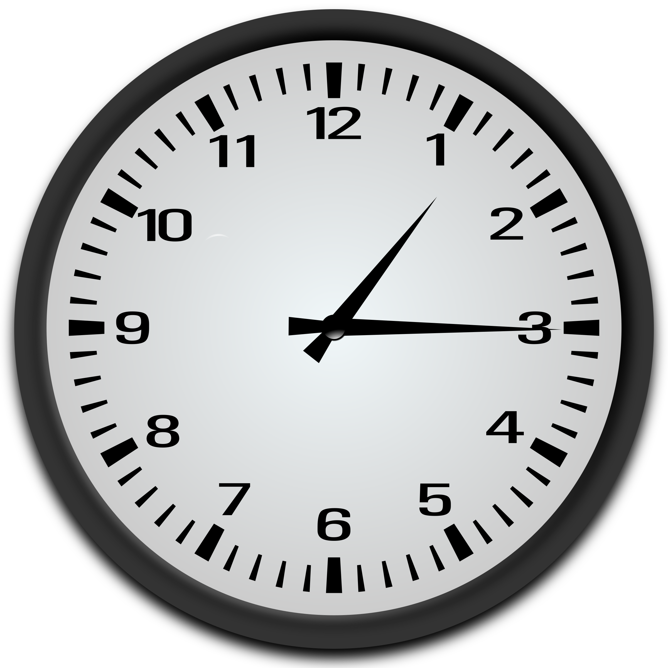  Je čtvrt na dvě.. | 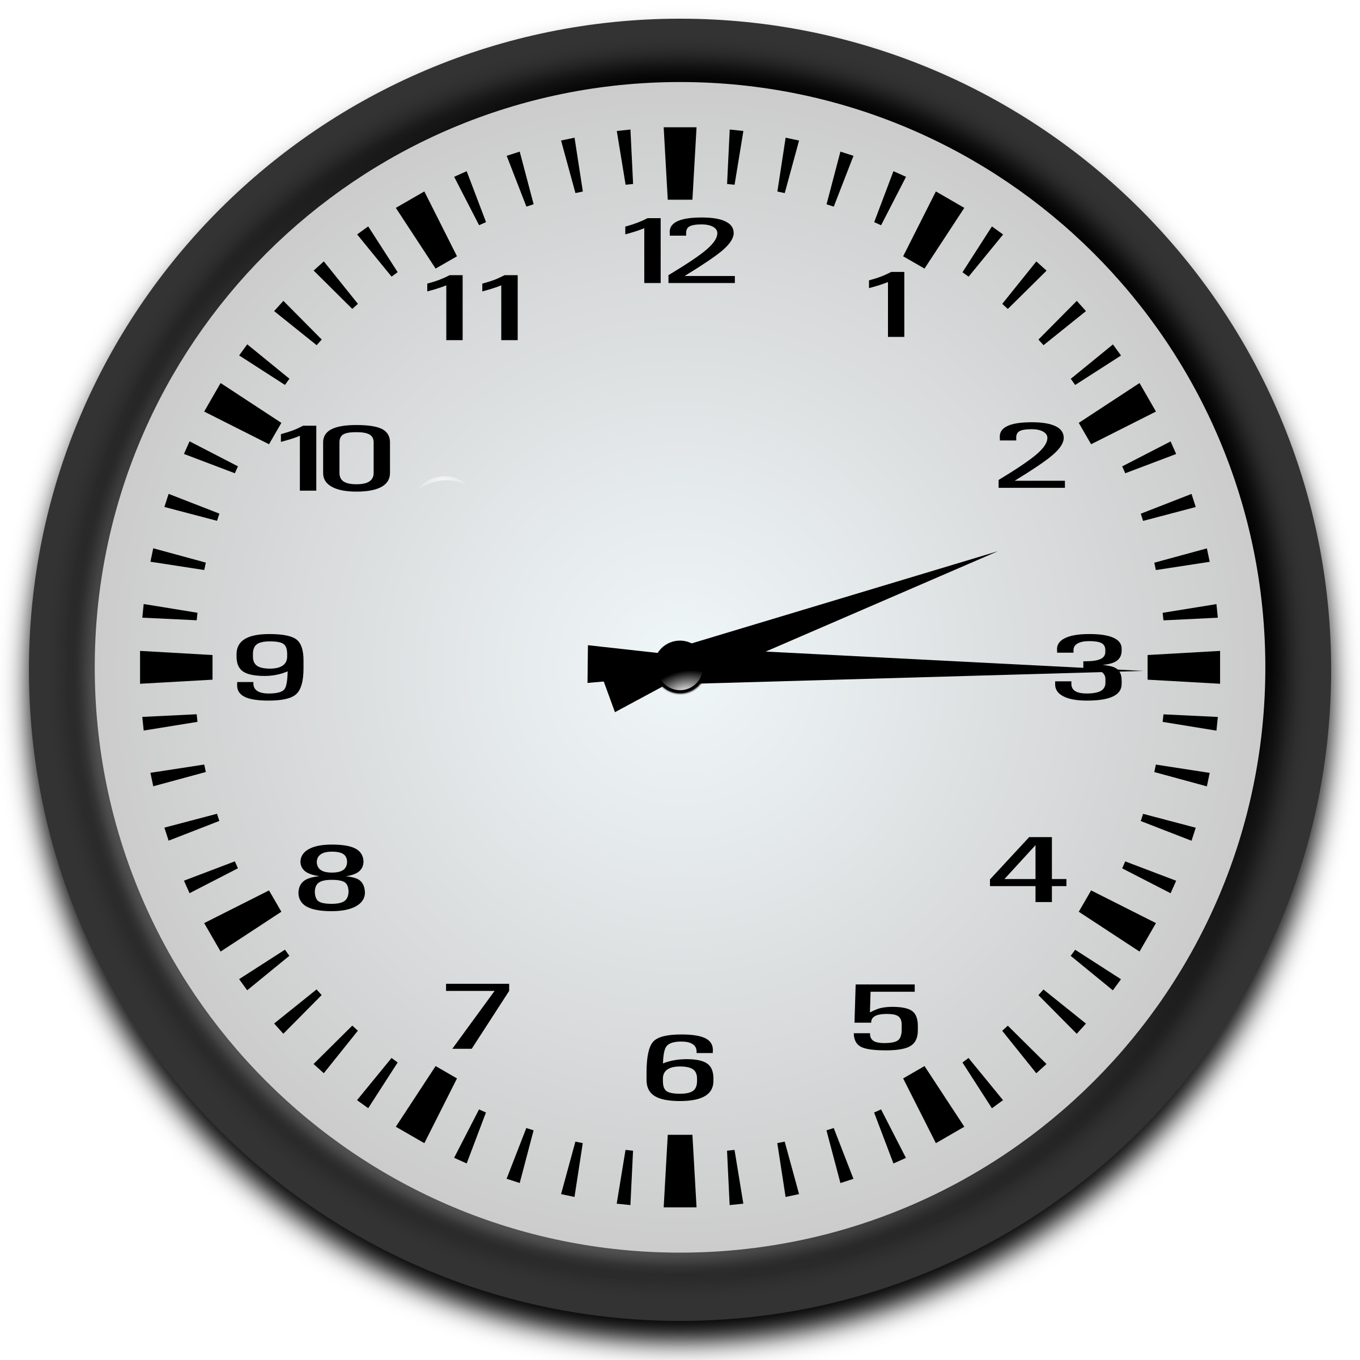  Je čtvrt na tři. | 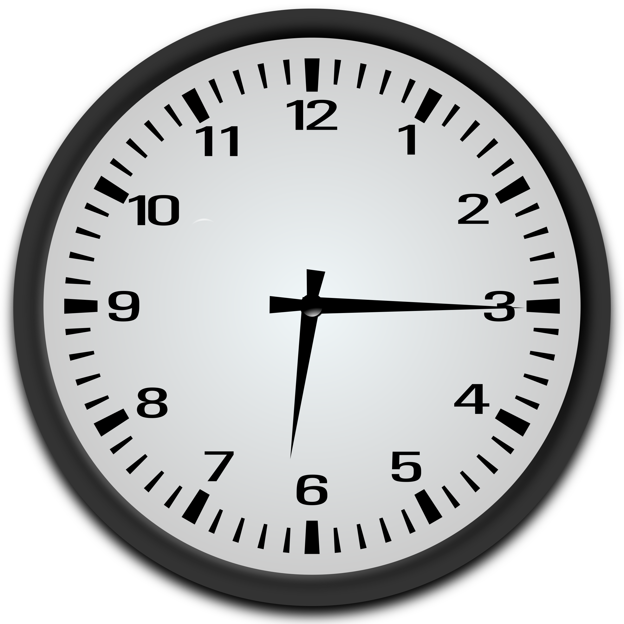  Je čtvrt na sedm.

If we look at these, you’ll notice that in Czech they relate everything to the upcoming hour (just as with time on the half hour). Je čtvrt na dvě literally translates as ‘it’s a quarter (moving) toward 2. Here cardinal numbers are used (tři, čtyři, pět…), and no ordinal numbers as in time on the half hour.

This is different from English, where we say that it’s a quarter past a certain hour.

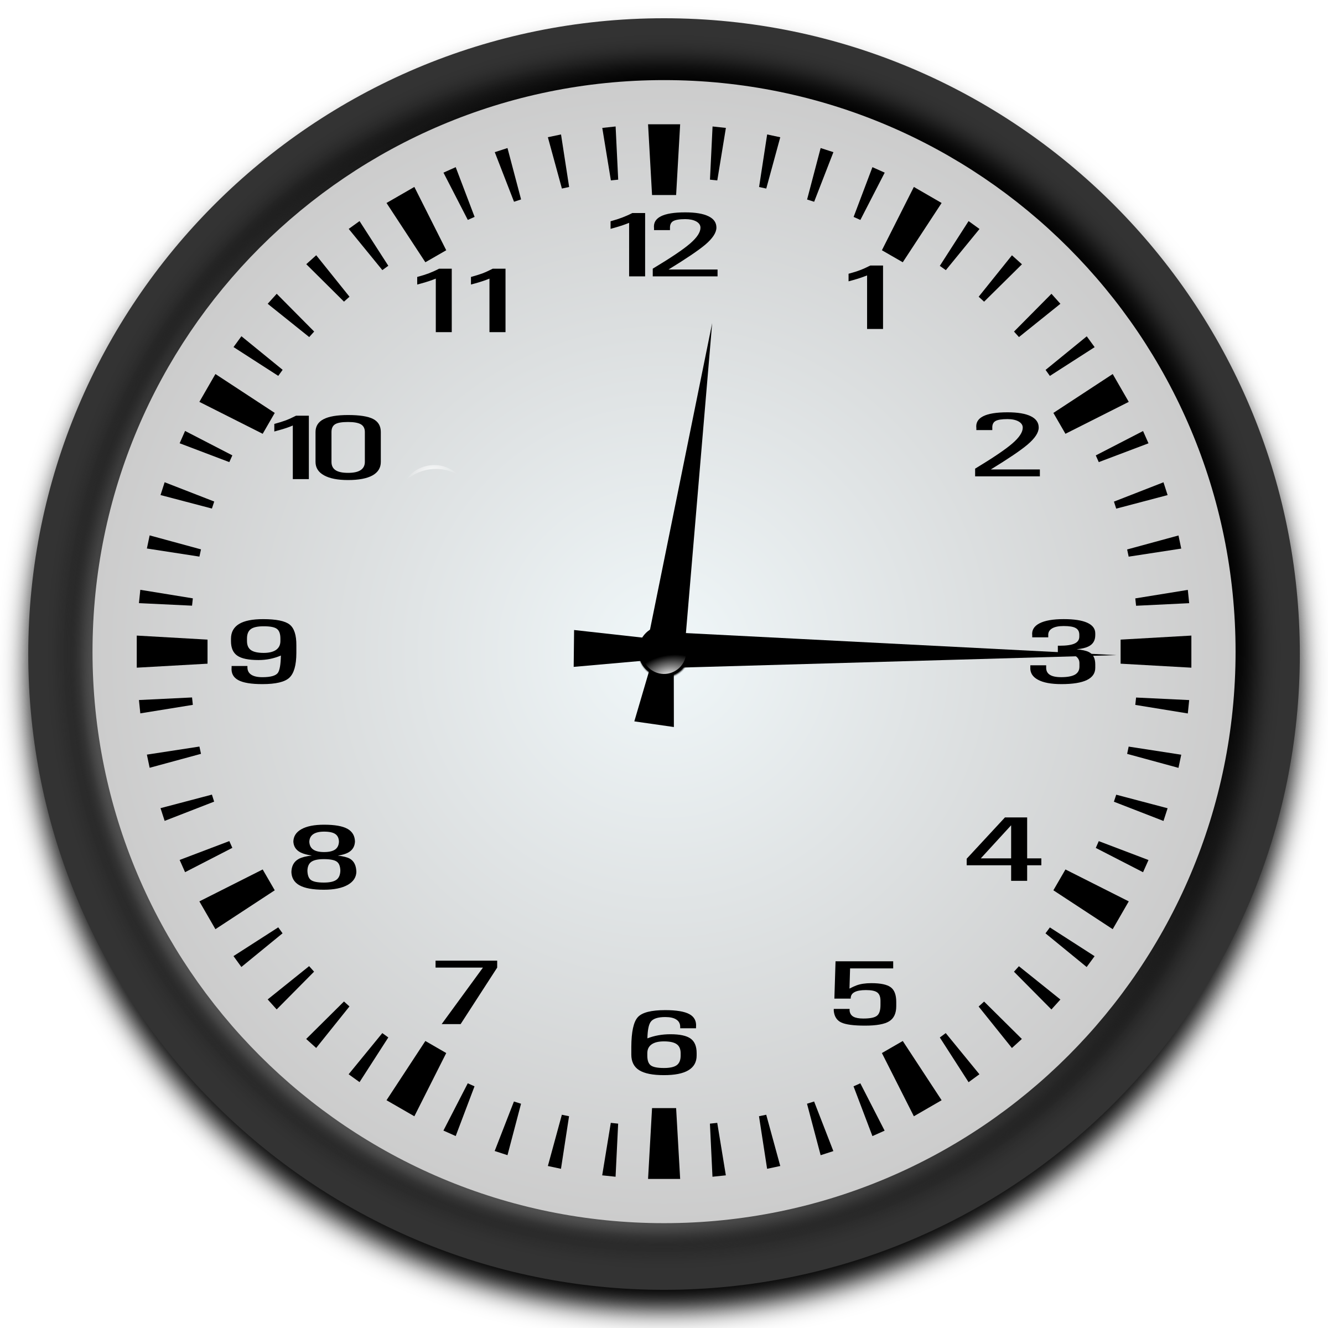
Je čtvrt na jednu.

Here we see that the accusative form is used after na (just like you say v jednu hodinu).

Not that bad, right? One more thing with time on the quarter hour – now let’s try the 45s, i.e. 1:45, 2:45, etc. These are formed similar, except instead of čtvrt ‘quarter’, we say tři čtvrtě ‘three quarters’.

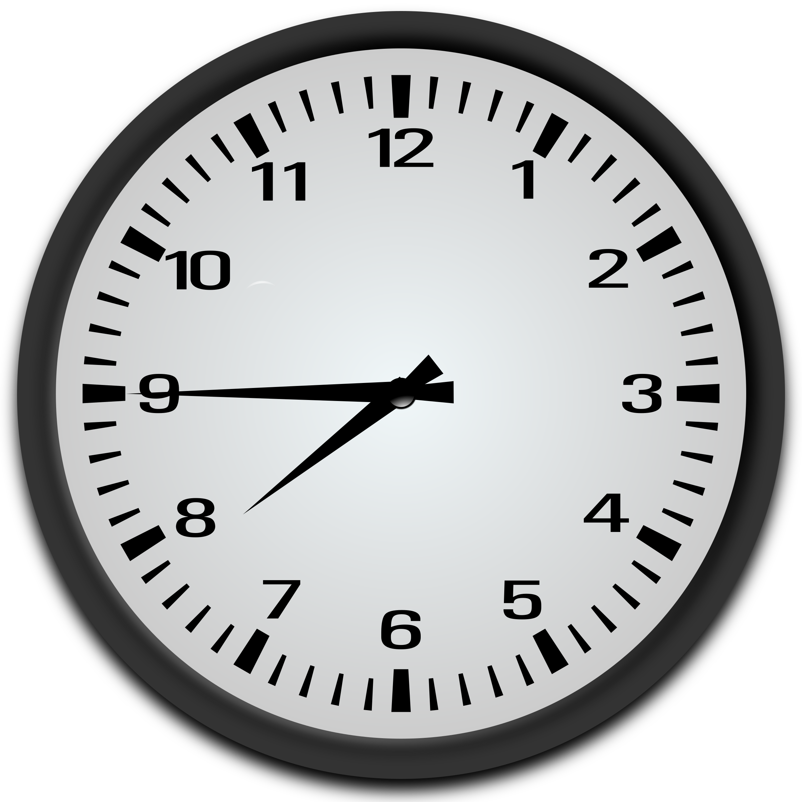  Je tři čtvrtě na osm. | 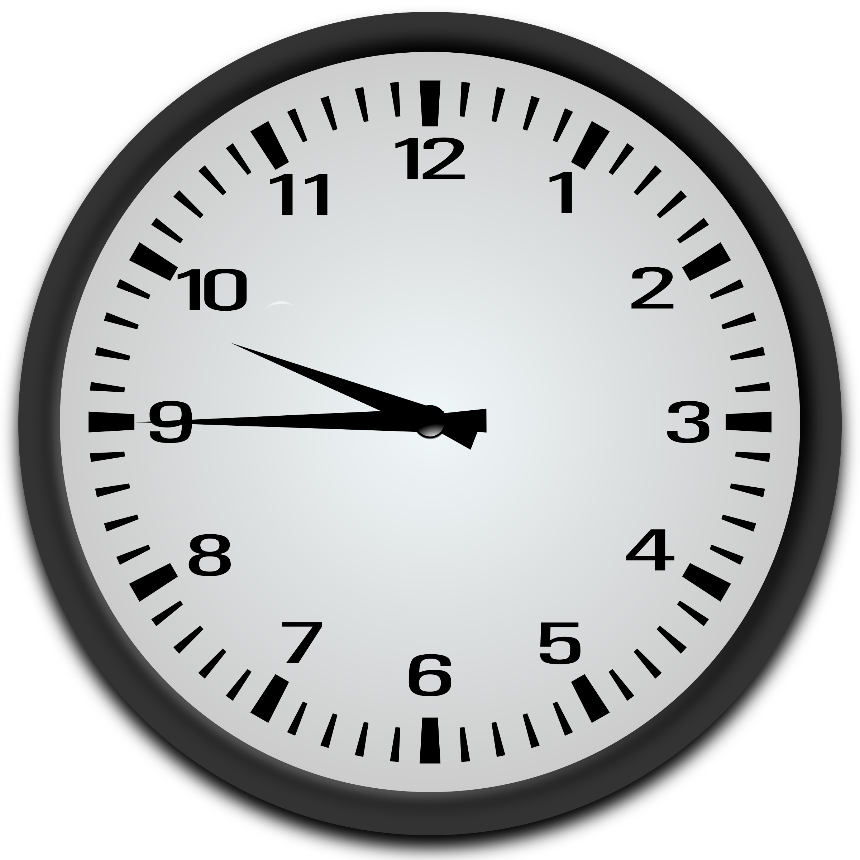  Je tři čtvrtě na deset. | 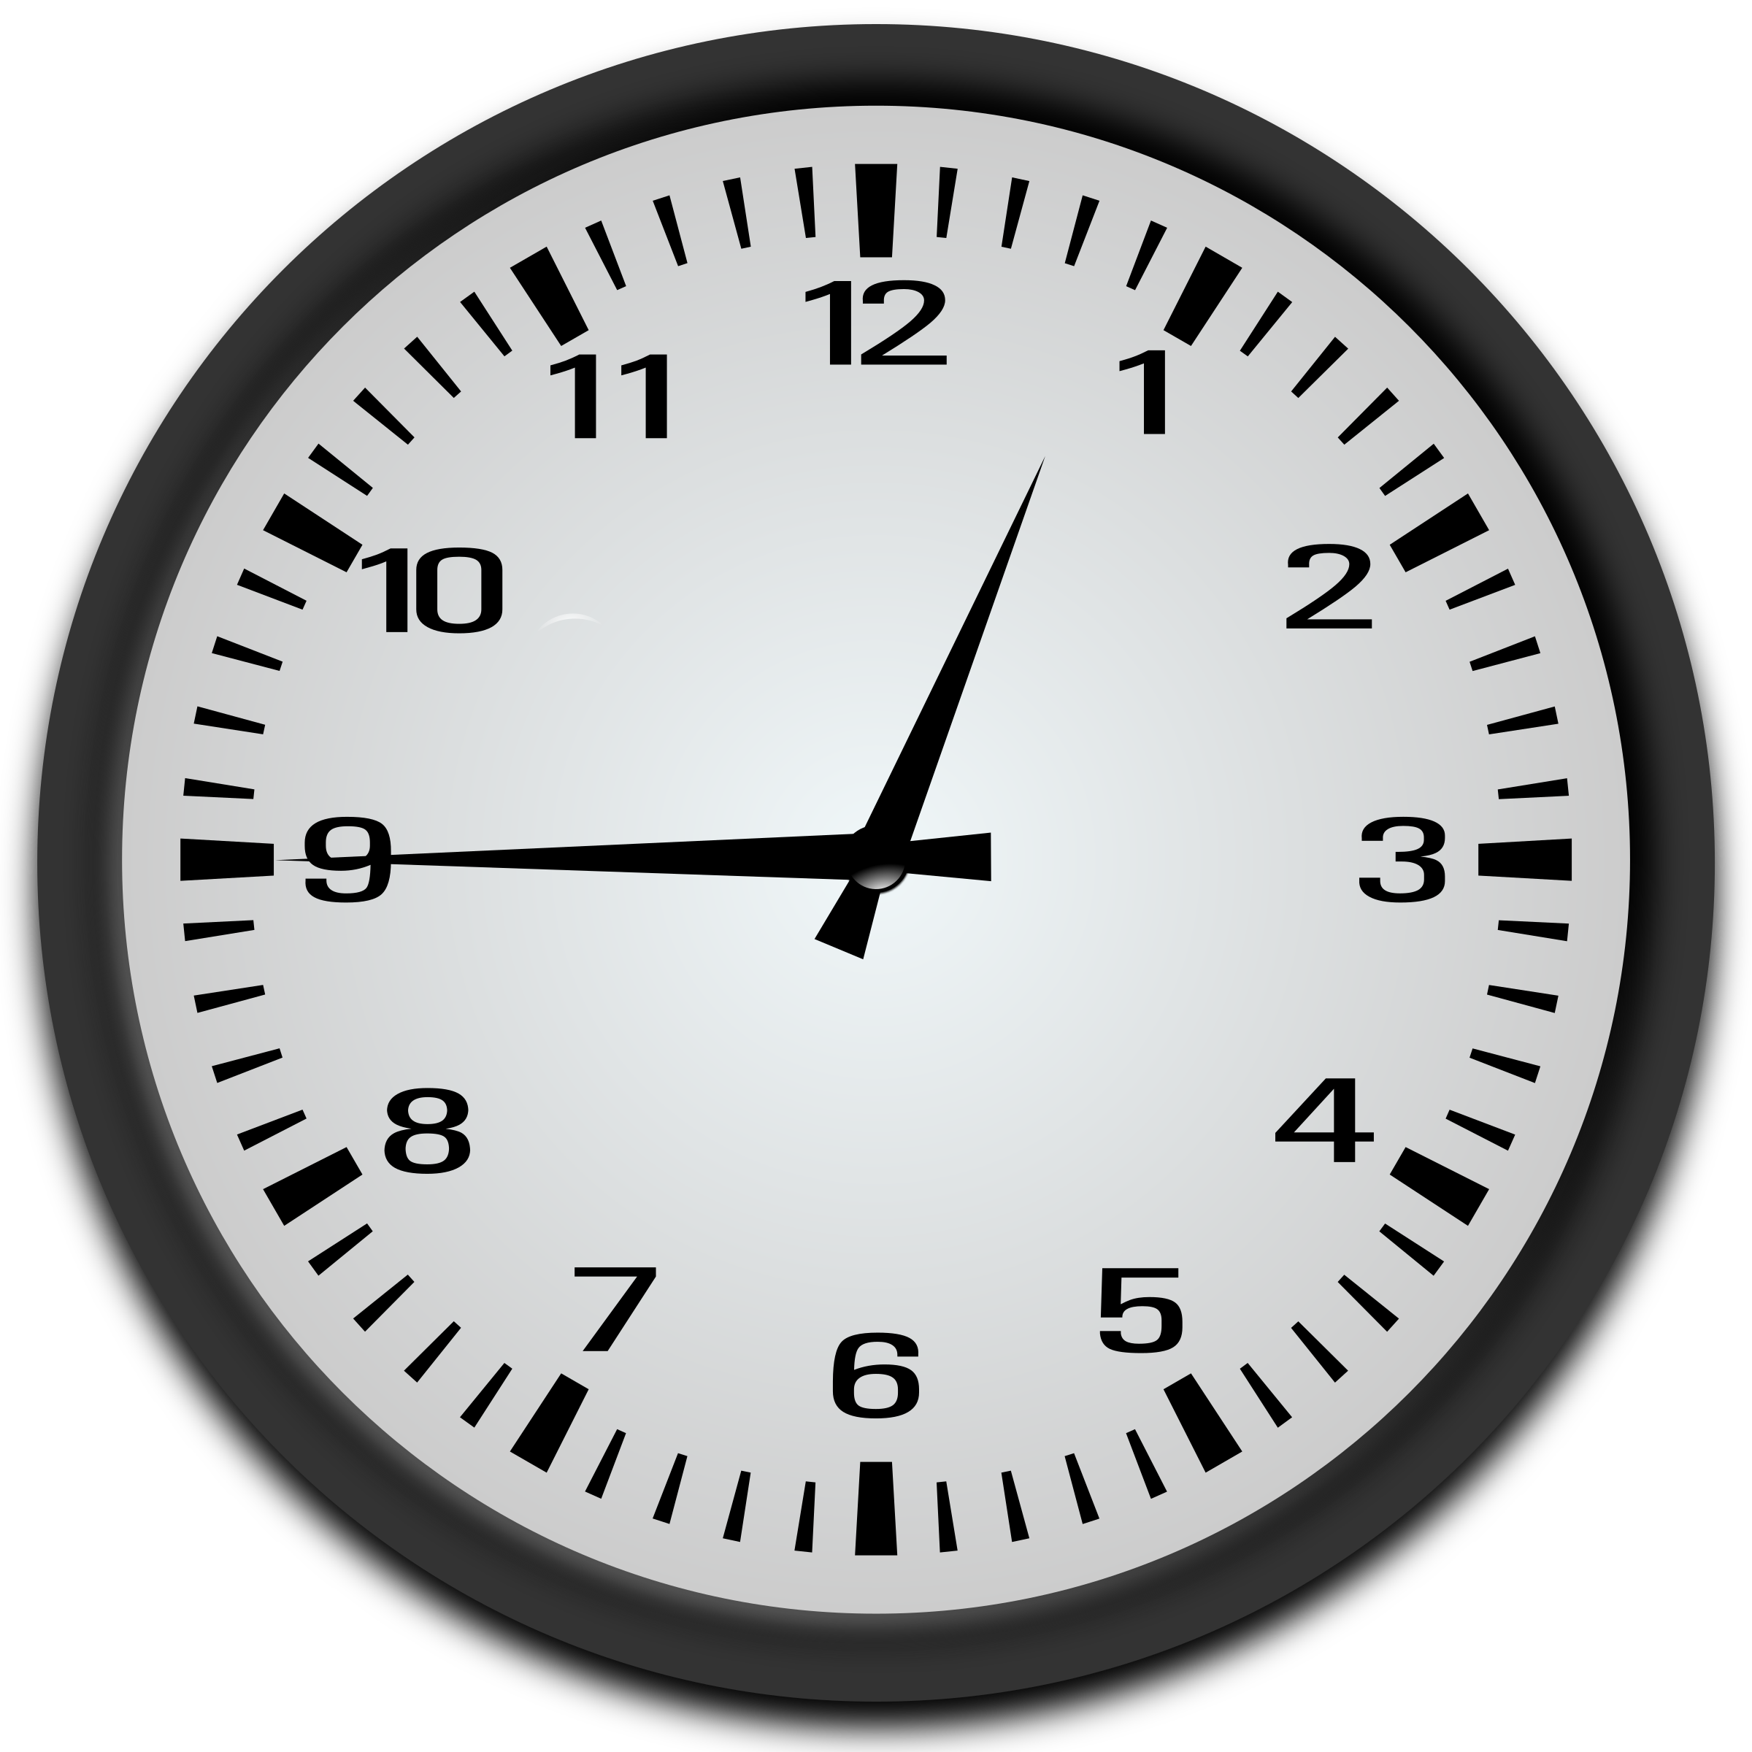  Je tři čtvrtě na jednu.

Images used in this document come from these sources.

the form dvě is used since we’re referring to hodiny (f.)
the feminine accusative form jednu is used since we’re referring to hodinu (f.)

