5. lekce - Tělo, zdraví a povaha / Unit 5 - Body, Health, and Personality

In this unit we will learn to describe people. We will begin by describing a person’s appearance more generally by learning terms for body parts, hair and eye color, complexion, etc. We will then learn how to describe various illnesses, pain, physical sensations, emotional states and mood. Finally, you will learn how to describe people in terms of their character traits and talk about what traits are ideal for friends, colleagues, and partners | 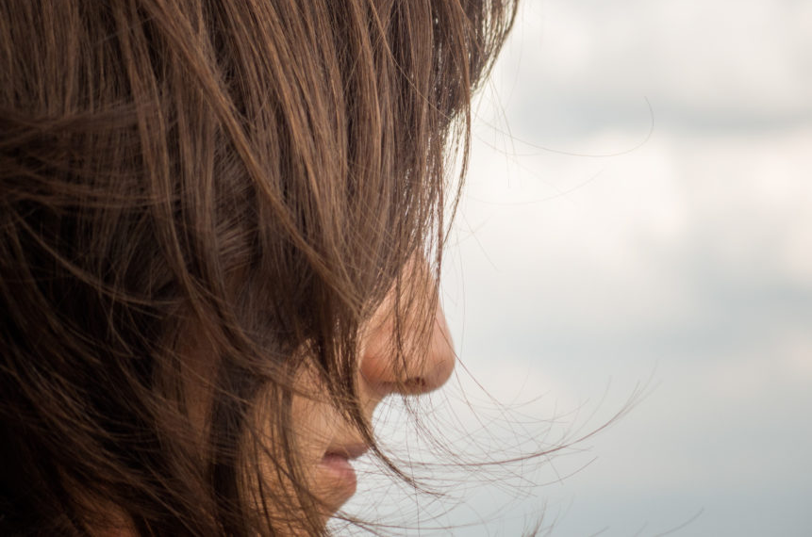

Communicative Goals | Grammar | Vocabulary
- name and describe parts of the body  - describe physical appearance of a person  - talk about how you are feeling (tired, sick, hot, cold, happy, sad, etc.)  - talk about being sick and express what hurts  - describe people in terms of their  - describe your emotional state | - dative of nouns and pronouns  - using the dative to express indirect object  - using the dative to express age  - using the dative to express physical sensations (je mi zle, je mi dobře)  - past tense  - comparatives | Unit 5 - Vocabulary List  - parts of the body  - physical description  - sickness and health  - the verb moct ‘to be able’

pre-class |  | in-class |  | post-class
These lessons and exercises should be completed before meeting with your instructor. |  | These activities should be completed with your instructor/class. |  | These assignments should be completed after the designated class meeting.
  Pre-class Lesson |  | 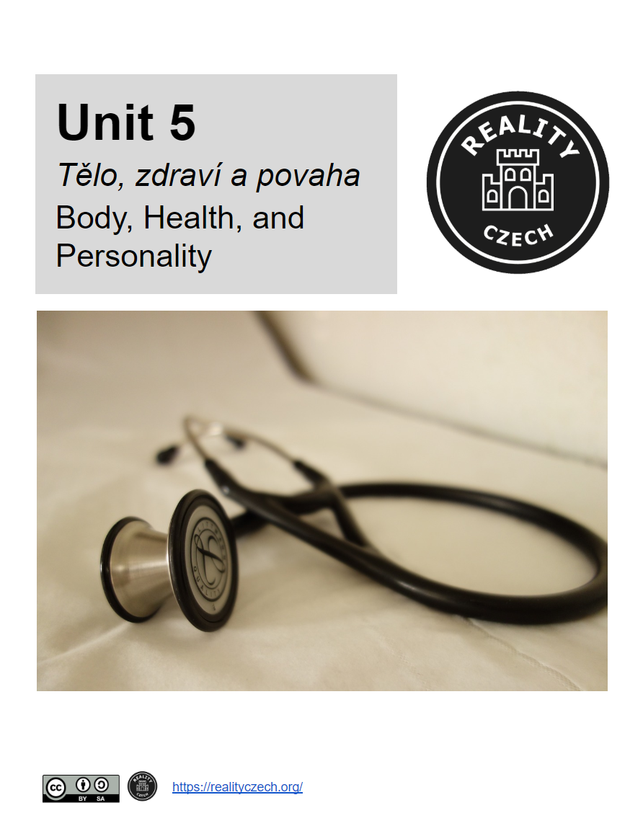  Unit 5 - Activity Book |  |   Post-class Homework

Pre-class Canvas Quiz

Pre-class Video

Pre-class Vocabulary or Grammar Drill

For more information about using these materials, see Using the Reality Czech Curriculum

5.1 - 5. lekce, 1. den
 | 5.1 - Barva vlasů - Hair color | Domácí úkol 5.1
 | 5.1 - Quizlet - Hair Color - Flashcards
 | 5.1 - Quizlet - Hair Color - Learning Exercise
 | 5.1 - Barva vlasů
 | 5.1 - Quizlet - Hair Color - Listening Exercise
 | 5.1 - Jaké vlasy? - Describing Hair in More Detail
 | 5.1 - Quizlet - Hair Description - Flashcards
 | 5.1 - Quizlet - Hair Description - Learning Exercise
 | 5.1 - Jaké mají vlasy? Krátké? Dlouhé? Kudrnaté?
 | 5.1 - Quizlet - Hair Description - Listening Exercise
 | 5.1 - Barva očí - Eye color
 | 5.1 - Barva očí
5.2 - 5. lekce, 2. den
 | 5.2 - Facial Features and Skin Color/Complexion | Domácí úkol 5.2
 | 5.2 - Quizlet - Pleť - Flashcards
 | 5.2 - Quizlet - Pleť - Learning Exercise
 | 5.2 - Postava - Describing Body Type / Figure
 | 5.2 - Quizlet - Postava - Flashcards
 | 5.2 - Quizlet - Postava - Learning Exercise
 | 5.2 - Jak oni vypadají? - Choose the correct description
 | 5.2 - Describing People
 | 5.2 - Popište následující lidi
 | 5.2 - Quizlet - Pleť - Listening Exercise
 | 5.2 - Quizlet - Postava - Listening Exercise
5.3 - 5. lekce, 3. den
 | 5.3 - Quizlet - Review Clothing | Domácí úkol 5.3
 | 5.3 - Quizlet - Review Appearance
 | 5.3 - Talking about how people looked -- basic past tense forms
 | 5.3 - Past tense of být and mít in descriptions
 | 5.3 - Describing People's Clothing and Appearance
 | 5.3 - Descriptions of People in Past - Translation
 | 5.3 - Making Comparisons -- Physical Appearance
 | 5.3 - Quizlet - Appearance Comparisons
 | 5.3 - Making Comparisons - Translation
5.4 - 5. lekce, 5. den
 | 5.4 - Části těla - Parts of the body | Domácí úkol 5.4
 | 5.4 - Quizlet - Body Parts - Flashcards
 | 5.4 - Quizlet - Body Parts - Learning Exercise
 | 5.4 - It hurts! Bolí mě to!
 | 5.4 - Quizlet - Bolest - Flashcards
 | 5.4 - Quizlet - Bolest - Learning Exercise
 | 5.4 - To mě bolí!
 | 5.4 - Quizlet - Bolest - Listening Exercise
 | 5.4 - Zlomeniny - Fractures
 | 5.4 - Zlomeniny - Broken Bones
 | 5.4 - Co jim je? What's wrong with them?
 | 5.4 - Physical Pain - Translation
5.5 - 5. lekce, 5. den
 | 5.5 - Jak se cítíš? Jak ti je? - How do you feel? | Domácí úkol 5.5
 | 5.5 - Nemoci - Illnesses
 | 5.5 - Quizlet - Nemoci - Flashcards
 | 5.5 - Quizlet - Nemoci - Learning Exercise
 | 5.5 - Co jim je? Jak se cítí?
 | 5.5 - Reality Czech - Jste často nemocní? Jak často?
 | 5.5 - Reality Czech - Jste často nemocní? Jak často?
 | 5.5 - Reality Czech - Jak se cítíte, když máte chřipku?
 | 5.5 - Reality Czech - Jak se cítíte, když máte chřipku?
 | 5.5 - Alergie
 | 5.5 - Jaké mají alergie?
 | 5.5 - Quizlet - Nemoci - Listening Exercise
5.6 - 5. lekce, 6. den
 | 5.6 - Příznaky nemocí - Symptoms | Domácí úkol 5.6
 | 5.6 - Quizlet - Příznaky nemocí - Flashcards
 | 5.6 - Quizlet - Příznaky nemocí - Learning Exercise
 | 5.6 - Practice Verbs Describing Symptoms
 | 5.6 - Quizlet - Příznaky nemocí - Listening Exercise
 | 5.6 - Impersonal Expressions with Sickness/Injuries
 | 5.6 - Practice Impersonal Sickness Constructions - Translation
 | 5.6 - Reality Czech - Oblékáte se jinak, když jste nemocní?
 | 5.6 - Quizlet - Clothing Review - Matching
 | 5.6 - Reality Czech - Oblékáte se jinak, když jste nemocní?
 | 5.6 - k doktorovi - going to the doctor - the verbs chodit and jít in Czech
 | 5.6 - chodit/jít k doktorovi
5.7 - 5. lekce, 7. den
 | 5.7 - Reality Czech - Co děláte, když vás bolí hlava? | Domácí úkol 5.7
 | 5.7 - Reality Czech - Co děláte, když vás bolí hlava?
 | 5.7 - have a drink (of something) - napít se
 | 5.7 - brát / vzít prášek - to take medicine
 | 5.7 - Quizlet - Léčba - Flashcards
 | 5.7 - Quizlet - Léčba - Learning Exercise
 | 5.7 - Quizlet - Léčba - Listening Exercise
 | 5.7 - Reality Czech - Co jíte a pijete, když máte rýmu nebo chřipku?
 | 5.7 - Reality Czech - Co jíte a pijete, když máte rýmu nebo chřipku?
 | 5.7 - Co děláte, když...? - Translations
 | 5.7 - Quizlet - All Health Expressions - Writing Exercise
 | 5.7 - Quizlet - All Health Expressions - Matching
5.8 - 5. lekce, 8. den
 | 5.8 - veselý a smutný - happy, sad, and other feelings | Domácí úkol 5.8
 | 5.8 - Quizlet - Emoce - Flashcards
 | 5.8 - Quizlet - Emoce - Learning Exercise
 | 5.8 - Emoce - Multiple Choice Descriptions
 | 5.8 - Emoce - Translation Sentences
 | 5.8 - Quizlet - Emoce - Listening Exercise
 | 5.8 - Co bych měl dělat? - What should I do?
 | 5.8 - Měl bych.../Měla bych...
 | 5.8 - bát se - 'to be afraid'
 | 5.8 - Čeho se bojíte?
5.9 - 5. lekce, 9. den
 | 5.9 - Quizlet - Počasí - Matching | Domácí úkol 5.9
 | 5.9 - Quizlet - Počasí - Listen and Spell
 | 5.9 - Describing the weather in pictures
 | 5.9 - Reality Czech - Ovliňuje počasí vaši náladu?
 | 5.9 - Reality Czech - Ovliňuje počasí vaši náladu?
 | 5.9 - Showing Indifference
 | 5.9 - vadit 'to bother'
 | 5.9 - Počasí a emoce - Translation Sentences
 | 5.9 - Povaha - Character Traits
 | 5.9 - Quizlet - Povaha - Flashcards
 | 5.9 - Quizlet - Povaha - Learning Exercise
 | 5.9 - Povaha - Multiple Choice
 | 5.9 - Quizlet - Povaha - Listening Exercise
5.10 - 5. lekce, 10. den
 | 5.10 - SoundCzech! - It's a sausage to me | Domácí úkol 5.10
 | 5.10 - SoundCzech! - It's a sausage to me
 | 5.10 - Additional Personality Traits
 | 5.10 - Quizlet - Povaha 2 - Flashcards
 | 5.10 - Quizlet - Povaha 2 - Learning Exercise
 | 5.10 - Povaha 2 - Multiple Choice
 | 5.10 - Quizlet - Povaha 2 - Listening Exercise

