3 | 1 | Lekcija 3: Braća i sestre

3.1 Zadatak 6. Sandra i njezina obitelj
🔊 Listen to dialogue one. Sandra’s younger sister is celebrating her 13th birthday. Laura has been invited to the birthday party. Arriving at Sandra’s place, Laura is getting to know Sandra’s family members. Listen to the dialogue and answer the questions.

(audio)
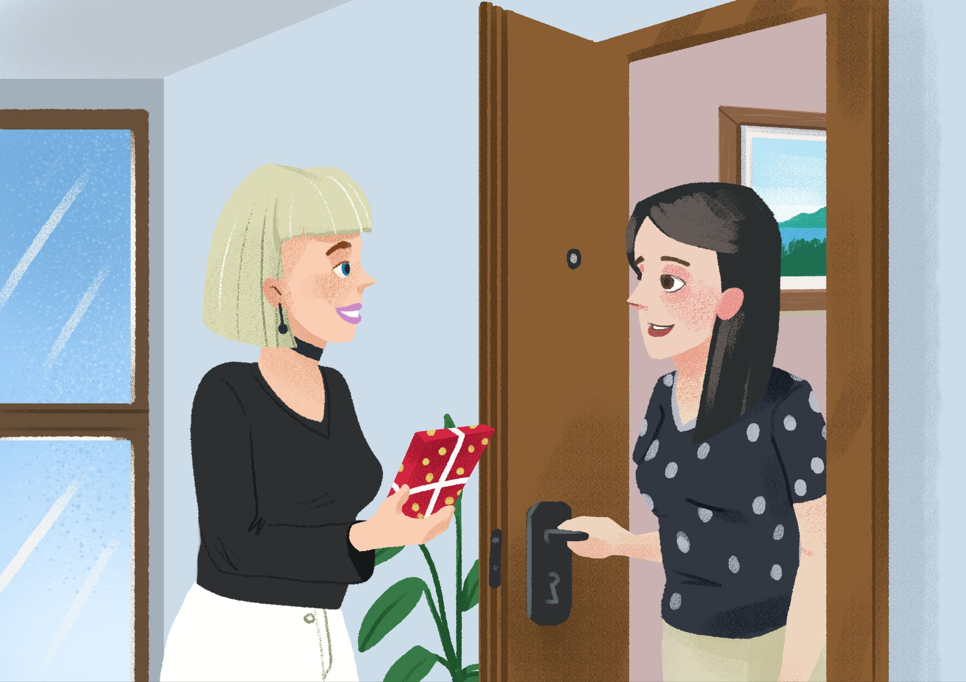

Odgovori na pitanja:
1 | Sandra ima sestru. Kako se zove njezina sestra?
1 | -
2 | Kamo Laura ide?
2 | - na večeru / na ručak / na koncert / na rođendan
3 | Što Laura ima za Katarinu?
3 | -

 |  |  | 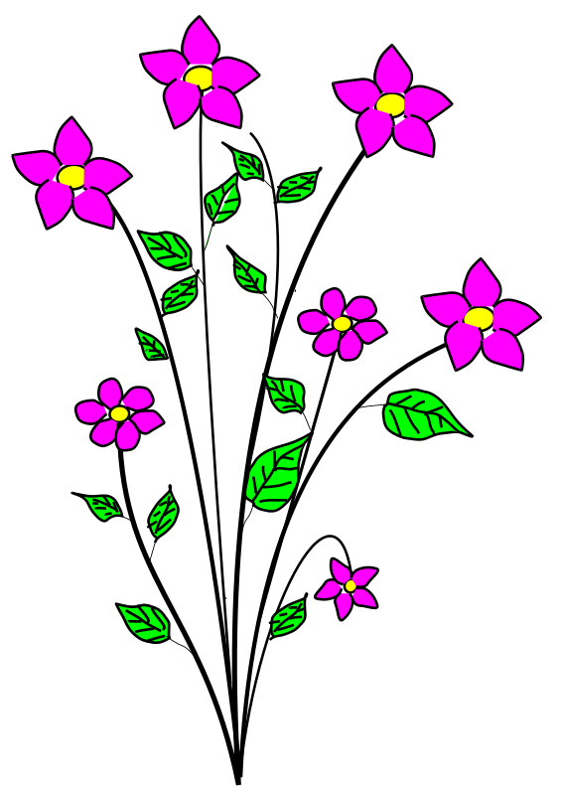

🔊 While you listen to dialogue two, look at Sandra’s family tree and complete the missing information. When you are done, talk with your classmate and take turns asking each other the question listed below. An example is provided for you. Not all names in Sandra’s family tree will be covered at this point. You can also download a fillable PDF.
(audio)
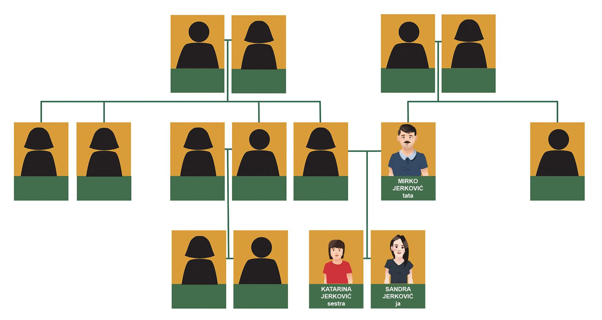
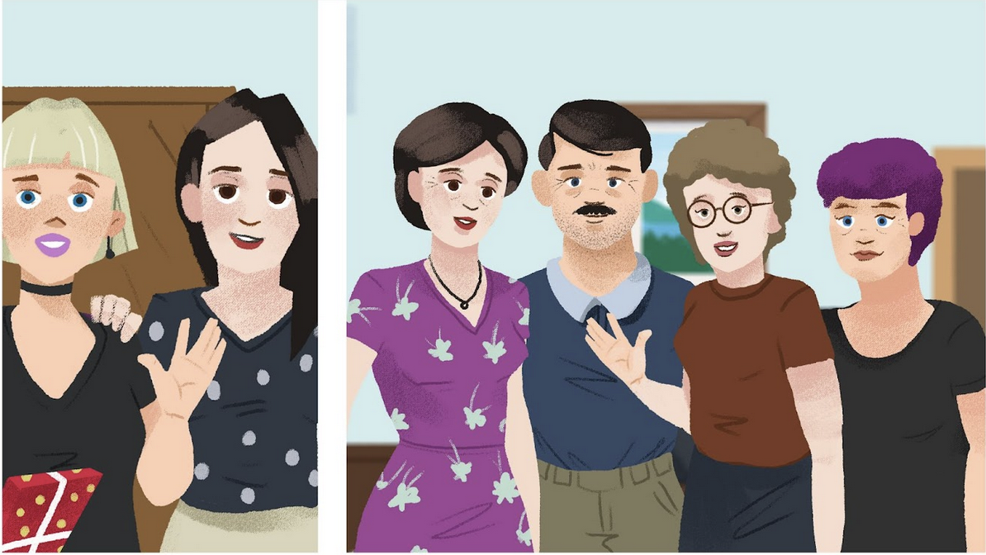

Koga ima Sandra?
Sandra ima | sestru | ona se zove | Katarina
Sandra ima | mamu | ona se zove
Sandra ima | tetu | ona se zove
Sandra ima | tetu | ona se zove
Sandra ima | ujnu | ona se zove
Sandra ima | sestričnu | ona se zove
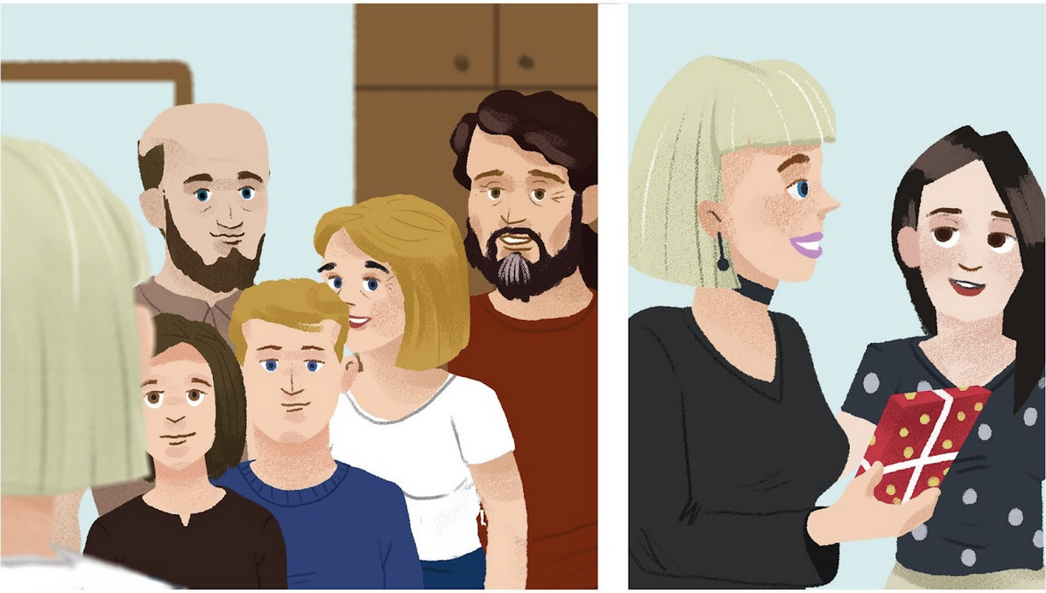
Sandra ima | tatu | on se zove
Sandra ima | ujaka | on se zove
Sandra ima | rođaka | on se zove
Sandra ima | bratića | on se zove

3.1 Zadatak 7. Obitelj Pavić
🔊 Listen to the family description below and label each person. Listen to their names and any other information that you find out about them. Write your information in the target language.
(audio)
obitelj | Tko su oni?
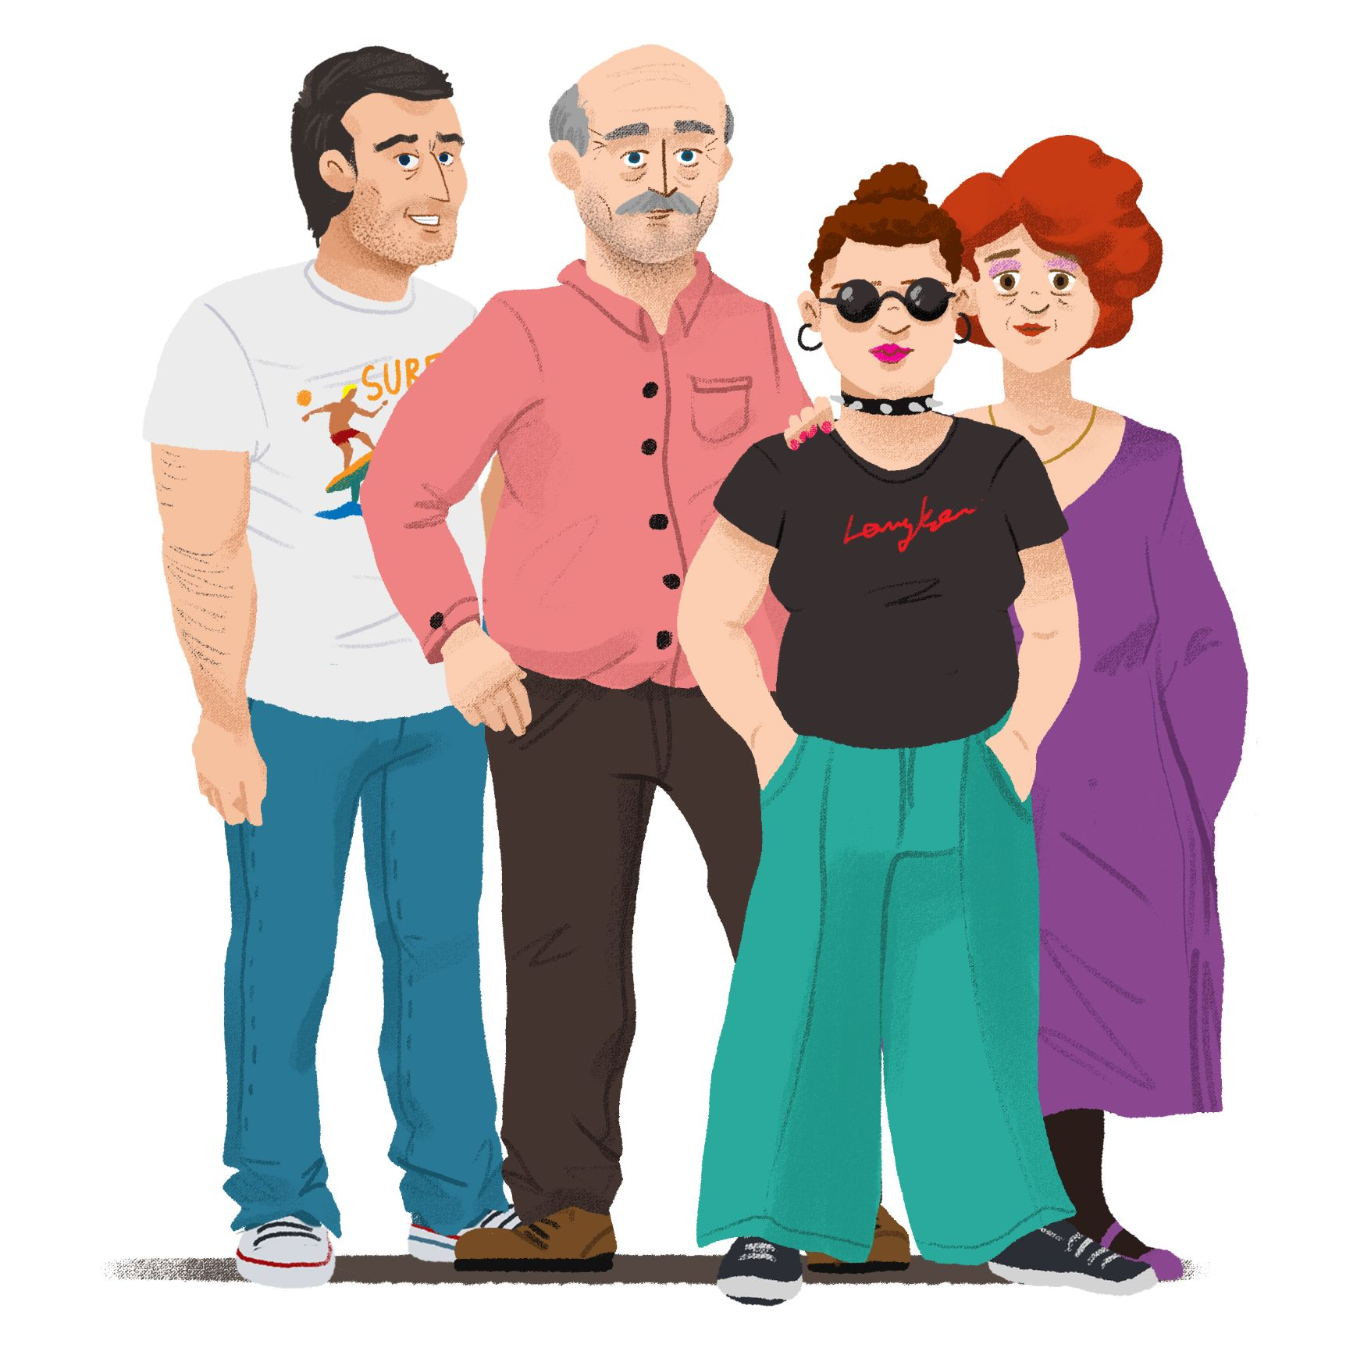 | ↦

3.1 Zadatak 8. Ivan i njegova obitelj

Part 1: Create a family tree.
🔊 Listen to the story below. Make Ivan Jukić’s family tree and indicate the name of each person and family relation from Ivan’s perspective. All information needs to be in the Nominative (dictionary) form. Be careful, while you listen to the text, personal names may appear in the Accusative form. You will need to listen to the story a few times. You can create a family tree directly in this document or separately on a piece of paper. If you create a family tree on a piece of paper, upload the image below.
(audio)

Ovo je njegova uža i šira obitelj:
Family tree

3.1 Zadatak 9. Članovi obitelji
Use Ivan Jukić’s family tree from the previous assignment as a guide to fill in the blanks with the appropriate family relationships and/or names. Be careful, you will need to use the Nominative and/or Accusative case. Pay attention to how the sentence is formed.

Ja sam Ivan. Ovo je moja uža i šira obitelj. Ja imam mamu, ona se zove _____________ . Ja također imam i _____________ Nevena. Moja _____________ se zove Darija, a moja starija _____________ se zovu _____________ i Josip. Ja imam i _____________ on je ekonomist. A njegova žena, moja _____________, zove se Jadranka. Jadranka i Stjepan imaju _____________ zovu se _____________ i Tino. To su moji _____________. A ovo je moja _____________ ona se zove Antonela. Moj tata ima _____________ Lidiju, to je moja _____________. On također ima i _____________ Ivu. Lidija nema muža, ali ima _____________. On se zove Stipe. To je moj _____________ . Moj _____________ Ivo ima _____________, ona se zove Irena. Ona je moja _____________ . Njihova kći Laura je moja _____________.

3.1 Zadatak 10. Tvoja obitelji
👥 Rad u paru. For this assignment, you will need to share a picture of your family with your classmate. If you do not feel comfortable sharing a picture of your family, find an appropriate picture online.
 | 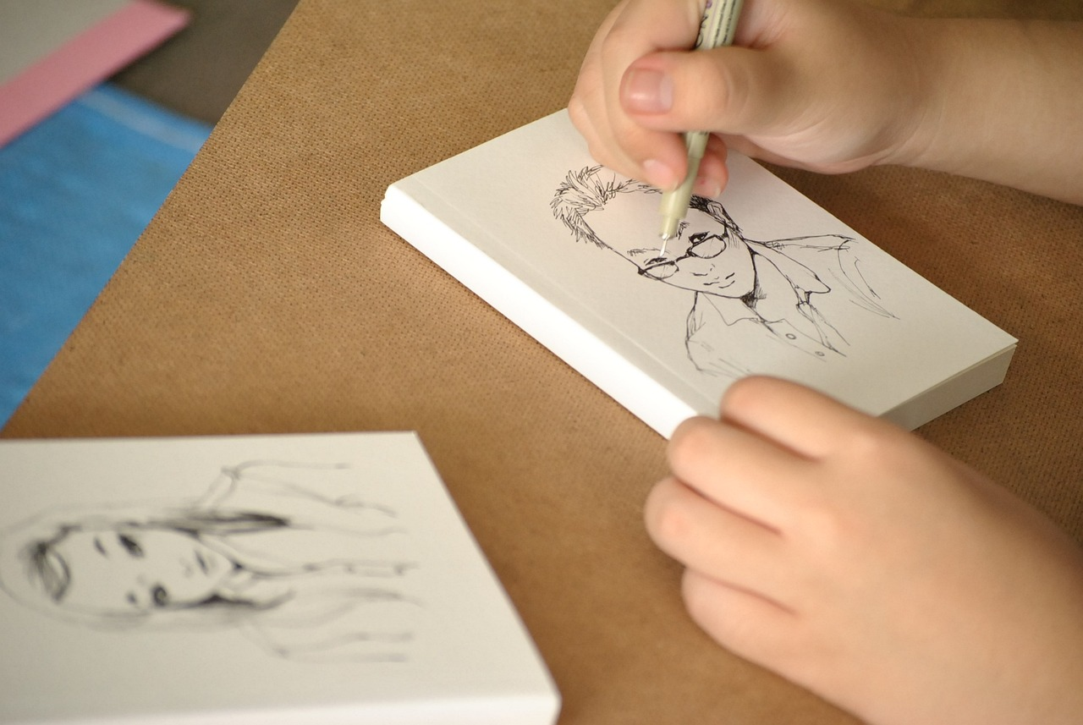
You will need to share a picture with your classmate who will ask you to say more about each family member. Be sure to include: their name, profession, relation to you, some personality traits, activities that they like to do. Also comment on whether you like to do the same things as your family members. Include comments on your classmate’s family members. Submit your video recording.

Images used in this document are from these sources.

