7 | 1 | Lekcija 3: Ljetni odmor

7.1 Zadatak 10. S kim na ljetovanje?
 |  | 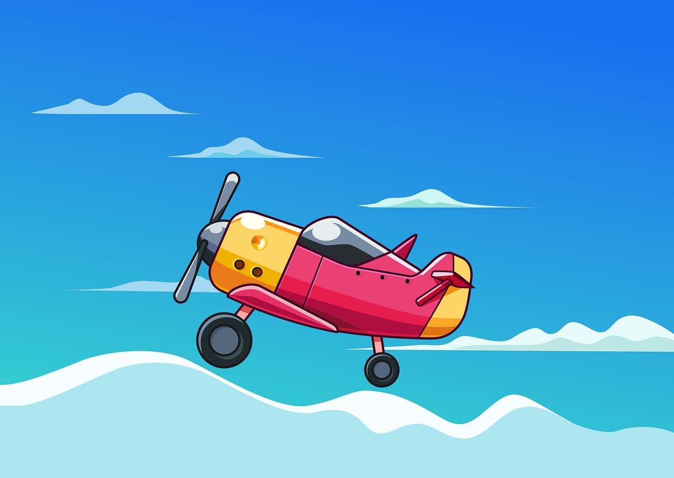 |  | 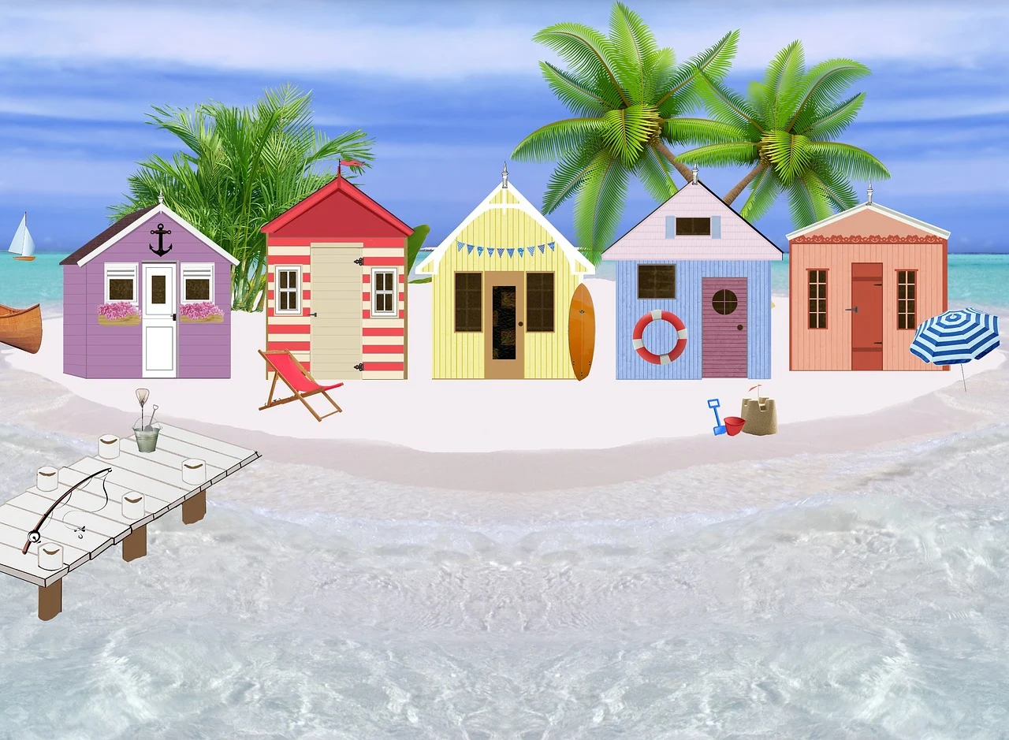
You already have your summer plans and you know where you want to go. However, you still don’t know who to go with. Maybe one of your classmates would be a good choice? Come up with a set of questions and interview two other classmates. Follow the example from our class session - you cannot use the questions from class. Add more rows if needed, but 10 questions is the minimum.
 |  | OSOBA 1 |  |  | OSOBA 2
 | Pitanje | DA | NE |  | DA | NE
1
2
3
4
5
6
7
8
9
10

When you have answers from two of your classmates, do a write-up and tell us who would be good company to travel with. Why?
| S kim želiš putovati i zašto?
→

7.1 Zadatak 11. S kim?
 | 
Video recording. Based on the previous task, meet with some other student that you did not interview. Present your findings and ask your classmate for their opinion. When giving your options for summer vacation, express your doubts about who to travel with and ask for suggestions. When your classmate offers their opinion, be sure to comment and express your final decision. Be sure to provide the reason for your final choice.
Submit your video online.

7.1 Zadatak 12. Moje mišljenje

Part 1
Read each statement in column (a). Then, connect it with its logical continuation in column (b).
 | (a) |  | (b)
a | S roditeljima je uvijek dosadno. | 1 | S njim ne mogu ići na plažu.
b | S prijateljicom je uvijek zanimljivo. | 2 | S njima se mogu zabavljati i ići na koncerte.
c | S bratom nije dobro ljetovati. | 3 | S njom nije dobro, ona je uvijek na laptopu.
d | S prijateljicama je dinamično. | 4 | S njima može biti ili dobro ili loše.
e | S bratićem? On je jako veseo. | 5 | S njima nije zanimljivo putovati.
f | S kolegicom je monotono. | 6 | S njom igram sportove i planinarim.
g | S prijateljima? Ne znam… | 7 | S njim je uvijek zabavno.
h | Sa sestričnom je uvijek aktivno. | 8 | S njom je odlično putovati, s njom idem na večeru, u klubove i na plažu.

a | b | c | d | e | f | g | h

Part 2
Look at column (a) again and the people who are mentioned. Write your personal statements for each person – how your vacation looks like with each of those people. Then provide more information for your statement, just as it was given in column (b) above. One example is written for you.
0 | Sa sestrom je uvijek uzbudljivo.
0 | - S njom je uvijek zanimljivo. Ona je uvijek za akciju i zna kamo ići.
1 | S roditeljima …
1 | -
2 | S prijateljicom …
2 | -
3 | S bratom …
3 | -
4 | S prijateljicama …
4 | -
5 | S bratićem…
5 | -
6 | S kolegicom …
6 | -
7 | Sa prijateljima …
7 | -
8 | Sa sestričnom …
8 | -
Images used in this document are from these sources.

