4 | 2 | Lekcija 1: Kako je bilo?

4.2 Zadatak 1. Gdje su oni bili?
Finish the sentences in the past tense by using the following locations. Be careful, use Locative and pay attention to which words take u or na. Answers may vary; there is more than one possible sentence structure/form.
koncert | kuća | kino | Brač
bar | planina | more | Francuska
fakultet | šuma | jezero | supermarket

Ana i Ines ___________ u ___________ | Marko ___________ na ___________
Tvoja kolegica _________ u _________ | Andrijana ___________ u ___________
Ja ___________ na ___________ | Ivo i Ivan ___________ na ___________
Oni ___________ na ___________ | Ja ___________ u ___________
One ___________ na ___________ | Ti ___________ u ___________

4.2 Zadatak 2. Gdje si bio/bila prošli četvrtak?
Think of your last Thursday. Where were you and why? What did you do there and why?
1 | Gdje si bio/bila? Što si radio/radila i zašto?
1 | -

4.2 Zadatak 3. Obiteljsko putovanje
🔊 Listen to the text about Tom and answer the questions in English.

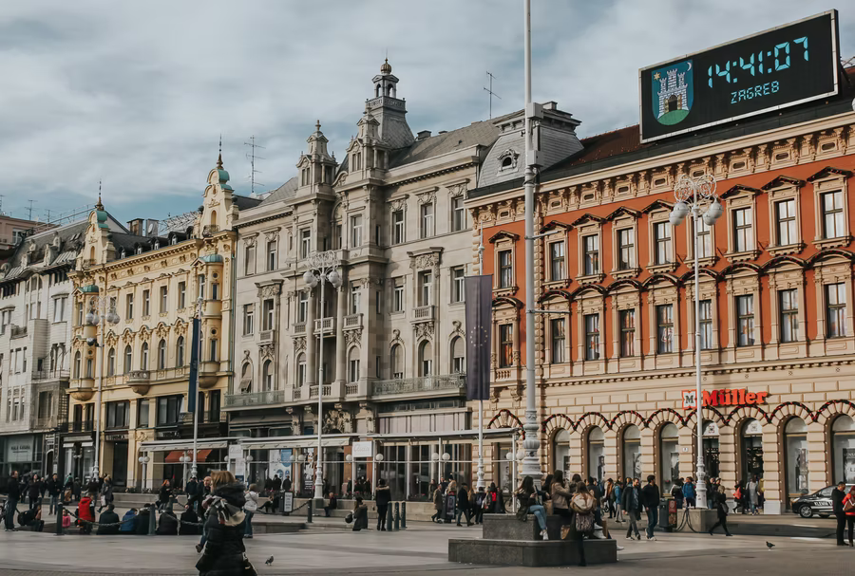 | 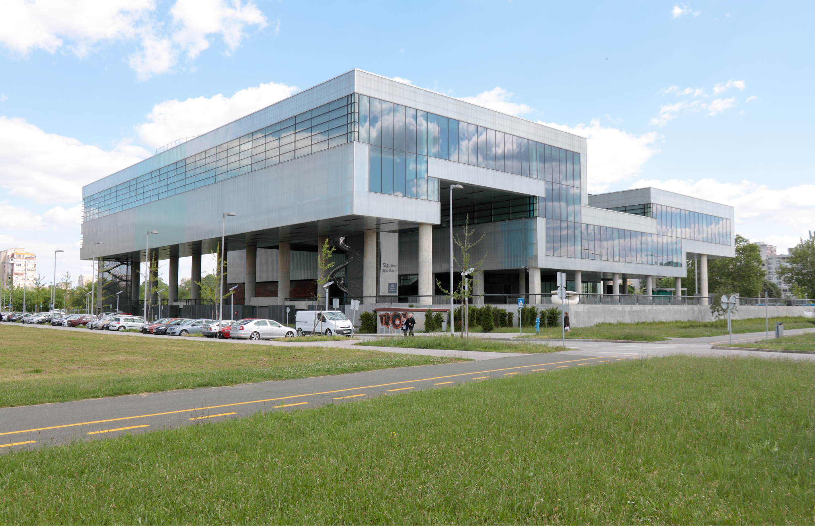
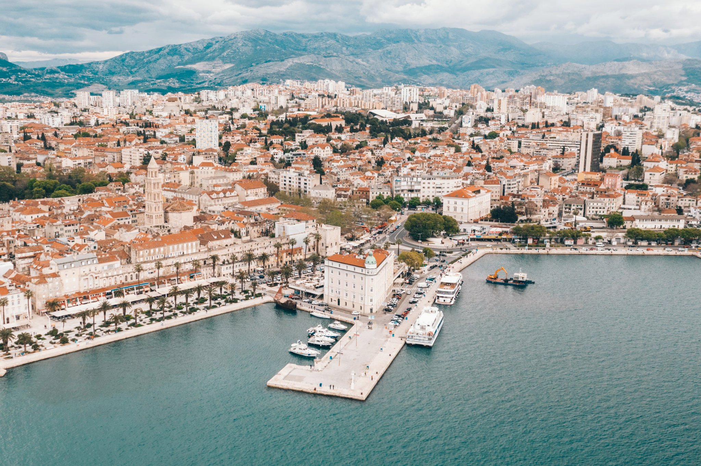 | 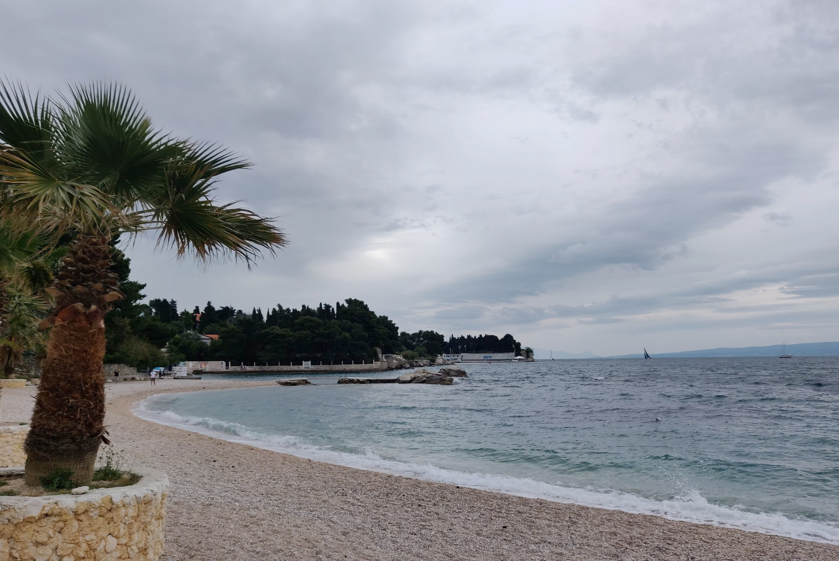
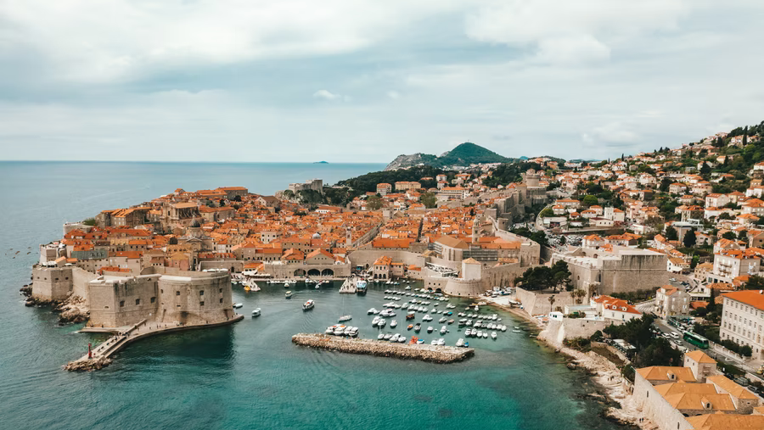 | 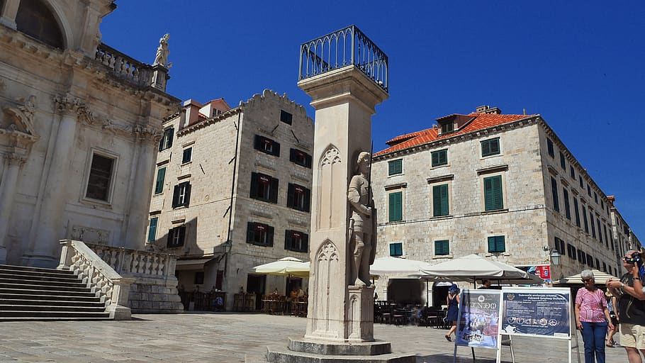

(audio)
1 | What is his favorite destination?
1 | -
2 | When did he visit, what is his favorite location?
2 | -
3 | Who was with him?
3 | -
4 | What cities did they visit?
4 | -
5 | What did they usually do during the day?
5 | -
6 | What did they usually do during the afternoon while it was hot?
6 | -
7 | What is his favorite place? Where is it located?
7 | -
8 | What did they usually do in the evening?
8 | -
9 | Did he like the food?
9 | -
10 | What type of food does he like?
10 | -
11 | What do we know about his siblings?
11 | -
12 | Did he go out with his siblings? Why?
12 | -
13 | What did his parents usually do in the evening? Who was with them?
13 | -

4.2 Zadatak 4. Tvoje omiljeno putovanje
Follow the example from the previous task and complete the assignment. Use the verbs that we covered in class as well. Choose one country/city that you already visited. Tell us about at least three different locations that you visited there. What did you do there? Who was with you (use the structure “moja mama i ja” when saying who was with you)?
 | 

[odgovor]
→

4.2 Zadatak 5. Tvoj prošli tjedan
Pair-work. Come up with at least 10 questions that you would like to ask your classmate about his/her last week. Talk with your classmate in order to collect answers. When you have all the answers, write a story about his/her last week.

Na primjer: Jesi li igrao/igrala košarku prošli tjedan?
Together with your writing, submit your recording with your classmate.

4.2 Zadatak 6. Omiljeno putovanje
Video recording. Make a dialogue with your classmate. Ask your classmate about his/her favorite trip in the past. Discuss what you did on your trip and provide your opinion about the time you spent in that location. Who was with you and what did you do there? During your presentation, your classmate will ask you to provide additional information about things you mentioned about your trip. You need to ask each other at least five questions. You can use the assignment from our class session since you already worked on a written format. However, try not to look at your writing while talking with your classmate.

4.2 Zadatak 7. Jučerašnji izlazak

| In English
Listen to the dialogue from our class session one more time. Pay attention to the first part of the dialogue – the part between Ines and Matija.
(audio)

| Talking about people
What do you think is the gist of the story? How did you interpret their conversation? What do you think happened in the past between Ines, Matija, and Marina? What do you think of Marina? What do you think Ines thinks about Marina? Justify your answer with an example from the dialogue.
1 | What does the phrase Pao mi je mrak na oči mean?
1 | -

| The evening out
Where was Ines last night? What do you think of both places? Are there similar places (the concept of places) in your city as well? Here are the links that you should investigate before answer the questions:
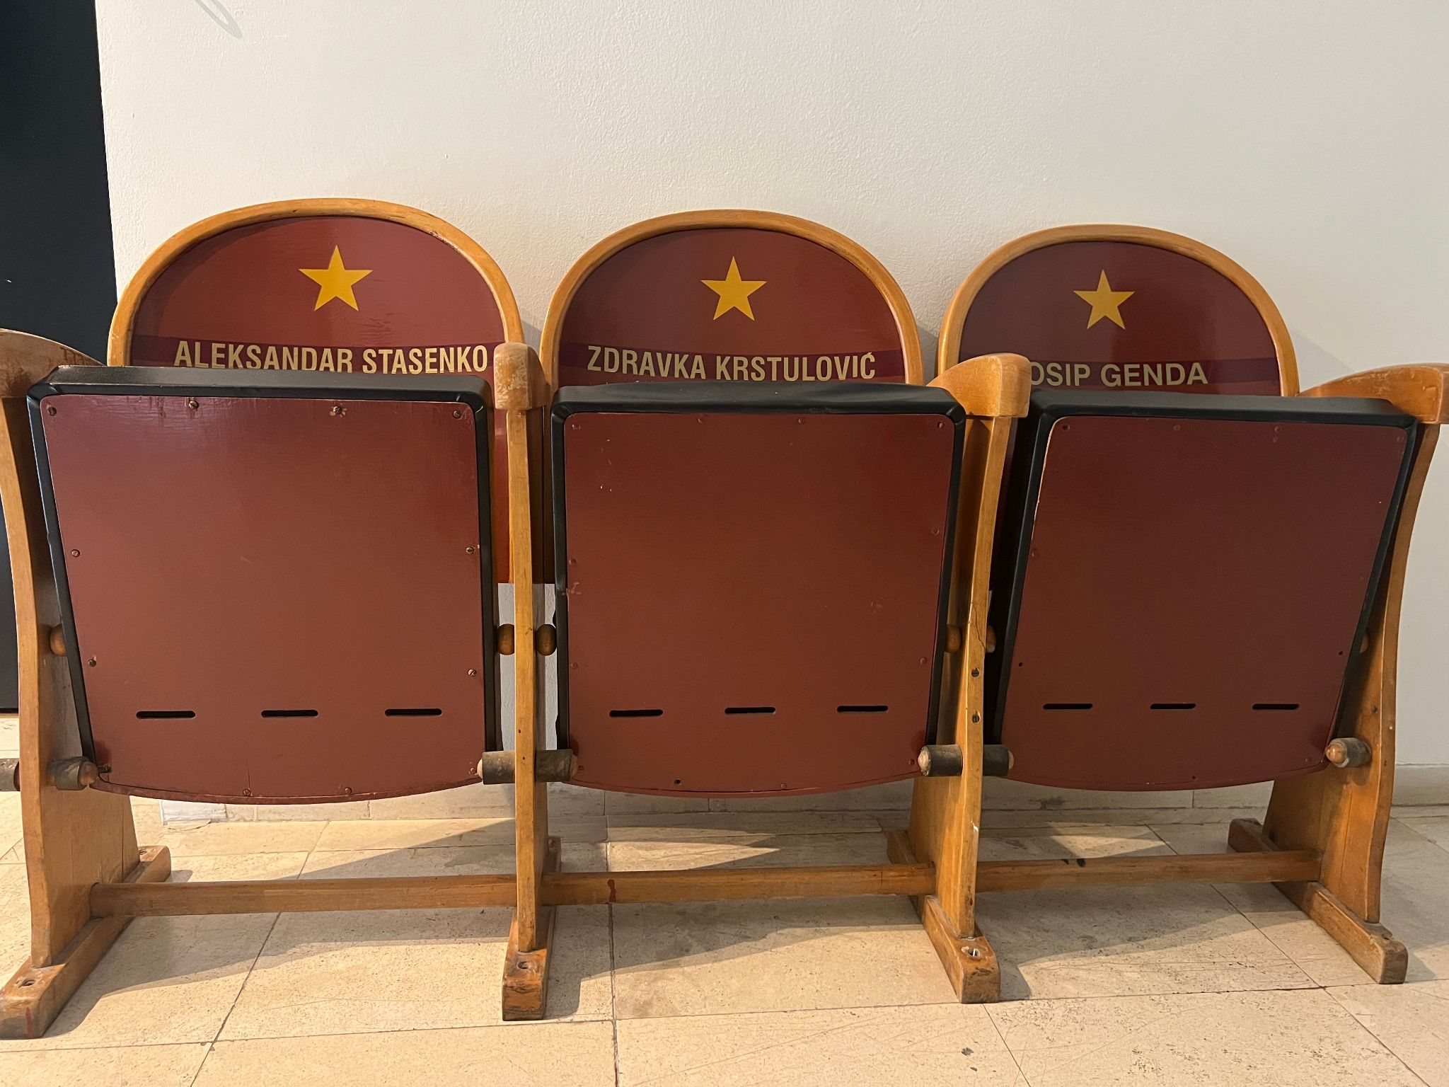 | 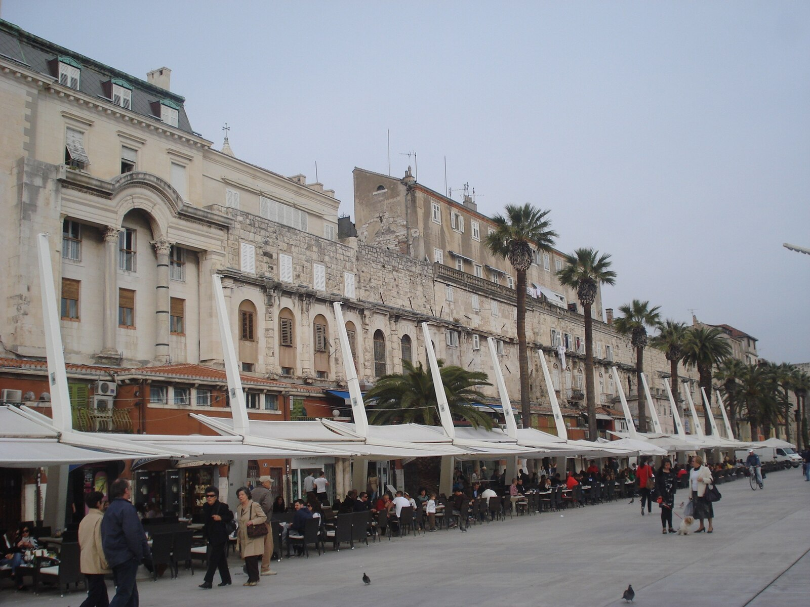
Kinoteka Zlatna vrata | Restoran Kinoteka

Odgovor:

Images used in this document are from these sources.

