3.2 - the verb jíst - to eat

Since we’re learning about food, we need to learn the verb jíst - to eat. This is obviously an important verb, and just like all the important things you have to learn, it’s a tiny bit irregular.

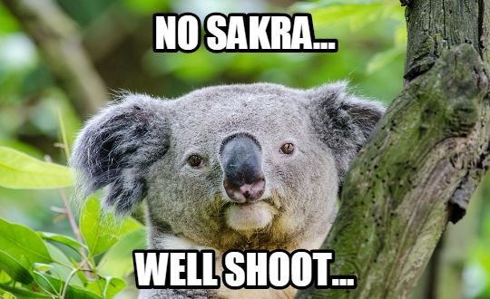

Here it is. As you can see, for the most part it looks like an -í- verb:

jíst - to eat
(já) | jím ‘I eat, am eating’ | (my) | jíme ‘we eat, are eating’
(ty) | jíš ‘you eat, are eating’ | (vy) | jíte ‘you eat, are eating’
(on/ona/ono) | jí ‘he/she eats, is eating’ | (oni/ony/ona) | jedí ‘they eat, are eating’

However, the 3rd-person plural form is jedí. While this may be hard to remember at first, my favorite way to remember this irregular form is of course the fact that it looks like the word Jedi, you know....

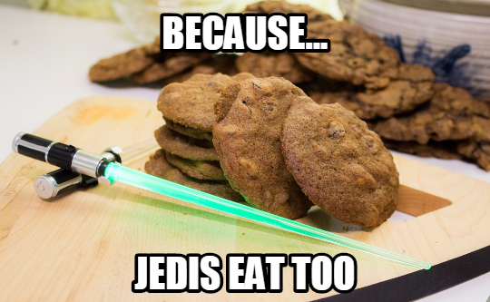
Yes, I just made that stupid joke. We’ll all live…

Using the verb jíst
When people eat something, the people (I, you, he, she, Karel, Pavel, students, etc.) are the subject. The thing they are eating is the direct object.

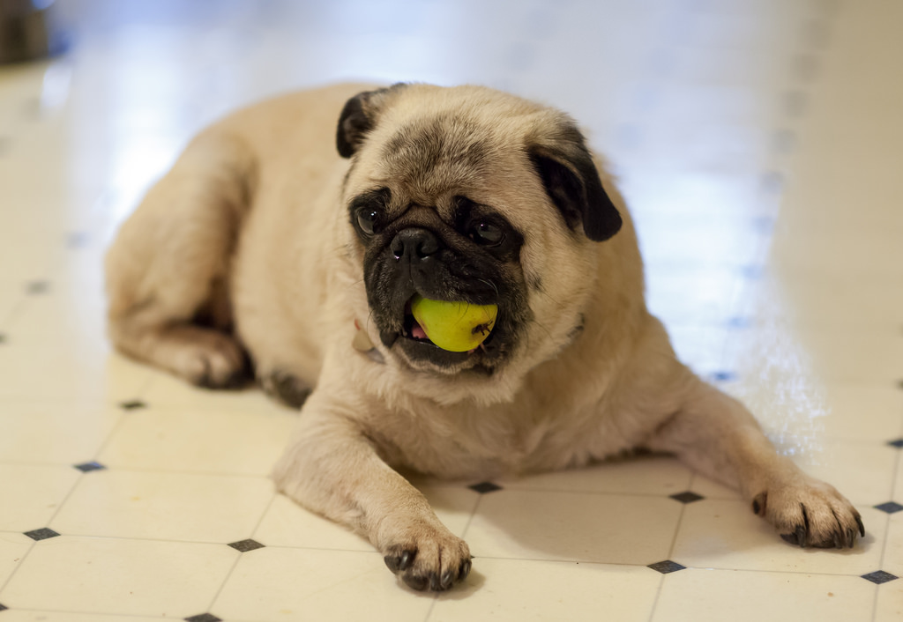 |  | 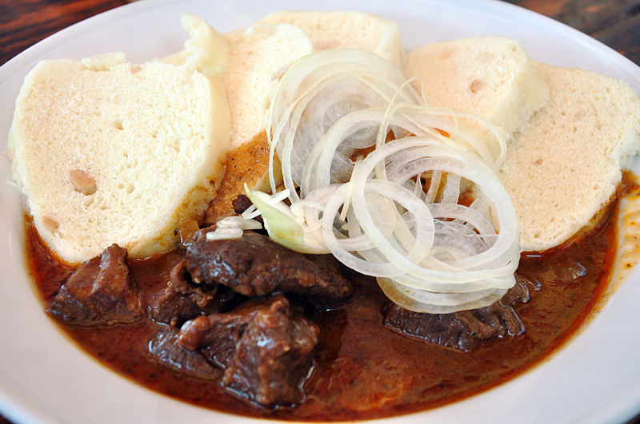
Pes jí hrušku.  The dog is eating a pear. | Lucka jí čokoládu.  Lucka is eating chocolate | Často jíme guláš.  We often eat goulash.

Each of these is using the accusative ending for the direct object (thing being eaten). We will review these endings in the upcoming lessons.

Images used in this document come from these sources.

