4. lekce - Počasí + Vzhled, Tělo, Zdraví / Unit 4 - Weather + Appearance, Body, Health

In this unit we will begin by talking about weather and how to describe the current weather situation.  We will then learn to talk about clothing, from describing what someone has on, talking about clothing wearing habits, a practice talking about buying clothes for yourself and others and our reactions to clothing that we see (like it, dislike it, etc.)  Additionally, we will learn how to describe a person’s appearance more generally by learning terms for body parts, hair and eye color, complexion, etc.  To the right you can download a copy of the activity book which contains exercises and activities to be completed along with each day in the textbook. For more information about using these materials, see Using the Reality Czech Curriculum | 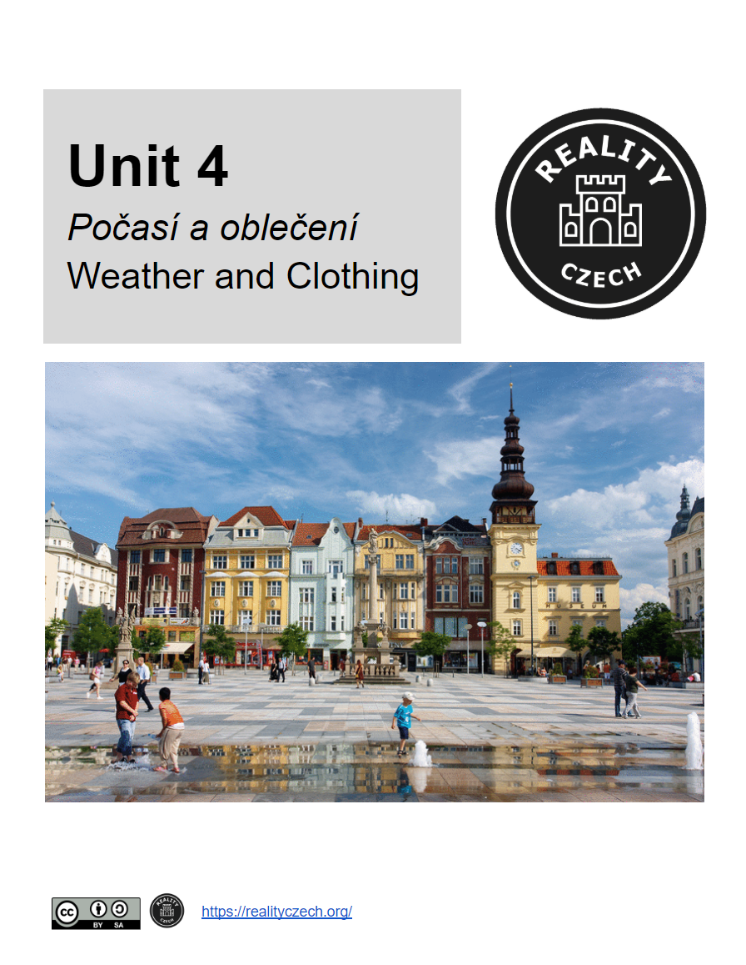  Unit 4 - Classroom Activity Book

Communicative Goals | Grammar | Vocabulary
- talk about the weather  - describe what a person is wearing  - express clothing preferences (i.e. what you like, what you don’t like, etc.)  - learn about buying clothes and the preposition pro + ACC ‘for’ | - dative of nouns and pronouns  - using the dative to express indirect object  - using the dative to express age  - weather adverbs and vocabulary  - using the dative to express physical sensation (je mi zima, je mi horko)  - líbit se | - clothing  - parts of the body  - physical description  - sickness and health  - the verb moct ‘to be able’

