3.7 – More on Ordering Food
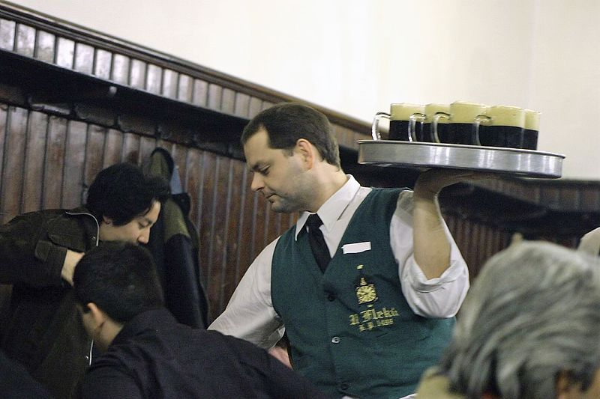
A waiter delivering beers at the bar U Fleků in Prague.

A Czech waiter or waitress will come to you and immediately greet you Dobrý den. In fact, if you pass them walking in they will often do this as well. Czechs are very much into greeting you. They will then ask you what you want to drink and eat. Very frequently, they will start like this:

Máte přání?
lit. Do you have a wish? this basically means - What can I do for you?

If you’ve been looking at the menu, they might ask you:

Máte vybráno?
Have you chosen (something)?

Or they may just ask:

Co si dáte?
What will you have?

Especially in the evening, when people might just be going out for drinks, they might ask you:

Budete jíst?
Will you be eating?

This is in the future tense (which we haven’t learned yet), but it’s a good phrase for you to be aware of for now.

Marking Down Your Order
As you order items, a sheet of paper placed on your table will be used to mark all the items that have been ordered. As you order more things throughout the evening, more marks are added.

The paper below is clearly from a somewhat larger gathering. This paper is then used to calculate the bill. We will talk more about payment in a later unit.
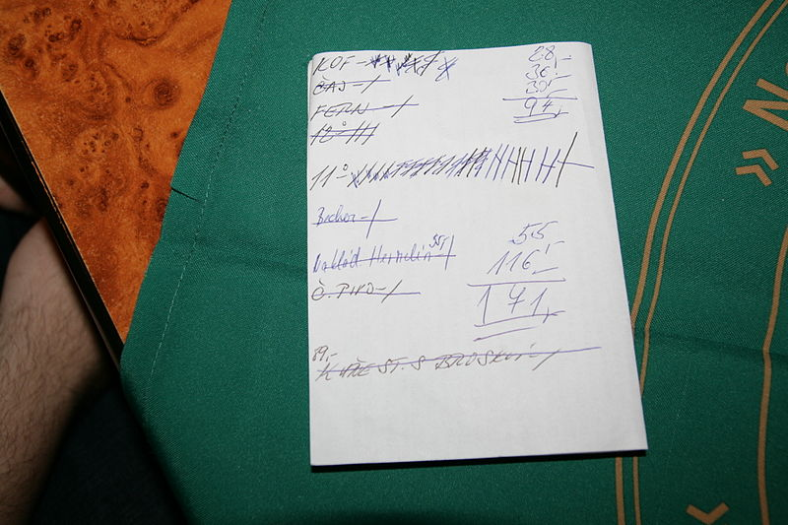

Finally, as they bring you your food, they will always say prosím ‘here you go’. Prosím is what I like to call and aloha word, in the sense that it has a ton of meanings (please, here you go, excuse me, etc.).

Images used in this document come from these sources.

