2.8 - the verb chtít 'to want'

We also need to learn the verb chtít - to want. This is another important verb to learn since you’ll want to talk about what you want.

Of course, it’s a bit irregular…

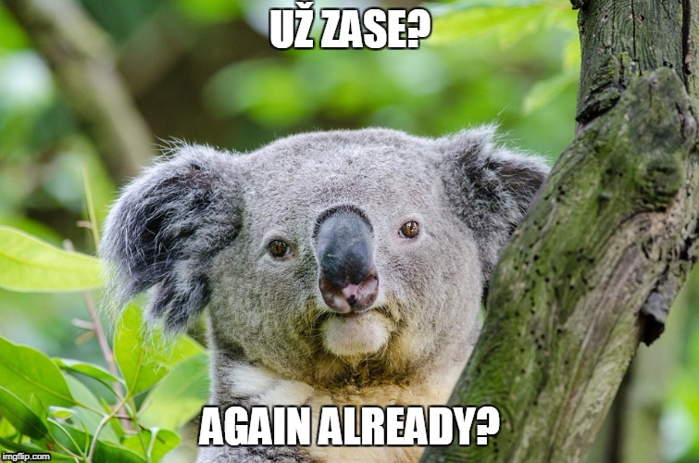

Here it is. As you can see, for the most part it looks like an -e- verb, though with some obvious exceptions (já and oni forms):

chtít to want
(já) | chci ‘I want’ | (my) | chceme ‘we want’
(ty) | chceš ‘you want’ | (vy) | chcete ‘you want’
(on/ona/ono) | chce ‘he/she wants’ | (oni/ony/ona) | chtějí ‘they want’

Now just like with some of the verb mít ‘to have’, it will be followed by the accusative. here are some examples with typical Czech foods/drinks.

Lenka chce guláš.
Lenka wants goulash.

Já chci pivo.
I want beer.

chtít + infinitive


You can also follow the verb chtít with an infinitive. Remember that the infinitive in Czech is the to ________ form, e.g. -

tančit - to dance
cestovat - to travel
plavat - to swim
zpívat - to sing

So you can say:

Martina chce zpívat.
Martina wants to sing.

Chceme běhat.
We want to run.

Images used in this document come from these sources.

