10.7 - Instrumental of Personal Pronouns

Below are the instrumental forms of personal pronouns:

já | mnou | my | námi / náma (coll.)
ty | tebou | vy | vámi / váma (coll.)
on | ním | oni (ony, ona) | nimi / nima (coll.)
ona | ní | oni (ony, ona) | nimi / nima (coll.)
ono | ním | oni (ony, ona) | nimi / nima (coll.)

In a few instances, there are colloquial varieties available. The colloquial varieties (náma, váma, nima) are very common in speech and should be used when speaking. The other forms (námi, vámi, nimi) are mostly found in writing.

Examples:

Šárka jede na dovolenou se mnou.
Šárka is going on vacation with me.

Pavel jde do hospody s námi / náma.
Pavel is going to the pub with us.

Nechci pracovat s ním.
I don’t want to work with him.

Reflexive Pronoun

Finally, there is a reflexive version of the reflexive pronoun (just like we have se and si). Remember, with reflexive pronouns you always have to look back to the subject of the sentence to know what they mean (i.e. myself, yourself, etc.).

reflexive | sebou

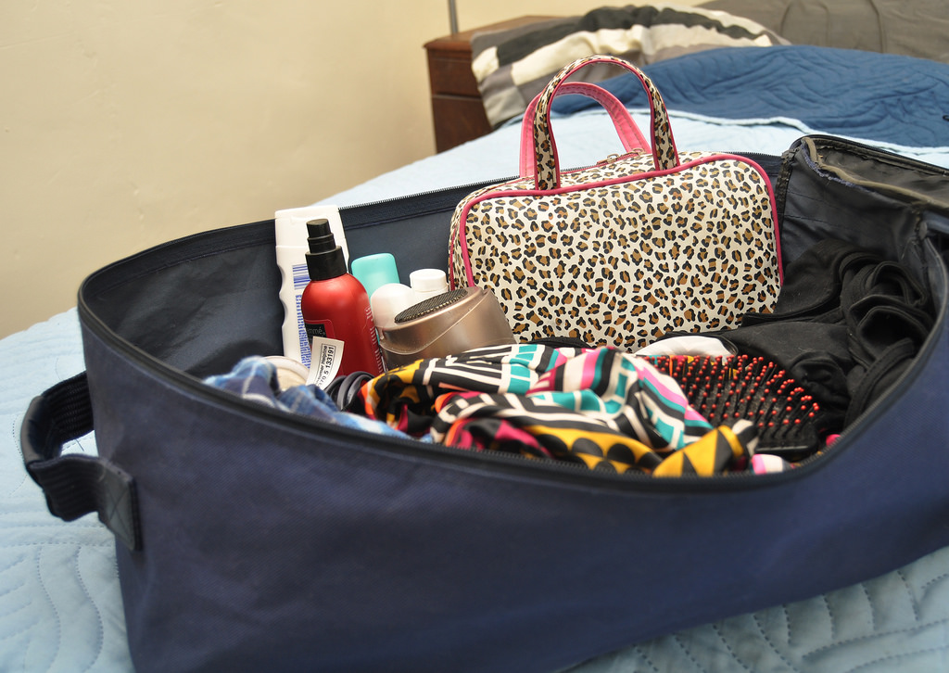 | 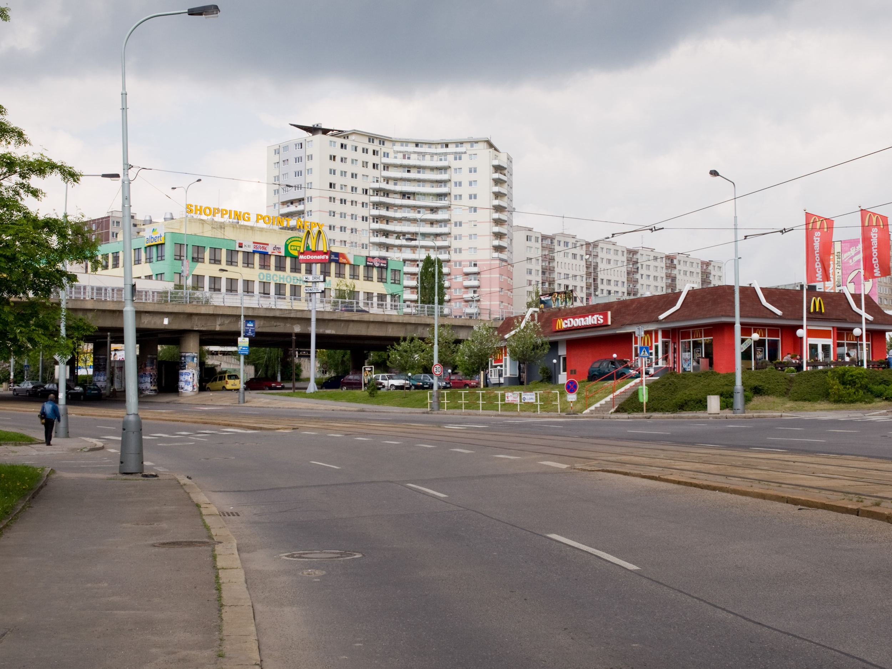
Co si vezmeš s sebou na dovolenou?  What are you going to take with yourself on vacation? | Chceš to tady nebo s sebou?  Do you want it for here or to go (lit. Do you want it here or with yourself)?

Images used in this document come from these sources.

note that the s followed by sebou blend together and often people incorrectly write it as just sebou, when they mean s sebou.

