4 | 1 | Lekcija 3: Kupnja u IKEA-i

| Bijela boja [White color]
Look at the following expressions that include the adjective “white” and consider what each one means.
 | 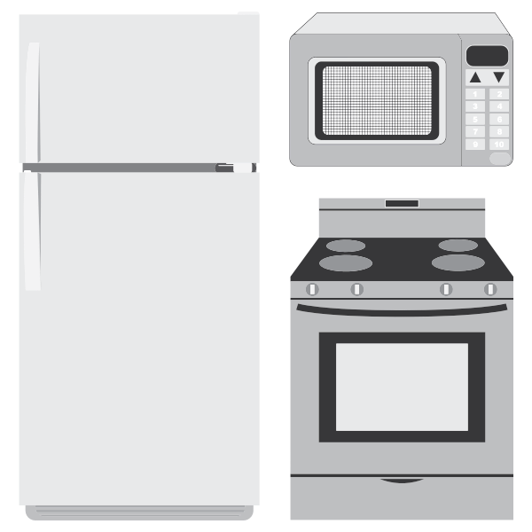 | 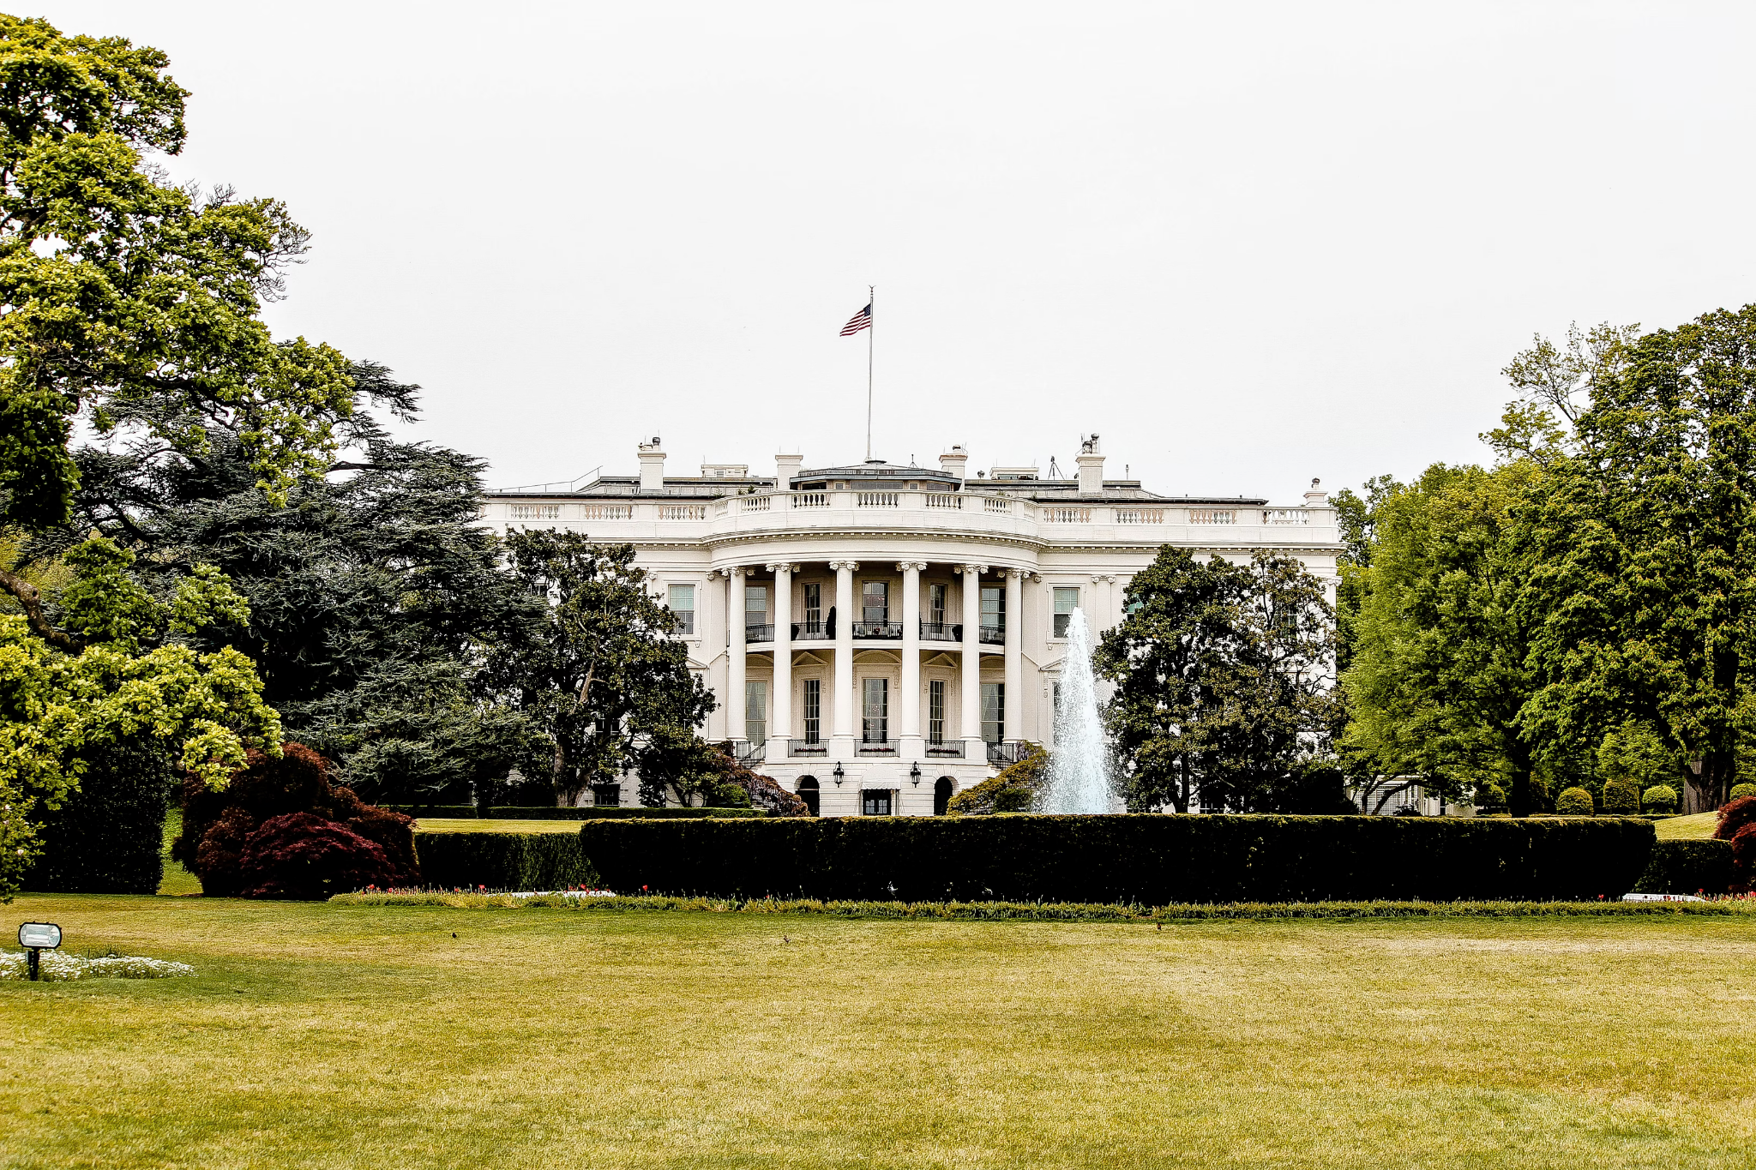
bijela zastava | bijela tehnika | bijela kuća
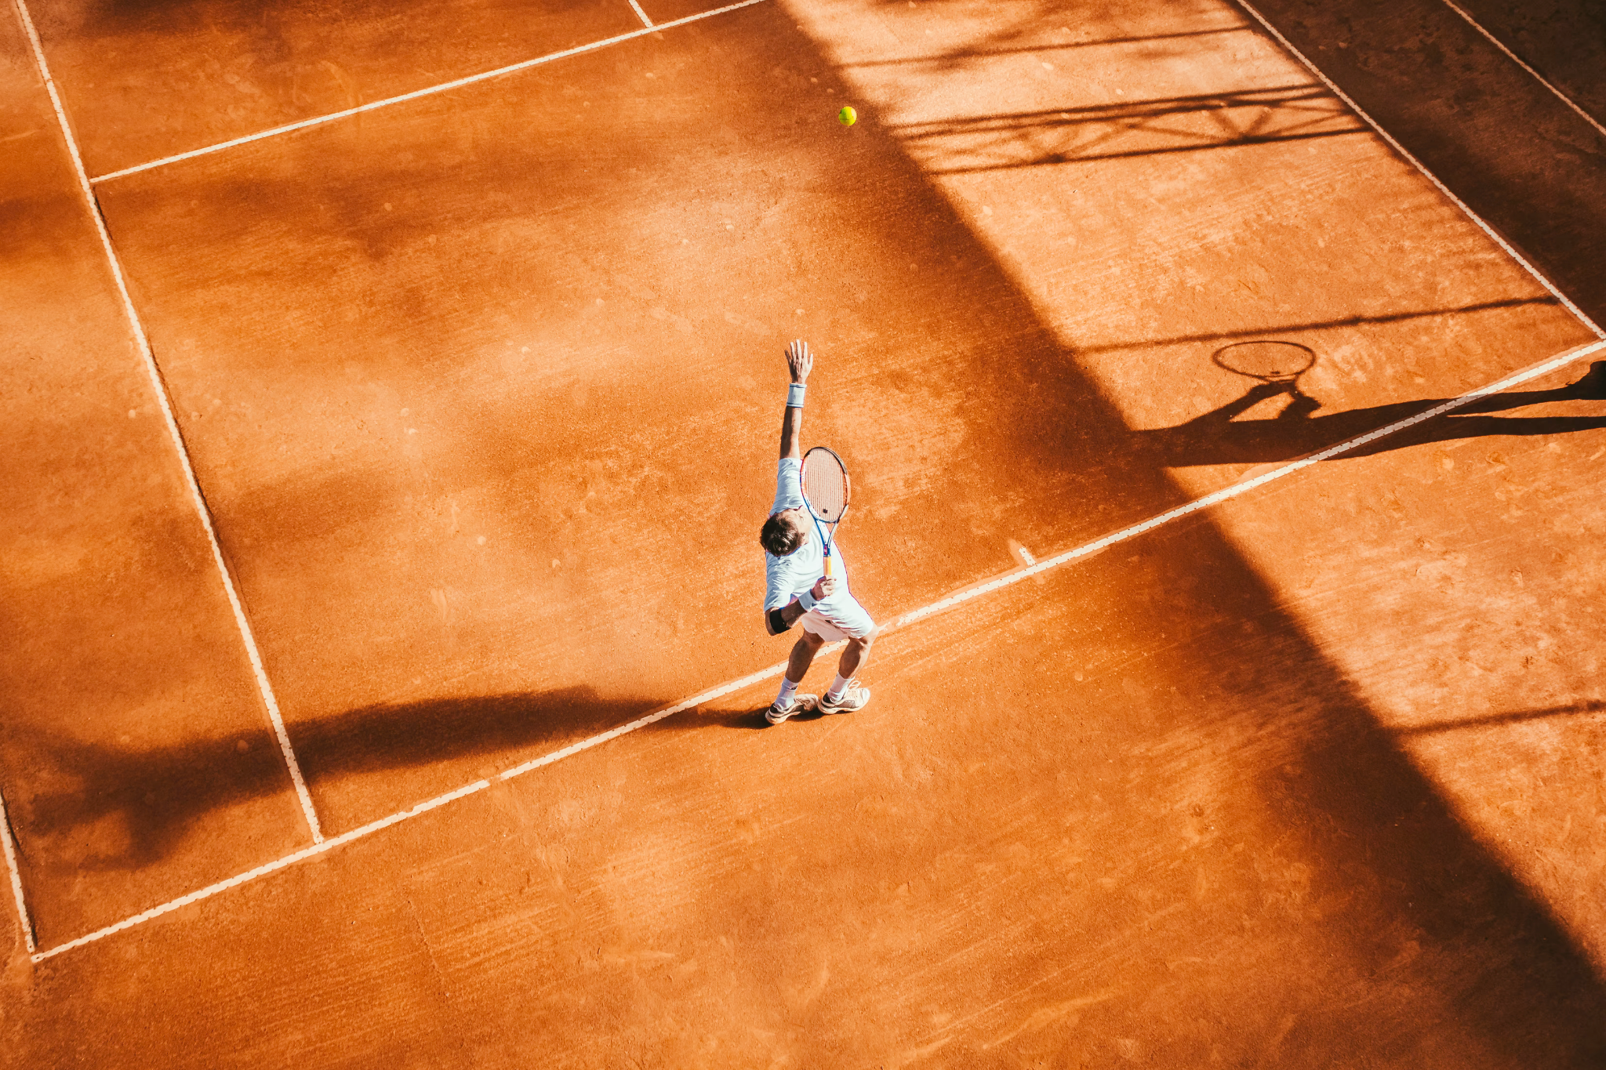 | 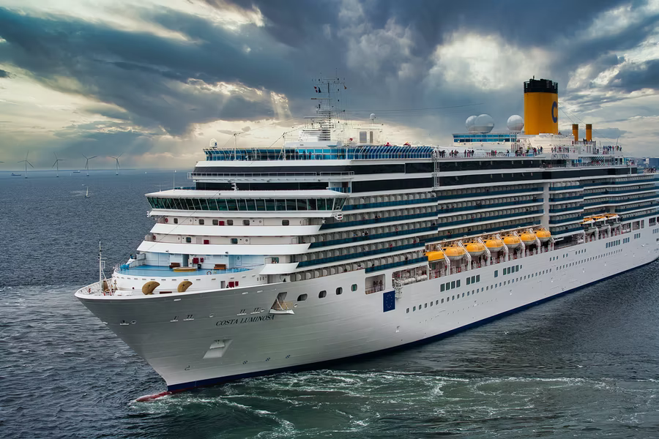 | 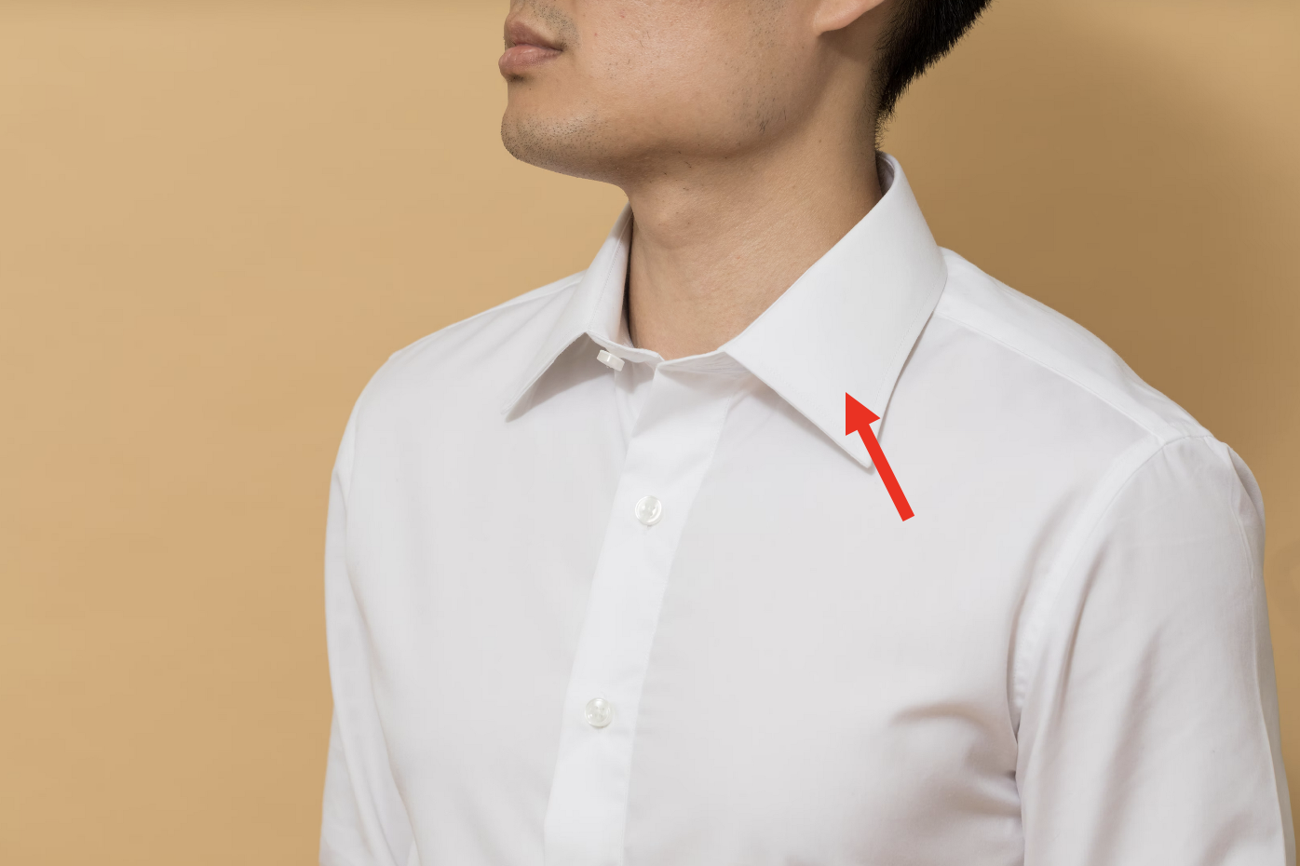
bijeli sport | bijeli brod | bijeli ovratnik
[h5p id="616"]

| Vanjski namještaj
Things that we can usually find on the balcony/patio:

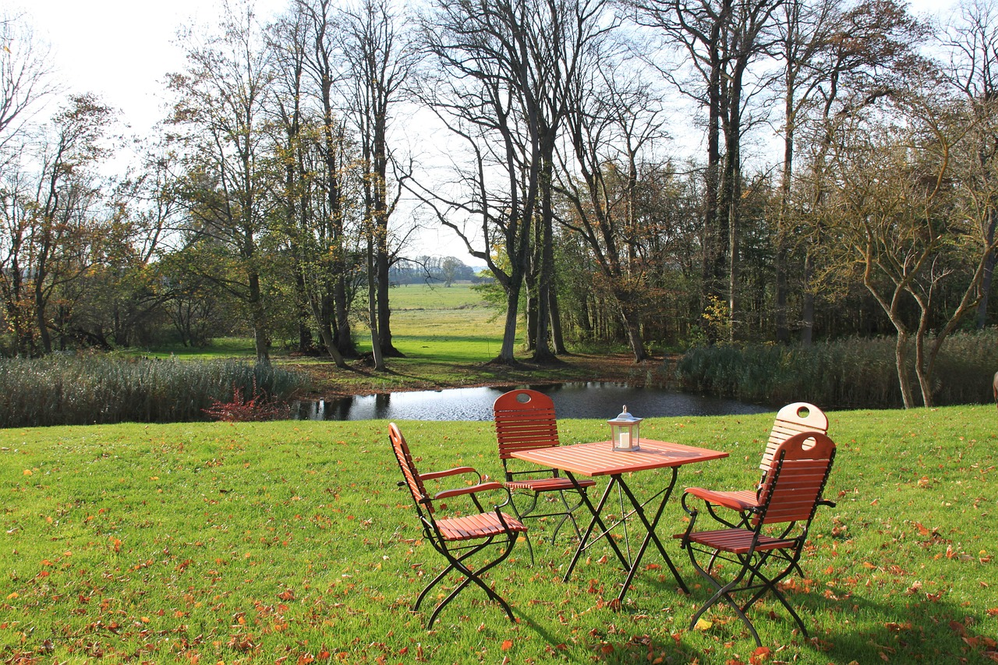 | 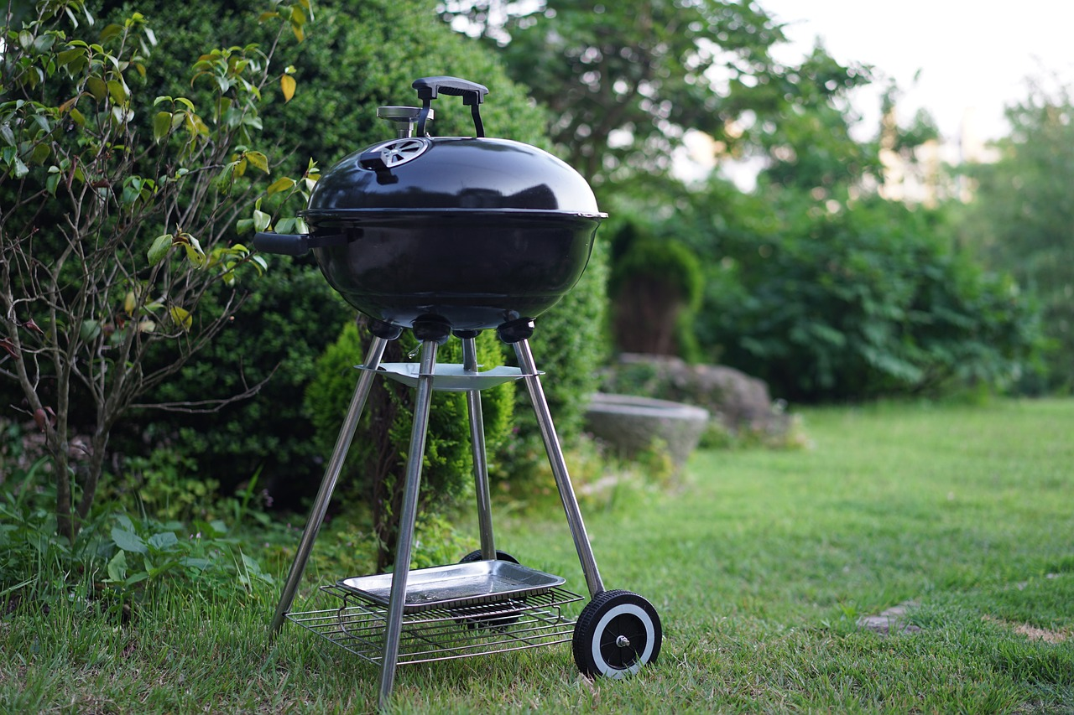 | 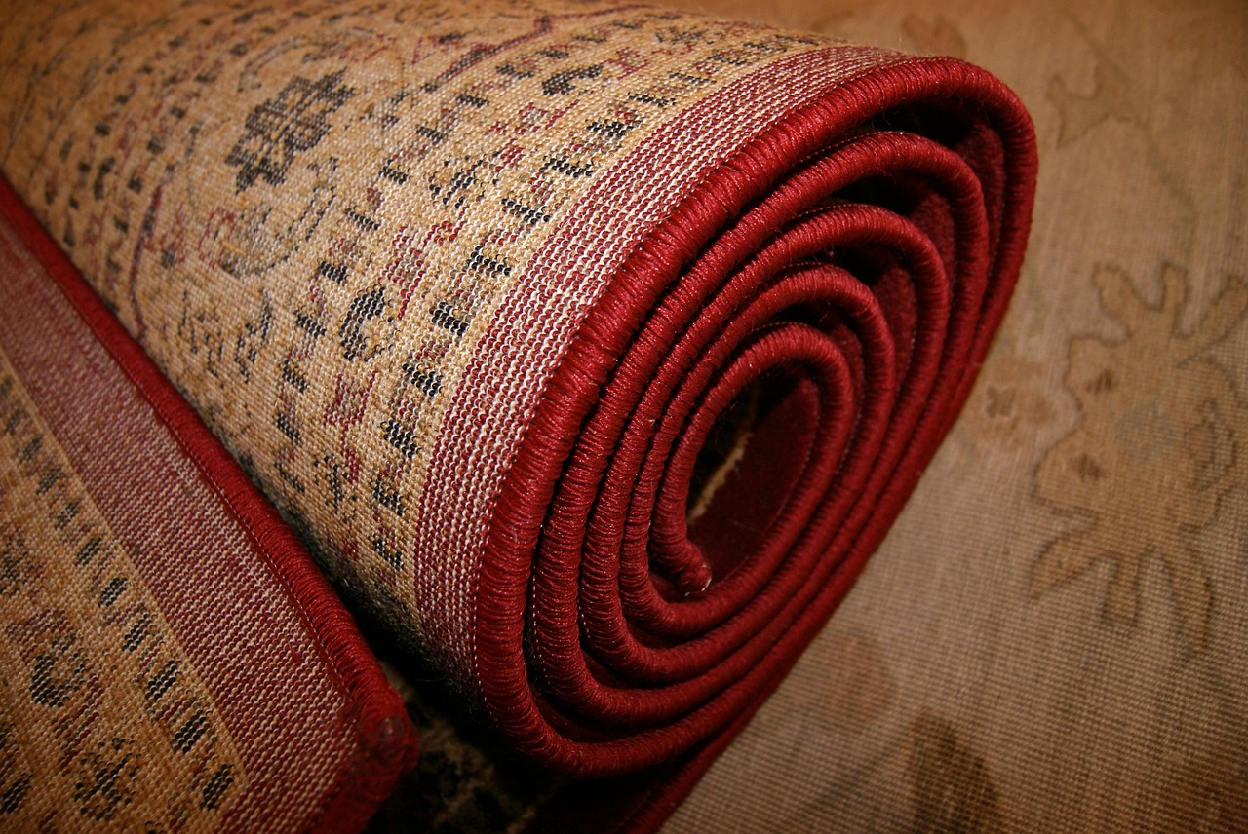
stol i stolice  (vanjski namještaj) | roštilj | tepih
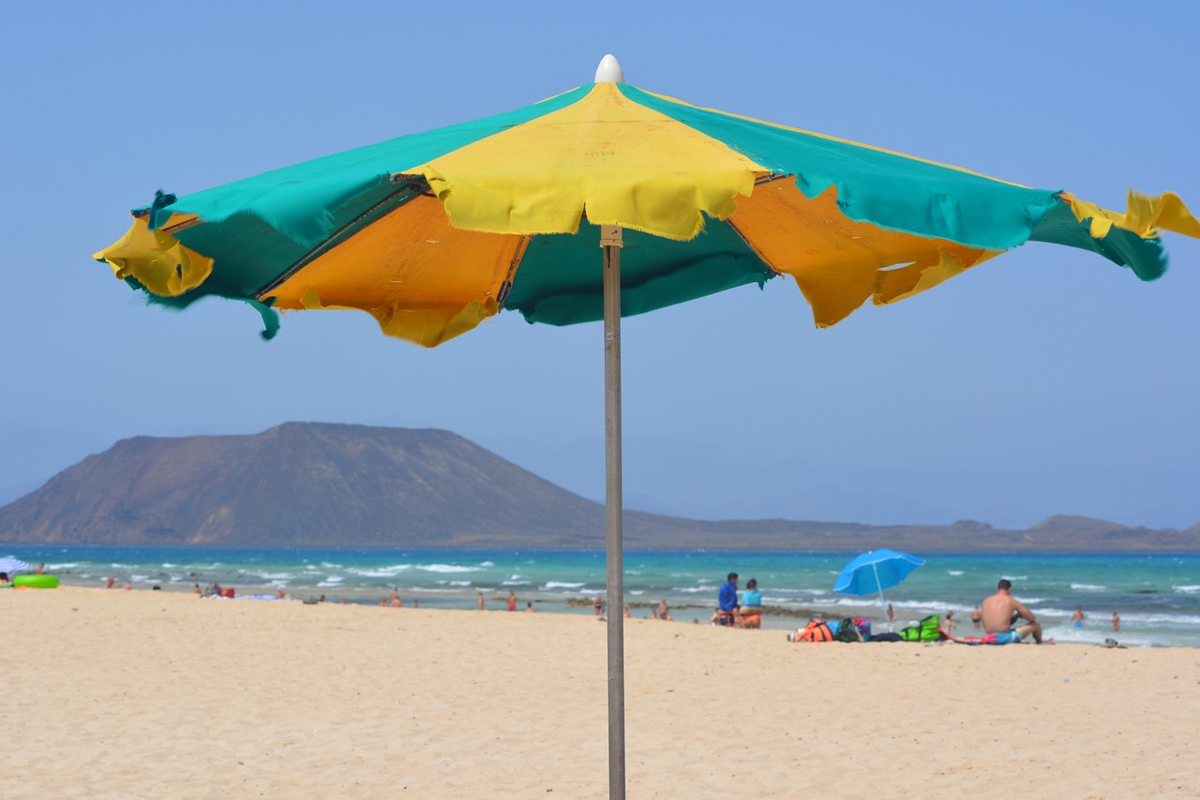 | 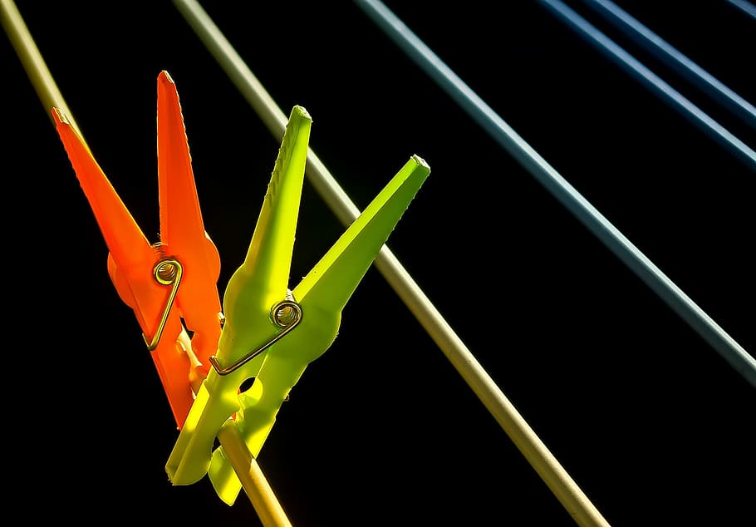 | 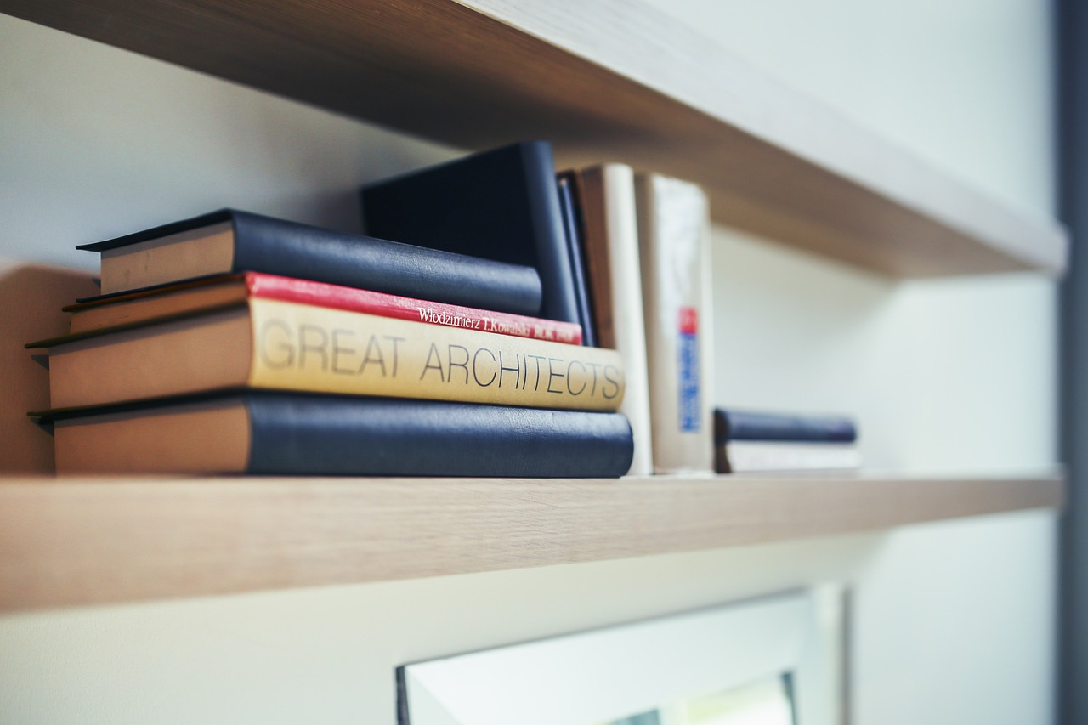
suncobran | rešetke za sušenje | polica
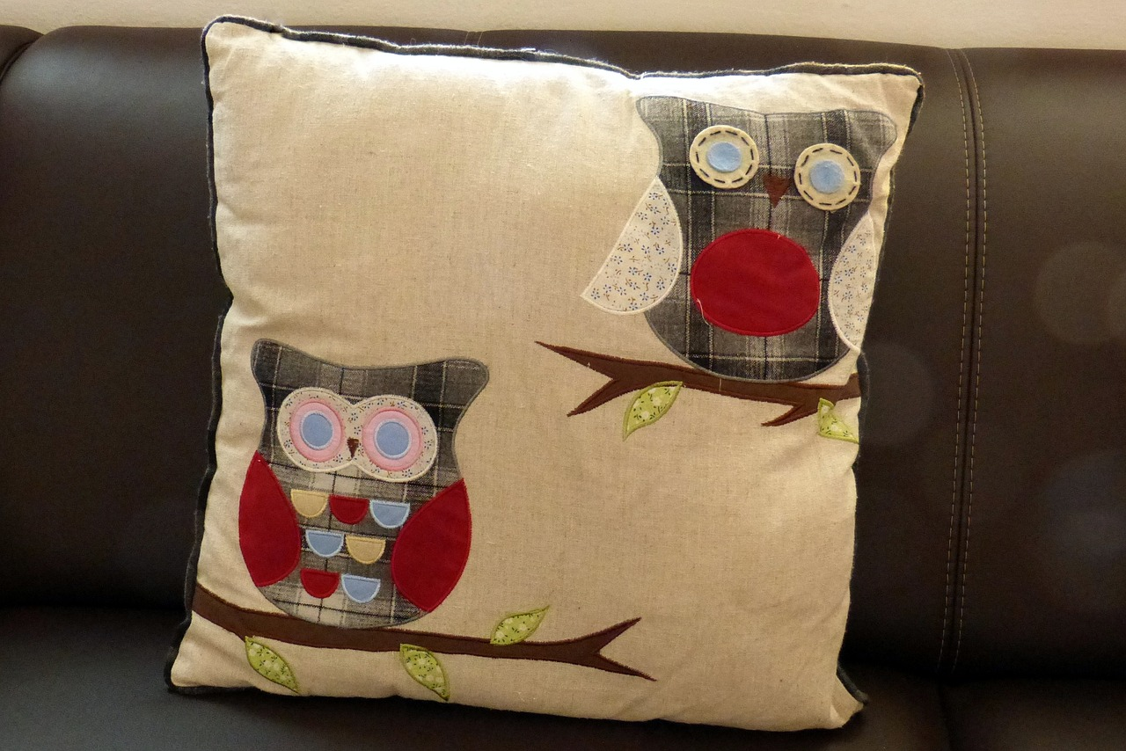 | 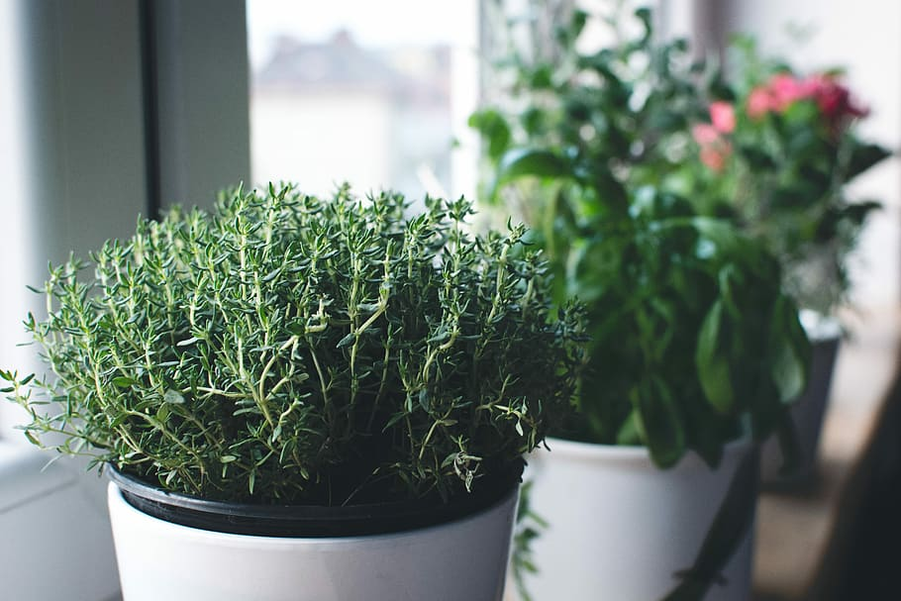 | 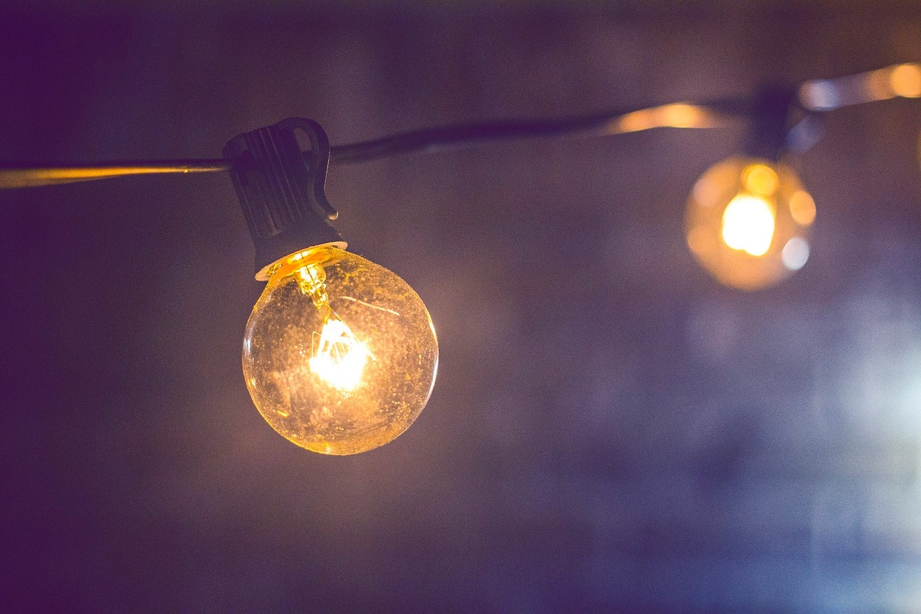
jastuk | biljke i tegle | rasvjeta

Choose the image that corresponds to the word given.
[h5p id="706"]
Images used in this document are from these sources.

