7.8 - Perfective Infinitives
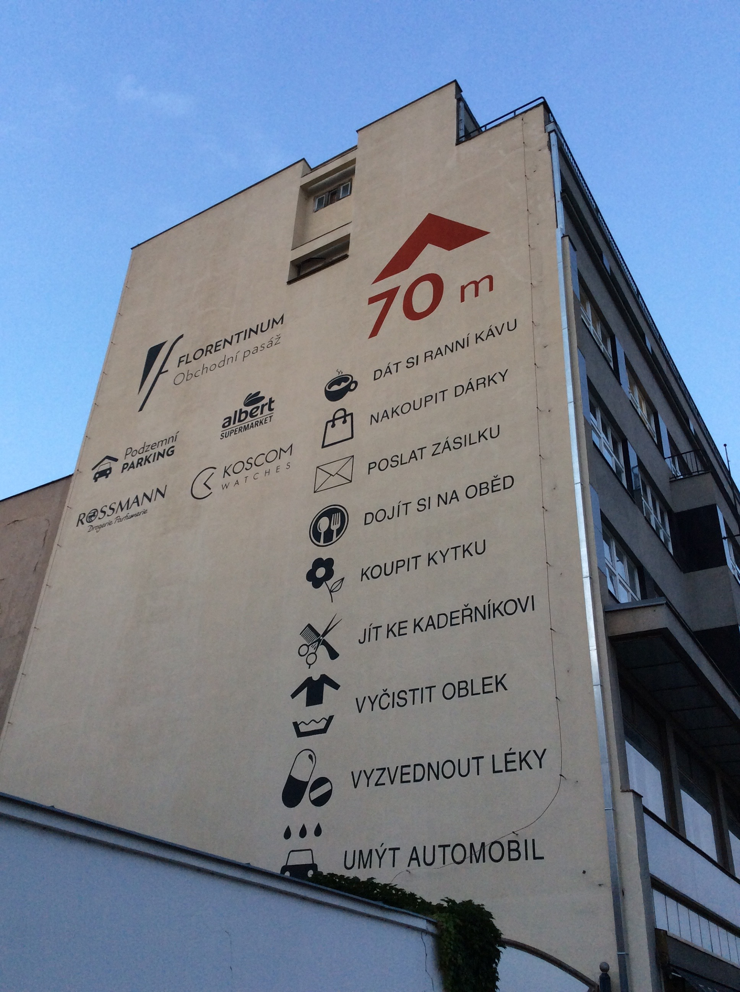

Take a look at this billboard on the side of a building. You should notice a lot of different infinitives for verbs we have learned so far. What aspect are basically all of these?



If you answered perfective, you are right! So why are they perfective? Well, it probably has something to do with the kind of advertisement this is. It is trying to promote the shopping area that is close by and the services it offers. These are all the things you can do 70m from that location.

And why in the infinitive? Well, probably the verb můžete... ‘you can…’ is understood here. So these are all the things you can do not too far from that sign. Cool, right?

Images used in this document come from these sources.

