3 | 2 | Lekcija 2: Podrijetlo

3.2 Zadatak 5. Koji jezik govoriš?
 | 
Video discussion. Post a video presentation of the languages you speak. In the video say what languages you speak and compare them by saying which one is easier/harder to learn? Also include one language that you wish you could speak. You will need to listen to your classmates’ presentations and find out who speaks the same language(s). We will check the answers in class the following day.

3.2 Zadatak 6. Sportaši
Look at the list of the names and write down who they are. Phrase your answers in the following way: Novak Đoković 🇷🇸 🎾 je srpski tenisač.
Serena Williams
Ivana Brkljačić
Michael Phelps
Lionel Messi
Christiano Ronaldo
Luka Modrić
Roger Federer

3.2 Zadatak 7. Moji interesi
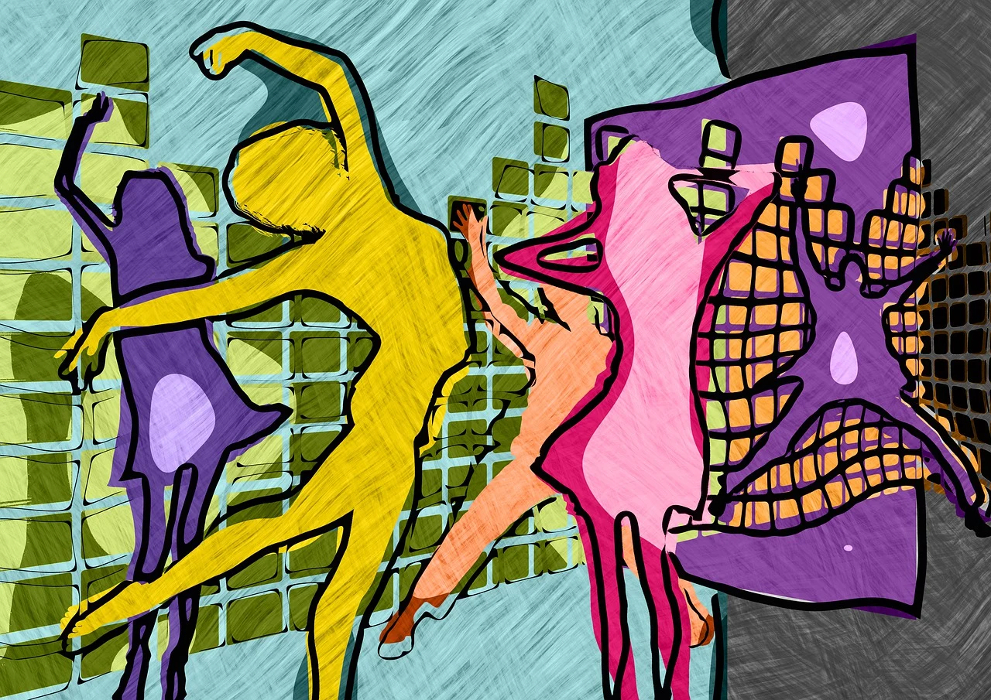 | 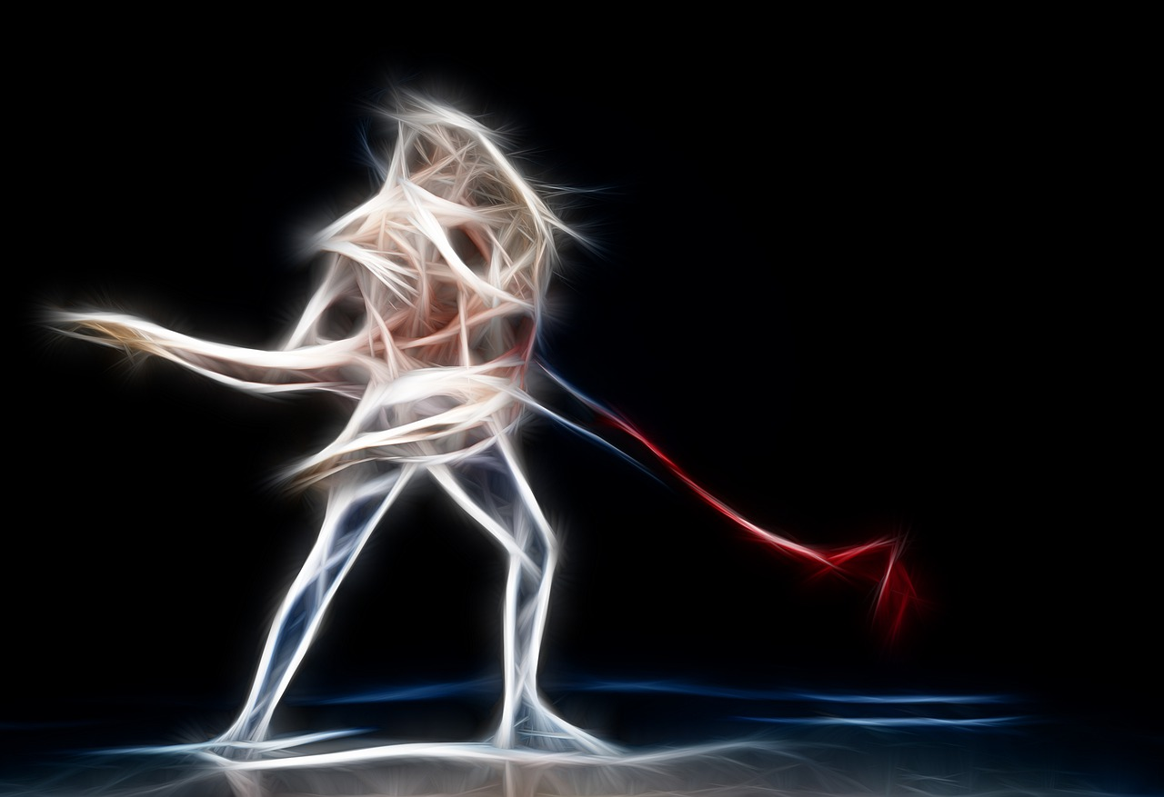
Look at the following list of things. Where are they originally from? When you complete the first question, answer the remaining set of questions below.
Odakle je?
 | valcer |  | balet
argentinski | tango |  | cha-cha-cha
 | sevdah |  | zumba
 | samba |  | riverdance (step ples)
 | flamenco |  | džudo
Što te zanima?
[odgovor] -
Što želiš naučiti?
[odgovor] -
Što je lako naučiti? (easy to learn)
[odgovor] -

Što je ovo i odakle potječe?
To je *austrijski* (ili bolje rečeno bečki) valcer. To je klasični ples.
https://en.wikipedia.org/wiki/Viennese_waltz#/media/File:Waltz1816_72.jpg
https://fr.wikipedia.org/wiki/Valse_viennoise#/media/Fichier:Tanzturnier_59.JPG
Što je ovo i odakle potječe?
To je *argentinski* tango. Obožavam taj ples.
https://en.wikipedia.org/wiki/Tango#/media/File:Tango_Porte%C3%B1o.jpg
Što je ovo?
To je *bosanska* sevdalinka, tradicionalna i emotivna pjesma.
https://commons.wikimedia.org/wiki/File:Damir_Imamovi%C4%87_-_WOMEX_15,_2015.10.24.JPG
Što je ovo?
To je *brazilska* samba, brzi i veseli ples.
https://commons.wikimedia.org/wiki/File:Samba_de_Roda_do_Rec%C3%B4ncavo_-_Bahia_-_3909_005.jpg
Što je ovo?
To je *španjolski* flamenco. Flamenco je ples s puno ritma.
https://flic.kr/p/vzuNA2 CC BY
Što je ovo?
To je *talijanski/ruski/francuski* balet.
https://www.pexels.com/photo/women-s-dancing-ballet-358010/

Što je ovo?
To je *kubanski* cha-cha-cha. To je latino ples.
https://commons.wikimedia.org/wiki/File:Ballroom_dance_competition_cha_cha_2.jpg

Što je ovo?
To je *kolumbijska* zumba. To je ples i fitness zajedno.
https://flic.kr/p/xNDdJz CC BY

Što je ovo?
To je *irski* step ples (ili Riverdance). Step ples je tradicionalni ples s brzim pokretima nogu.
https://flic.kr/p/9gCbrR CC BY

Što je ovo?
To je *japanski* džudo. Džudo je borilačka vještina.
https://commons.wikimedia.org/wiki/File:Judo_throw.jpg

Što je ovo?
To je *brazilska* capoeira. To je ples i borilačka vještina.
https://hr.wikipedia.org/wiki/Capoeira

Što je ovo?
To je *korejski* k-pop. K-pop je moderna pop glazba.
https://flic.kr/p/hPxM8D CC BY SA

Lionel Messi 🇦🇷 ⚽
Serena Williams 🇺🇲 🎾
Ivica Kostelić 🇭🇷 ⛷️
Michael Phelps 🇺🇲 🏊
Christiano Ronaldo 🇵🇹⚽
Luka Modrić 🇭🇷 ⚽
Roger Federer 🇨🇭 🎾

