2.2 - Conjugation of -í- verbs

There are a few -í- verbs in this chapter. The endings are as follows:

(já) | -ím | (my) | -íme
(ty) | -íš | (vy) | -íte
(on/ona/ono) | -í | (oni/ony/ona) | -í /(-ějí/ejí)

Most -í- verbs end in -it, -et, or -ět, such as mluvit ‘to speak’

(já) | mluvím ‘I speak, am speaking’ | (my) | mluvíme we speak, are speaking’
(ty) | mluvíš ‘you speak, are speaking’ | (vy) | mluvíte ‘you speak, are speaking’
(on/ona/ono) | mluví ‘he/she speaks, is speaking’ | (oni/ony/ona) | mluví ‘they speak, are speaking’

Occasionally the ending on the infinitive is different, such as with spát ‘to sleep’, which otherwise looks like it would be an -á- verb. However, we just have to memorize that it’s an -í- verb:

(já) | spím | (my) | spíme
(ty) | spíš | (vy) | spíte
(on/ona/ono) | spí | (oni/ony/ona) | spí

The 3rd plural endings -ějí/ejí are common only among a verbs in Czech whose infinitive ends in -et/-ět. In virtually every instance that -ějí/ejí is used in standard Czech as the 3rd plural ending, it is possible to use -í instead. In other words, don’t worry about the verbs with this alternate form too much beyond recognizing the form as an alternate. The following is an example of a verb that allows the -ějí/ejí ending:

(já) | umím | (my) | umíme
(ty) | umíš | (vy) | umíte
(on/ona/ono) | umí | (oni/ony/ona) | umějí/(umí)

Here are some common -í- verbs that you will use in this chapter:

mluvit to talk, speak
myslet to think
spát to sleep
rozumět to understand
tančit to dance
učit se to study
umět to know a skill
cvičit to exercise
uklízet to clean
vařit to cook

  Jana často uklízí.  Jana often cleans. | 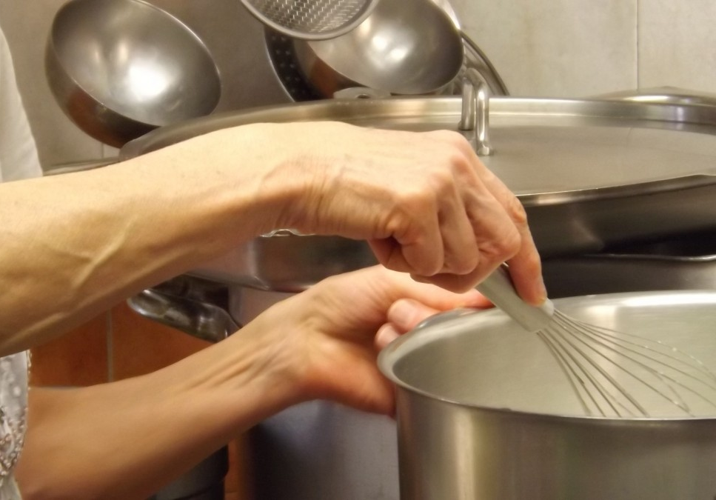  Pavla vaří.  Pavla is cooking.
  Jan spí.  Jan is sleeping. | 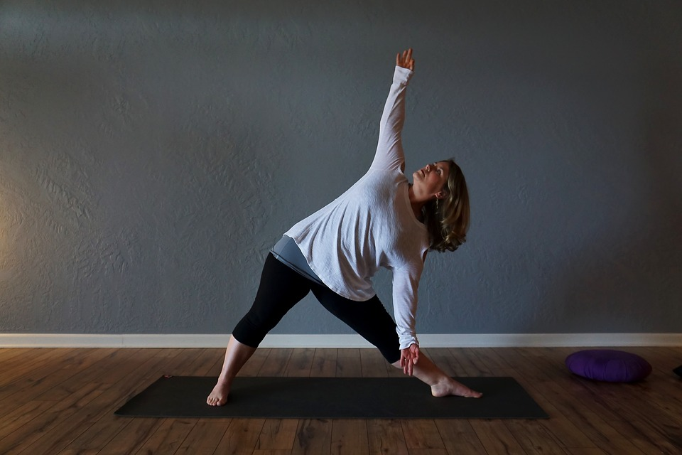  Věra cvičí každý den.  Věra exercises every day.

Images used in this document come from these sources.

