8 | 3 | Lekcija 3: U restoranu

| Jelovnik
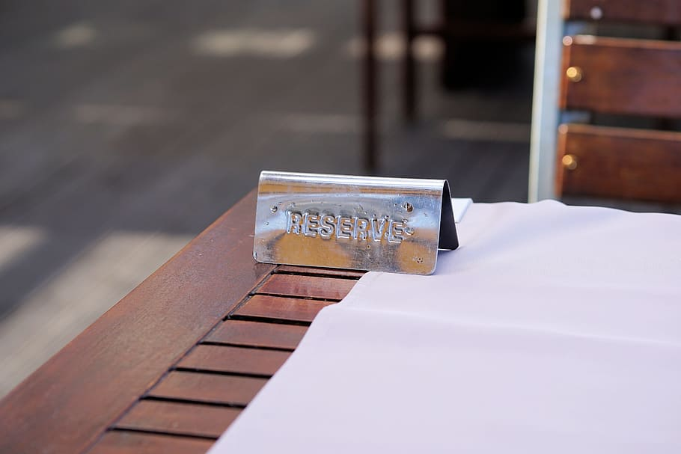 | 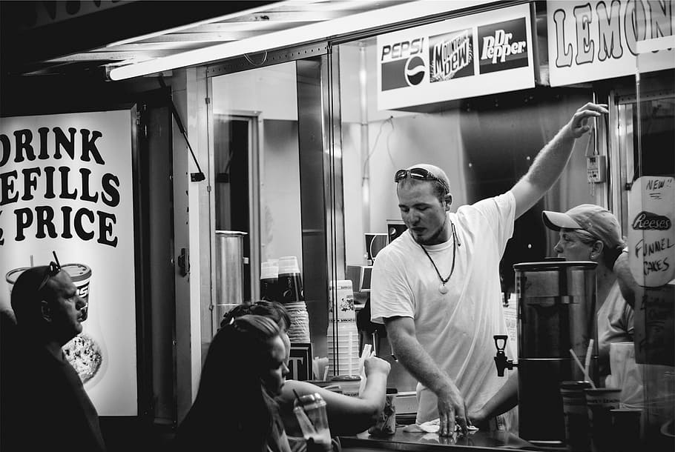
rezervirati stol | naručiti jelo/piće
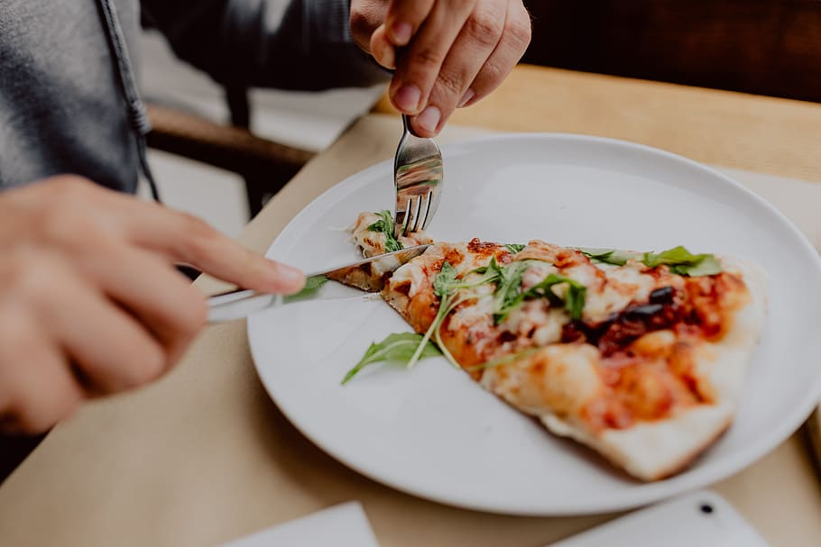 | 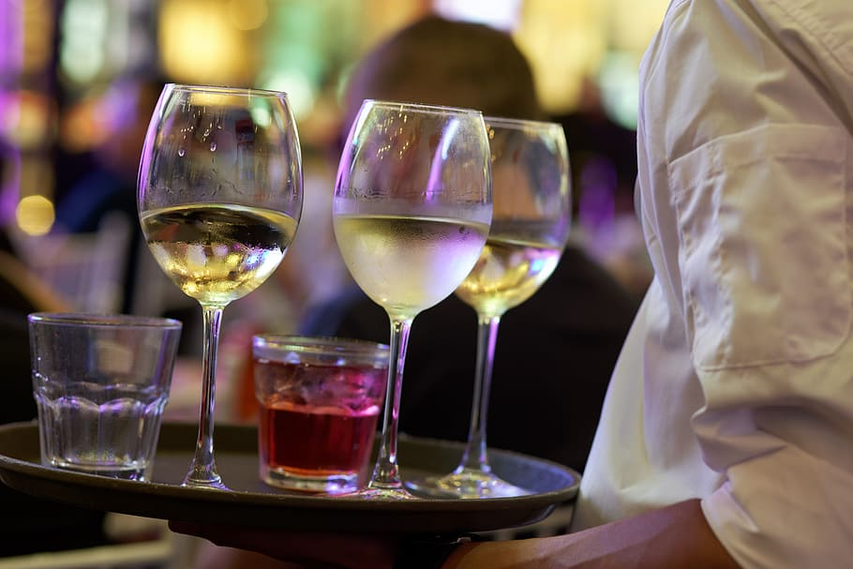
probati jelo/piće | uzeti čašu (vina)
[h5p id="805"]
Images used in this document are from these sources.

