9 | 2 | Lekcija 2: Životopis

9.2 Zadatak 7. Intervju
Sandra and Mario practiced some questions for Sandra’s interview. Read her notes and find out what she anticipates that she might be asked during the interview. You will need this vocabulary for the task below and for our next class session.
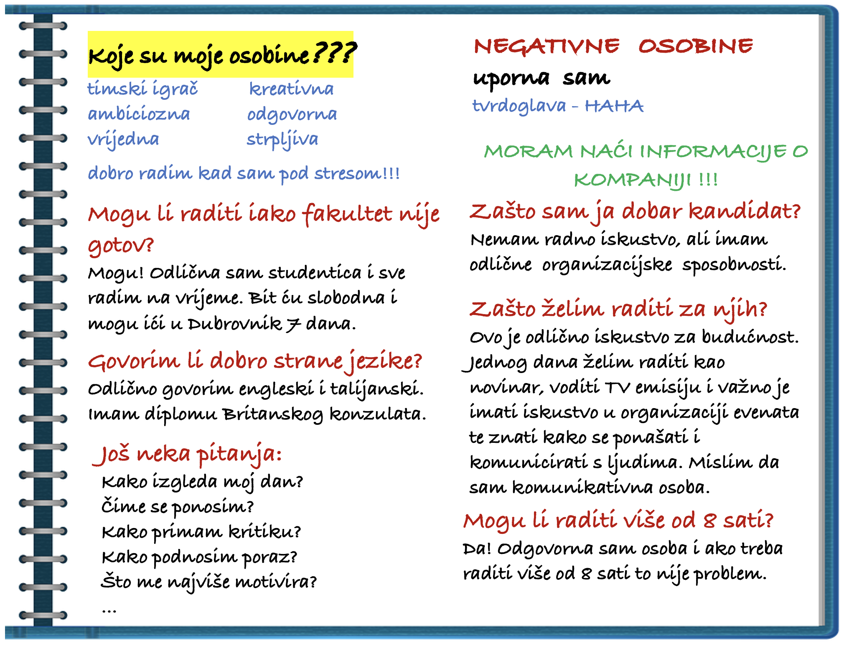
ponositi se  to be proud of | primiti  to receive | podnositi  to endure | ponašati se  to behave
Now let’s think of Ines and her potential questions for the interview. Imagine that you are Ines. How would you answer the following questions? Before answering the questions, remind yourself of the following: (1) What is the job that Ines is applying for; (2) Read her CV one more time.
1 | Zašto želite raditi za nas?
1 | -
2 | Koje su Vaše najbolje osobine?
2 | -
3 | Koje su Vaše negativne osobine?
3 | -
4 | Vi ste još studentica. Što želite naučiti na ovom poslu? Što će Vam biti korisno u budućnosti?
4 | -
5 | Možete li raditi cijelo ljeto? Hoćete li morati ići u Split?
5 | -
6 | Jeste li fleksibilni za radno vrijeme? Možete li raditi više od osam sati dnevno?
6 | -
7 | Možete li raditi i vikendom?
7 | -
8 | Što za Vas znači timski igrač?
8 | -
9 | Vidim da govorite tri strana jezika. Jeste li jednako dobri u komunikaciji na engleskom, talijanskom i ruskom?
9 | -
10 | Imate li Vi neko pitanje za mene?

9.2 Zadatak 8. Sandra šalje e-mail
Go back to our class session and look at the email that Ines composed. It will help you complete this task. Imagine that you are Sandra. Mario helped you write your CV and now you need to send an email and apply for a job position. For this job, a cover letter was not needed so you will need to say a few words about yourself and express your interest in the position in your email.
Go back to the previous lesson to remind yourself what job Sandra is applying for. Something that can also help you in writing this email is the information from Unit 7 – how to write a formal email.
Prijava na natječaj –
Prima:
Predmet:
E-mail poruka

9.2 Zadatak 9. Ines ili Sandra?
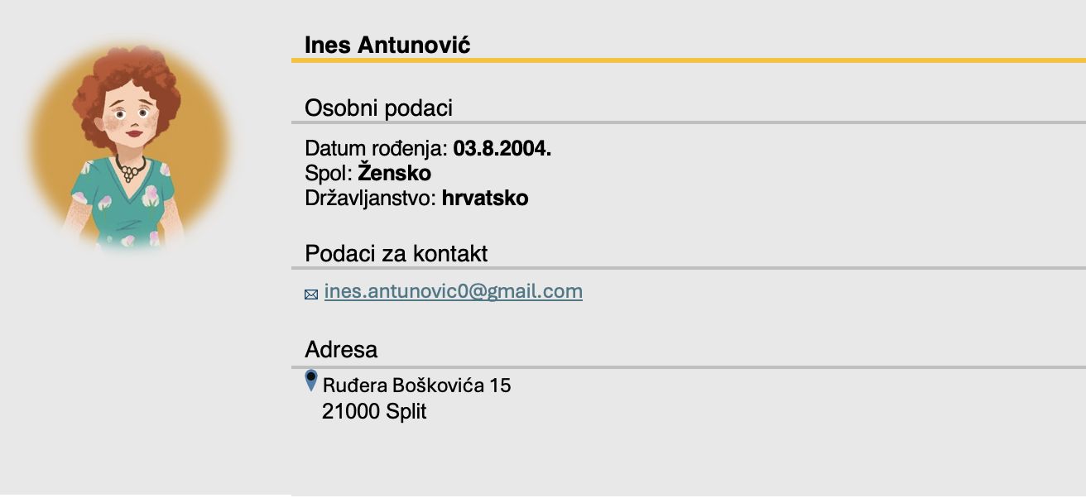
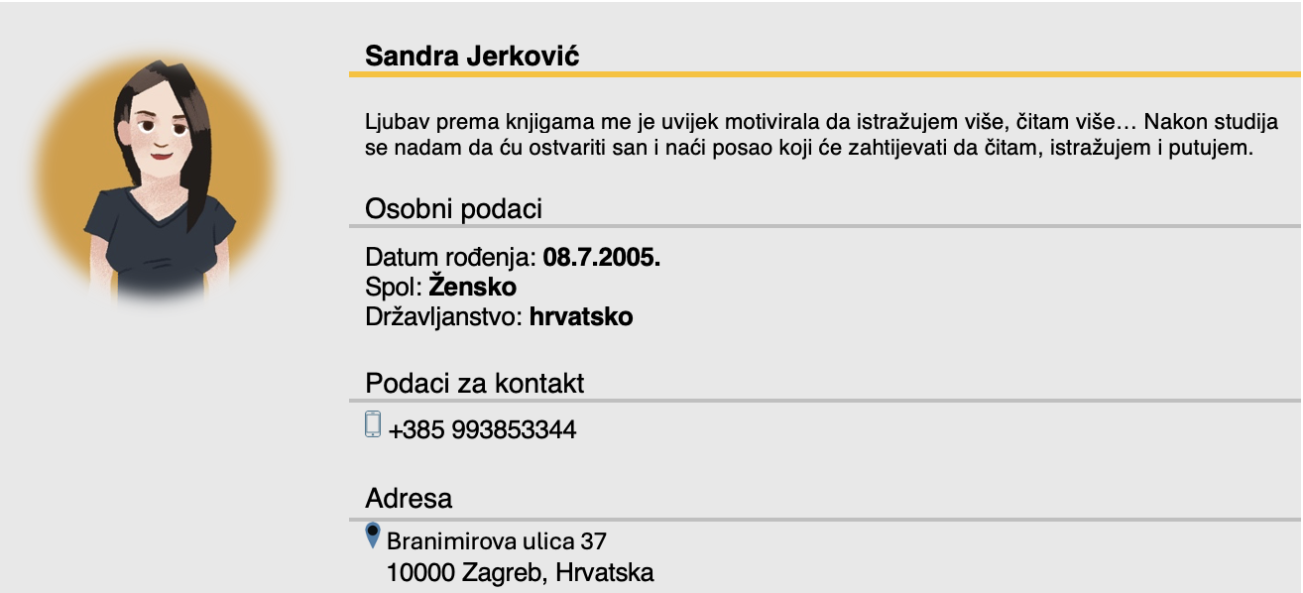

Based on what you learned in class today – who has the better, more professional introductory part of their CV? Do you see any difference at all or are they the same? Describe in detail your opinion in English as much as possible.
Q/A | Who has the better introductory part? Why?
Q/A | -

9.2 Zadatak 10. CV: EU ili SAD?
So far you have learned the basic structure of the European Curriculum Vitae. Investigate further online about how to write a good CV in the European style. When you have more information about the European way of writing a CV, think of your past experience writing a CV in the U.S. What are the differences and similarities? Which one do you prefer? Why?
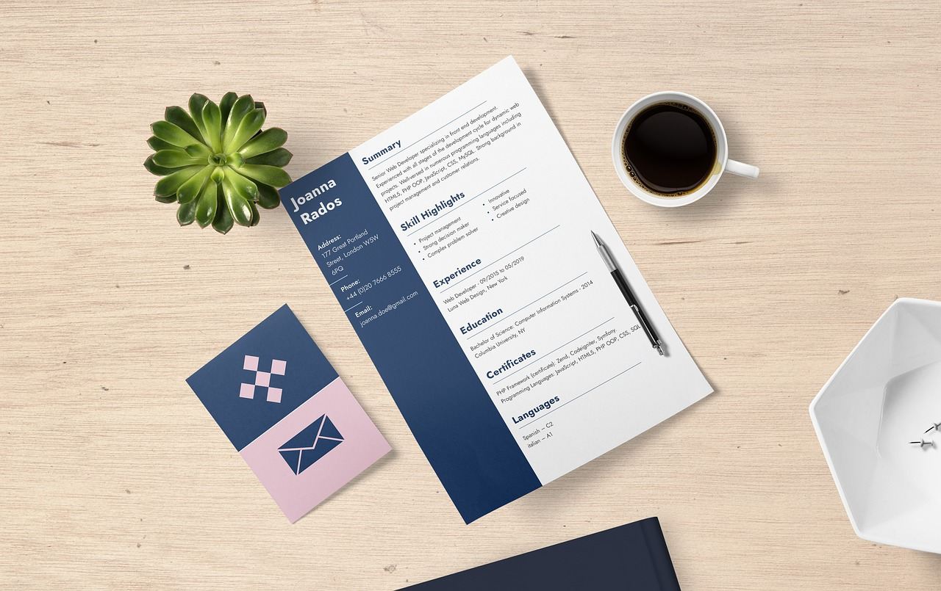 | 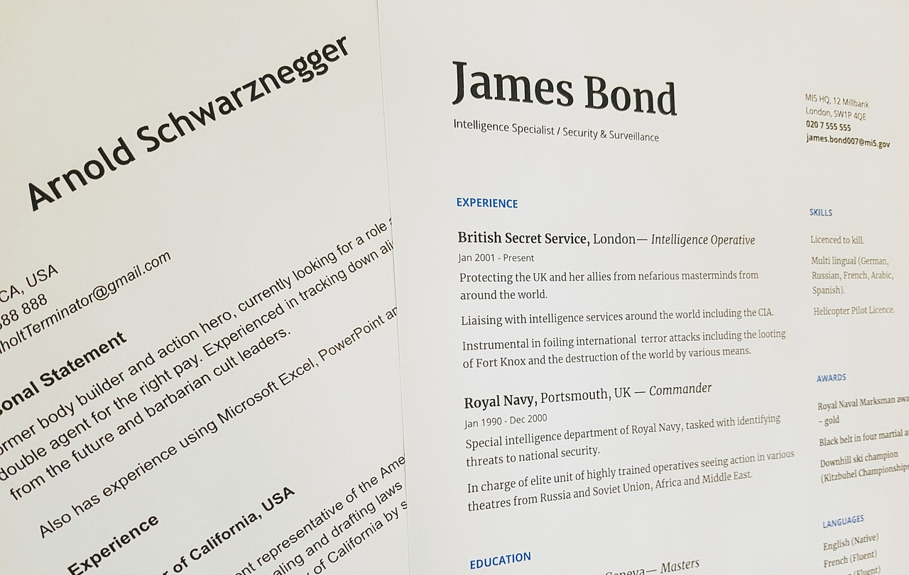

| In English
Q/A | Differences between the European and U.S. Curriculum Vitae.
Q/A | -

Images used in this document are from these sources.

