10.3 - Řídit auto vs. jet/jezdit autem

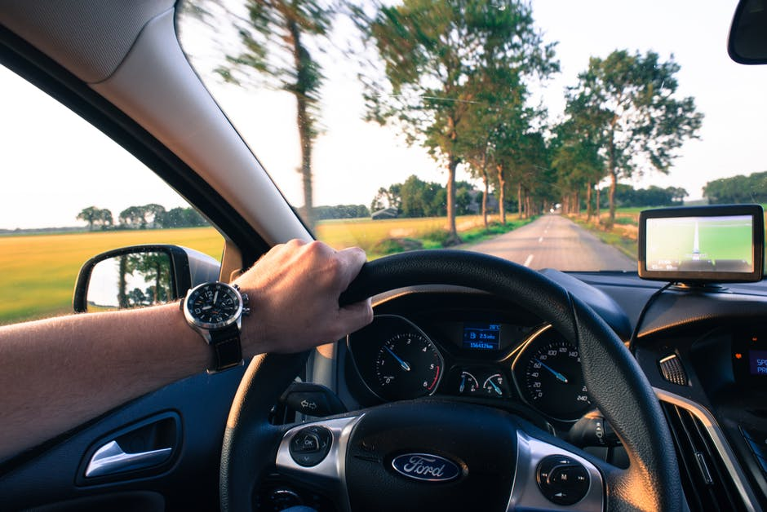 | 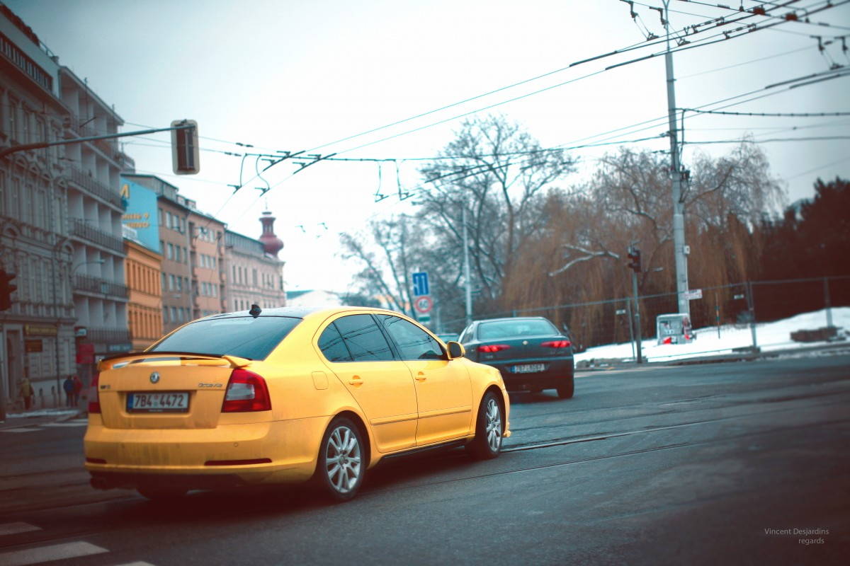

Ok, so we need to provide a few quick notes regarding two expressions:

- řídit auto - ‘to drive a car’ - This is a very specific expression that focuses on the act of driving, i.e. being behind the wheel. You won’t use this at all to describe driving to a place.
- jet/jezdit (autem) - ‘to go by vehicle, (drive)’ - So we often use drive in English to mean go by car. If that’s what you mean, then use our familiar verbs jezdit and jet.

That’s pretty much it. These sections below give a few more examples:

řídit (auto) - ‘to drive a car’
- So you might talk about knowing how to drive a car, in which case you can say Umím řídit or vice-versa Neumím řídit.
- If someone has had anything to drink, then they might say Nemůžu řídit ‘I can’t drive’, or someone might say that they can - Můžu řídit.
- Or they might travel by car a lot (as a passenger), but want to specify that they don’t drive - Neřídím moc často or Nikdy neřídím.

If you drive, you’ll need a řidičský průkaz ‘driver’s license’ (which is different from your ID card - občanský průkaz). Colloquially this is called a řidičák:
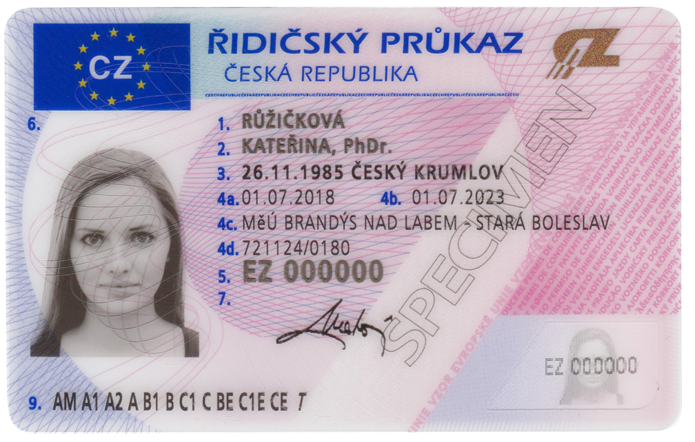

jet/jezdit (autem) - ‘to go by car, to drive’
Use this whenever you want to say that you are going somewhere. It can get confusing because in English we often use the word drive to mean we’re taking our car somewhere. In these cases, however, when you’re specifying a place you’re going to, use jezdit / jet:

Obvykle jezdím do práce autem.
I usually drive to work / go to work by car.

Zítra pojedeme do Brna asi autem.
Tomorrow we’ll probably drive to Brno.

Images used in this document come from these sources.

