5 | 2 | Lekcija 1: Planovi za praznike

| Glagoli – aktivnosti za zimske praznike
 |  | 
kititi bor | ići na kuhano vino | kupiti poklone
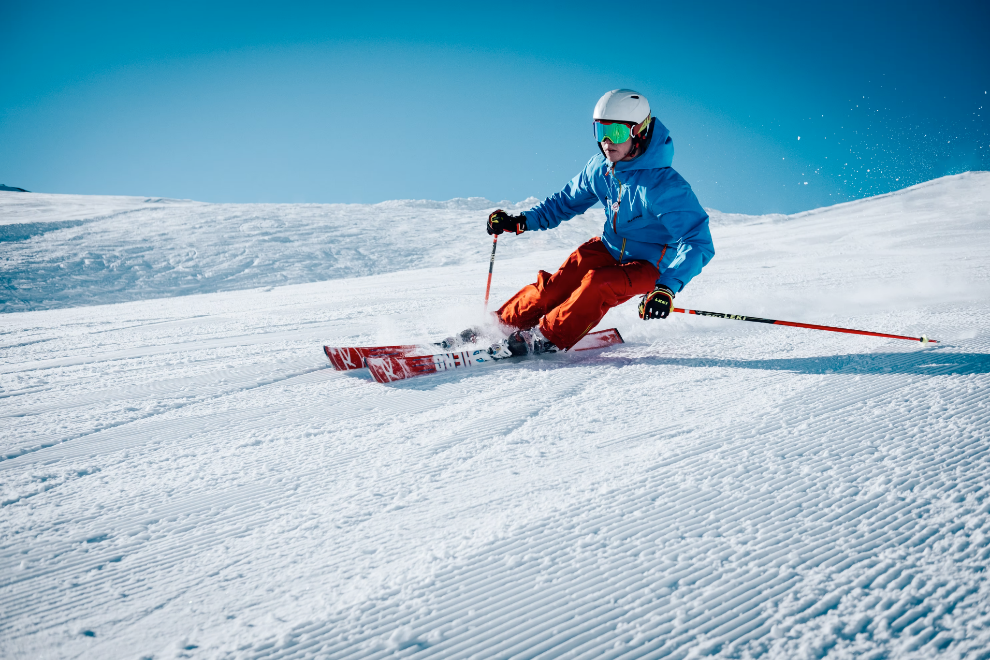 |  | 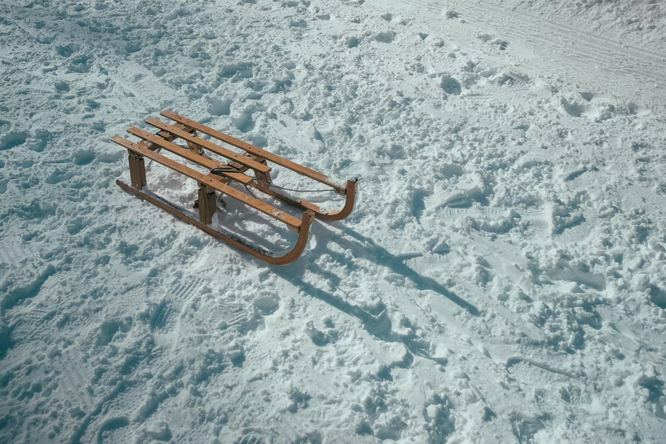
skijati (se) | klizati (se) | sanjkati (se)
 |  | 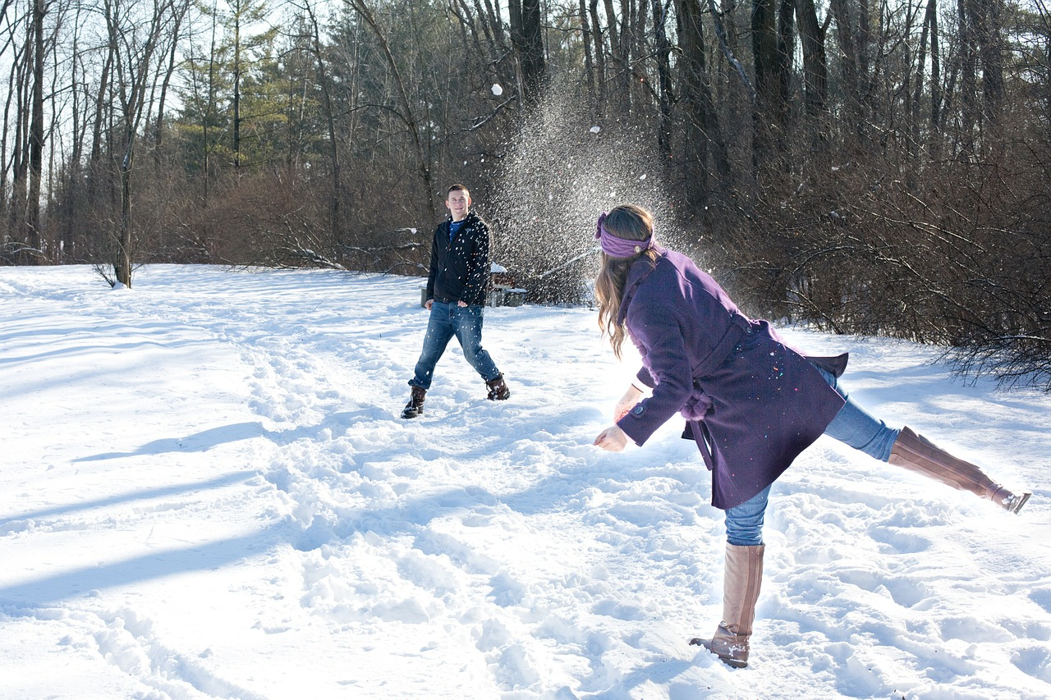
bordati (se) | voziti snowmobile | grudati (se)

| Arhitektura u Hrvatskoj
Croatian cultural heritage is marked by different styles that were created throughout history. Look at the following styles, presented by a specific architectural achievement in Croatia. Then, write the name of the city in the form of the statements below.

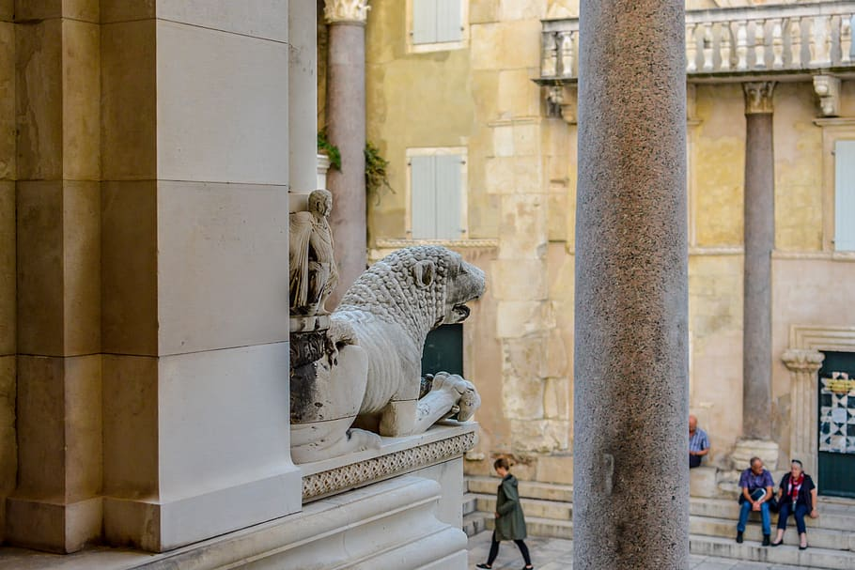 | 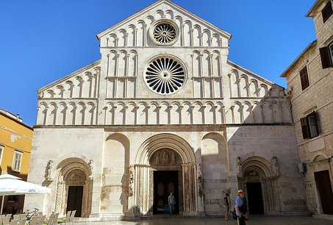
Dioklecijanova palača, Split (4. stoljeće) | Sveta Stošija, Zadar (12.-13. stoljeće)
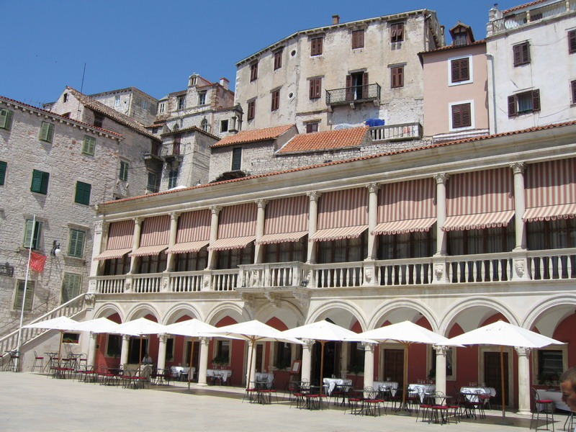 | 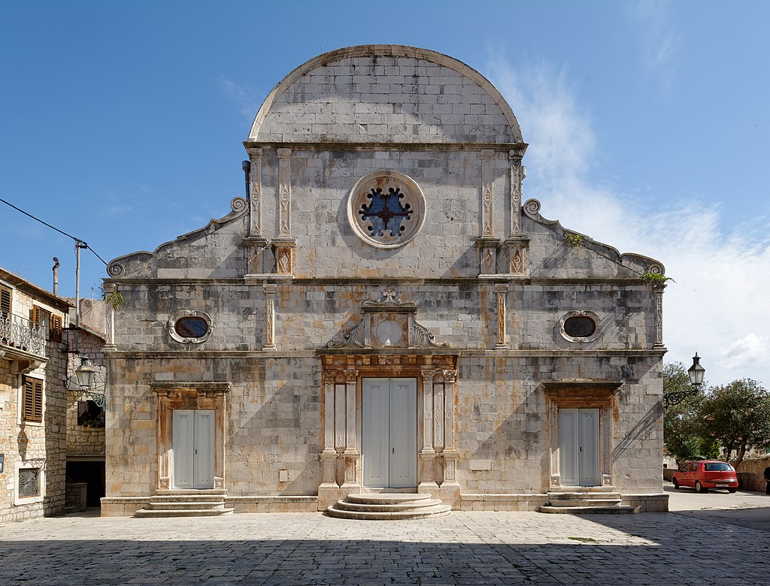
Gradska vijećnica, Šibenik (16. stoljeće) | Crkva sv. Stjepana, Hvar (17. stoljeće)
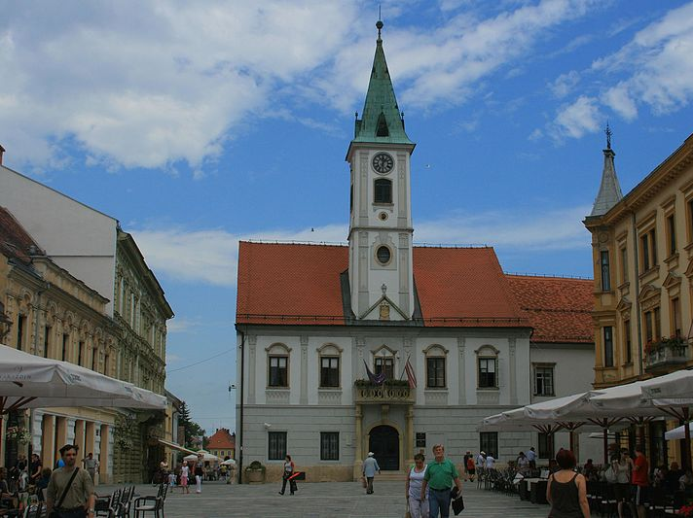 | 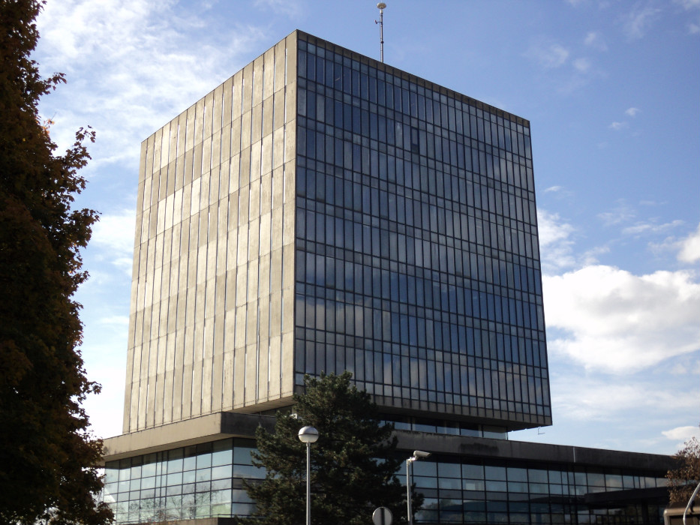
Gradska vijećnica, Varaždin (16. stoljeće) | Kockica, Zagreb (20. stoljeće)

5.2 Zadatak 1. Arhitektura
Based on the information provided above, write the name of the city in the form of the statements below. Each city is well known for its architectural style.
[h5p id="641"]

5.2 Zadatak 2. Kulturno blago
Look at the following traditional Croatian products. Write where each of them is from. If you ever find yourself in the area, make sure to try them, have or bring them home as a souvenir.
[h5p id="642"]

Images used in this document are from these sources.

