3 | 1 | Lekcija 2: Krv nije voda

3.1 Zadatak 1. James i njegova obitelj
Review James’ family tree and mark in the column (a) if he has the relatives listed. Then, in column (b), mark if you have the listed relatives.
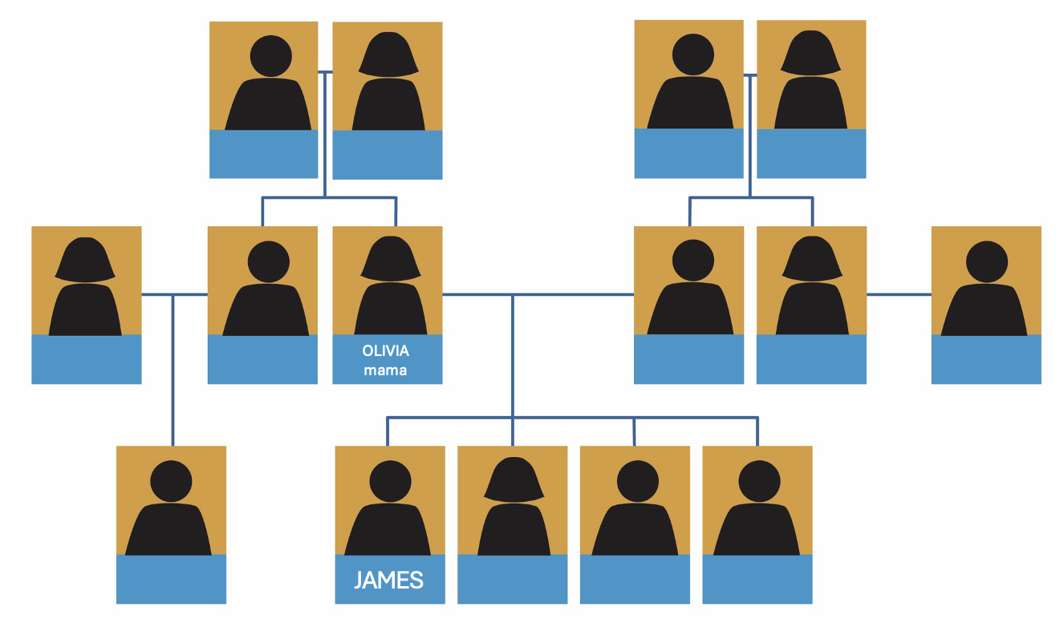
 | A | Obitelj i rodbina | B
1. | DA | brat
2. | DA | sestra
3. | DA | djed
4. | DA | baka
5. | DA | ujak
6. | DA | ujna
7. | DA | teta
8. | DA | tetak
9. | NE | stric
10. | NE | strina
11. | DA | rođak (bratić)
12. | NE | rodica (sestrična)

3.1 Zadatak 2. Davor i njegova obitelj
Members of Davor’s family are presented below in a specific pair. Take the role of the first person listed and then state what your relationship is to the second person in the pair. Write complete sentences.
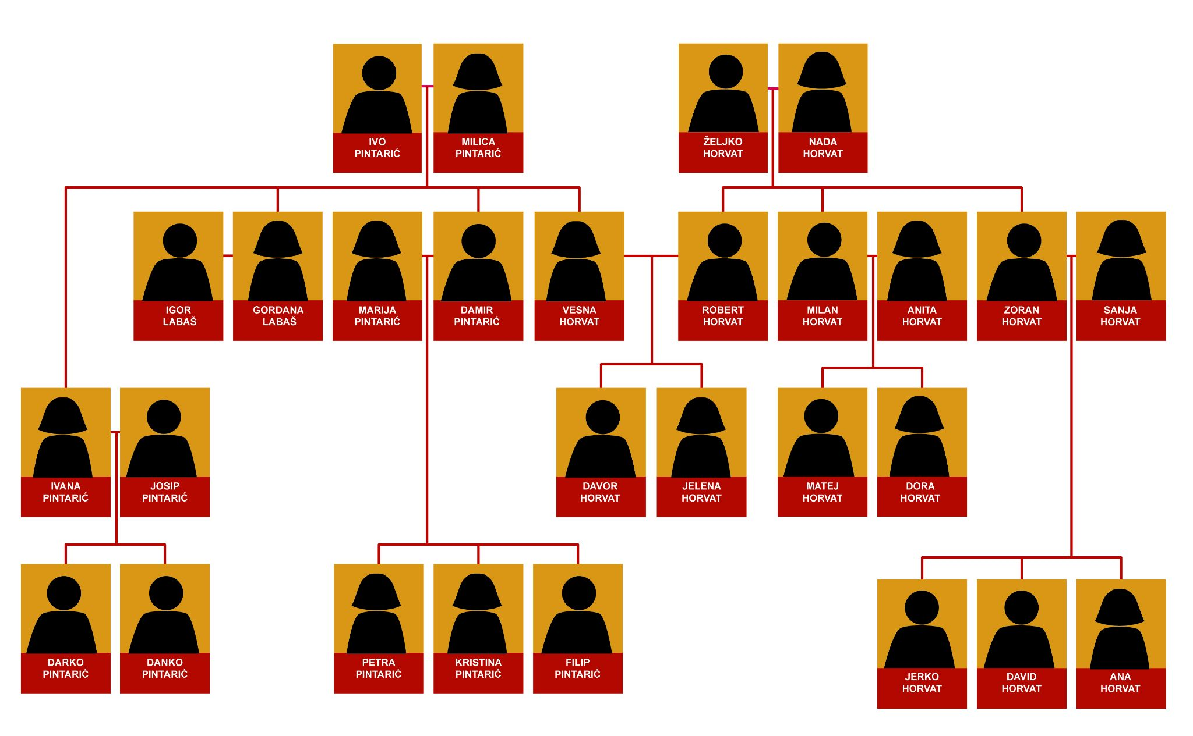
The first pair is done for you.
Davor Horvat / Jelena Horvat. | ↦ Ovo je moja sestra.
Davor Horvat / Igor Labaš. | ↦
Milica Pintarić / Filip Pintarić. | ↦
David Horvat / Petra Pintarić. | ↦
Milan Hovat / Jerko Horvat. | ↦
Matej Horvat / Sanja Horvat. | ↦
Danko Pintarić / Jelena Horvat. | ↦
Ana Horvat / David i Jerko Horvat. | ↦
Vena Horvat / Josip Pintarić. | ↦
Kristina Pintarić / Gordana Labaš | ↦
Željko Horvat / Davor i Jerko Horvat. | ↦
Matej Horvat / Nada Horvat. | ↦
Kristina Pintarić / Ivana Pintarić. | ↦
Jelena Horvat / Zoran i Milan Horvat. | ↦
Jelena Horvat / Ivo Pintarić i Željko Horvat. | ↦

| In English
Question
If you look at Davor’s family tree again, which consists of two main families – Horvat and Pintarić – why does the last name Labaš suddenly appear within the family tree?
↦

3.1 Zadatak 3. Tko govori?
Use Davor’s family tree as a point of reference. Look at the beginning of the sentence. Pay attention to who is talking and finish the sentence with a logical ending.
Milica: | Gordana i Damir su moja | →
Anita: | Dora je moja | →
Zoran: | David i Jerko su moji | →
Anita: | Milan je moj | →
Petra: | Darko, Danko i Davor su moji | →
Kristina: | Milica je moja | →
Nada: | Robert i Vesna su | →
Jelena: | Marija i Ivana su moje | →
Jerko: | Dora i Matej su moji | →

3.1 Zadatak 4. Moja obitelj
Pair-work. In class you already worked on your family tree. Add any relatives that you may not have included originally. Visually organize your family tree and meet with another classmate. Present to each other your family and relatives. Your classmate will ask you additional questions about them, such as – occupation, traits, and physical characteristics. Submit your video recording online.

3.1 Zadatak 5. Mario i njegova rodbina
🔊 Listen to the text and complete the family tree by writing the name under each appropriate picture. Not all names will appear in listening. You can also download a fillable PDF.
(audio)
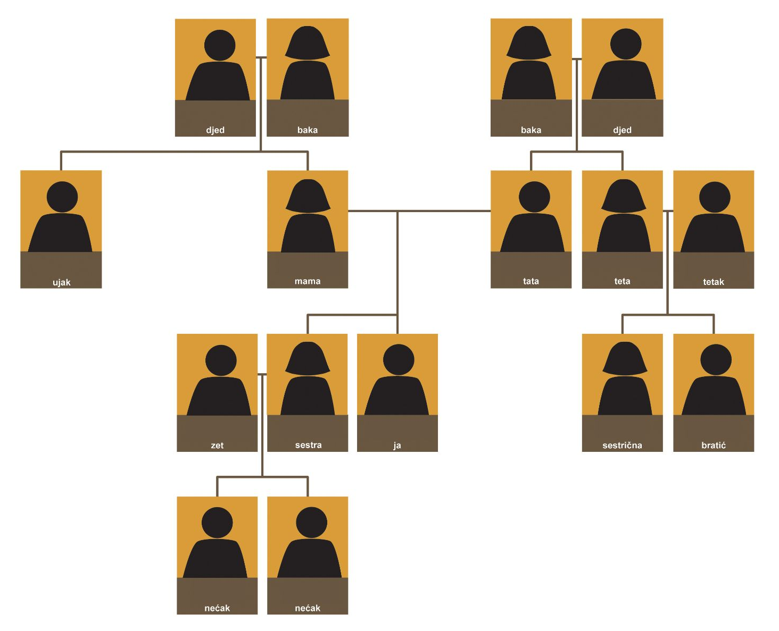
During the listening you heard four different last names. Which ones did you hear? If needed, listen to the presentation one more time. Match the appropriate last name with each character.

| In English
Question
Why did you give each character that specific last name? What is the reasoning behind your answer?
↦
Who in the family has the same first name? Is that a pure coincidence? Explain your answer.
↦

Images used in this document are from these sources.

