1.8 - Stating your Age

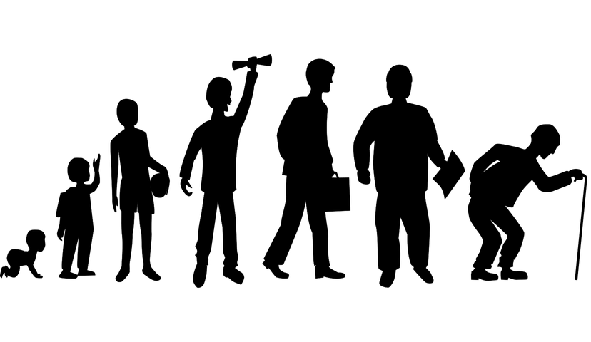
Here we’re going to learn how to say how old you are and also how to ask someone how old they are.

‘How old are you?’
Let’s start first with the question:

Kolik je ti let?
‘How old are you’ (informal)?

Kolik je vám let?
‘How old are you? (formal)

To answer this question, you will say:

Je mi ____ let.
‘I’m ____ years old.’

Je mi 22 let.
‘I’m 22 years old’

‘How old is he? How old is she?’
You can also ask about other people:

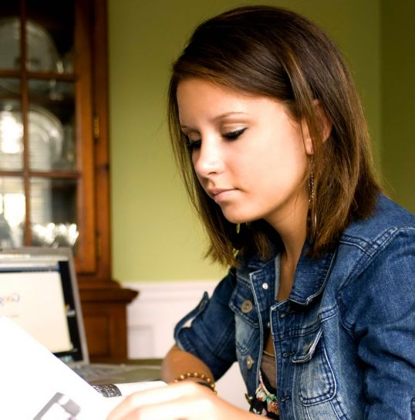  Kolik je jí let?  ‘How old is she?’  Je jí 22 let.  ‘She is 22 years old.’ | 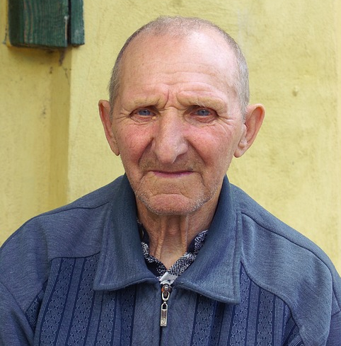  Kolik je mu let?  ‘How old is he?’  Je mu ____ let.  ‘He is ____ years old.’

We will eventually (toward the end of the course) learn more about some of the grammar behind this, but for now all of these can be learned as simple phrases.

Images used in this document come from these sources.

