1 | 1 | Lekcija 2: Kako se zoveš?

| Države
In this video, you’ll learn how to say the names of different countries in Croatian (we picked just a few). Before each country name is said out loud, you’ll first see its flag—can you guess the country? Then listen carefully to the Croatian name, and repeat it out loud. Be sure to turn on the closed captions to see how each country's name is spelled in Croatian. You can also pause the video at any time to repeat or write the names down.
🌎 Practice as much as possible and try to remember as many names as you can—but don’t worry if you don’t get them all right away. Every bit of exposure helps!

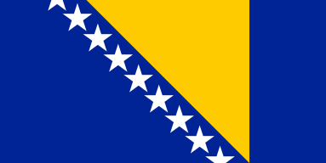 | 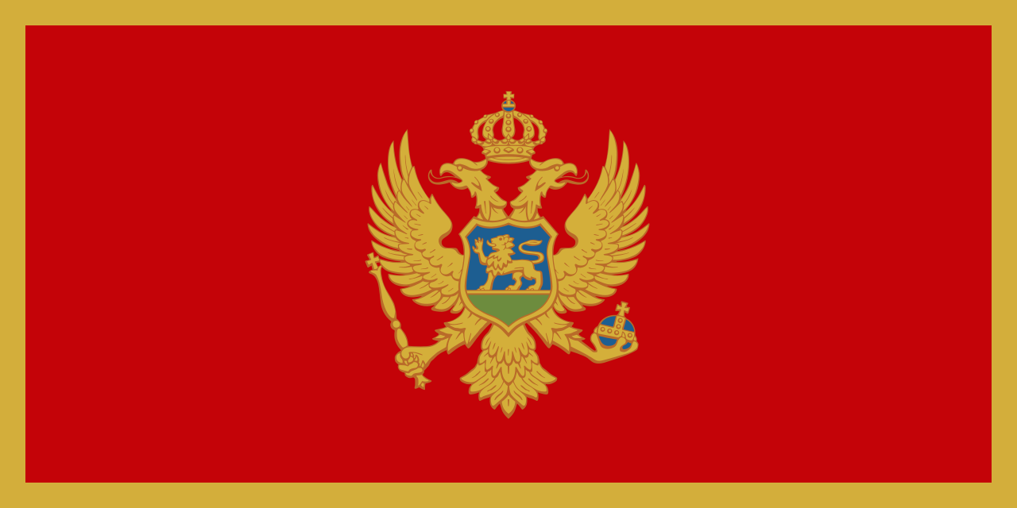 | 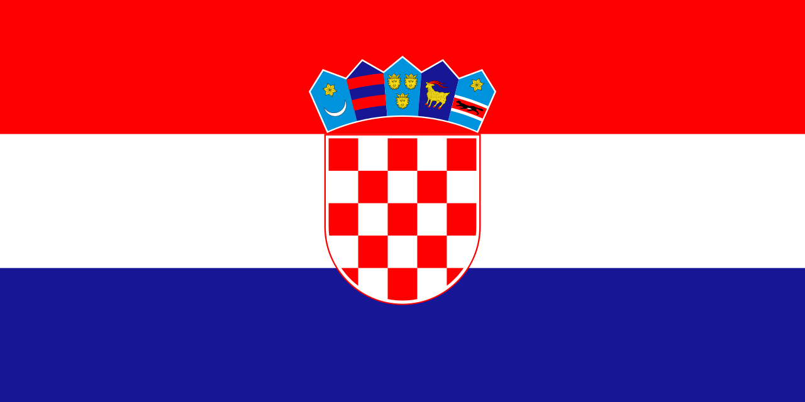
(audio) | (audio) | (audio)
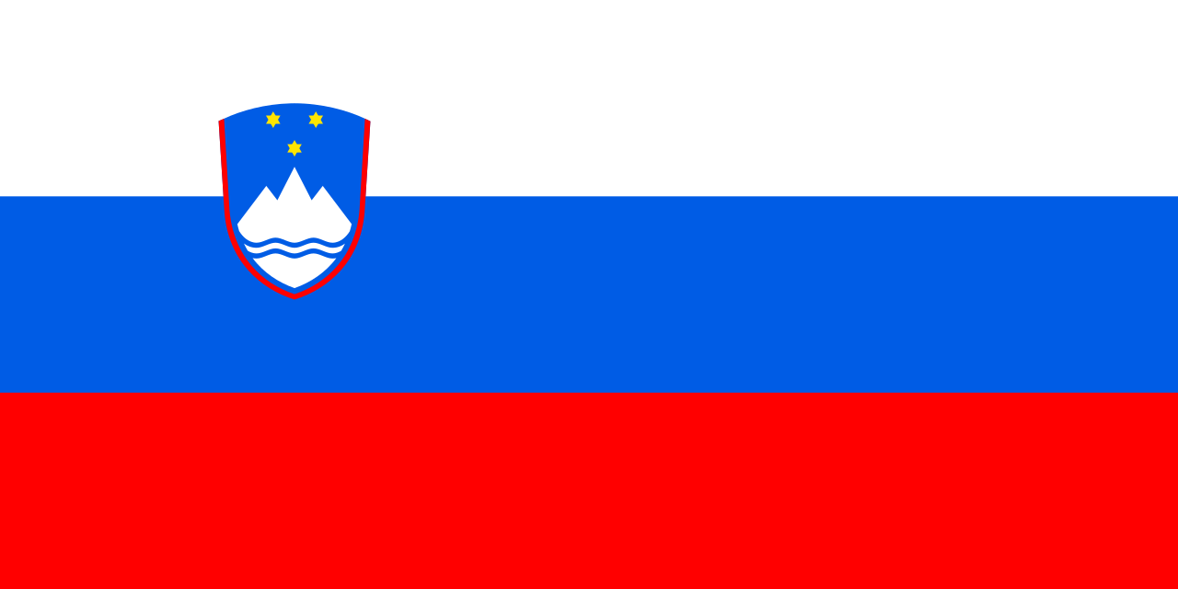 | 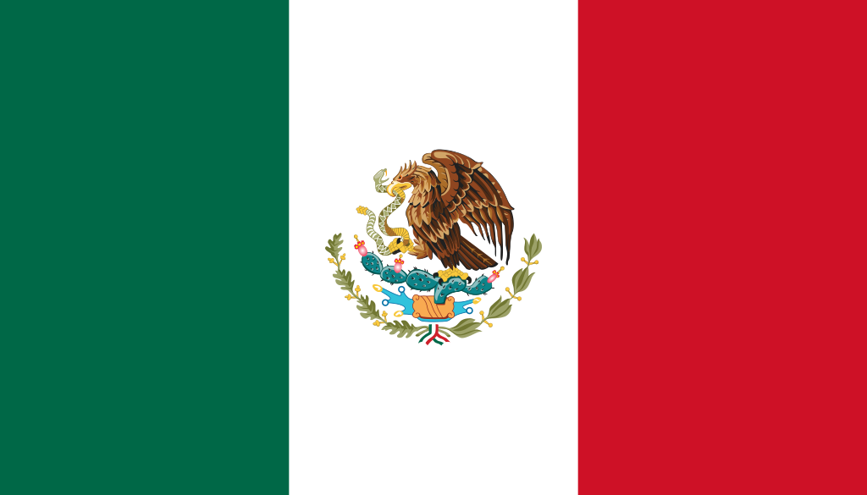 | 
(audio) | (audio) | (audio)
 |  | 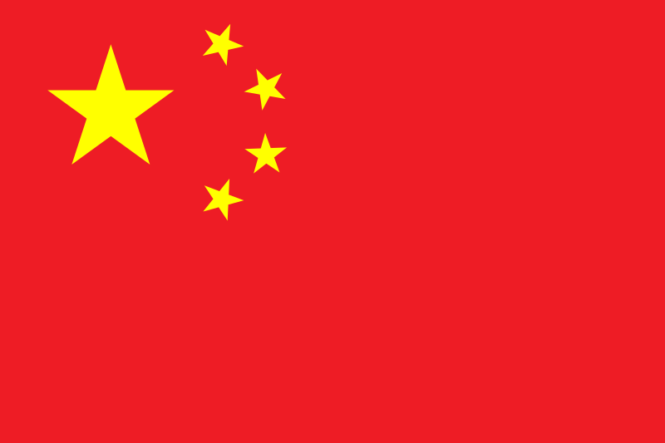
(audio) | (audio) | (audio)
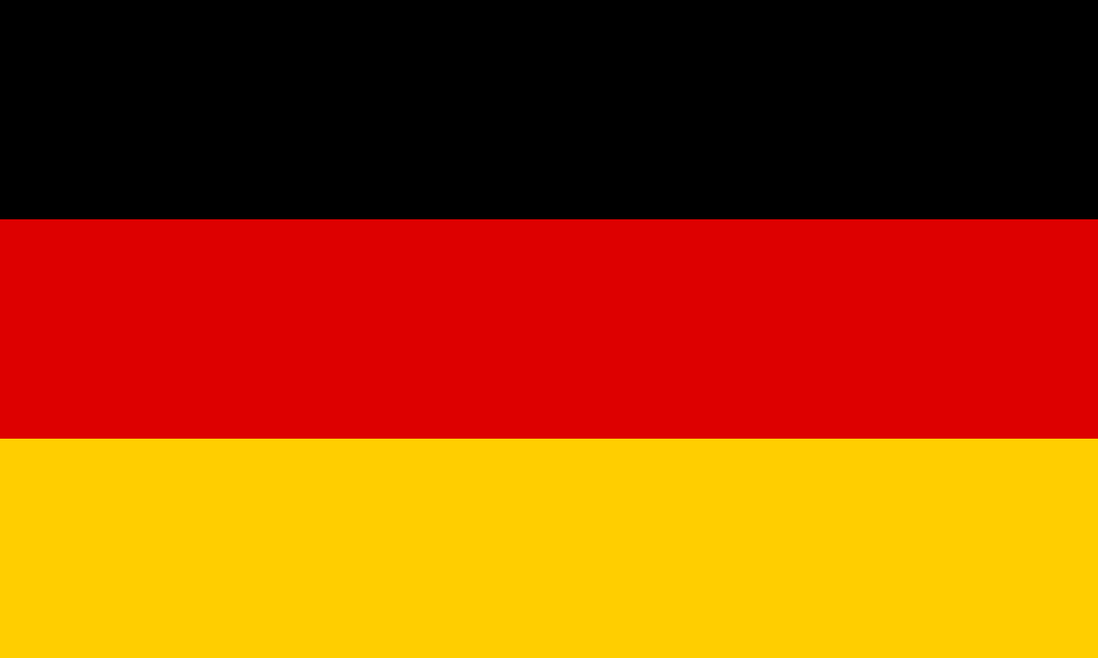 | 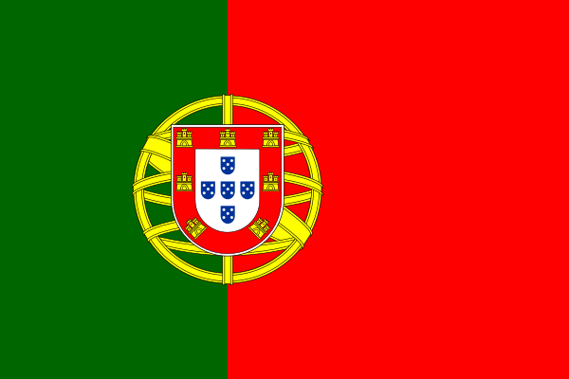 | 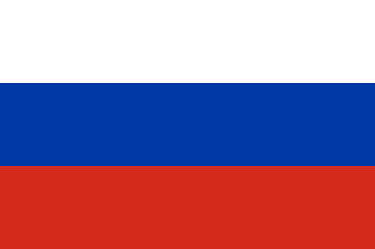
(audio) | (audio) | (audio)
 | 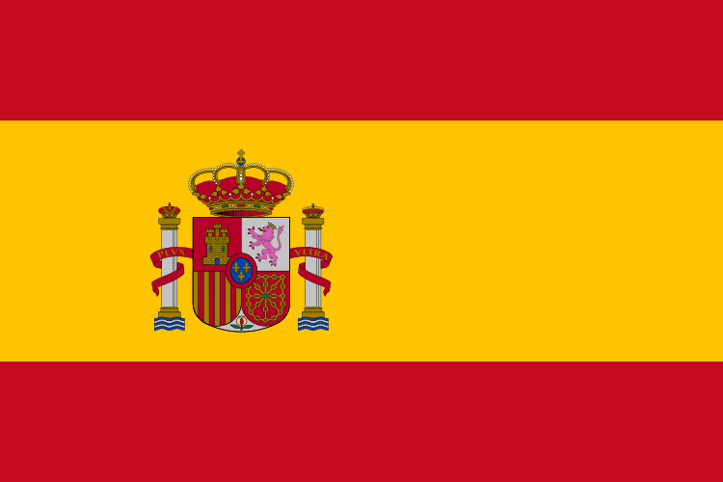 | 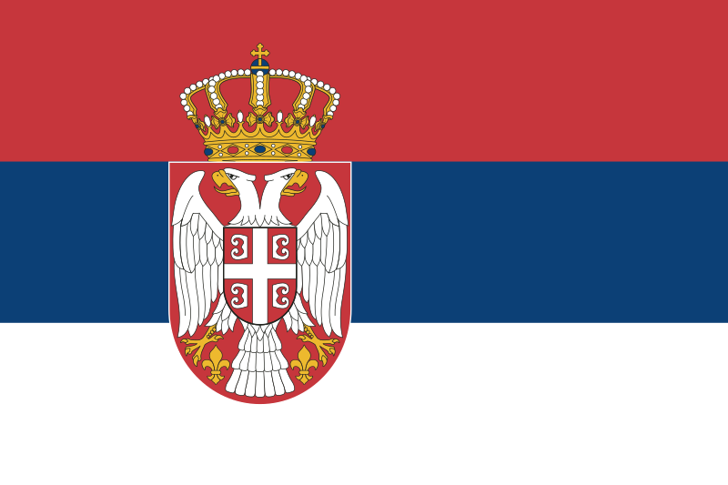
(audio) | (audio) | (audio)

1.1 Zadatak 6. Država i zastava
🌍[h5p id="582"]
🌎[h5p id="584"]

| Europa
[h5p id="43"]

| Svijet
[h5p id="44"]

1.1 Zadatak 7. Države

| Geografija
Help Laura and James learn more about countries in Europe. Follow the numbers on the map and choose the correct name of the country from the drop-down menu. If you have difficulties, check the help button (“i”) next to each drop-down menu.
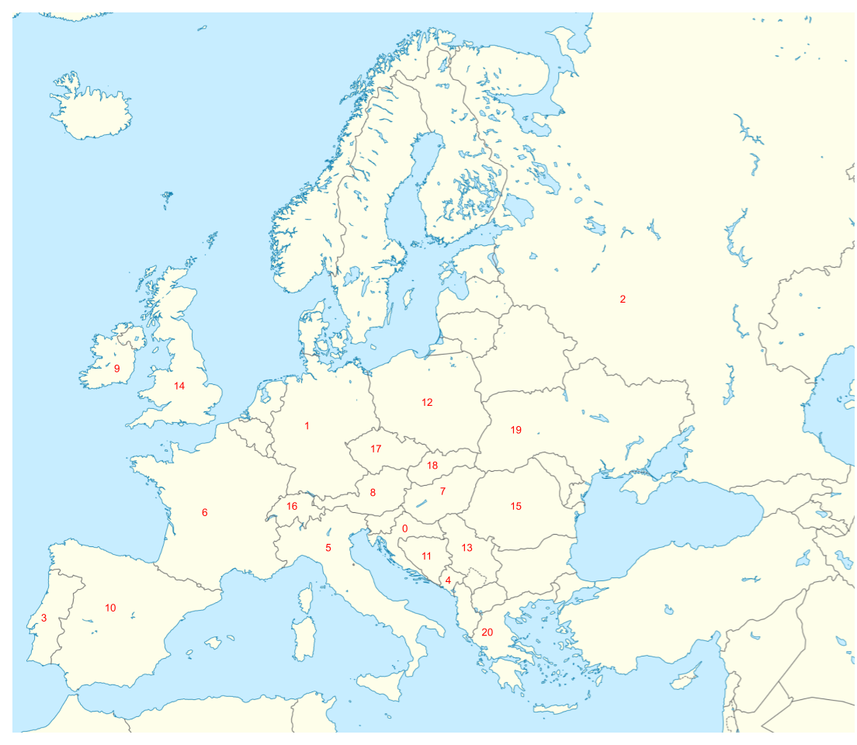
[h5p id="133"]

1.1 Zadatak 8. Koje je boje?

Mark the correct colors that appear on each flag.
[h5p id="676"]

| Names
Let’s investigate the most common name structure in the area. How do masculine names end? How feminine names end? Look at the list below to find the answers.

| Masculine names ending in: a consonant, / -e, / -a, / -o
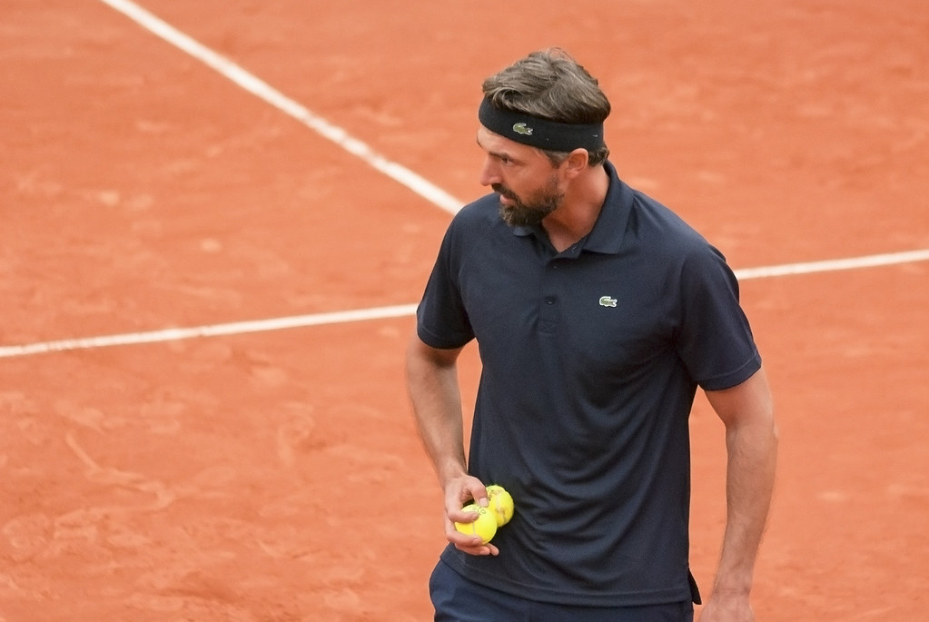 | 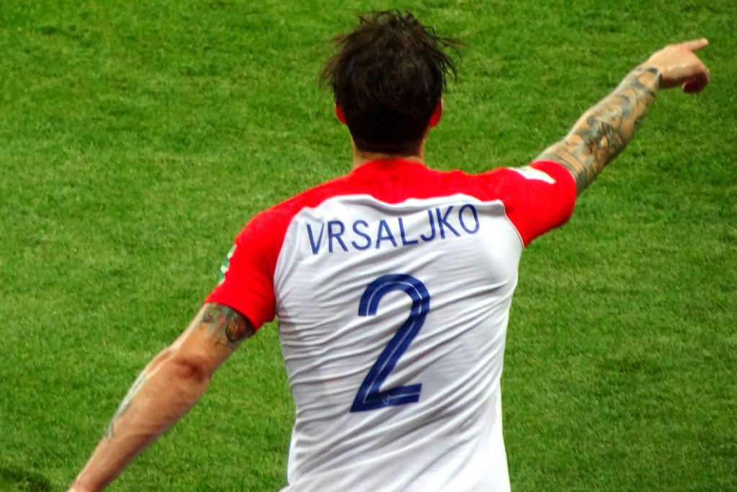
Goran Ivanišević | Šime Vrsaljko
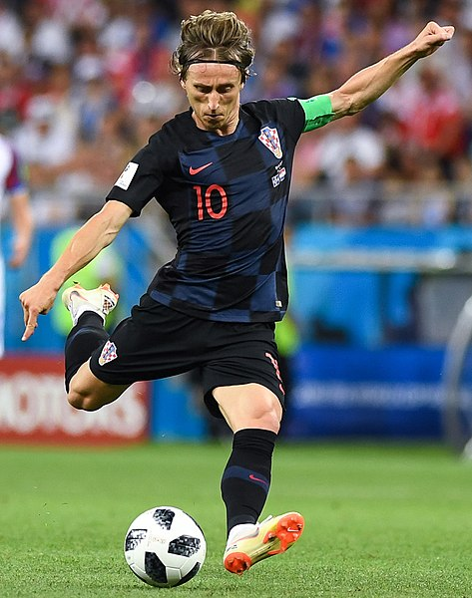 | 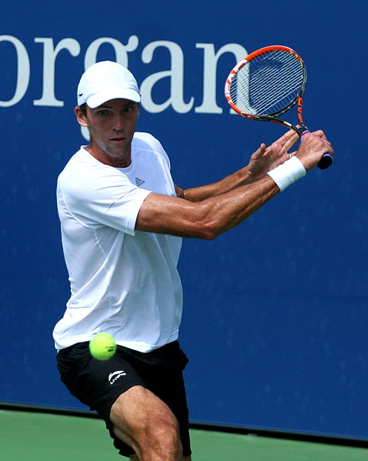
Luka Modrić | Ivo Karlović

| Feminine names ending in -a
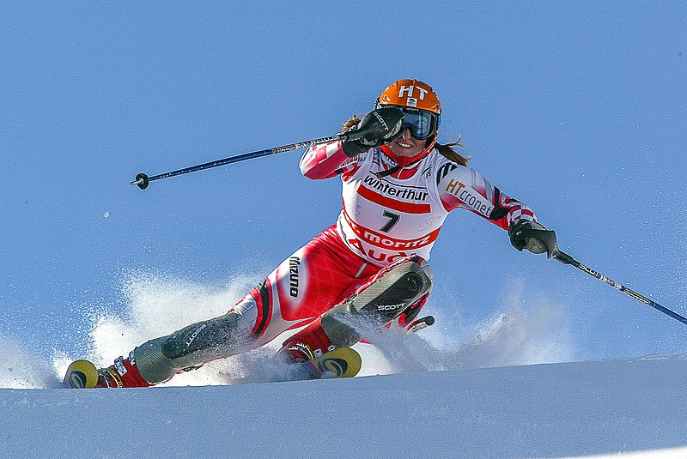 | 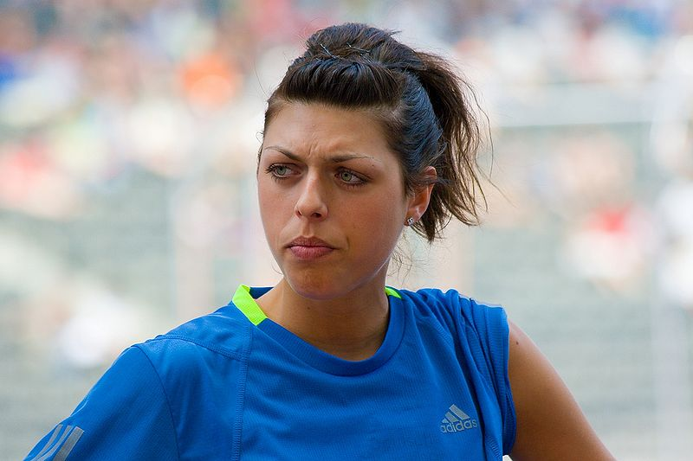
Janica Kostelić | Blanka Vlašić

| Names indicating both masculine and feminine
Some names can be used for men and women. Check the list below. If you want to know more about these people and their importance/significance in society feel free to search them online.

Saša Lozar | Saša Broz
Matija Dedić | Matija Vujica
Nikica Kalogjera | Nikica Marinović
Vanja Drach | Vanja Rupena

1.1 Zadatak 9. Dijalog

Drag and drop the following lines in order to make a cohesive dialogue.
[h5p id="6"]

All flag images are from https://commons.wikimedia.org and are in the public domain. 🔺
All other images used in this document are from these sources.

