4.1 - Počasí - Talking about the Weather
First, we’re going to be talking about what the weather is like today, so we need the word for today:  dnes or dneska (colloquial)  If you want to ask about the weather (počasí), ask the question:  Jaké je dnes počasí?  What kind of weather is there today?  or colloquially:  Jaké je dneska počasí?  Finally, you might use the word venku - outside | 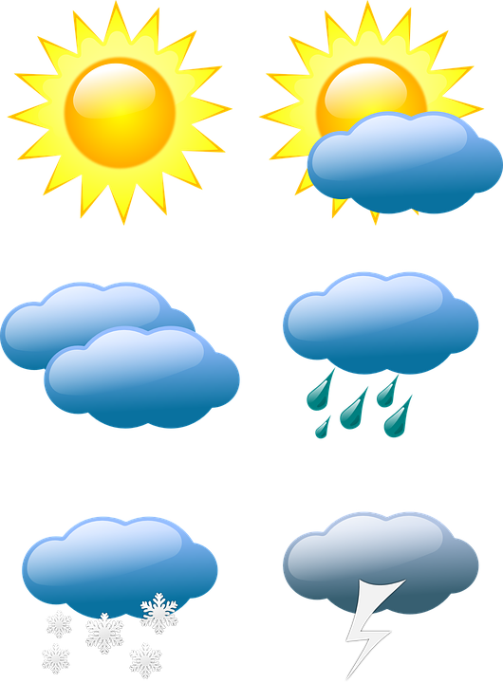

You can respond using a number of weather adverbs (don’t worry too much about why they are considered adverbs; just know that these are the forms you need to use).

Weather Adverbs
dusno | muggy
chladno | cold, cool
hezky | pretty
horko | hot
hnusno | disgusting
jasno | clear
mlhavo | foggy
oblačno | cloudy
pěkně | pretty
polojasno | partly cloudy
příjemně | pleasant
slunečno | sunny
sucho | dry
teplo | warm
vedro | really hot, scorching hot
vlhko | humid
zataženo | overcast
zamračeno | cloudy
zima | cold (technically a noun)

Examples:
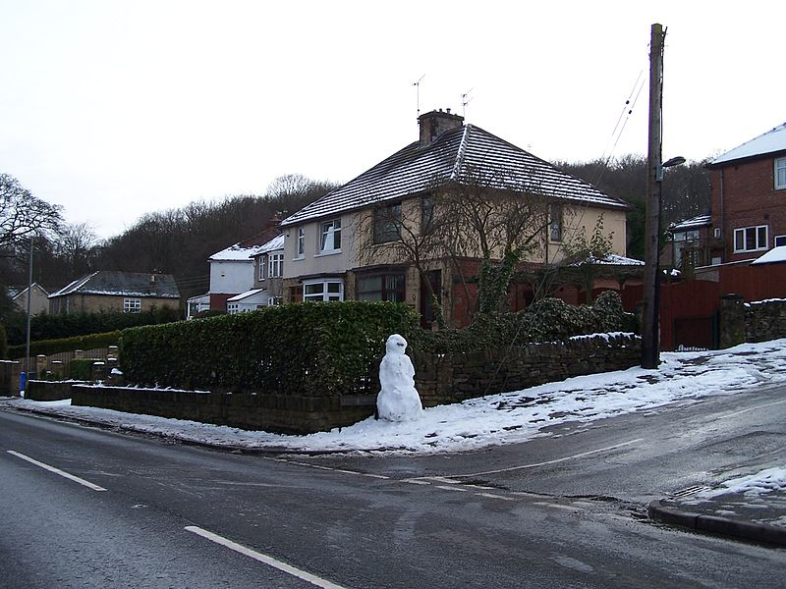 |  | 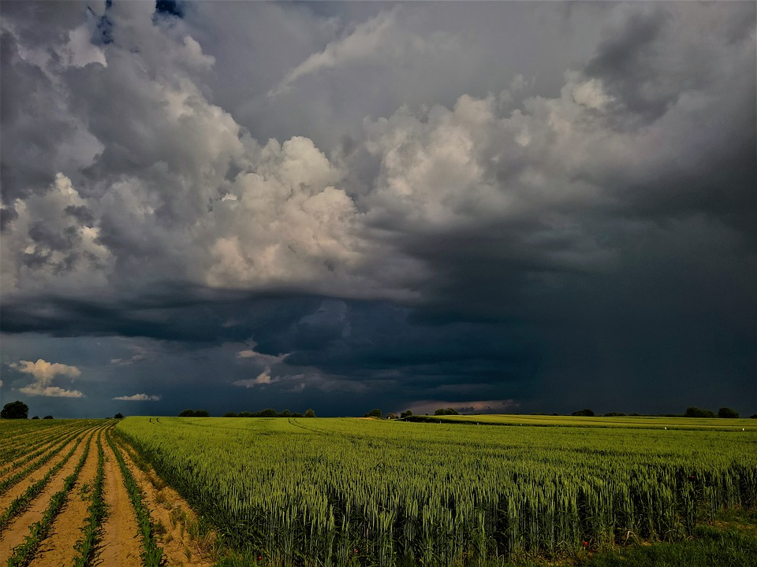
Venku je velmi chladno.  It’s very cold outside. | Venku je horko.  It’s hot outside. | Je dusno a zamračeno.  It’s muggy and cloudy.

The word zima - ‘cold’ is actually a noun (you’re actually saying something like ‘there is coldness’. You’ll literally say:

Je velká zima.
‘It is great cold’ i.e. ‘It’s very cold’.

Another noun that might come in handy is bouřka ‘storm’. You can say:

Venku je bouřka.
There’s a storm outside.

Weather Verbs
blýskat se | to flash
blýská se | there’s lightning (lit. it’s flashing)
foukat (-á-) | to blow
fouká vítr | the wind is blowing
mrznout (mrzn-; -e-) | to freeze
mrzne | it’s freezing
padat (-á-) | to fall
padá sníh | snow is falling
poprchávat(-á-) | to drizzle
poprchává | it’s drizzling
pršet (-í-) | to rain
prší | it’s raining
sněžit (-í-) | to snow
sněží | it’s snowing
svítit (-í-) | to shine
svítí slunce | the sun is shining

You can use some of the above verbs to talk about the weather as well. These will be used in the 3rd person naturally (i.e. - you won’t say ‘I’m raining’, ‘you’re snowing’, etc.)

 | 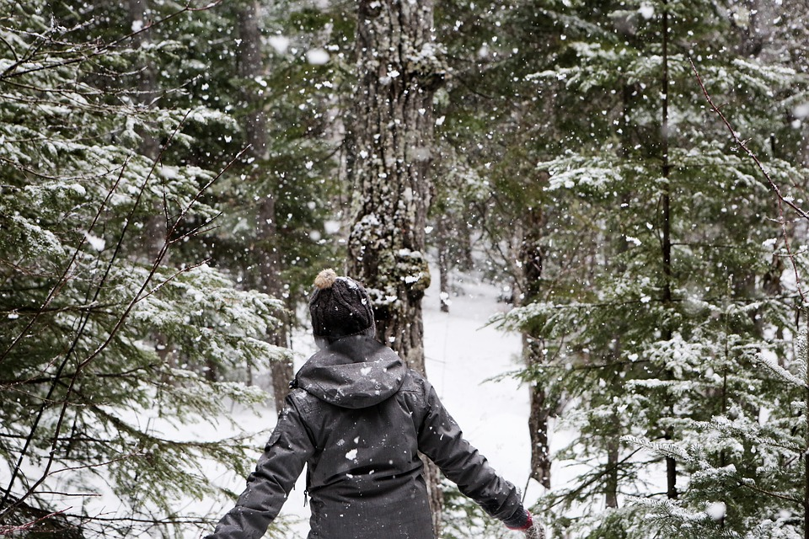 | 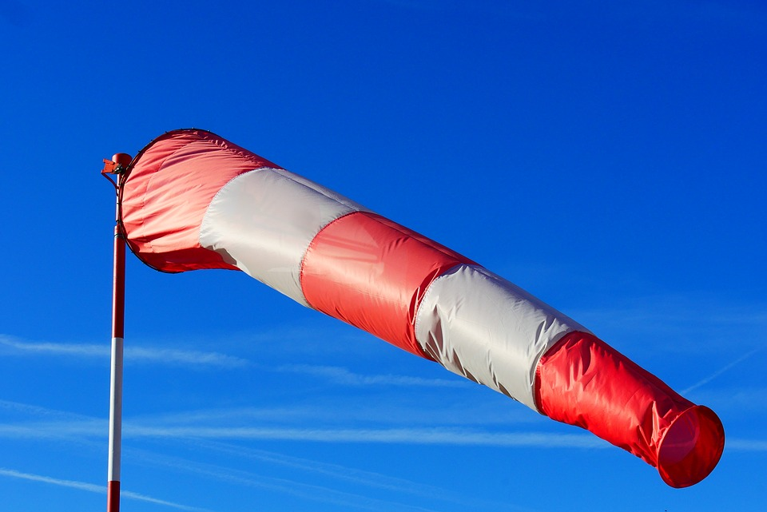
Dnes prší.  It’s raining today. | Tady často sněží.  It snows often here. | Fouká silný vítr.  A strong wind is blowing.

Images used in this document come from these sources.

