6 | 4 | Lekcija 1: [NE]Prikladna odjeća

6.4 Zadatak 1. Što nose?
You will hear a description of what each person is wearing. Listen for the items of clothing and mark the items that you hear and you see below.
(audio)
 | 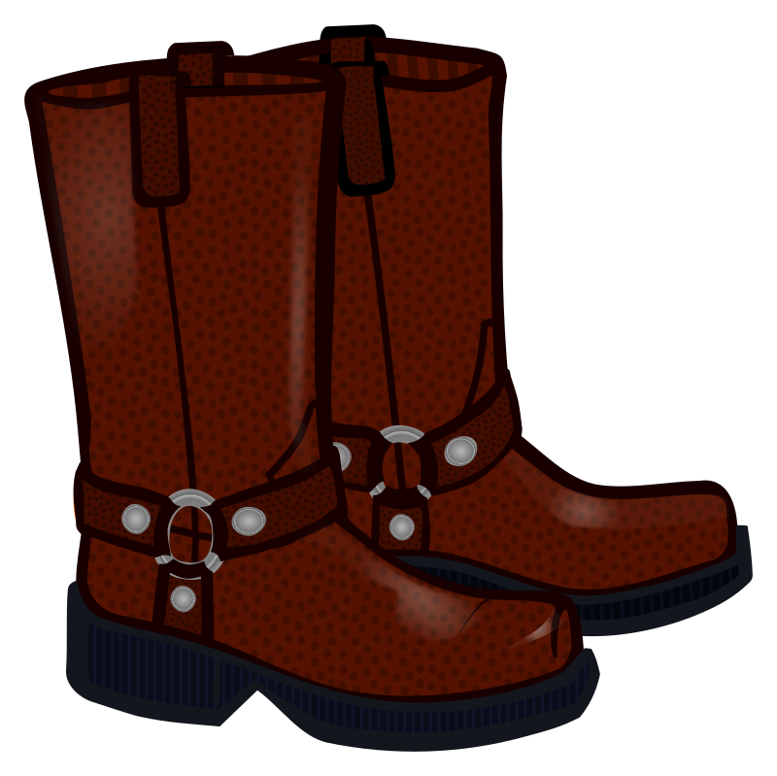 | 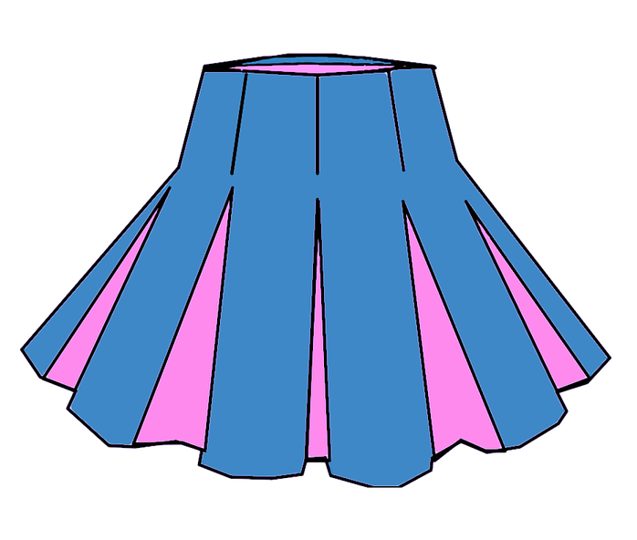 | 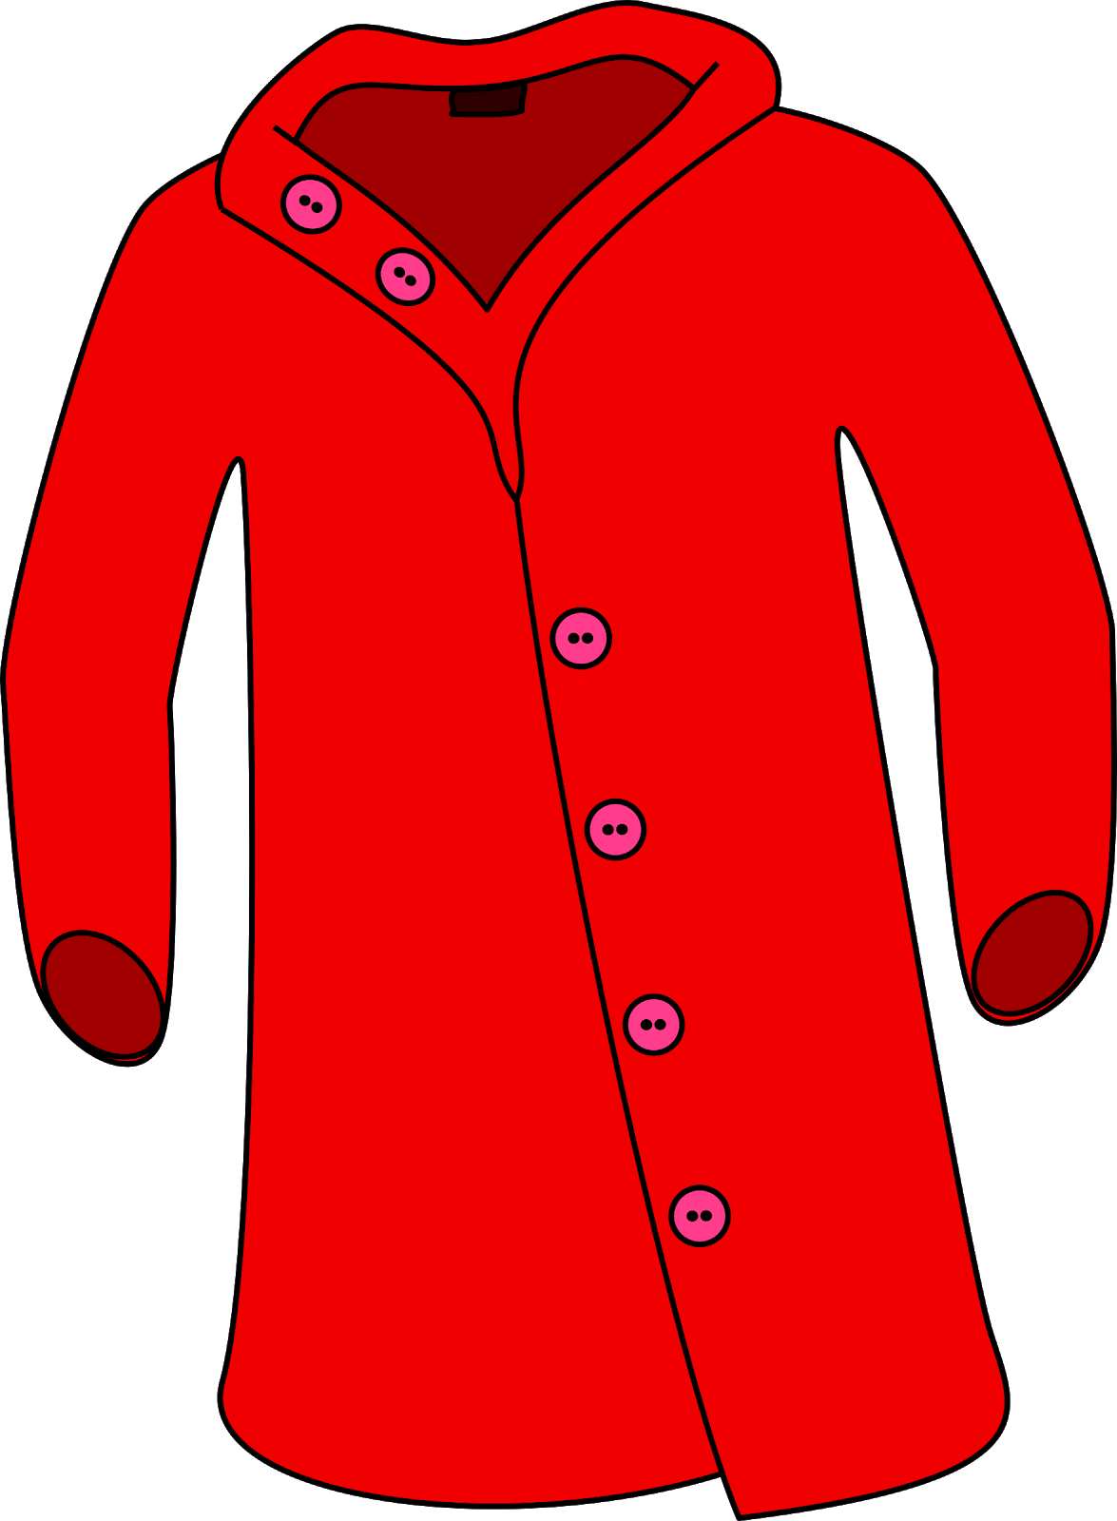 | 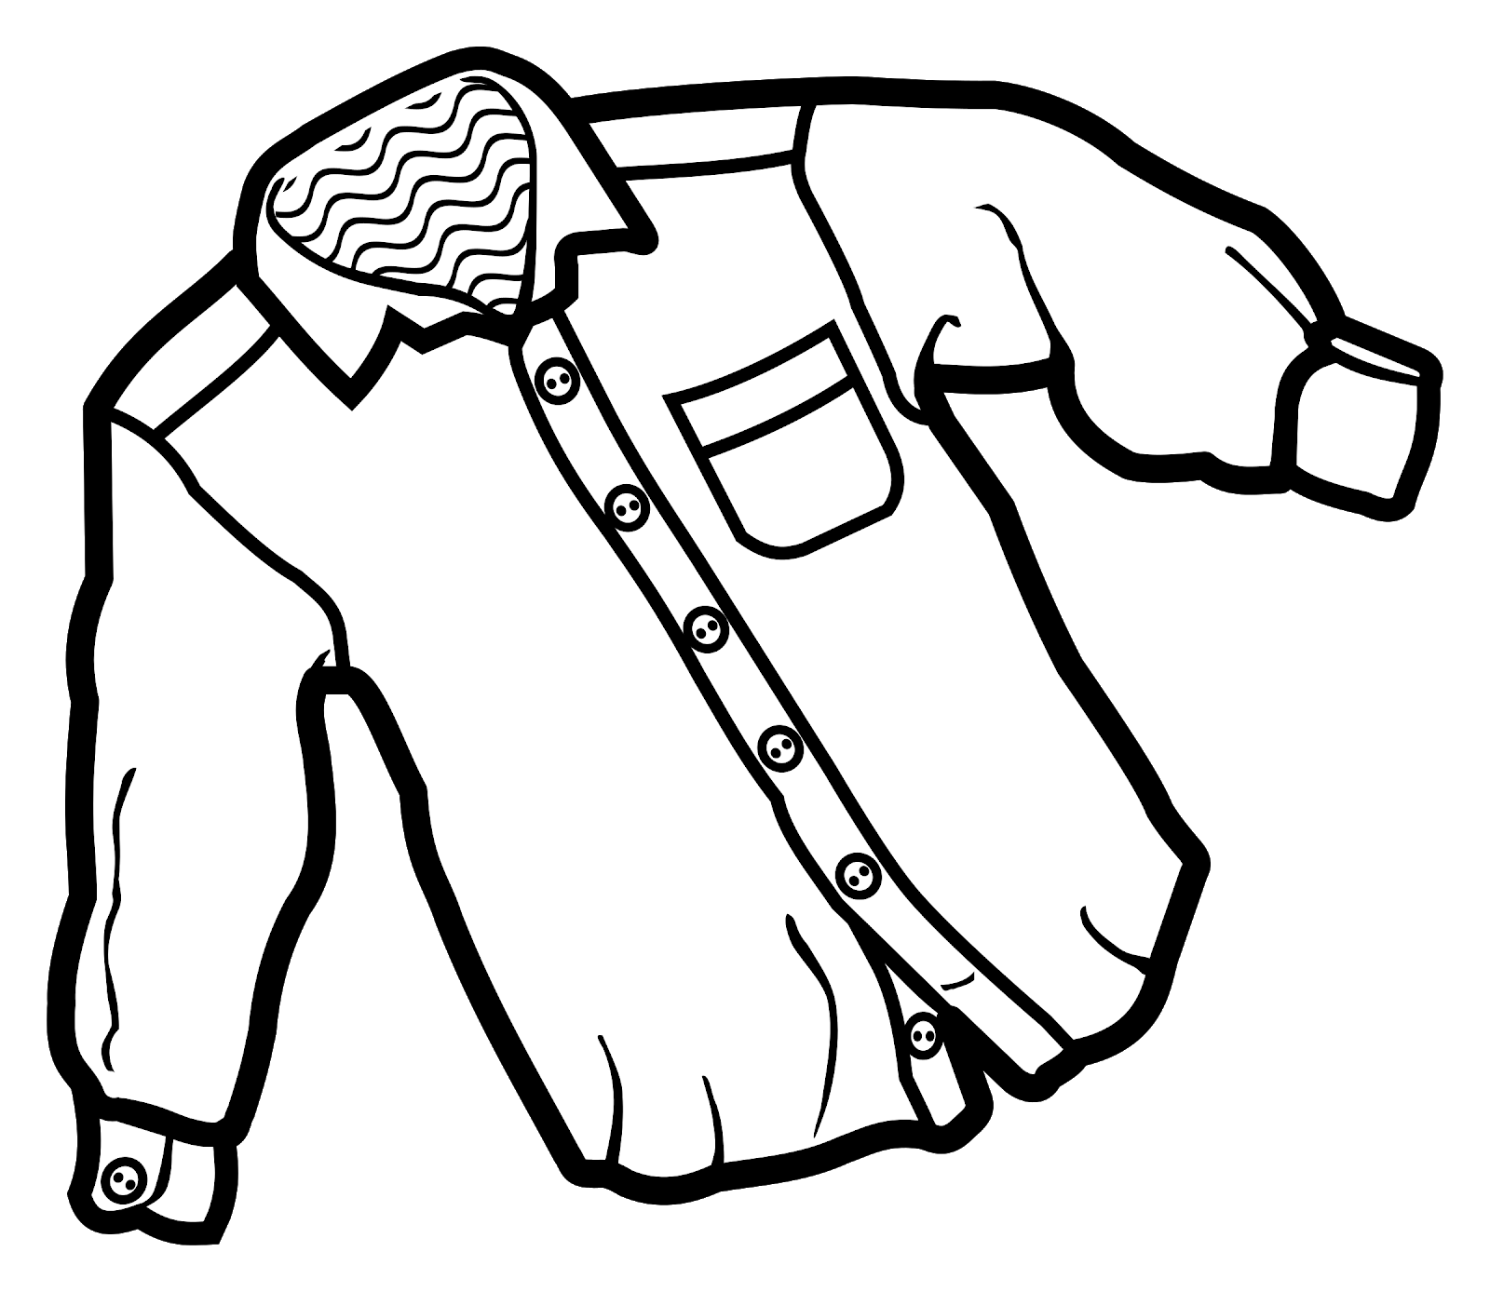 | 
(audio)
 |  | 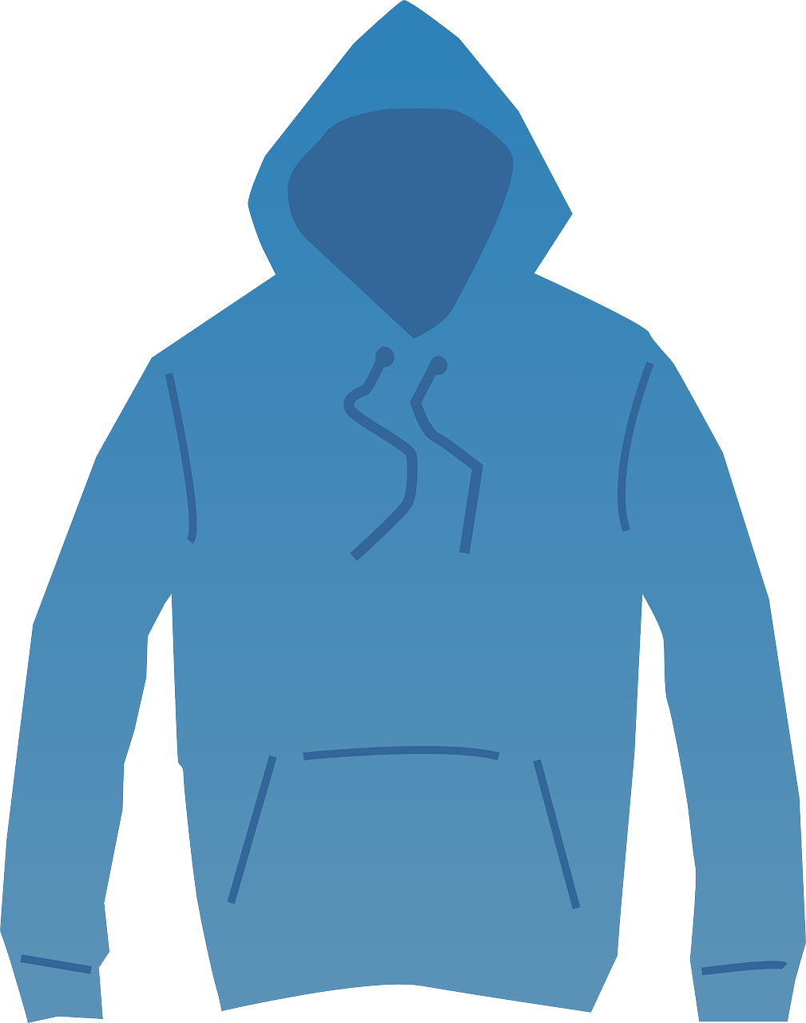 | 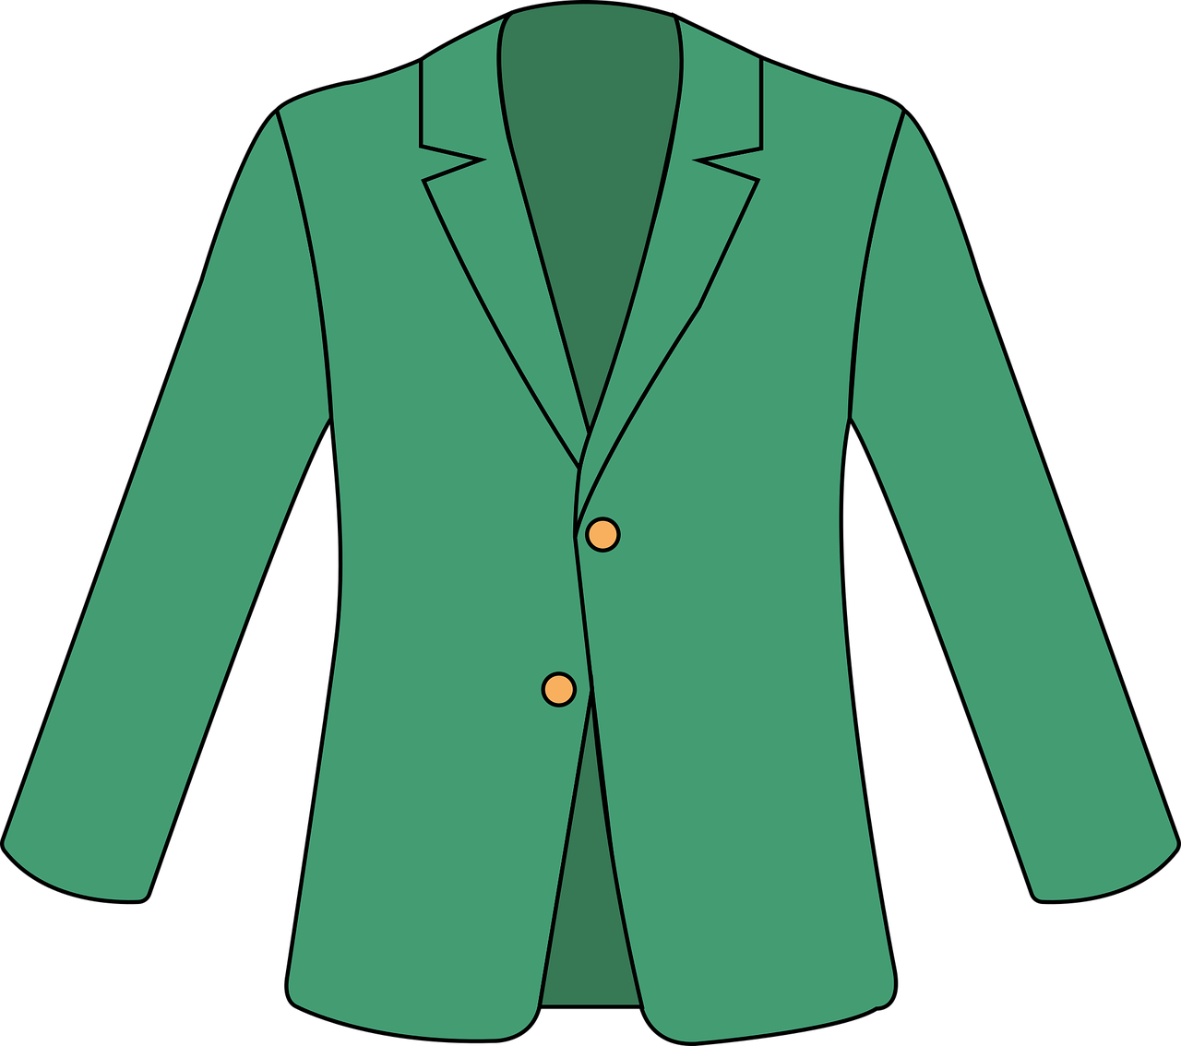 |  | 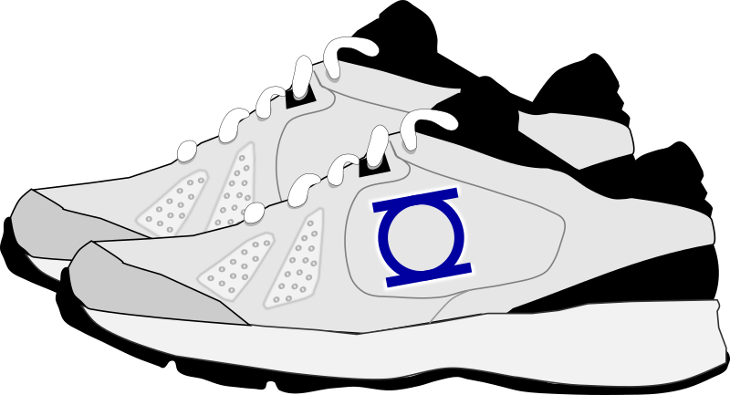
(audio)
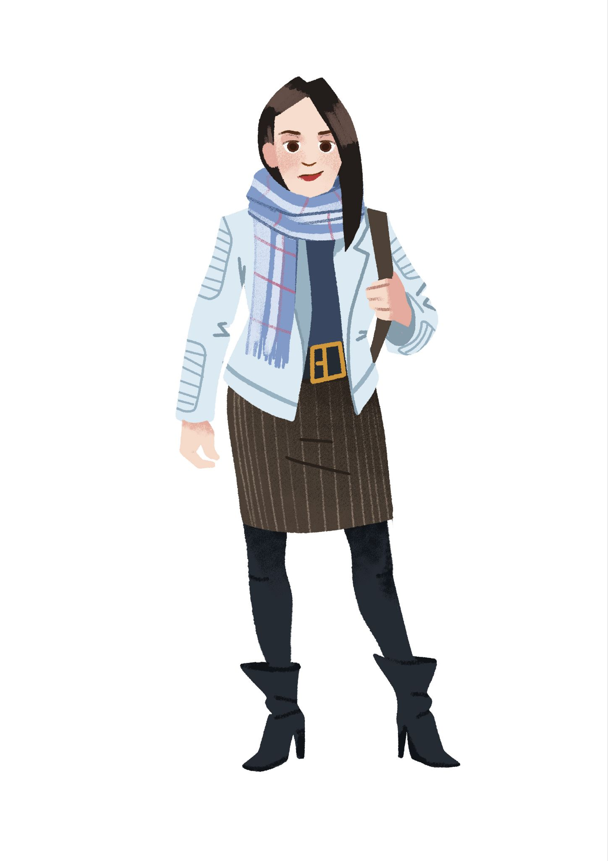 | 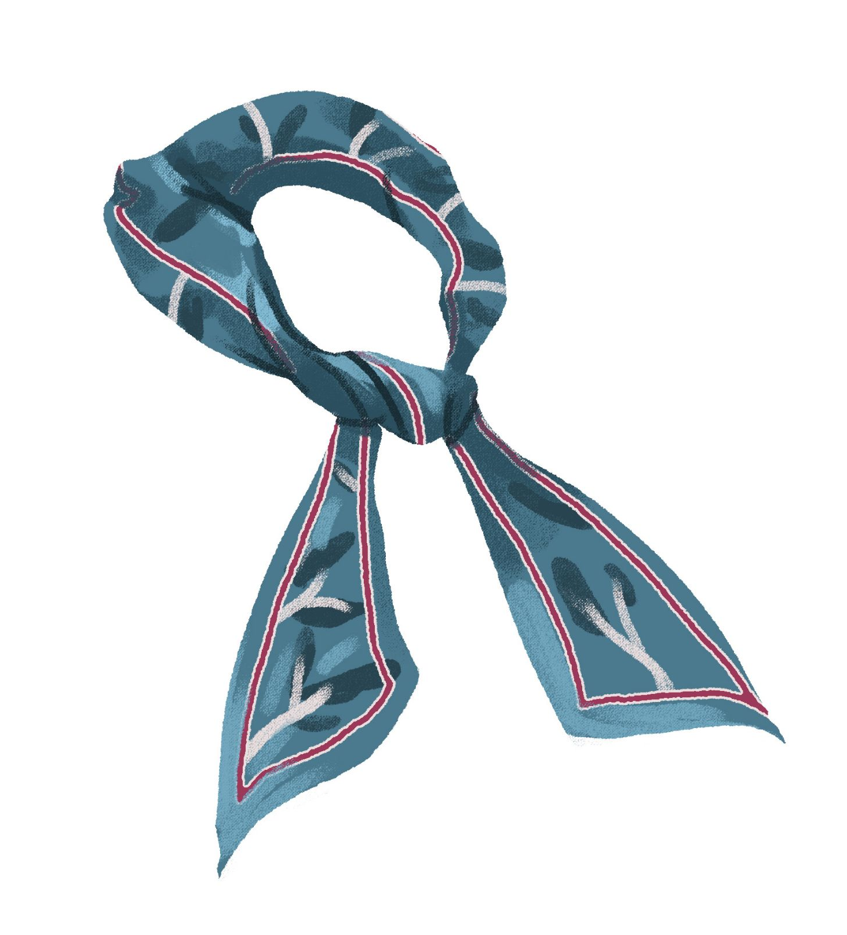 |  |  |  | 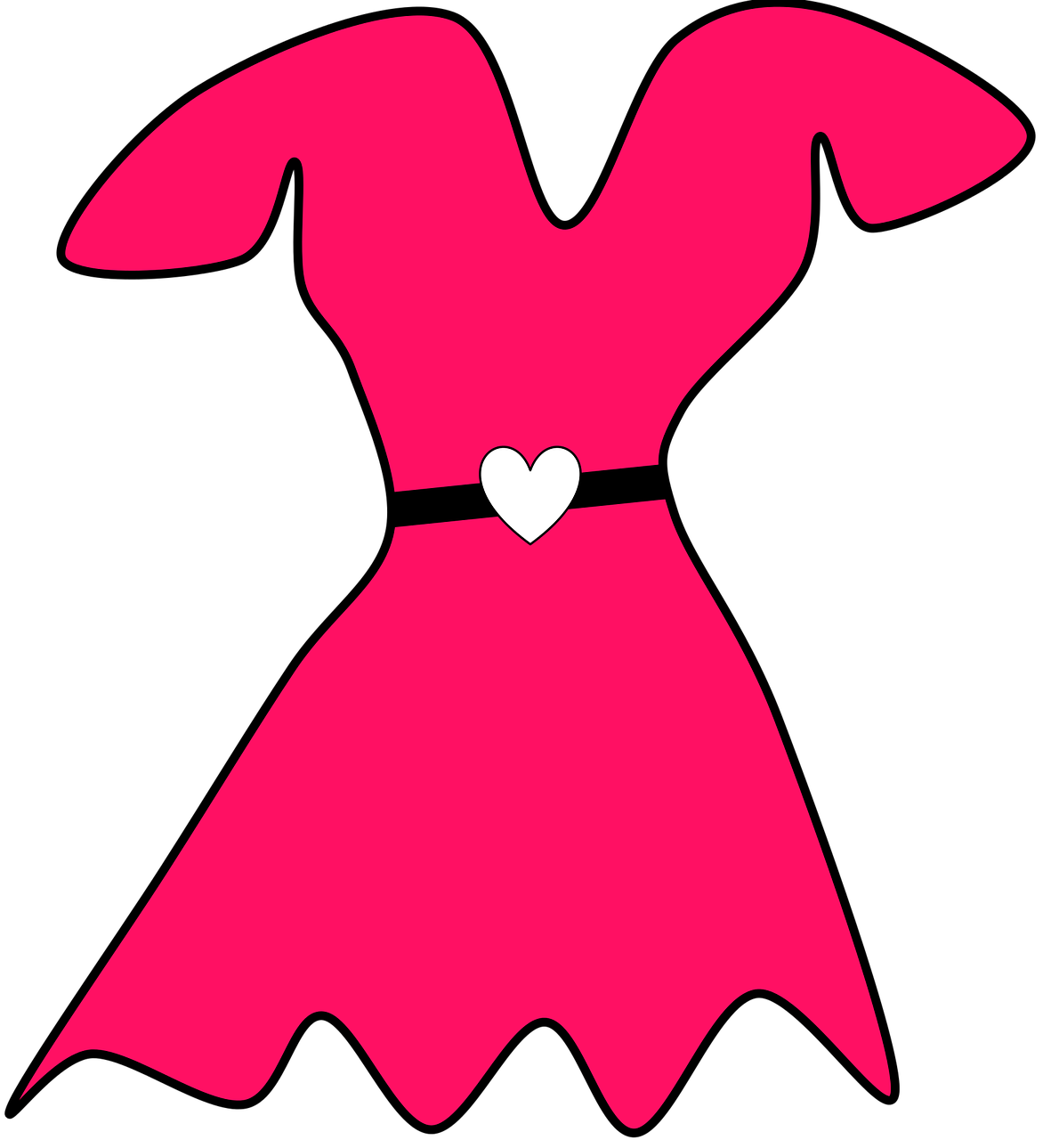
(audio)
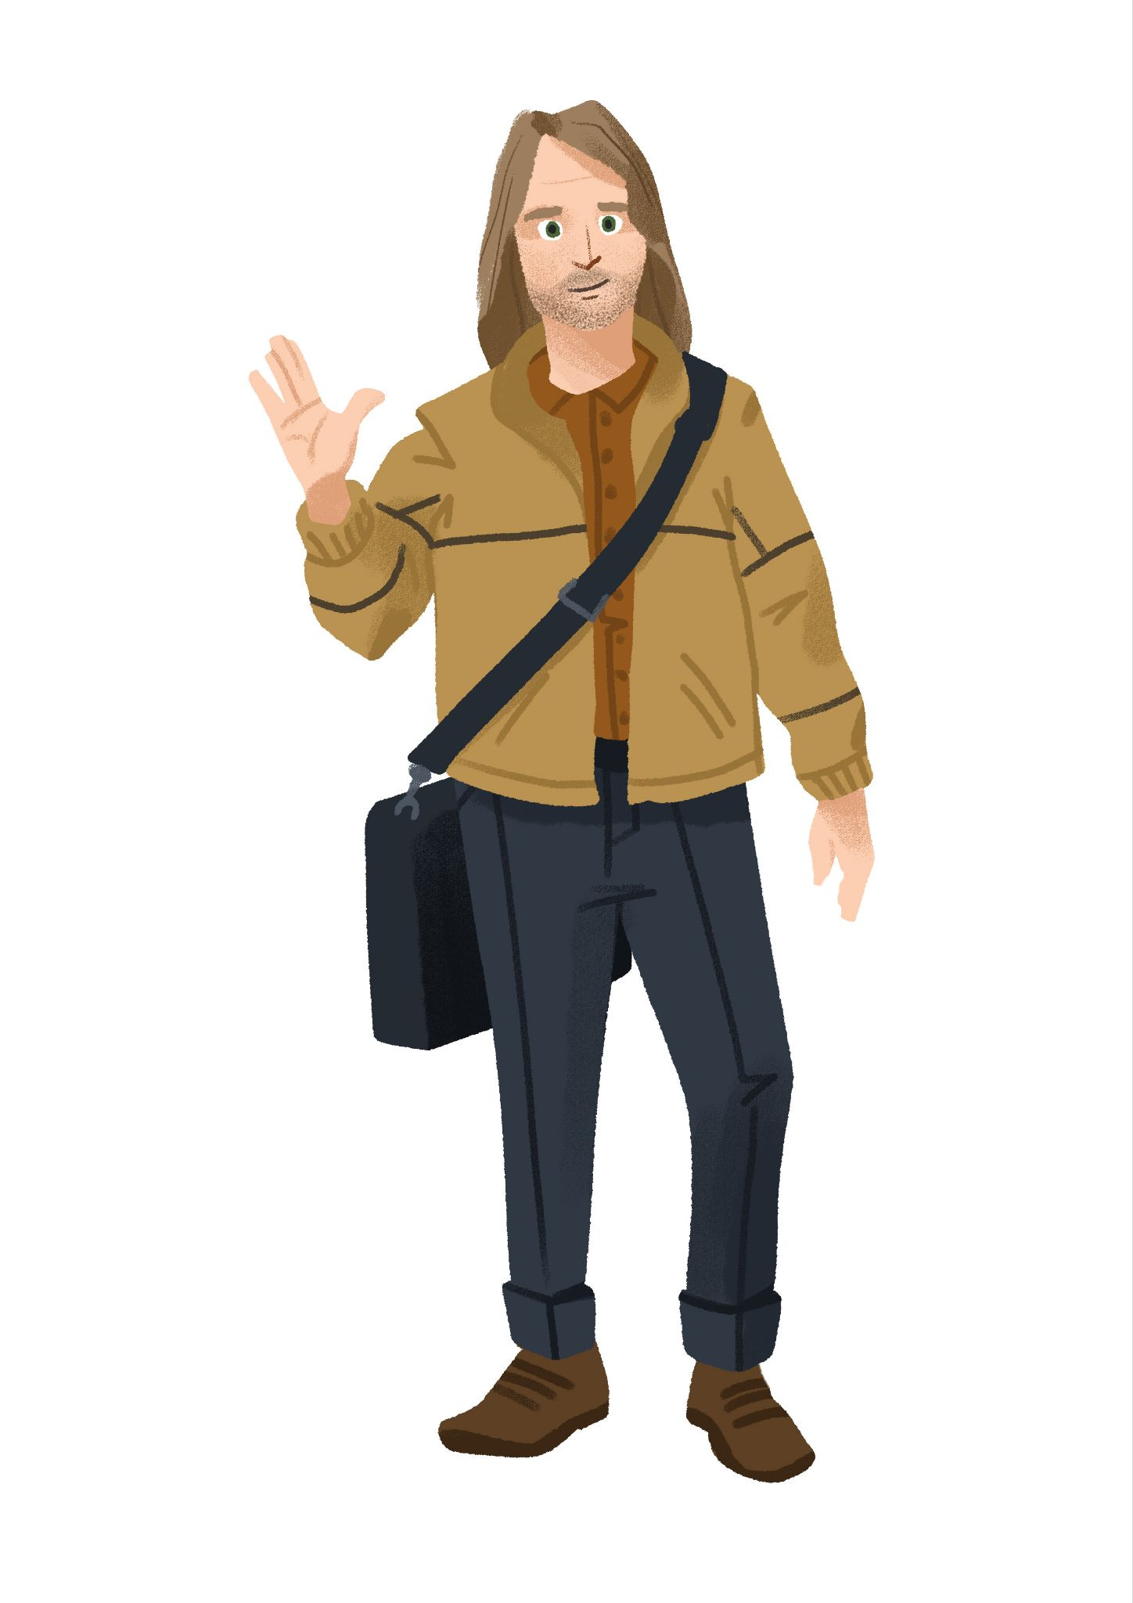 |  | 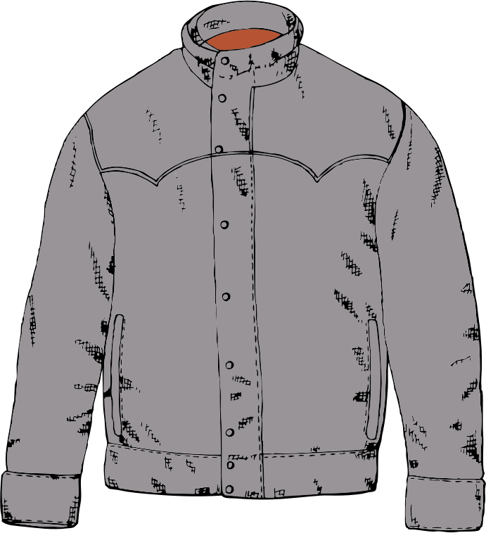 | 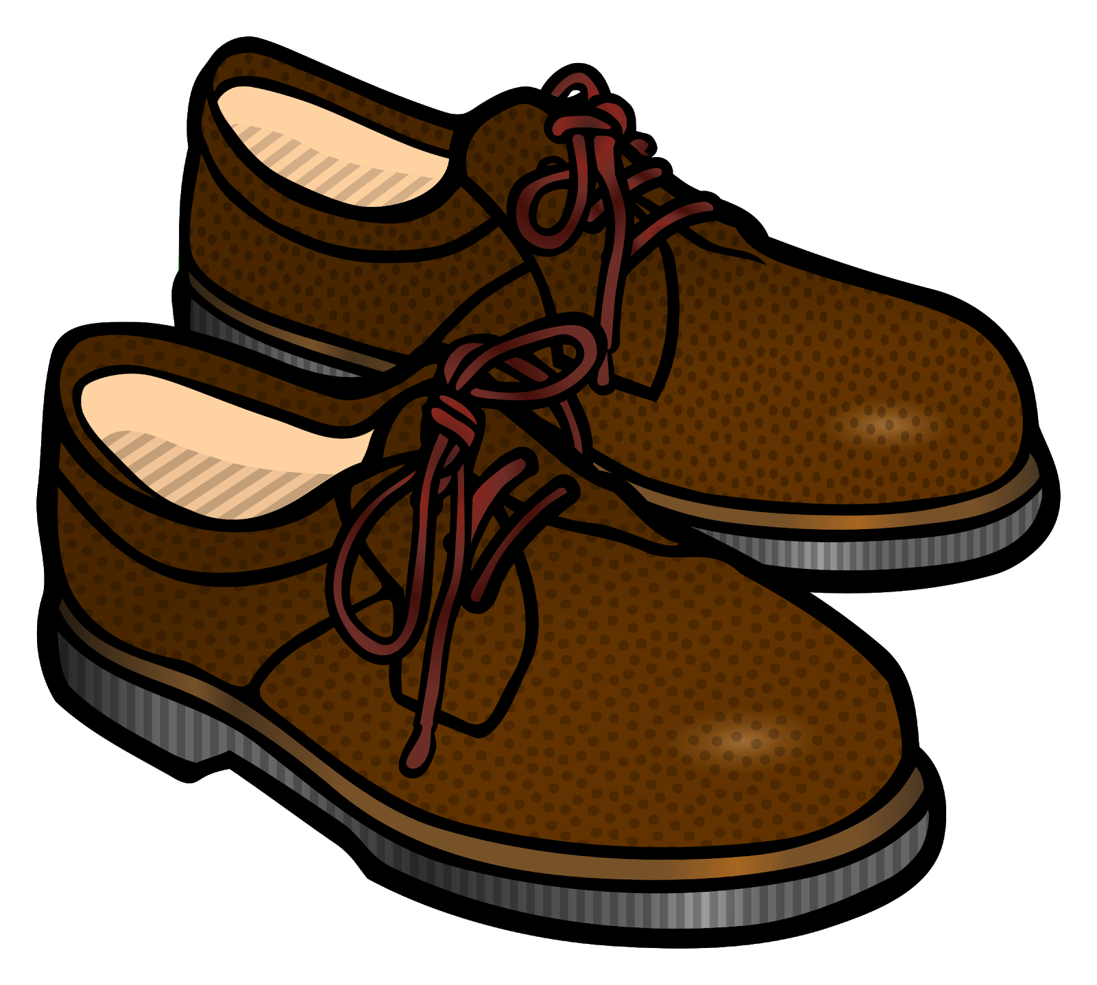 |  | 

6.4 Zadatak 2. Moram se spakirati
(audio) Listen to the text while Sandra is packing for a trip this February. She is thinking about what to pack based on the weather and events at the final destination. Circle the items that our student will pack.
 | 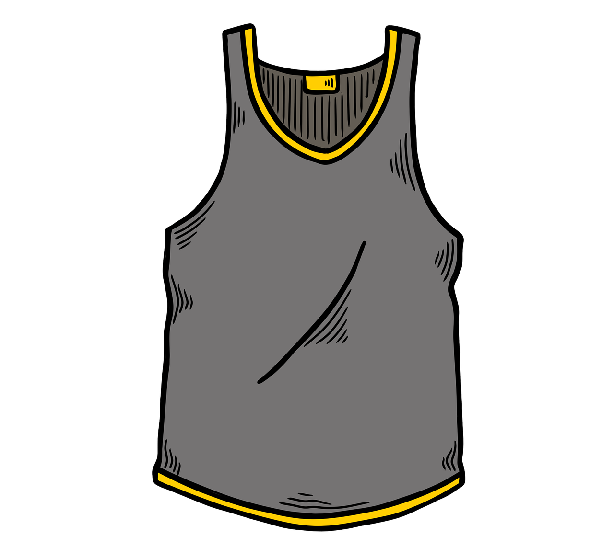 | 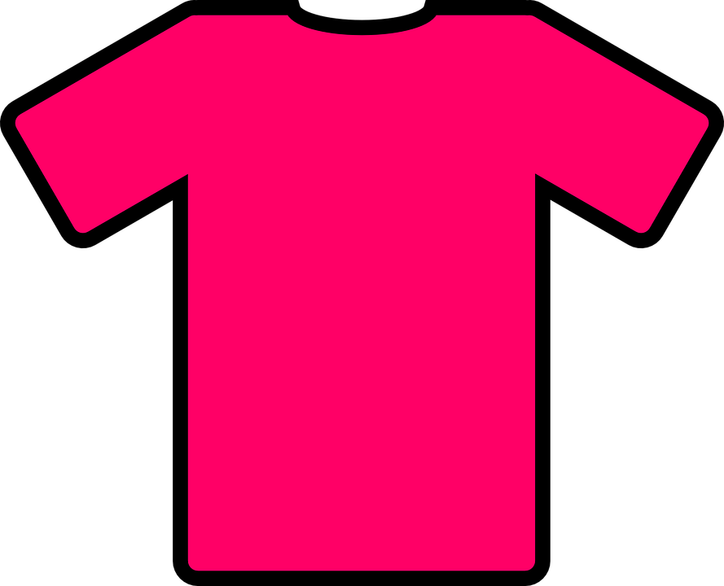
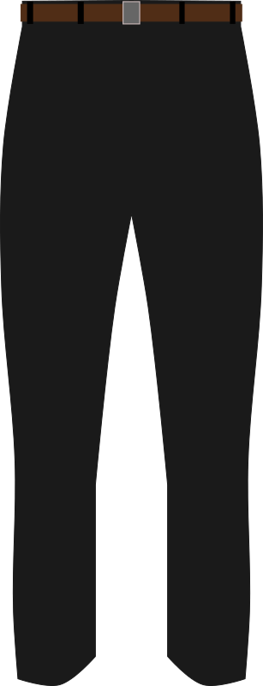 | 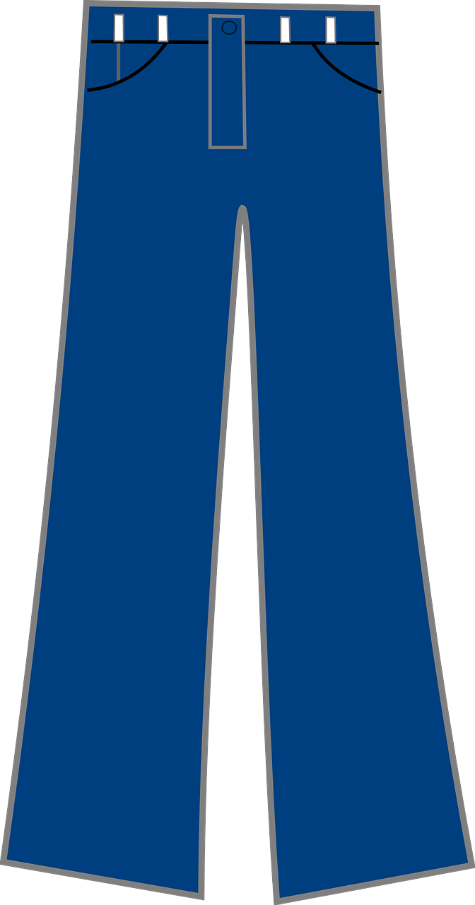
 |  |  | 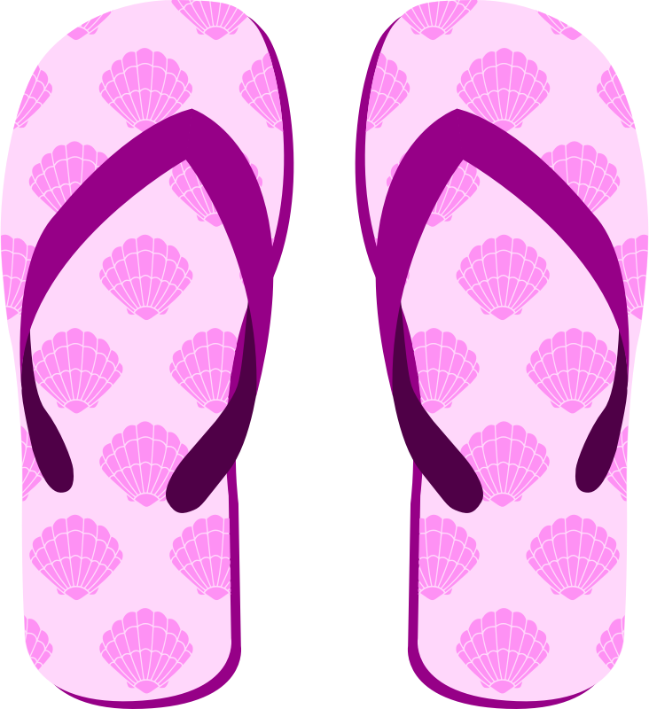

1 | Kamo Sandra putuje ovaj vikend?
1 | -
2 | Kamo će ići u četvrtak? Zašto?
2 | -
3 | Što Sandra još treba spakirati?
3 | -

6.4 Zadatak 3. Šoping centri
Check the link and pick one shopping center.

| Hrvatski
Answer in Croatian. Find stores that you like.
1 | Koje tri trgovine želiš posjetiti?
1 | -
2 | Što želiš kupiti u tim trgovinama?
2 | -
3 | Koje se još trgovine nalazu u šoping centru?
3 | -
4 | Imaju li te trgovine i u SAD-u?
4 | -
5 | Koja je adresa šoping centra?
5 | -
6 | U koliko sati otvara i zatvara šoping centar?
6 | -

| English
Answer in English. Look at all 4 shopping centers.
1 | Which one do you like the best? Why?
1 | -
2 | If you traveled to the region, have you ever been to any of these places?
2 | -
3 | What do you think of these places?
3 | -
4 | How different/similar these places are from those we have in the US?
4 | -

6.4 Zadatak 4. Večernji izlazak
👥 Pair-work. Meet with one of your classmates. Make arrangements for an evening out and discuss what you will wear. Ask for suggestions. Discuss the place(s) you are going to and discuss the weather at the location. Find the appropriate outfit for your night out - ask for suggestions. You do not want to be cold or hot. You also want to be dressed appropriately for the occasion. Submit your video recording online.

Images used in this document are from these sources.

