9 | 1 | Lekcija 1: Sport i rekreacija

| Baviti se + Instrumental case
In this lesson you encountered phrases such as: (1) Luku zanima plivanje. (2) Luka se bavi košarkom. It is important to distinguish between these two sentences and the verb they contain.
The verb | Meaning | Grammar structure
Zanimati (se) | Indicates your interest in something (it does not necessarily include your expertise in the field/things you are interested in). | Zanima / Zanimaju + personal pronoun in the Accusative + noun in the nominative (singular or plural)  Zanima me sport.  Zanimaju me sportovi.
Baviti se | Indicates your engagement in something recreationally and/or professionally. In can be roughly translated with English equivalent of “to be engaged in something and practice it” | Baviti se + noun in the instrumental case.  Bavim se sportom.  Bavim se tenisom i golfom.

BAVITI SE
SINGULAR |  |  | PLURAL
(audio) | ja | bav-im se | (audio) | mi | bav-imo se
(audio) | ti | bav-iš se | (audio) | vi | bav-ite se
(audio) | on/-a/-o | bav-i se | (audio) | oni/-e/-a | bav-e se

9.1 Zadatak 1. Čime se bave?
Choose the appropriate noun that best represents what the picture shows.
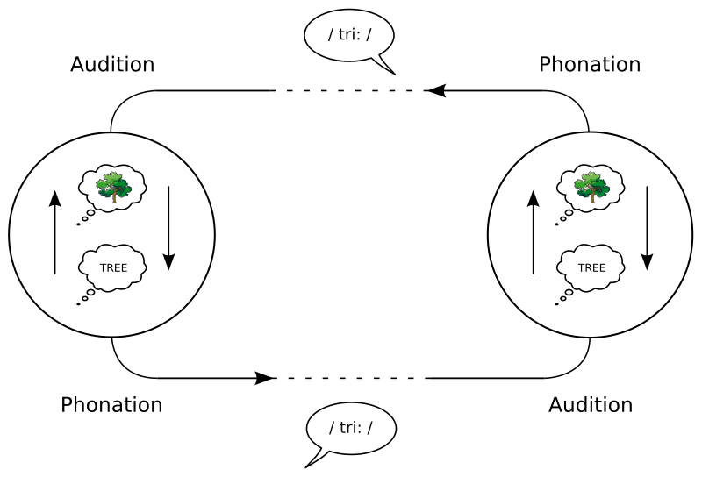 | 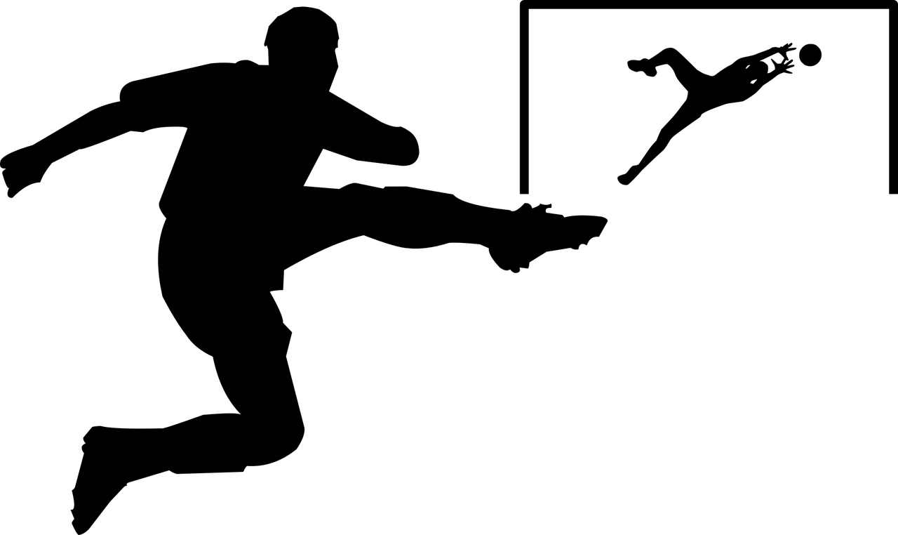 | 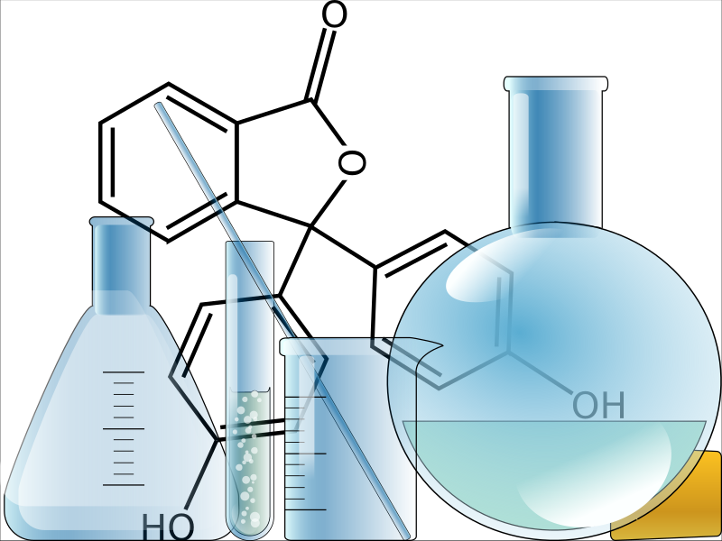 | 
slika 1 | slika 2 | slika 3 | slika 4
 | 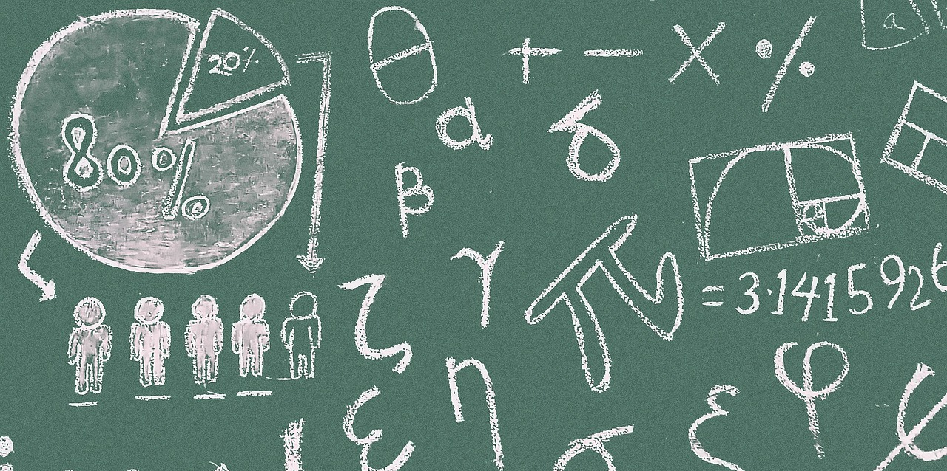 | 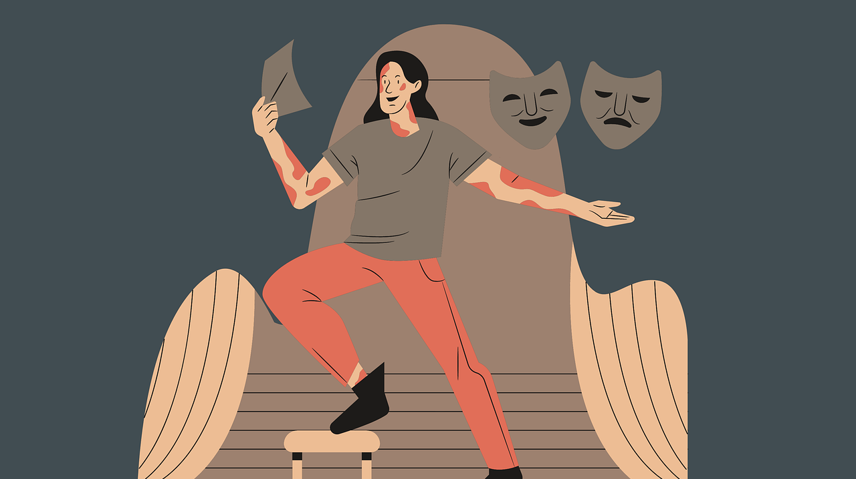 | 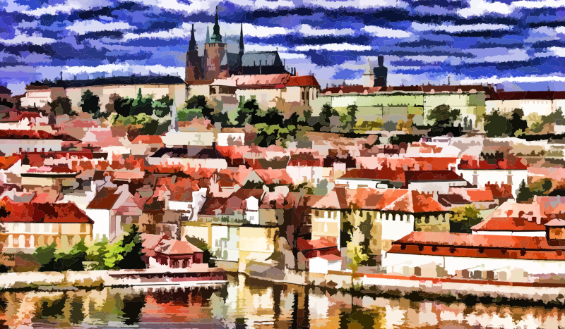
slika 5 | slika 6 | slika 7 | slika 8
[h5p id="830"]
Now look at the list of the following people and finish the sentences by using the nouns from above. What is their professional occupation? One example is given to you.
[h5p id="828"]

9.1 Zadatak 2. Koja je ovo aktivnost?
Look at the following pictures. Each of them shows a certain action. You already know the verbs for these actions. Now, you need to write a verbal noun (example: kuhati – kuhanje) form for each of them. We have already talked about verbal nouns. If you need to refresh your memory, check Unit 7 for more information.
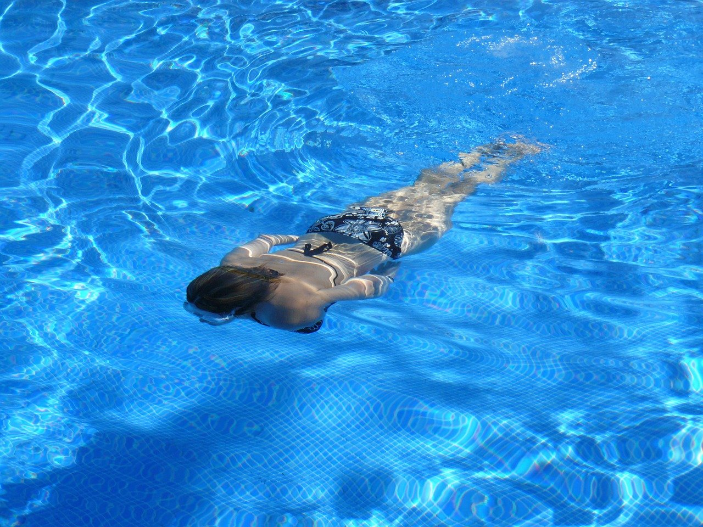 | 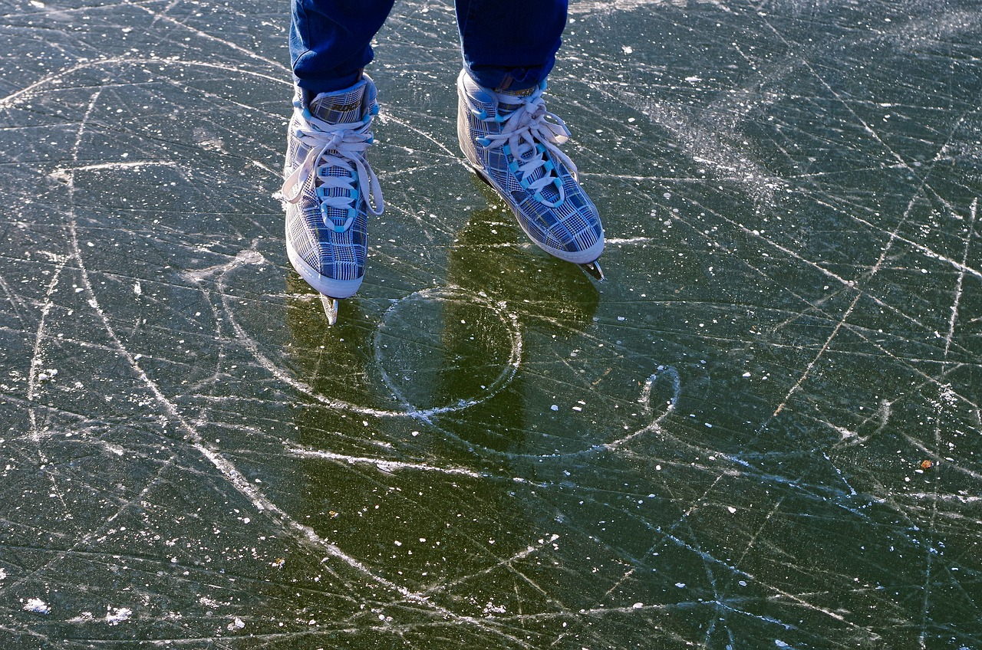 | 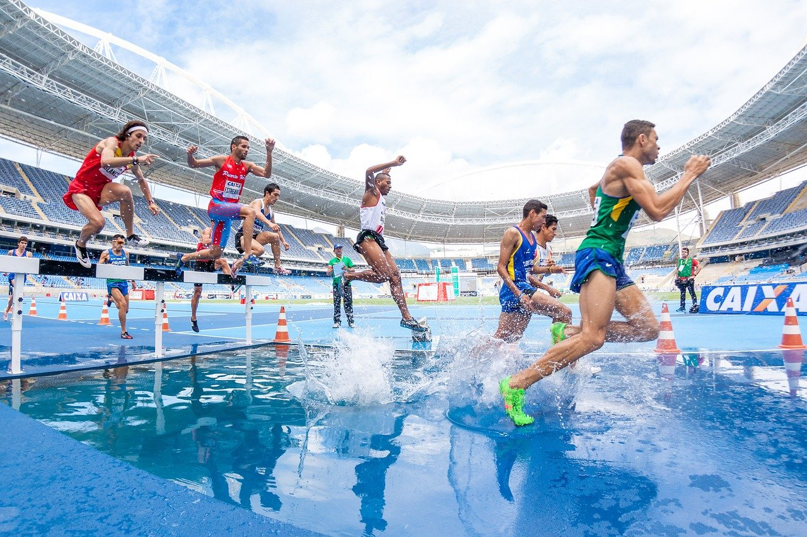 | 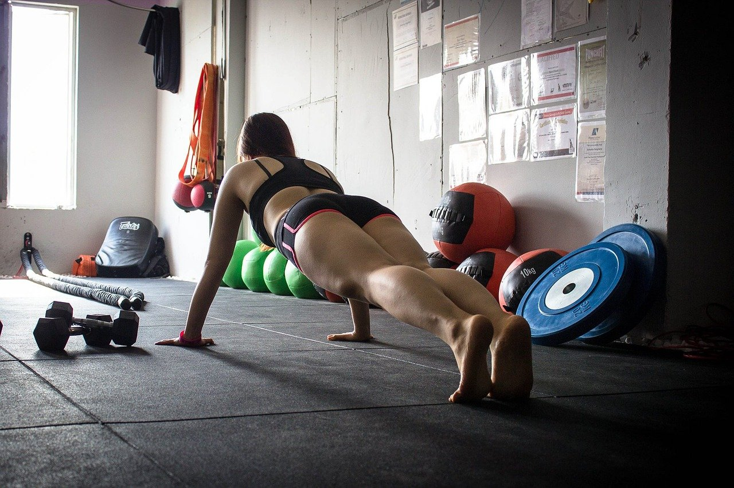
slika 1 | slika 2 | slika 3 | slika 4
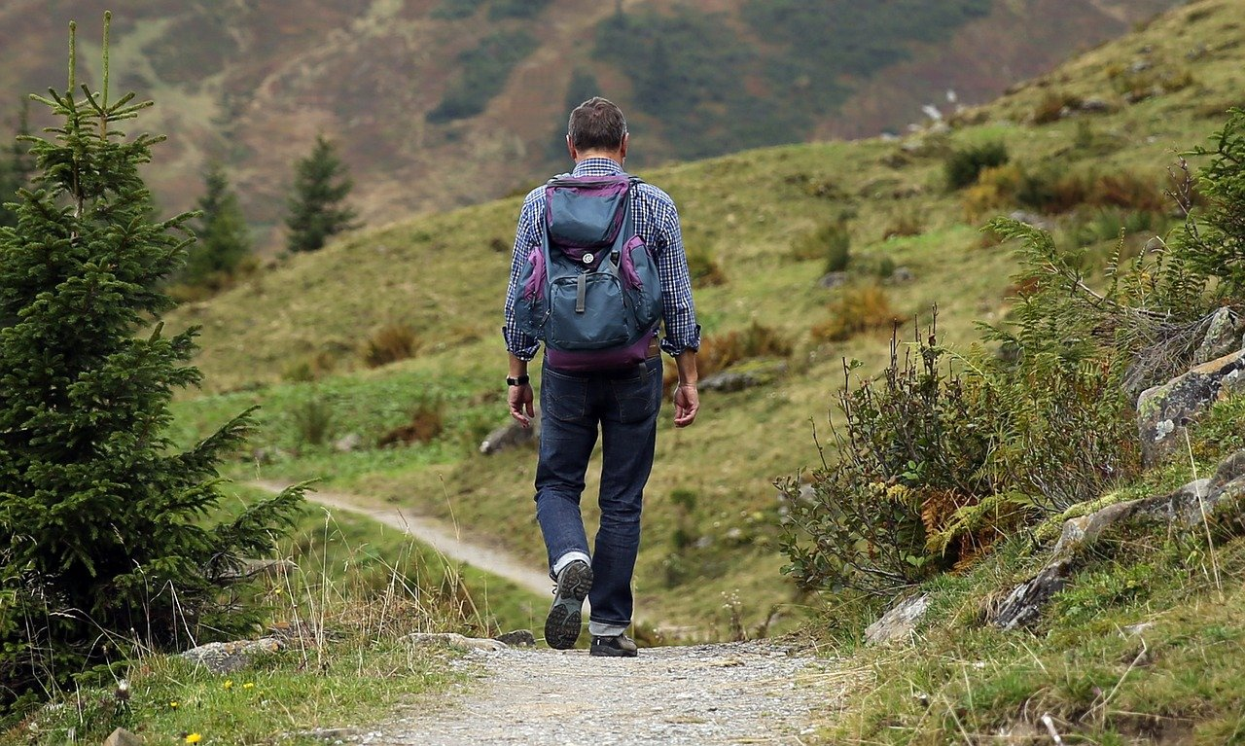 | 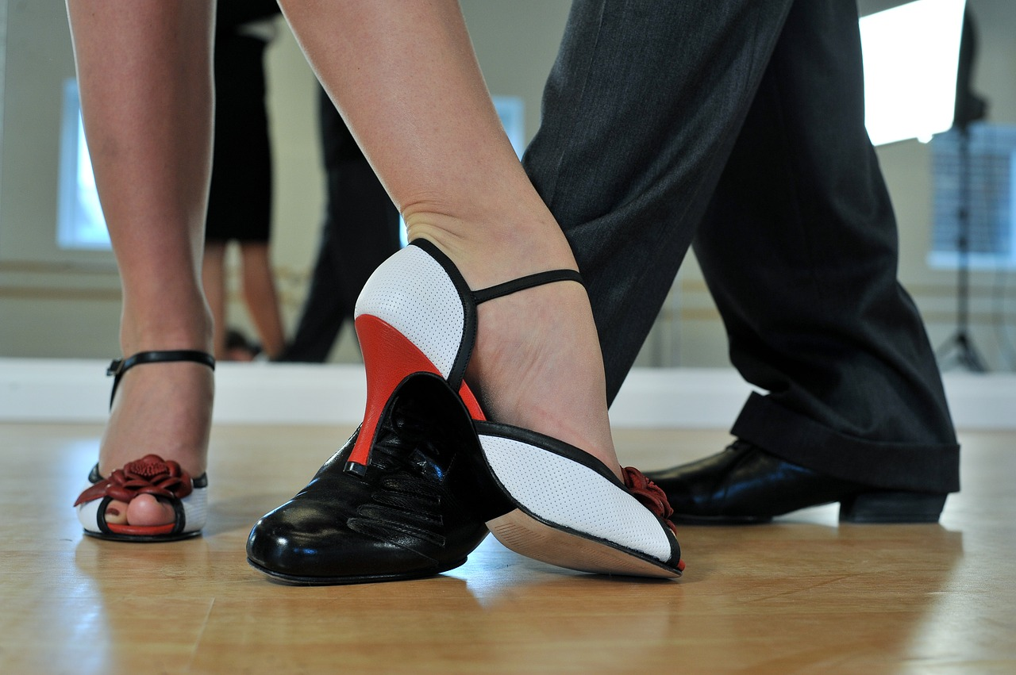 | 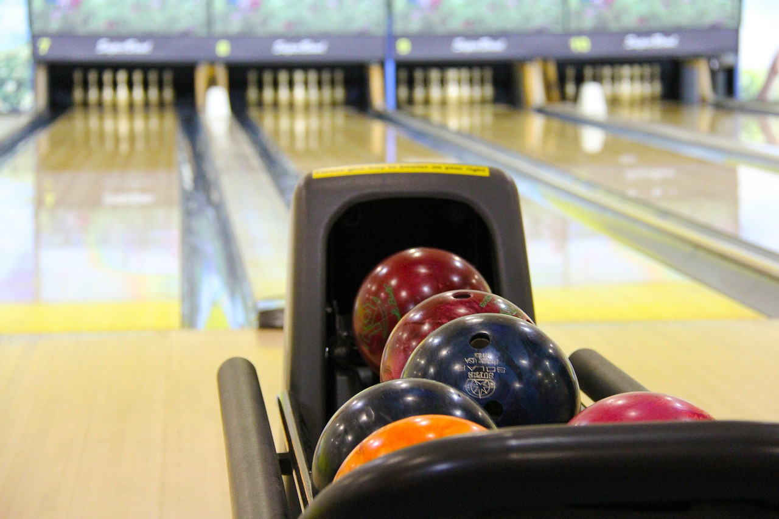 | 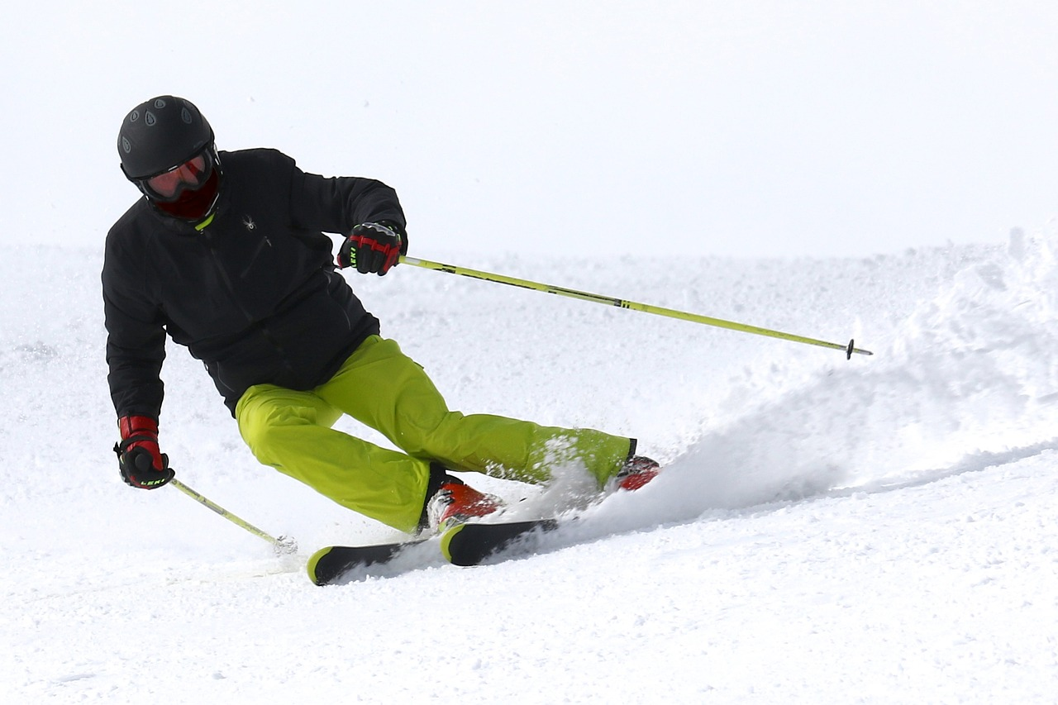
slika 5 | slika 6 | slika 7 | slika 8

Look at the pictures above and finish the sentences. Use a verbal noun in your answers.
[h5p id="829"]

Images used in this document are from these sources.

