7.1 - Ranní ptáče nebo sova?

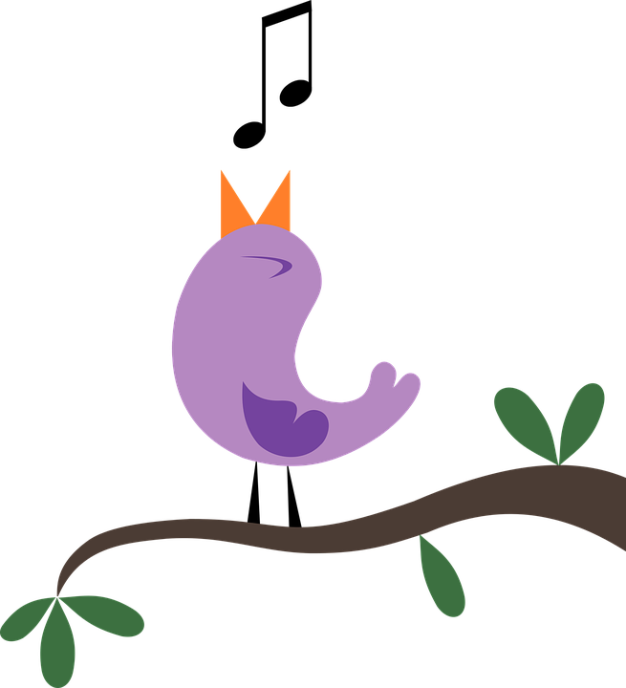  ranní ptáče | 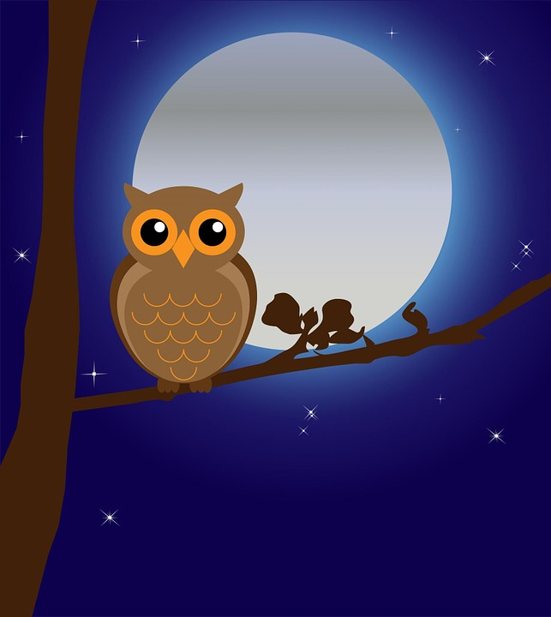  sova

We will be talking about whether we are morning or night people. Are you an early bird - ranní ptáče? Or more of a night owl - sova?

Images used in this document come from these sources.

