8.2 - Names of Languages

We’re studying Czech, right?

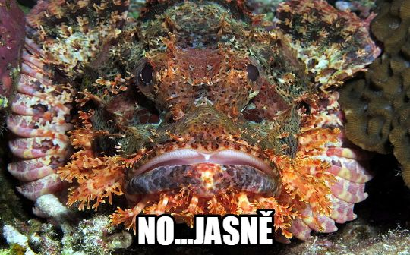

What word actually corresponds to the word Czech, when we talk about it as a subject that we’re studying.

The word is…

čeština!!!

The word čeština is a feminine noun that means the Czech language. We’ll be using it here in the context of subjects in school. So if you wanted to say that you are studying Czech, you’d say:

Studuju češtinu
I am studying Czech.

Likewise, we could talk about textbooks or courses –

učebnice češtiny - Czech textbook (lit. textbook of Czech)
hodina češtiny - Czech class (lit. hour of Czech)

Now what about making nouns like this out of other languages:

It’s easy, really…

Language adverb ends in.. | ...then the language noun is... | Examples
-sky | -ština | česky → čeština  rusky → ruština  španělsky → španělština
-cky | -čtina | anglicky → angličtina  řecky → řečtina

The only exception to this rule is the word němčina ← německý.

Not too hard, right!?!?

Images used in this document come from these sources.

Remember, these are the forms we used when we said things like mluvím česky, umím rusky, neumím španělsky...

