1.1 - Czech Greetings
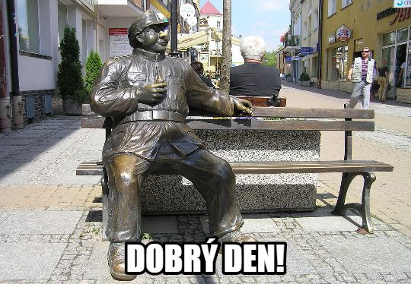

This lesson includes some of the most common ways of greeting and saying goodbye to people. These are divided into two groups: formal and informal

Formal Greetings - these are used in with instructors, people in stores or offices, police officers, waiters, strangers, etc. or any other situation in which you are speaking with another adult that you are not personally acquainted with on close terms.

Dobrý den - Hello
Na shledanou - Goodbye
Nashle - Bye

Informal Greetings - informal greetings are used primarily with friends, other students, and children.

Ahoj, Nazdar, Čau - Hi
Ahoj, Nazdar, Čau - Bye

Introduction Phrases
Já jsem... - I am...
To je... - This is…
Těší mě - Pleased to meet you.
Mě taky - Pleased to meet you too.

Images used in this document come from these sources.

